**ОБВОДИЛКИ ДЛЯ МАЛЫШЕЙ**

*1.  
[](http://img0.liveinternet.ru/images/attach/c/4/81/59/81059054_large_obvod_06.jpg)  
  
  
3.  
[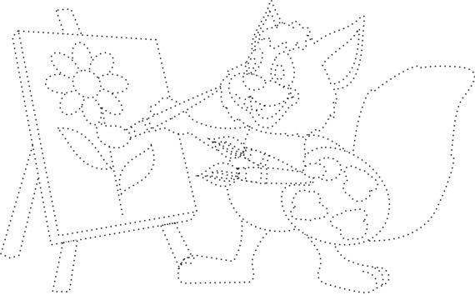](http://img0.liveinternet.ru/images/attach/c/4/81/59/81059056_large_belochka1.jpg)  
  
4.  
[](http://img1.liveinternet.ru/images/attach/c/4/81/59/81059057_large_bln.jpg)  
  
5.  
[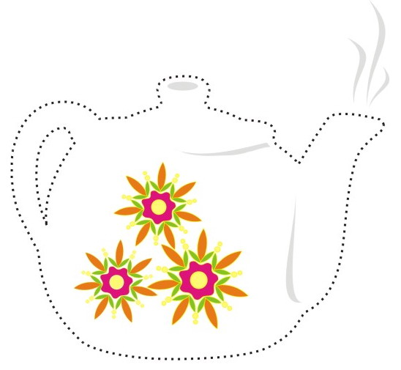](http://img0.liveinternet.ru/images/attach/c/4/81/59/81059058_large_chainik.jpg)  
  
6.  
[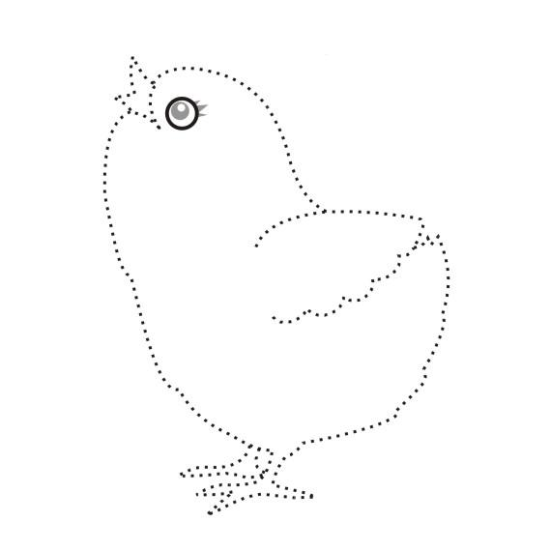](http://img1.liveinternet.ru/images/attach/c/4/81/59/81059059_large_chicken.jpg)  
  
7.  
[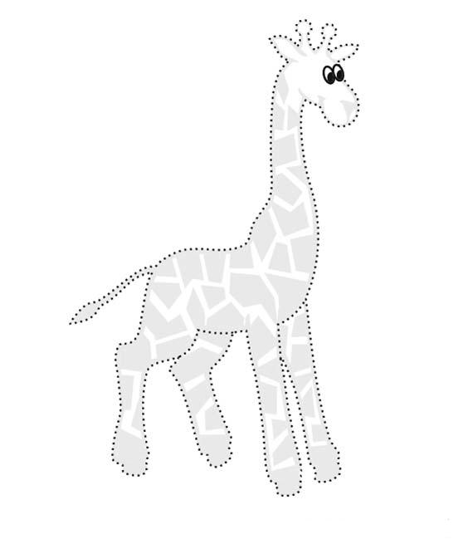](http://img0.liveinternet.ru/images/attach/c/4/81/59/81059060_large_depict_01.jpg)  
  
8.  
[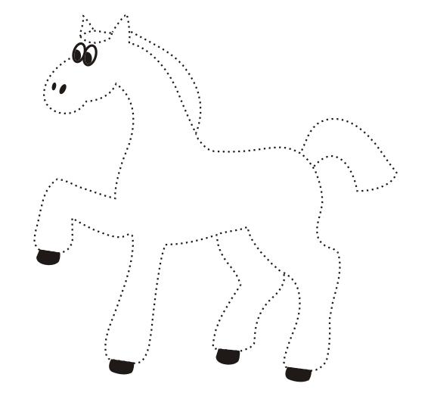](http://img1.liveinternet.ru/images/attach/c/4/81/59/81059061_large_depict_02.jpg)  
  
9.  
[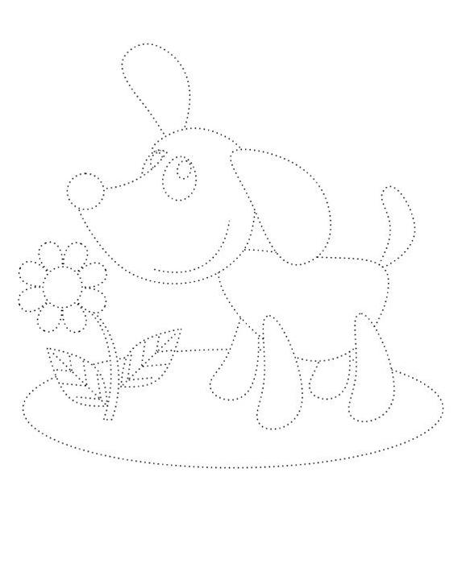](http://img0.liveinternet.ru/images/attach/c/4/81/59/81059062_large_dog_1.jpg)  
  
10.  
[](http://img1.liveinternet.ru/images/attach/c/4/81/59/81059063_large_domik.jpg)  
  
11.  
[](http://img0.liveinternet.ru/images/attach/c/4/81/59/81059064_large_dorogki_15.jpg)  
  
12.  
[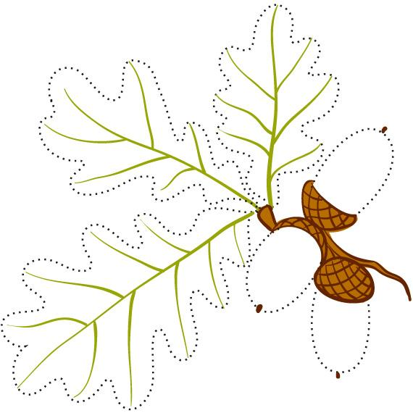](http://img1.liveinternet.ru/images/attach/c/4/81/59/81059065_large_dubok01.jpg)  
  
13.  
[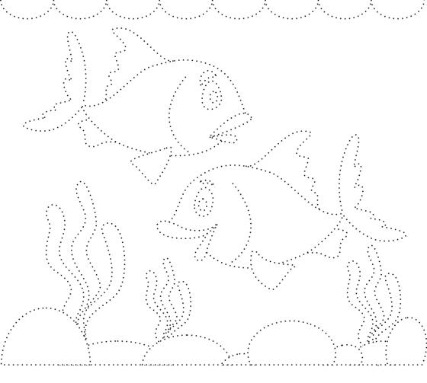](http://img0.liveinternet.ru/images/attach/c/4/81/59/81059066_large_fish_11b.jpg)  
  
14.  
[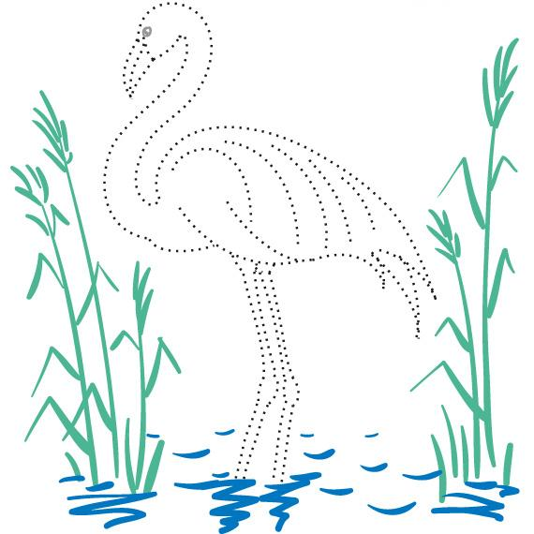](http://img1.liveinternet.ru/images/attach/c/4/81/59/81059067_large_flamingo01.jpg)  
  
15.  
[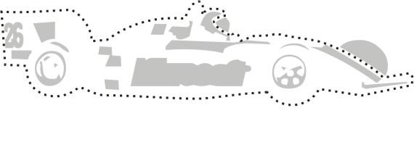](http://img0.liveinternet.ru/images/attach/c/4/81/59/81059068_large_gonki.jpg)  
  
16.  
[](http://img1.liveinternet.ru/images/attach/c/4/81/59/81059069_large_karandash.jpg)  
  
17.  
[](http://img0.liveinternet.ru/images/attach/c/4/81/59/81059070_large_kistochka.jpg)  
  
18.  
[](http://img1.liveinternet.ru/images/attach/c/4/81/59/81059071_large_kolibri01.jpg)  
  
19.  
[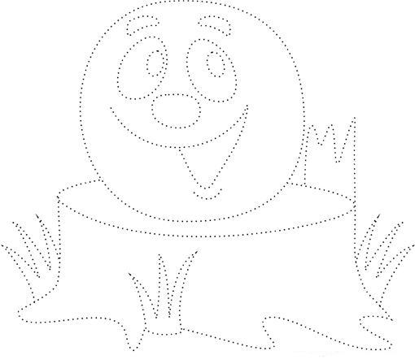](http://img0.liveinternet.ru/images/attach/c/4/81/59/81059072_large_kolobok_1.jpg)  
  
20.  
[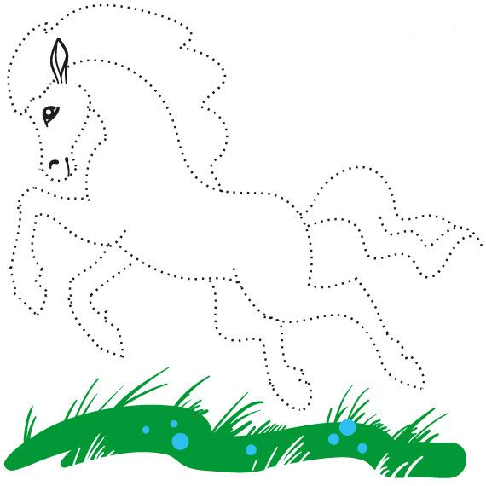](http://img1.liveinternet.ru/images/attach/c/4/81/59/81059073_large_kon01.jpg)  
  
21.  
[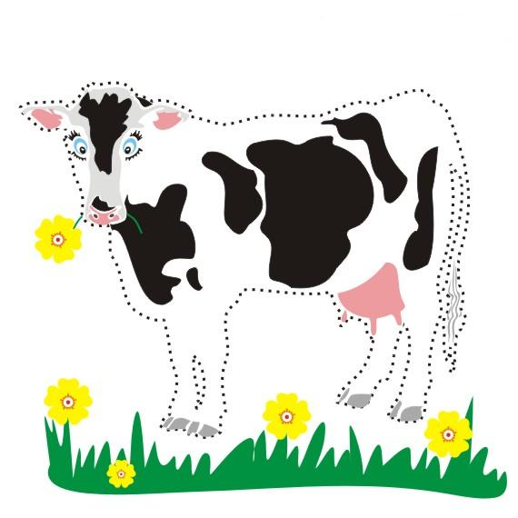](http://img0.liveinternet.ru/images/attach/c/4/81/59/81059074_large_korovka.jpg)  
  
22.  
[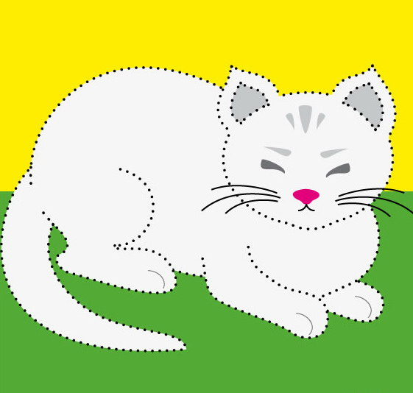](http://img1.liveinternet.ru/images/attach/c/4/81/59/81059075_large_koshe4ka.jpg)  
  
23.  
[](http://img1.liveinternet.ru/images/attach/c/4/81/59/81059077_large_koshka.jpg)  
  
24.  
[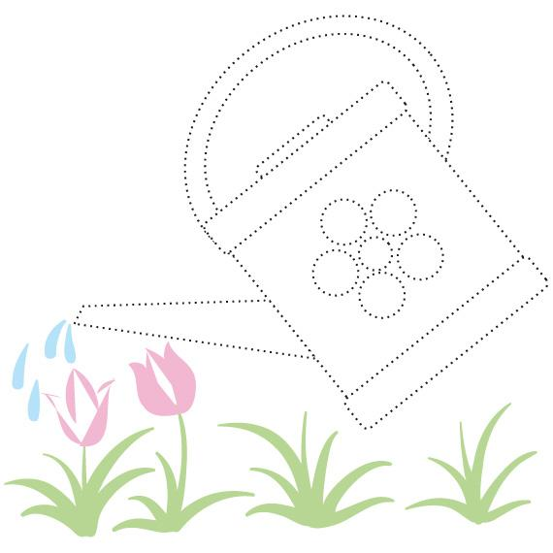](http://img0.liveinternet.ru/images/attach/c/4/81/59/81059078_large_leika01.jpg)  
  
25.  
[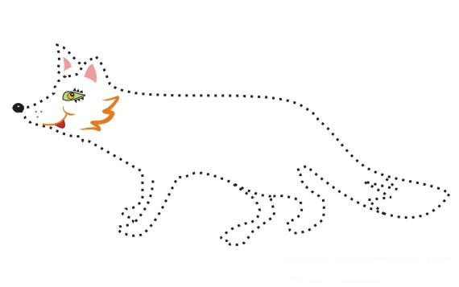](http://img1.liveinternet.ru/images/attach/c/4/81/59/81059079_large_lisa.jpg)  
  
26.  
[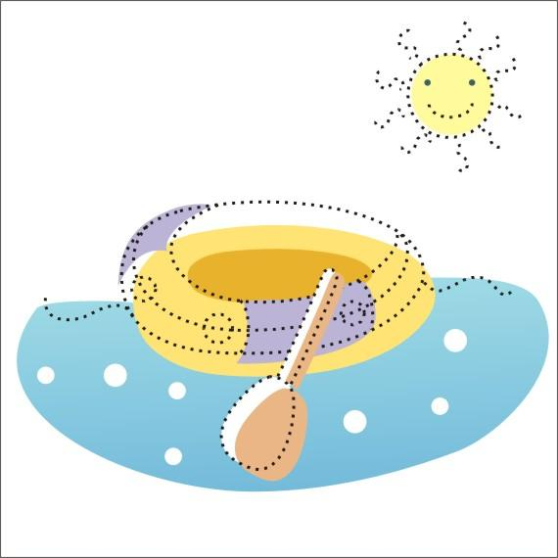](http://img0.liveinternet.ru/images/attach/c/4/81/59/81059080_large_lodka.jpg)  
  
27.  
[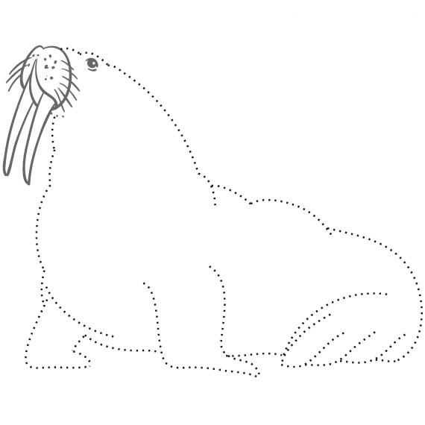](http://img1.liveinternet.ru/images/attach/c/4/81/59/81059081_large_morj01.jpg)  
  
28.  
[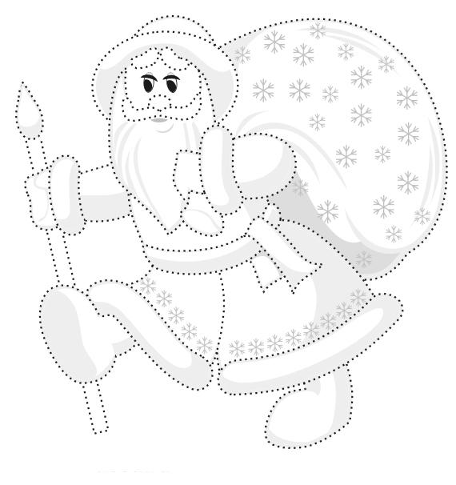](http://img0.liveinternet.ru/images/attach/c/4/81/59/81059082_large_obvod_03.jpg)  
  
29.  
[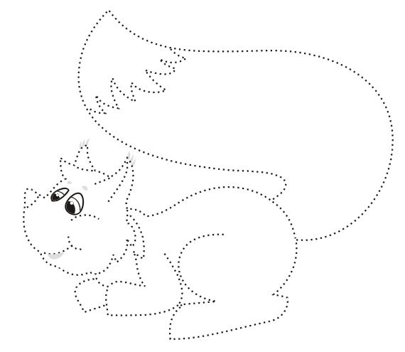](http://img1.liveinternet.ru/images/attach/c/4/81/59/81059083_large_obvod_04.jpg)  
  
30.  
[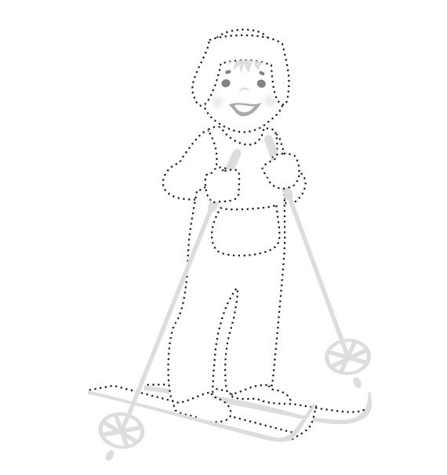](http://img0.liveinternet.ru/images/attach/c/4/81/59/81059084_large_obvod_05.jpg)*