[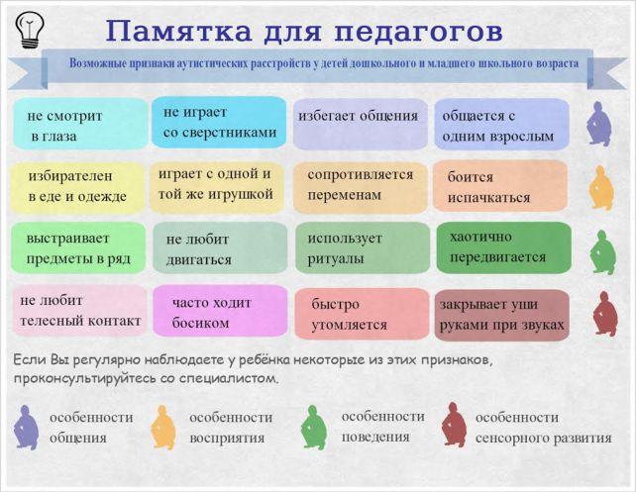](http://5psy.ru/images/stories/img3/%D0%BF%D0%B0%D0%BC%D1%8F%D1%82%D0%BA%D0%B0-%D0%B4%D0%BB%D1%8F-%D0%BF%D0%B5%D0%B4%D0%B0%D0%B3%D0%BE%D0%B3%D0%BE%D0%B2-%D0%BF%D1%80%D0%B8%D0%B7%D0%BD%D0%B0%D0%BA%D0%B8-%D0%B0%D1%83%D1%82%D0%B8%D1%81%D1%82%D0%B8%D1%87%D0%B5%D1%81%D0%BA%D0%B8%D1%85-%D1%80%D0%B0%D1%81%D1%81%D1%82%D1%80%D0%BE%D0%B9%D1%81%D1%82%D0%B2.jpg)

[](http://5psy.ru/images/stories/img3/%D0%BF%D0%B0%D0%BC%D1%8F%D1%82%D0%BA%D0%B0-%D0%B4%D0%BB%D1%8F-%D0%BF%D0%B5%D0%B4%D0%B0%D0%B3%D0%BE%D0%B3%D0%BE%D0%B2-%D0%BF%D1%80%D0%B8%D0%B7%D0%BD%D0%B0%D0%BA%D0%B8-%D0%B0%D1%83%D1%82%D0%B8%D1%81%D1%82%D0%B8%D1%87%D0%B5%D1%81%D0%BA%D0%B8%D1%85-%D1%80%D0%B0%D1%81%D1%81%D1%82%D1%80%D0%BE%D0%B9%D1%81%D1%82%D0%B2.jpg)