- 7 -
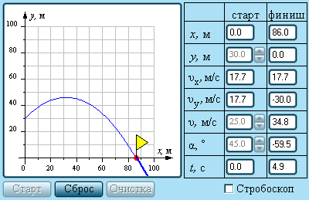
Рис.1.

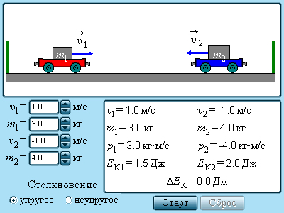
Рис.2

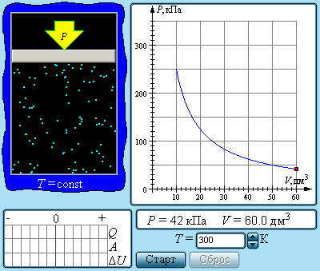
Рис. 3.
- 9 -
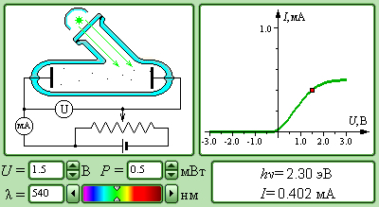

Рис.7

Самостоятельная работа ( рабочийлист2)

1. Упругое взаимодействие
Параметры системы тел до столкновения:
m₁ = ₋₋₋₋₋₋₋₋₋₋₋ m₂ = ₋₋₋₋₋₋₋₋₋₋₋₋₋₋₋ V₁ = ₋₋₋₋₋₋₋₋₋₋₋₋₋₋ V₂ = ₋₋₋₋₋₋₋₋₋₋₋₋₋₋₋₋₋₋₋₋ E₁ = ₋₋₋₋₋₋₋₋₋₋₋₋₋₋₋₋₋₋₋ E₂ = ₋₋₋₋₋₋₋₋₋₋₋₋₋₋₋₋₋ E = ₋₋₋₋₋₋₋₋₋₋₋₋₋₋₋₋
P₁ = ₋₋₋₋₋₋₋₋₋₋₋₋₋₋₋₋₋₋₋₋ P₂ = ₋₋₋₋₋₋₋₋₋₋₋₋₋₋₋₋₋₋₋₋₋ P = ₋₋₋₋₋₋₋₋₋₋₋₋₋₋₋₋₋₋₋₋₋₋
После столкновения:
V₁' = ₋₋₋₋₋₋₋₋₋₋₋₋₋₋ V₂' = ₋₋₋₋₋₋₋₋₋₋₋₋₋₋ E₁' = ₋₋₋₋₋₋₋₋₋₋₋₋₋₋₋₋₋ E₂' =₋₋₋₋₋₋₋₋₋₋₋₋₋₋₋₋ P₁' = ₋₋₋₋₋₋₋₋₋₋₋₋₋₋₋₋₋₋₋₋₋₋₋₋₋₋₋ P₂'= ₋₋₋₋₋₋₋₋₋₋₋₋₋₋₋₋₋₋₋₋₋₋₋₋₋
Δ E = ₋₋₋₋₋₋₋₋₋₋₋₋₋₋₋₋₋₋₋₋₋₋₋₋₋ P' = ₋₋₋₋₋₋₋₋₋₋₋₋₋₋₋₋₋₋₋₋₋₋
Вывод : --------------------------------------------------------------------------------------------------------------------------------------------------------------------------------------------------------------------------------------------------------------------------------------------------------------------------------------------------------------------------------------------------------------------------------------------------------------------------------------------------------------------------------------------------------------
2. Неупругое взаимодействие.
Параметры системы тел до столкновения :
m₁ = ₋₋₋₋₋₋₋₋₋₋₋₋₋₋ m₂ = ₋₋₋₋₋₋₋₋₋₋₋₋₋₋₋ V₁ = ₋₋₋₋₋₋₋₋₋₋₋₋₋₋₋₋₋ V₂ = ₋₋₋₋₋₋₋₋₋₋₋₋₋₋₋₋₋ E₁ = ₋₋₋₋₋₋₋₋₋₋₋₋₋₋₋₋E₂ = ₋₋₋₋₋₋₋₋₋₋₋₋₋₋₋₋₋₋E = ₋₋₋₋₋₋₋₋₋₋₋₋₋₋₋₋₋
P₁ = ₋₋₋₋₋₋₋₋₋₋₋₋₋₋₋₋ P₂ = ₋₋₋₋₋₋₋₋₋₋₋₋₋₋₋₋₋ P = ₋₋₋₋₋₋₋₋₋₋₋₋₋₋₋₋₋₋₋₋
После столкновения :
V₁' = ₋₋₋₋₋₋₋₋₋₋₋V₂' = ₋₋₋₋₋₋₋₋₋₋₋₋E₁'= ₋₋₋₋₋₋₋₋₋₋₋₋₋₋₋E₂' = ₋₋₋₋₋₋₋₋₋₋₋₋₋E' = ₋₋₋₋₋₋₋₋₋₋₋₋₋₋P₁' = ₋₋₋₋₋₋₋₋₋₋₋₋₋₋₋₋₋₋₋₋₋P₂' = ₋₋₋₋₋₋₋₋₋₋₋₋₋₋₋₋₋₋₋₋₋₋₋
ΔE = ₋₋₋₋₋₋₋₋₋₋₋₋₋₋₋₋₋₋₋₋ P' = ₋₋₋₋₋₋₋₋₋₋₋₋₋₋₋₋₋₋₋₋₋₋₋₋
Вывод :---------------------------------------------------------------------------------------------------------------------------------------------------------------------------------------------------------------------------------------------------------------------------------------------------------------------------------------------------------------------------------------
Рис.8

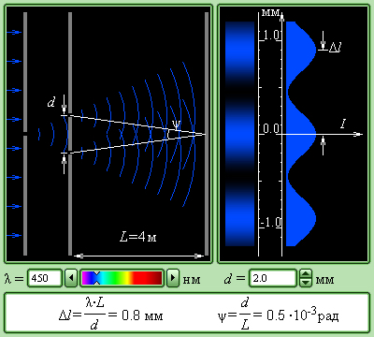
Рис. 4.

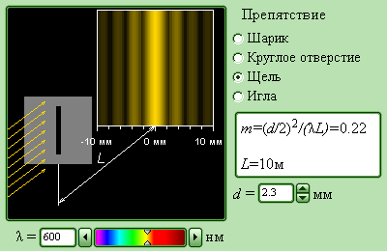
Рис.5

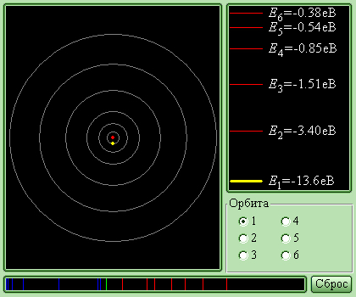
Рис.6

