OPEN LESSON
IN THE MEDIA

Date: April 27
Class: 9th
Topic: “News and Newspapers”
Teacher: Tatiana Vereshkina

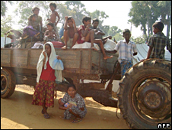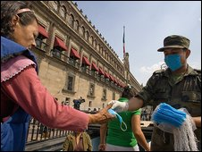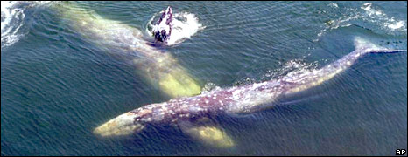
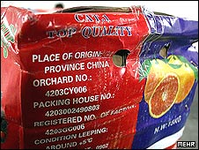

SAINT-PETERSBURG GYMNASIA № 105
27 APRIL 2009

Outline

Goals of the lesson in the field of:
•Information technologies - to teach the students use smart board;
•English language – reading and listening to the news, practicing small
oral statement; using specific vocabulary and
grammar structures ;
•Social skills – be aware of what is happening in the world.

 | Teacher | Students’ Activities | Technical and Visual Aids
1 | Greetings and topic introduction.  How often do you usually watch TV or listen to the radio?  When do you usually do these things? Which are your favourite and least favourite channels?  News  People primarily read the newspapers for… news! News can be a breaking story, a long running story?  It is important it is read today. We rarely pick up yesterday’s newspaper to read about current news.  Think about an article you have read recently. Why was it in the news? Was it a breaking or a long running story? How important and significant was it?  Understanding news articles  News stories unswer the following questions:  What happened?  When did it happen?  Who was involved?  Where did it happen?  Why/how did it happen?  These questions are answered briefly in the first and in the second paragraphs of the article.  Do you watch the news on TV?  Where do you get your news?  Discuss. Look at the list of sections from a newspaper.  - Do newspapers in Russia have all these sections?  - Do they include other information?  - What other sections might a newspaper include? | Look at the types of programmes below. Do you usually find them on TV or on radio or on both?  Students answer the teachers questions and identify the types of programme and where it is found.  documentaries  sports coverage  crime mysteries  travel news  “reality” shows  cartoons  national news  game shows and puzzles  phone-ins  local news  soap operas  sit coms  adverts  . Students answer the teachers questions | Topic on the blackboard.  Smart board  Computer program  Cutting Edge  Smart board  Computer program  Cutting Edge
  News | Health | Sport
  Politics | Horoscopes | Crosswords
  Business | Obituaries | TV listings
  Editorial | Weather | Classified
  Science | Showbiz | Personal
2 | What’s in the news for the week?  a)  b) Watching news “Pig Flu” pandemic” | Students present the Internet articles on the most important events.  Discuss the articles and answer the other students’ questions.  Discussion of the film.
3 | Work in small groups. You are in charge of a new programme on a local TV station and it is tour job to select the three leading stories for the programme. To night you have the following seven news items to choose from. Discuss each one and choose the best three. | Students work in small groups. They make a presentation of the chosen items for a TV programme.
4 | Let us check the home task. You have read the newspaper article “Hot on the Trail of Angelina Jolie”.  a)Match the words from the article to the definitions:  b) Look at the highlighted words and expression in the text and complete the sentences:  c)Read the article and choose the best answer for the question  d)Discuss the questions:  1 Would you describe Paparazzi as “scum”?  2 Do you think it’s ethical to invade a celebrity’s privacy? | Answering the teacher’s questions.  - Why do you think people like to read about famous people in magazines and newspapers?  - What motivates someone to work as a “paparazzi”?  - What skills do you need?  - Is it always an exciting job?  Student give their answers:  1 Many people don’t hunt to kill. They just do it for the thrill of a chase.  2 Wolves hunt in groups or as a pack.  3 We hit the jackpot when we won the lottery and made a million dollars.  4 She was furious when she saw the stories of her private life splashed across the front page of a tabloid newspaper.  5 The hunters were closing the net on their prey but the lion still managed to escape.  6 We have the escaped prisoner cornered in the building. We need more police to help capture him.  1-C  2- A  3-A  4-C  5-B  6-D  7-C  8-B  Students discuss the questions.
  scoop | an exclusive story that no other newspaper has
  mundane | uninteresting or unexciting
  sources | people who provide information for journalists
  uncanny | strange
  fetch upward | sell for more than (an amount of money)
  ethics | set of beliefs about what is  right and wrong
  invading privacy | to get involved in a person’s life without permission
  scum | people you think are very unpleasant (informal)
4

5 | Reading and vocabulary.  News stories.  - Read the headlines and 2 or 3 o them and try to guess what the article is about.  - Can you guess which headlines these words relate to?  - Read the articles and match them to the headlines quickly.  - Work in pairs  - Discuss in groups  - Which of the stories have happy endings for the people concerned?  - Which have unhappy endings?  - Which story in the most romantic, the funniest and the most unbelievable ? | Read the headlines  Work with the vocabulary:  air traffic controller  baseball bat  hijack  marriage register  slippers  wallpaper  giant cheque  ink  pay off debts  soft toys  Read the articles  Guess the meaning of the words from  the context.  Tried to rob a bus?  Threaten to commit suicide?  Caused panic in Chicago airport?  Was raising money for charity?  Was fined 130 euro by a judge?  Rescued his ex-wife from a burning house?  Was presented with a giant cheque?  Thought there was a hijacker on board the plane?  Caused 165,000 accidents last year?  Caused 700 injuries every year? | Task sheets with headlines and vocabulary  Texts with articles  Ex.4, p.63
6 | Language focus  The Passive | Read the sentences about the news stories and underline the main verb in each.  ( which verb is active or passive?)  Forming the passive | Smart board  Computer program  Ex. 1, p.63
7 | Summing up You worked well. I give you the following marks:  Hometask: Go to the International Herald Tribune Web site at www.iht.com and find a news story that interests you. Complete the following grid.  Do the crossword. |  | Crossword
  Story headline
  What
  When
  Who
  Where
  Why/how

