6 th FORM
MOSCOW SCHOOL OLIMPIAD

Your name |  | Maximum | 50 | Result

ФИО учителя, номер школы__________________________________________

Part I
Listening.
- Listen to the text and decide wether these statements are True or False.

 | Statement | True | False
1 | A man carried a new case in his hands.
2 | He was wondering why people who had much money were never satisfied but always wanted more.
3 | Fortune decided to help him.
4 | Fortune put in the man’s bag a lot of money.
5 | The man became the richest man in the world.

b) Listen to the text and choose the correct answer
1.One day a man was … along the street.
  - walking
  - riding
  - running
  - jogging
- He said: “If I only had enough … , I should not ask for anything else.”
  - money
  - to drink
  - to eat
  - friends
- At this moment … came down the street.
  - an old lady
  - a Magician
  - Fortune
  - A child
- If a diamond falls down to the ground, it will become … .
  - gold
  - grass
  - dust
  - water
- Fortune disappeared leaving the man in … .
  - the street
  - the room
  - the wood
  - the garden

Max | 10
Points

II. Reading
Read the text and do tasks.

Sam was the son of a farmer. His father's farm was poor, and Sam worked on it for a very long time, one day Sam decided to sell the farm and buy a new one in a better place. He bought a farm in the east of the country. But his new neighbours advised him to build a room under the ground so that his family could hide there as the wind was very strong in the east and could break windows and doors. Sam built a room under the ground. The work was very hard and it took him a lot of time. But after that the weather was very good for a very long time and Sam was angry btcause he thought he had wasted a lot of time on that room. But one day there was very strong wind, and Sam and his family had to go down into their room under the ground. They spent there much time and when they left it they saw that all windows and doors were broken. Sam was not angry about his work. «I'm glad I have built that room,» he said.

- Write down whether following statements are true, false or not stated

- Sam moved to a new place because he had married
  - true
  - false
  - not stated

- He bought a farm in the east of the country
  - true
  - false
  - not stated

- His friend gave him a piece of advice
  - true
  - false
  - not stated

- Sam followed it and was glad he did
  - true
  - false
  - not stated

- The room under the ground was very big.
  - true
  - false
  - not stated.

- Choose the right variant
  - Sam was a son of a ………….
- farmer
- worker
- doctor
- teacher

  - One day Sam decided to……….
- to buy a car
- to sell a farm and buy a flat
- to sell a farm and buy a new one
- to sell a car and buy a farm

  - Sam bought a farm in the…………of the country.
- west
- east
- centre
- north

  - His neighbours advised him to build
- a big house
- a room under the ground
- a garage
- a barn

  - The wind could break…
- a roof
- a roof and windows
- doors
- doors and windows

MAX | 10
POINTS

Part III.
Usage
Choose the correct word
1.Too much … is bad for you.
a) son b) sun c)sung d) song
2. They washed … faces and went to bed.
a) their b) there c) them d) where
3. … are wild animals that can run very fast.
a) deers b) dear c) deer d) bear
4. Her hair … very long two years ago.
a) was b) is c) were d) are
5. We decided to … in front of our school.
a) meat b) beat c) neat d) meet

Read the text and fill the gaps with verbs.

The world’s first stick-on postage …(1) in England in 1840. By 1842 the world’s first stamp collectors were already enjoying a hobby that …(2) on the conquer the world. It …(3) at the top of the popularity ever since.
Nineteenth-century postage stamps … (4) mostly of the standard small size. But then it was discovered that larger, more colourful stamps were so popular that people …(5) them for their private collections as well as for mailing letters.

1. A) was issued B) issued C) were issued D) issue
2. A) has gone B) went C) had gone D) is going
3. A) remains B) will remain C) was remained D) has remained
4. A) are B) were C) will be D) have been
5. A) would buy B) will buy C) buy D) bought

Max | 10
Points

Part IV
Quiz
How much do you know about Great Britain? Decide whether these statements about Great Britain are true or false.

№ | Statement | True | False
1 | If you hire in Great Britain you will have to drive on the left.
2 | If you go shopping in Edinburgh you will have to change your English pounds to Scottish pounds.
3 | The oldest university of Great Britain is Cambridge.
4 | If you go on a sight-seeing tour of London you will be able to see Buckingham Palace.
5 | Queen Victoria reigned sixty-four years.
6 | If you go on a boat trip down the River Thames you will pass Dover.
7 | If you take a ferry to Northern Ireland you will cross over the English Channel.
8 | The Loch Ness Monster supposed to live in Scotland.
9 | You can see wax models of famous people in Buckingham Palace.
10 | If you fly from London to Scotland you will have to show your passport at the airport.

MAX | 10
POINTS

Look at the maps. Can you write the names of the countries you see below?

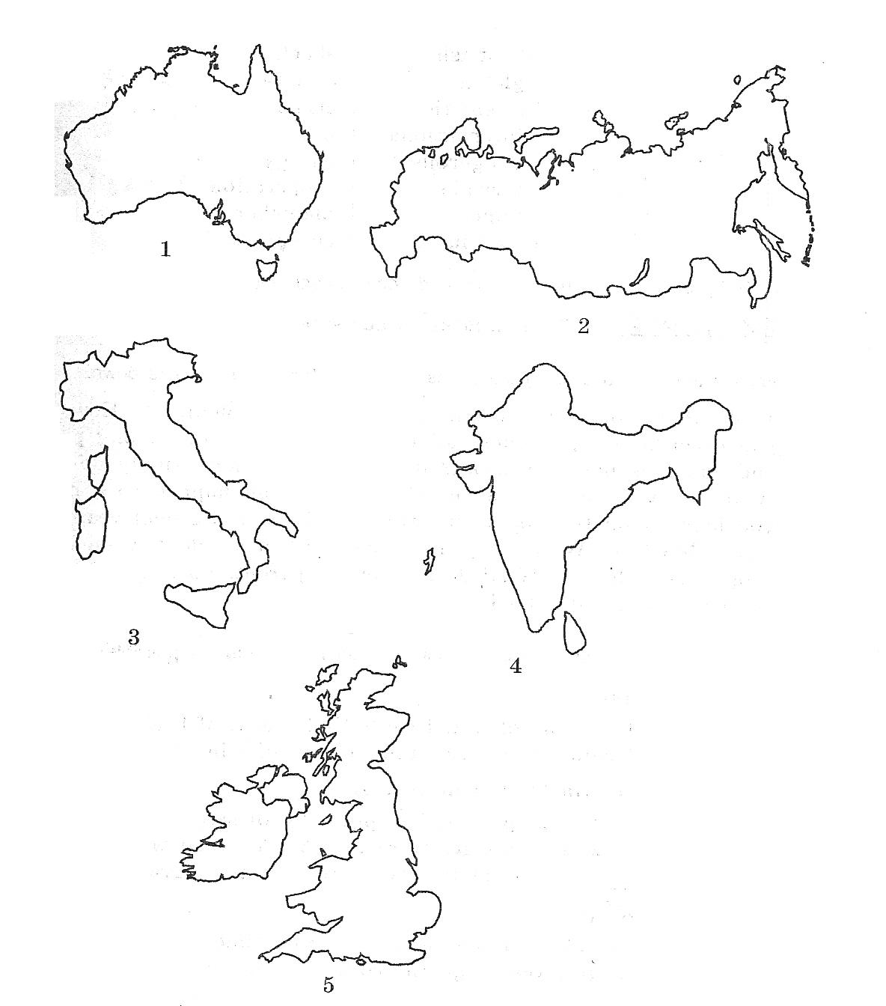

MAX | 5
POINTS

Part V
Writing
Write a helpful reply to this note from a friend.

Dear Ann!
Next month I’m coming to your country for the first time! What are the best places to see? Where can I stay? What will the weather be like? What clothes should I bring? Could you give me some ideas?
Many thanks!
Helen

________________________________________________________________________________________________________________________________________________________________________________________________________________________________________________________________________________________________________________________________________________________________________________________________________________________________________________________________________________________________________________________________________________

MAX | 5
POINTS

Текст на аудирование

Fortune
One day a man was walking along the street. He carried an old bag in his hands. He was wondering why people who had so much money were never satisfied but always wanted more. “As for me,” he said, “if I only had enough to eat, I should not ask for anything else.”
Just at this moment Fortune came down the street. She heard the man and stopped.
“Listen,” she said, “I want to help you. Hold your bag, and I shall put diamonds into it. But if a diamond falls down to the ground, it will become dust.” The man agreed. He quickly opened his bag and Fortune put there a lot of diamonds. The bag began to grow heavy. “Is that enough?” asked Fortune. “Not yet.” The man’s hands began to tremble.
“You’re the richest man in the world now,” said the Fortune. “Just a few more, and a few more,” said the man. Another diamond was added and the bag slipped. All the diamonds fell down to the ground and became dust.
Fortune disappeared leaving the man in the street.

ОТВЕТЫ:

PART I
a)
  - FALSE
  - TRUE
  - TRUE
  - FALSE
  - FALSE

b)
1. A
2. C
3.C
4.C
5.A

PART II
a)
1. FALSE
2. TRUE
3. FALSE
4. TRUE
5. NOT STATED
b)
1. A
2. C
3. B
4. B
5. D

PART III
a)
1. B
2. A
3. C
4. A
5.D
b)

1.C
2. B
3. D
4. B
5. A

PART IV
a)
1. TRUE
2. FALSE
3. FALSE
4. TRUE
5. TRUE
6. FALSE
7. FALSE
8. TRUE
9. FALSE
10. FALSE

b)
1. Australia
2. Russia
3 Italy
4. India
5 Great Britain

PART V

1.ПРИВЕТСТВИЕ- 1 БАЛЛ
2. БЛАГОДАРНОСТЬ- 1 БАЛЛ
3. ОТВЕТЫ НА ВОПРОСЫ- 2 БАЛЛА
4. ОКОНЧАНИЕ ПИСЬМА- 1 БАЛЛ.

