All Year Round

**«Времена года» - игра-путешествие для учащихся 6 класса**

Это урок игра-путешествие.

***Задачи:***

*Образовательная:* расширение кругозора учащихся.

*Развивающие:* развитие познавательной активности и творческих способностей учащихся, формирование мотивации к изучению английского языка и умений использовать имеющиеся знания в новой коммуникативной ситуации.

*Воспитательные:* развитие интереса к культуре и традициям других народов, умения работать в команде.

*Оборудование:* Интерактивная доска.Необходимо подготовить тексты заданий, ручки, карандаши и бумагу для письменных заданий; оборудование для проведения игр.

**Ход урока.**

**Teacher:**

- Hello, children! *(Hello, Мария Петровна!)*

- I am glad to see you. *(We are glad to see you too.)*

- How are you? (*We are fine! And you?)*

- I’m OK! Thanks!

- Sit down, please.

- Who is on duty today? *(I’m on duty today)*

- Who is absent? *(Nobody is)*

- What week day is it today? *(Today is…)*

- What date and month is it now? *(Today is the* …)

- Thank you? Sit down, please.

**Teacher:**

Let’s begin our lesson (слайд №1)Сейчас мы с вами отправимся в небольшое путешествие по временам года. Мы встретим на своём пути 12 станций (слайд №2). Узнаем много интересного о культуре и традициях Англии и Америки. На некоторых станциях нас ждут игры и занимательные задания.

We can travel in different seasons of the year. There will be 12 stations on your way. In the station you should do a task. Let’s start.

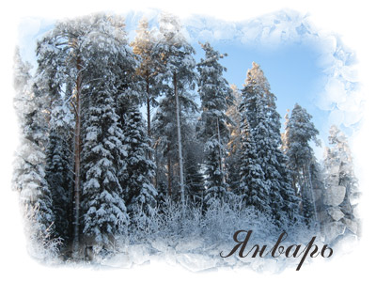

**Station "January"(слайд №3)**

**Pupils read:** It is January. It’s a cold winter month. January is the first month of the year. We celebrate New Year's Day in January. In January is 31 days.

**Teacher:** Yes, all right. What can you do in January?

**Pupils:** We can ski and skate….(слайд № 4, №5, №6)

**Teacher:** Who have a birthday on January?

**Pupils:** Nobody.

**Teacher:** It’s great. Go on to the next station.

**Station "February"(слайд №7)**

**Pupils read:** You are welcome. February is the second month of the year. It is the short month.

**Teacher:** Who have a birthday on February?

**Pupils:** Nobody.

**Teacher:** I think you like February very much because this month you can celebrate one of the nice holidays. What holiday is it?

**Pupils**: It is Valentine's Day(слайд №8).

**Teacher:** Yes, your answer is right. Do you know the symbols of this holiday?

**Pupils:** Yes, we do. We have Valentine cards, sweets, chocolate, and flowers.

**Teacher:** А сейчас ваше первое задание. На этих полосках бумаги вы видите некоторых сказочных героев. Вы должны правильно подобрать пары.

*(Учащиеся подбирают пары из полосок бумаги, на которых написаны имена:* Winnic-the-Pooh, Piglet, Cinderella, Prince. Dead Princess, Yelissei, Thumbellina, Elf, Harry' Porter, Hermione, Alice, Donald Duck, Snow White.

***Должны получиться пары:*** Winnie-the-Pooh - Piglet; Cinderella -Prince; Dead Princess - Yelissei; Thumbellina - Elf; Harry Porter -HermioneJ

**Teacher:** Very good. I see you like to read books and you know the names of famous friends.

**Station "March"**(слайд №9)

**Teacher:** What month is it?

**Pupils:** It is March.

**Teacher:** OK! Who have a birthday on March?

**Pupils:** I have got. My birthday is on the...

**Pupils:** Can you say some words about this month?

**Children:** Yes, we can. March is the first spring month and the 3th month of the year.

**Teacher:** Do you know what holiday is on the 17Ih of March? (слайд №10)

**Children:** No we don’t.

**Teacher:** Look at screen. Let’ read about St. Patrick's Day.

*17 марта - это день памяти покровителя Ирландии, святого Патрика. В этот день устраивается парад с песнями и плясками. Патрик, по преданию, принес христианство на языческий остров и изгнал всех змей. С именем святого Патрика связано множество легенд, например, что он с помощью трехлистного клевера (shamrock) объяснял людям понятие Святой Троицы. В Ирландии существует традиция прикреплять к одежде листок трилистника, символизирующий крест.*

*The 17" of March is a national holiday in Ireland St. Patrick's Day. People send greeting cards to their friends and relatives. On that day they wear green clothes and a shamrock. A shamrock is the national emblem of Ireland.* (слайд №11)

**Teacher:** Well done. Go on to the next station.

**Station "April"**(слайд №12)

**Pupils read:** You are welcome in April. It’s the 4th month of year. It is a very beautiful spring month. You can see green leaves in the trees and first spring flowers in the forest and gardens.

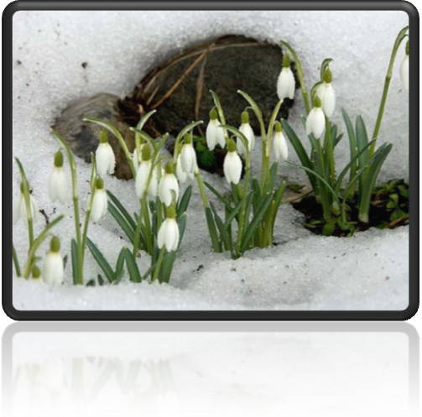

**Teacher:** What holiday do the English celebrate in April? (слайд №13, №14) English people celebrate Easter Day. The Easter symbols are Easter eggs and Easter rabbits. English children like to play Easter games. And what about you? Let's play an Easter game, Давайте встанем в круг. Один из вас будет пасхальным зайцем, он встанет в центр круга и закроет глаза. А мы будем передавать друг другу за спиной это пасхальное яйцо, и говорить такие слова:

**Bunny, Bunny,**

**Your egg you can't find.**

**Somebody has it,**

**Check behind.**

Пасхальный заяц должен угадать, у кого находится яйцо. У него 3 попытки. Если он угадал, то тот, у кого находится яйцо, встает на его место в круг. Если зайцу не удалось угадать, у кого яйцо, он остается в круге. So. let's start!

*(Дети играют в игру.)*

**Teacher:** I am sorry, but we should go to the next station. I am very pleased with you. You can play English games.

**Station "May"**(слайд №15)

**Teacher:** What month is it?

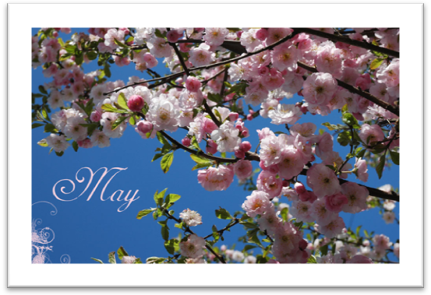

**Pupils:** It is May.

**Pupils:** OK! Can you say some words about this month?

**Children:** Yes, we can. May is the 5th month of the year.

**Teacher:** It is May, the month of flowers.

People like it because give them a lot of flowers. It is the month of warm rains, the bright rainbow, green trees and busy bees.

So listen to me and try to remember the following poem.

***Физкульминутка:*** Дети закрывают глаза и представляют майскую природу.

**Springtime.**

**A small green frog**

**On a big brown log;**

**A black and yellow bee**

**In a little green tree;**

**A red and yellow snake**

**By a blue-green lake,**

**All sat and listened**

**To red bird sing,**

**“Wake up, every body,**

**It’s spring! It’s spring!**

**Station "June"**(слайд №16)

**Teacher:** My dear friends! You are welcome in summer! Now you have a lot of free time. Why?

**Children:** Because we have summer holidays.

**Teacher:** What you can do in June?

**Children:** We can play …

**Teacher:** OK! Who have a birthday on March?

**Pupils:** I have got. My birthday is on the...

**Teacher:** I’ve prepared an interesting task for you. Look at these pictures and these encoded words. Write these words correctly under the pictures.

*(Раздаём детям 5 картинок (на них нарисованы лягушка, белка, бабочка, рыбка и цветок) и 5 карточек с подписями для картинок, в которых перепутаны буквы. Дети должны расшифровать слова и сделать правильные подписи под картинками.)*

**Карточка 1: g f о г *(frog)***

**Карточка 2: l f w o (*wolf)***

**Карточка 3; s if h *(fish)***

**Карточка 4: u t г 1 b t e f у *(butterfly)***

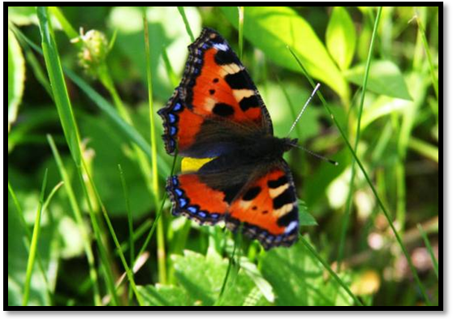

**Карточка 5: u m r s m e *(summer)***

**Station "July"**(слайд №17)

**Teacher:** It is July: It is second summer month. My weather is hot and sunny. I am rich because there are a lot of fruit and vegetables in July. There are a lot of berries and mushrooms in the forests. Let's go to my garden. You can help me to gather my harvest. This is a basket. I’ll ask you riddles about different fruits and vegetables. If you guess what fruit or vegetable you can put it into your basket. Are you ready?

**Children:** Of course! (слайд №18)

*(Детям задают загадки об овощах и фруктах. Когда дети их отгадывают, они кладут картинку с этими овощами в корзинку.)*

**Teacher:** So, listen to the first riddle, please.

1. This vegetable is long and green.

It is so tasty with sour cream, *(a cucumber)*

2. My head is green and round.

I always grow on the ground.

I always wear lots of coats,

I am the best food for the goats, *(a cabbage)*

3. Look at me! My cheeks are red.

Make some salad and eat with bread.

I am juicy, I am sweet.

Would you like to taste a bit? *(a tomato)*

4. You can see it on the tree

Pick up it for you and me.

Make some jam or cook some pies.

This fruit is always sweet and nice. *(an apple)*

5. You can't cook soup without it,

This vegetable isn't sweet.

But for chips it is so good.

I think you like this tasty food, *(a potato)*

**Teacher:** Eat a lot of fruit and vegetables. They've got a lot of vitamins.

**Station "August"**(слайд №19)

**Teacher:** It is August. It is the last summer month. A lot of families go to the seaside or to the country to spend their holidays there. They often visit their relatives. Do you remember the words on the topic "Family"?

Children: Yes, we do.

**Teacher:** Find 7 words on the topic "Family" and write them below. (слайд №20)

|  |  |  |  |  |  |  |  |
| --- | --- | --- | --- | --- | --- | --- | --- |
| **G** | **С** | **0** | **U** | **S** | **I** | **N** | **I** |
| **R** | **U** | **H** | **В** | **I** | **Z** | **N** | **С** |
| **A** | **N** | **N** | **T** | **S** | **V** | **W** | **0** |
| **N** | **C** | **F** | **A** | **T** | **H** | **E** | **R** |
| **N** | **L** | **E** | **A** | **E** | **H** | **Z** | **R** |
| **Y** | **E** | **G** | **Y** | **R** | **0** | **E** | **I** |
| **L** | **В** | **R** | **0** | **T** | **H** | **E** | **R** |
| **E** | **M** | **0** | **T** | **H** | **E** | **R** | **V** |

*(Дети должны найти слова в таблице и записать их. По вертикали: uncle, sister, granny; no горизонтали: cousin, aunt, father, brother, mother.)*

**Teacher:** I am very pleased. I think you love your families very much.

**Station "September"**

(слайд №21)

**Teacher:** What month is it?

**Pupils:** It is September.

**Teacher:** What can you say about this month?

**Children:** It is the first autumn month and the 9th month of the year.

**Teacher:** What can we do on September?

**Children:** We go to school again. We can meet our friends there and tell them about your summer holidays. You have different lessons every day. I know some pupils like Math.

**Teacher:** Oh, very good. I am sure you always get good marks.

**Station "October"**(слайд №22)

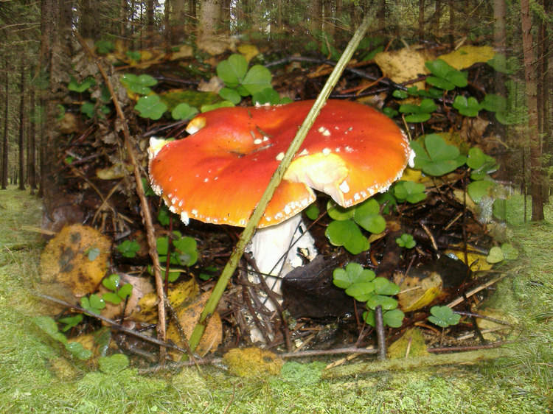

**Teacher:** What month is it?

**Pupils:** It is October.

**Teacher:** OK! Who have a birthday on October?

**Pupils:** I have got. My birthday is on the...

**Pupils:** What can you say about this month?

**Children:** It is the 10th month of the year.

**Teacher:** You are welcome in October. In late October the days grow shorter and the nights grow longer. It's colder and darker and cold winds blow. The leaves fall down from the trees. The year is ending. It's time of a very funny holiday. Do you know what holiday people celebrate at the end of October?

**Children:** It's Halloween. (слайд №23, №24)

**Teacher:** You are right. And how do people celebrate this holiday?

**Children:** They have Halloween's parties.

**Teacher:** And who comes to these parties?

**Children:** Skeletons, witches, ghosts, pirates, black cats, goblins, and bats come there.

**Teacher:** Thank you very much. You can go to the next station.

**Station 'November"**(слайд №25)

**Teacher:** What do you now about this month?

**Children:** It is November. It’s the 11th month of year.

**Teacher:** Dear friends! In November Americans celebrate Thanksgiving Day. They have parties, they eat roasted turkey, popcorn and pumpkin pies. They have much fun playing some Indian games, because the Indians helped them to survive many years ago. Let's play such a game. You know the Indians taught the pilgrims to hunt and to fish. So I am going to fish now. Положите руки на стол. Я буду читать стихотворение, как только я закончу его, вы должны быстро убрать руки со стола. Тот, чья рука будет «поймана», становится «рыболовом». Listen to the poem!

**I am fishing, I am fishing.**

**I've been fishing for the whole day.**

**What a pity, I could catch nothing,**

**All the fishes have swum away.**

*(Дети играют 2-Зтура игры.)*

**Teacher:** Thank you very much. I hope you like this game.

**Station "December"**

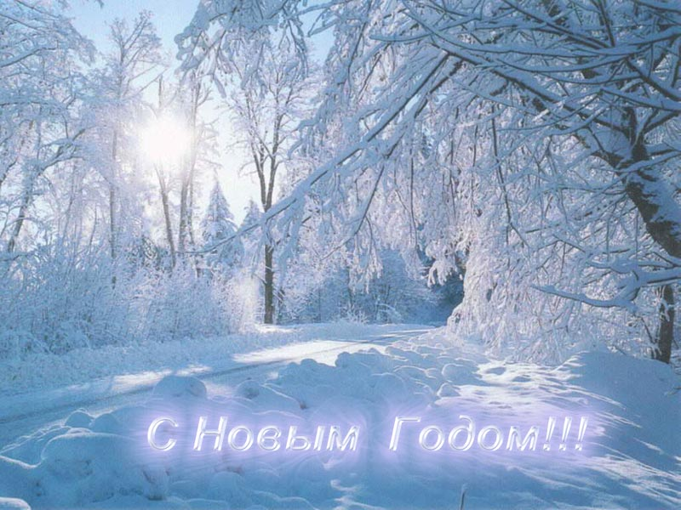

(слайд №26-№29)

**Teacher:** What month is it?

**Pupils:** It is December.

**Teacher:** OK! Who have a birthday on October?

**Pupils:** I have got. My birthday is on the...

**Pupils:** What can you say about this month?

**Children:** It is the last month of the year.And it is Christmas month.

**Teacher:** Do you like Christmas?

**Children:** Yes, we do.

**Teacher:** Let’s write down your homework. You mast write the letter.

*(Дети должны написать письмо Санта Клаусу.)*

**Teacher:** Very nice. Teacher: Dear children! Your trip is over. You could do a lot of tasks. Look at our calendar. It is so nice! You have learned a lot of interesting things about traditions in Great Britain and the USA. I hope you can learn more and more about them at our English lessons and parties. Thank you. I would like you to remember your unusual trip. These are some souvenirs for you.

“All Year Round And Celebrations”

**«Времена года и праздники» - урок-путешествие**

**для учащихся 6 класса**

**(второй год обучения)**

**Литература.**

1. Интернет ресурсы.
2. Поурочные разработки по английскому языку к УМК М.З.Биболетовой.
3. Внеклассные мероприятия по английскому языку. Издательство Глобус.