Контрольная работа в 8 классе (углублённый уровень)

I. Listening.

a)

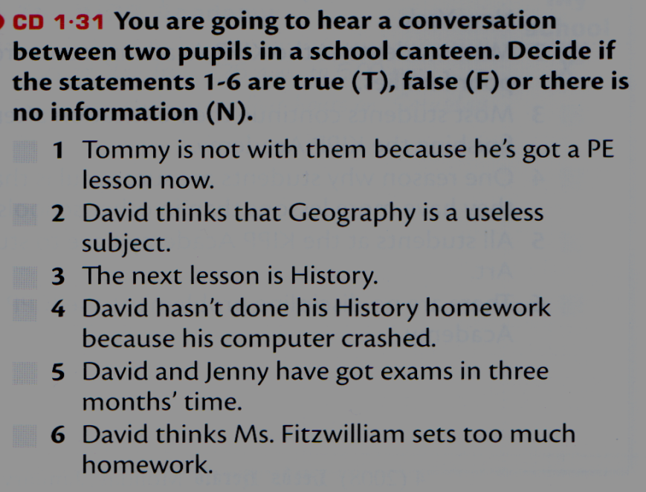

b)

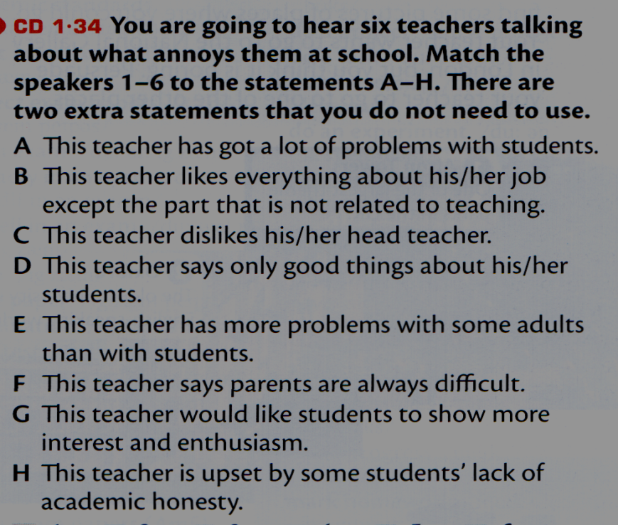

Контрольная работа в 8 классе (углублённый уровень)

I. Listening.

a)



b)



II. Use of English.

a) Use the right preposition.

1) The teacher asked the pupil on duty to hand … the essays.

2) “Are your papers finished? It’s time you should hand them …,” said Mr Adams.

3) It was late night, our car was broken …, we couldn’t repair it and didn’t know what to do.

4) The skill of making pottery was handed … from generation to generation.

5) The police broke … the door and rushed into the entrance hall.

6) I asked one of the boys to hand … the copies to the class.

7) World War II broke … in 1939.

8) Our television hasn’t broken … since it was fixed.

9) In the year 2000 a terrible epidemic of foot-and-mouth disease broke … in Europe.

10) I’ve got some new textbooks here that I want to hand … .

b) Choose the right word.

1) If Harry (weren’t, hadn’t been) a wizard, he wouldn’t (be able, have been able) to do the things he could.

2) If Alice (didn’t take, hadn’t taken) a tablet, she would (have, have had) a splitting headache now.

3) But for the queue, Bob would (buy, have bought) a ticket for a football match yesterday.

4) If Ann (made, had made) notes during the lectures in winter, she would ( be able, have been able) to use those materials for her exams tomorrow.

5) If your aunt (didn’t enroll, hadn’t enrolled) you at that nearby school, you would (have, have had) to go to school by bus.

6) If Jane (weren’t, hadn’t been) a real witch now, she wouldn’t (be, have been) able to turn people into animals so often.

7) If John (didn’t vanish, hadn’t vanished) so unexpectedly, I would (explain, have explained) to him all the complicated things then.

8) Mr Adams is not a very popular teacher. If he (didn’t drone, hadn’t droned) on at his lessons, his pupils would (listen, have listened) to him attentively.

9) If they didn’t have a habit of messing around in class, they would always (know, have known) what answer to give.

10) If the door (didn’t squeak, hadn’t squeaked) when you were leaving the room, you wouldn’t (wake, have woken) the baby.

II. Use of English.

a) Use the right preposition.

1) The teacher asked the pupil on duty to hand … the essays.

2) “Are your papers finished? It’s time you should hand them …,” said Mr Adams.

3) It was late night, our car was broken …, we couldn’t repair it and didn’t know what to do.

4) The skill of making pottery was handed … from generation to generation.

5) The police broke … the door and rushed into the entrance hall.

6) I asked one of the boys to hand … the copies to the class.

7) World War II broke … in 1939.

8) Our television hasn’t broken … since it was fixed.

9) In the year 2000 a terrible epidemic of foot-and-mouth disease broke … in Europe.

10) I’ve got some new textbooks here that I want to hand … .

b) Choose the right word.

1) If Harry (weren’t, hadn’t been) a wizard, he wouldn’t (be able, have been able) to do the things he could.

2) If Alice (didn’t take, hadn’t taken) a tablet, she would (have, have had) a splitting headache now.

3) But for the queue, Bob would (buy, have bought) a ticket for a football match yesterday.

4) If Ann (made, had made) notes during the lectures in winter, she would ( be able, have been able) to use those materials for her exams tomorrow.

5) If your aunt (didn’t enroll, hadn’t enrolled) you at that nearby school, you would (have, have had) to go to school by bus.

6) If Jane (weren’t, hadn’t been) a real witch now, she wouldn’t (be, have been) able to turn people into animals so often.

7) If John (didn’t vanish, hadn’t vanished) so unexpectedly, I would (explain, have explained) to him all the complicated things then.

8) Mr Adams is not a very popular teacher. If he (didn’t drone, hadn’t droned) on at his lessons, his pupils would (listen, have listened) to him attentively.

9) If they didn’t have a habit of messing around in class, they would always (know, have known) what answer to give.

10) If the door (didn’t squeak, hadn’t squeaked) when you were leaving the room, you wouldn’t (wake, have woken) the baby.