Практико-значимый проект
по английскому языку
Коноваловой Анны Александровны
преподавателя Зарайского педагогического колледжа им. В.В. Виноградова
на тему
«Формирование лингвокультурологической компетенции в процессе обучения английскому языку»

г. Коломна
2012

Лингвокультурологический подход к изучению иностранного языка, основанный на лингвокультурологии – науке, занимающейся исследованием исторических и современных языковых фактов через призму духовной культуры, появился в связи с новыми представлениями о языке как явлении культуры. Появление данного направления связано, прежде всего, с развитием гуманитарных наук и появлением большого количества данных в психологии, культурологии, социологии, политологии и др., в результате чего, возникла необходимость выявления основных моментов в общении, поведении, сознании людей, а также в системе их ценностей и языке
Для наиболее полного погружения в культуру изучаемого языка, необходимо ознакомление с культурным фоном, который стоит за единицами языка и который позволяет соотнести поверхностные структуры языка с их глубинной сущностью. Поэтомe необходимо уделять большое внимание пословицам, поговоркам, фразеологизмам, идиомам , разговорном языке, делая акценты на различных смыслах, которые вкладывают представители разных культур в одни и те же слова, а также на особенностях употребления той или иной фразы.
Цель проекта: предложить упражнения для отработки употребления идиом и устойчивых выражений в английском языке.
Категория учащихся: учащиеся старших классов школы и студентов 1-2 курсов образовательных учреждений СПО.

Learning English with MISTERDUNCAN
What is an idiom?

Watch the video and fill in the gaps. (видео приложение 1)
Idiom is a … or saying that has a deep …

Match idioms with their meanings
1. Waste not want not a. to make money without doing very much work
2. Once bitten twice shy b. a person who is obviously intelligent and
not easy to fool
3. Pot calling the kettle black c. if you never waste things you’ll never lose them
4. Back to the drawing board d. you never make the same mistake twice, you
learn from your mistakes
5. Throw the baby out with the bathwater e. one person blames another for the same
fault that they have
6. Laugh all the way to the bank f. get to the point, don’t spend much time
explaining things
7. There are no flies on him g. we start all over again, we begin from the start
8. Don’t beat about the bush h. to throw away the useful things as well as the useless

Watch the video and check your answers, write down the rest of the idioms, give Russian equivalents.
Ключ:1c,2d,3e,4g,5h,6a,7b,8f

Множество идиом пришли к нам из литературы, в частности из произведений Шекспира.
Match an idiom with its definition and the play it comes from. Discuss the results.
- To be in a pickle
- To go on a wild goose chase
- To have someone in stitches
- To set someone's teeth on edge
- To eat someone out of house and home
- To be as dead as a doornail
- To vanish into thin air
- To wear your heart on your sleeve
- To have a heart of gold
- To do something all in one fell swoop
- To make someone laugh uncontrollably
- To show your emotions
- To consume so much food that there is very little left.
- To be in a difficult situation
- To be a very kind person
- To do everything at the same time, or in one go
- To search for something unsuccessfully
- To make someone feel annoyed or uncomfortable
- Dead, no life, quiet
- To disappear
Ключ: Shakespeare’s plays: The Tempest (1d), Henry V(9e), Othello (7j,8b), Romeo and Juliet (2g), Henry IV(4h,5c,6i), Twelfth Night (3a), Macbeth (10f).

Translate idioms in context
1.Sarah was in a pickle when she realized that she had missed the last bus home
2. I went on a wild goose chase around the supermarket trying to find my favourite cheese. No luck!
3. Sue always has me in stitches. She’s just so funny!
4. I hate the sound of someone sharpening a knife. It sets my teeth on edge.
5. When my brother comes to visit me, he eats me out of house and home but I still love him!
6. Although my hometown is as dead as a doornail, I still enjoy going back in the holidays.
7. I don’t know where my keys are. They've vanished into thin air.
8. I always know if Jack is feeling sad because he wears his heart on his sleeve.
9. Robert's got a heart of gold because he always does his elderly neighbour's shopping.
10. I like to do my homework all in one fell swoop and relax afterwards.

Animal Idioms
- Monkey … : bad or dishonest behavior (business)
- If someone lets a secret be known especially by mistake, we can say they let the cat out of the … (bag)
- If someone is unpopular because they’ve done something wrong we can say they’re in the dog … (house)
- To make a dog’s … of something: to make a mess of something (dinner)
- To talk the hind legs off a … : to talk a lot (donkey)
- Straight from the horse’s … : when you get some information directly from the person responsible for it (mouth)
- To have a memory like an … : to be able to remember things easily and for a long time (elephant)
- This place is a … : a very dirty or untidy place (pigsty)
- To take the bull by the … : to do something difficult in a brave and determined way (horns)
- Pigs might … : when someone says something that we think will never happen (fly)

Weather idioms
- To be on cloud … : to be happy and excited (nine)
- Like … lightning: very quickly (greased)
- To be … the weather: to feel slightly unwell (under)
- The … before the storm: a quiet or peaceful period during which there is a lot of activity or argument (calm)
- A storm in a … : a lot of unnecessary anger and anxiety about something that’s not important (teacup)
- To steal someone’s … : to do something to take success or praise away from someone else by focusing on what you’ve done (thunder)
- To have one’s … in the clouds: to be out of touch with reality (head)
- To rain cats and …: to rain heavily (dogs)
- Every … has a silver lining: even if things look very bad there must be some good outcome as well (cloud)
- It never rains but it …: when things go wrong they go very badly wrong (pours)

Weather Idioms

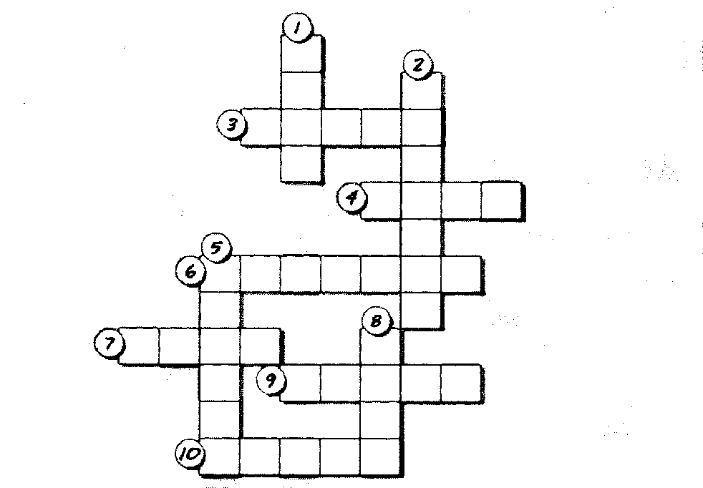

Animal Idioms

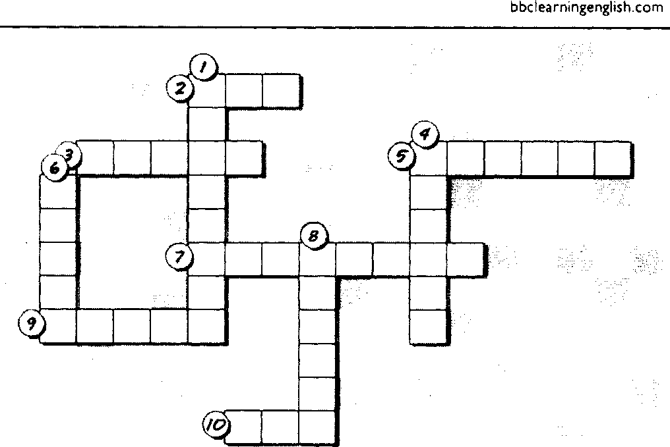

Open the brackets by choosing the right idiom for a definition
l. ‘Please stop that (mischief) and do some serious work."
(a) dog and pony show (b)monkey business (c) piggyback (d) road hog
2. The little boy asked many questions until his mother finally said that (asking too many questions will get him into trouble).
(a) the cat had got his tongue (b) you can't teach an old dog new tricks (c)curiosity killed the cat (d) there is 'more than one way to skin a cat
- "Please (be patient and wait) while I make a phone call."
call the dogs off (b) have a whale of a time (c) flog a dead horse (d)hold your horses
- The new product is (a good source of money) for our company.
(a) a cash cow (b) as strong as an ox (c) a horse of a different color (d) a dark horse
- The little boys thought that their friend was (easily frightened) because he would not play with the dog.
- as awkward as a cow on roller skates (b) a kangaroo court (c) as quiet as a mouse
(d)a scaredy-cat
- The car engine stopping while driving on the freeway was the (thing that finally made me decide to do something) so I finally sold the car.
(a) straw that broke the camel's back (b) black sheep of the family (c) cat on a hot tin roof d) wolf in sheep's clothing
- He is the (most important person) in his company.
(a) holy cow (b) dog in the manger (c) alley cat (d) top dog
8. Many people believe that (you can make much money); in the city so they are moving there in large number
(a) silence is golden (b) seeing is believing (c) it is third time lucky (d) the streets are paved with gold
9. The teddy bear was (not visible) so the little boy soon forget about it.
(a) once bitten, twice shy (b) out of sight, out of mind (c) in for a penny, in for a pound (d) nothing ventured, nothing gained
10. The mother did not speak with her daughter for several weeks but she believed that (not hearing anything meant that everything was probably all right) so she did not worry
(a) necessity is the mother of invention (b) no news is good news (c) there is no smoke without fire (d) nothing succeeds like success

Особое место в языке занимают условные сокращения, которые употребляются в приглашениях и коротких записках.
- If you are invited to a party and you are asked to bring something to drink what would they tell you?
- COD (b) ASAP (c) RSVP (d) BYOB (bring your own bottle)
- You order something from a supplier and they say that they will send you the product and you can pay the delivery person. What is this called?
- DIY (b) ASAP (c) COD (cash on delivery) (d) C/O
3. Your friend owes you some money and wrote a small memo to say this. What is it called?
(a) PLO (b) ETA (c) IQ (d) IOU (I owe you)
4. When someone is sick you can give them lots of something which may help them. What can you give them?
(a)TLC (tender Loving Care) (b) OD (c) PE (d) SOS
- Recently, many stores sell things to help people build things in their homes. What are they sometimes called?
(a) HQ stores (b) COD stores (с) AOB stores (d) DIY stores (do it yourself)
- What is it called when the police charge someone with drinking alcohol when they are driving?
(a) DIY (b) DU (driving under the influence) (c) APB (d) BYOB
- You write something on the back of a piece of paper and you want to make sure someone reads it. What can you write on the front?
(a) ASAP (b) TLC (c) RSVP (d) PTO (Please turn over)

Современный английский язык полон различных разговорных выражений, которые со временем теряют свою неформальность и «разговорность».
Translate these sentences, paying attention to the use of colloquial phrases.
- My aunt has her finger in a pie and makes friends easily. (involved in different activities)
- Having answered the question, Mary looked sheepish. (look embraced or ashamed)
- At my birthday party my colleagues really went bananas. (act almost out of control)
- After the graduation Tom had been working for peanuts. (to work for a very small payment)
- The weekend was very relaxing and we came in the office bright-eyed and bushy-tailed. (full of energy and enthusiasm)
- The test was really hard. The student made it by the skin of their teeth.(just managed to do it)
- The old couple couldn’t sleep because of the Hullabaloo next door.(a loud noise of commotion)
Сленг также является отражением состояния языка в современном обществе. Материал в видео приложении 2 предлагает обзор данной темы.
Для реализации лингвокультурологического подхода в обучении английскому языку принципы культуросообразности и развивающего обучения являются центральными.
Это достигается следующими методами:
1) поощрение и стимулирование интереса учащихся;
2) поощрение творческого подхода;
3) метод проблемных ситуаций и проблемных вопросов;
4) частично-поисковый и исследовательский методы;
5) контент-анализ и лингвокультурологический анализ пословиц, поговорок, фразеологизмов и характерных для англичан высказываний;
6) метод освоения всех аспектов языка через призму культуры;
7) метод приучения, предназначенный для выработки навыков культуры поведения;

