Secondary school №1

FAMILY TREE

The work has been done
by Tiunova Kate
The teacher: Obukhova N.A.

Vereshchagino 2012
CONTENTS

3
4
5
6
7
- Introduction

- Passport of the project

- Conclusion

- Literature

- Appendix

Introduction

We learned the words about the family in the 2d form. It was our first acquaintance with it. Later in the 5th form we got more information about every member of the family: traits of character, family description, occupation, hobby. Now in this form we have learned the words about the relations in the family, parents’ and children’s responsibilities.
When the teacher asked us to draw family tree and write all our relatives on it. It seemed to me the scheme in the book was very simple and not convenient. I have an idea to work out my own scheme, to collect and to show more information about my relatives. I’d like to design my own family tree. I think know the roots of my family is very important and actual in nowadays.

Genealogia is (a Greek word) a historical discipline studying an origin
and relatives of different hinds and persons of a various social origin.

The aim of my work is the design of my family tree.

Tasks

- to collect information about my relatives
- to translate it into English
- to design the scheme of my family tree

The methods

- To take the interview
- To work with the file of the family (photos, letters, dairies)

I would like to make an electronic album of my family.

Passport

The first state – preparation
What to do | How to do | Participant | Responsible | Date
1. to collect information about relatives | to work with albums, letters, dairies | Tiunova K. | Tiunova K. | January
2. to talk with parents about relatives | to take an interview | Tiunova K. parents relatives | Tiunova K. | January
3. to work out the scheme of the family tree | to work in the internet | Tiunova K.  a sister | Tiunova K. a teacher | February
The second stage – writing
1. to work with information | to write texts using symbols as a plan | Tiunova K. | Tiunova K. a teacher | March
1. to work with information | to translate texts into English | Tiunova K. | Tiunova K. a teacher | March
1. to work with information | to scan photos | Tiunova K. a sister | Tiunova K. a teacher | March
- To design an electronic album “Family Tree” | to make slides (presentation) | Tiunova K. a teacher | Tiunova K. a teacher | March
The third stage - conclusion
1. to make a conclusion | to appreciate all stages | Tiunova K. a teacher | Tiunova K. a teacher | March
2. to perform the results of the project | to show the project relatives, and classmates | Tiunova K. | Tiunova K. | April

The conclusion

I have achieved the aim of my work. I’ve designed the electronic album
“Family Tree”. First of all I found the example of the scheme of my family tree, then I collected the information about my relatives.I worked with family’s file,
interviewed relatives, read letters and diaries.

During my work on the project I have improved my English, have learned
how to make slides and have known how to do the project. Finally I have made
a genealogical tree of three generations of my family.

I hop English written texts can be used as cards at the lessons.
I’m sure the electronic album “Family Tree” will be added by my children and
they will pass it from one generation to another.

You’d be nuts to miss a chance to take part in this competition. I think
that my work is interesting and fascinating not only for me but for some
students who wants to know about their own relatives. It is not the end of my work I continue my work.

Literature

- Family’s file

- Wikipedia

- Enjoy English 3 – Student’s Book - Obninsk: Titul Publishers, 2007.
M.Z. Biboletova.

- English-Russian Dictionary - Moscow Russian Language Publishers 1981, 53000 entries, V.K. Muller.

Appendix 1

Scheme family tree

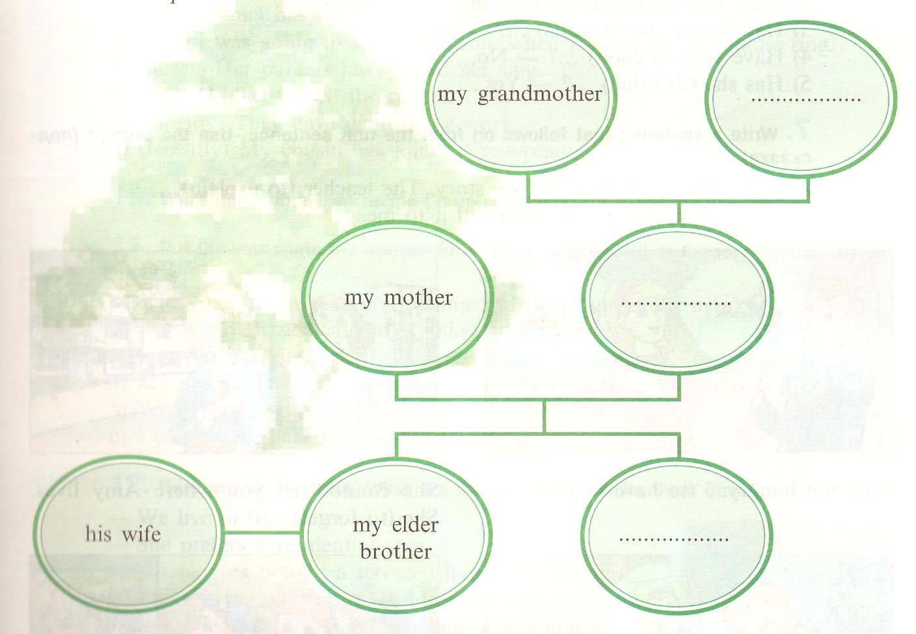

Appendix 2

Symbols

- Date of birth

X Wedding

? Education

☺ Children

~ Job ( occupation )

* Participant of the WWII

¤ Orders

Appendix 3

File

- Tiunov Aleksandr Filimovich – my greatgrandfather
- 20 September 1909
+ 09 May 2001
X 1927
? 2 classes
~ a farmer
☺ 3 children
* 1941 – 1945
¤the Order of the Red Star

Tiunov Aleksandr Filimonovich was born in the village Voznesenskoe, Perm region. He was born in an ordinary family. Sasha was the 6th child in the family, but the 1st son. He began to help his father about the house very early.
He studied at school 2 years and then worked on the the farm. In 1927 he married .
He went to the front at the beginning of the Great Patriotic War. He was hurt several times but each time he returned on the first line of the front. He was a sergeant. He took part in a heavy fighting near Stalingrad and destroyed 2 tanks. He sat in the trench with 2 hand-grenades to use against the tanks. When the tanks were near enough, he stood up and threw the grenades and the tanks caught fire. The attack was stopped. He was awarded the order of the Red Star for heroism. My grandad passed the war from Kursk to Berlin.
After the war he came back and worked on the farm. He finished his working period at the age of 70 . At that time he had three adult sons: Boris, Iliya and Valentin.

- Tiunova (Melekhina)Ekaterina Konstantinovna– my greatgrandmother

- 05 December1907
+ 27 December 1994
? ---
~ a nurse, a gardener
X 1927
☺ 3 children
¤ The Red Banner
She was born in the village Pinaevka, Okhansk region. At the age of 9 she began to work in the fields. She worked in the fields from early morning till late at night , that’s why she couldn’t attend school. That little girl had to work very hard in order to help her parents. She got married in 1927 and went to Voznesenskoe. During the great Patriotic War she worked as a nurse , helped to take care of sick soldiers. She treated and saved many people after heavy illness. People respected her for kindness and care.
My greatgrandma helped our army to fight against Germans. After the ending of the WW II she was awarded the order of the Red Banner for her heroic labour. After the war she worked in the garden and planted fruit, vegetables and flowers.

- Suvorov Andrey Ivanovich– my greatgrandfather
- 18 October 1893
+ 30 June 1978
? ----
~ a blacksmith
☺ 2 children
He was born in the village Buldjry, Kudymkar. He was a son of a collective farmer. Andrey was not a big boy but he was healthy and his duty was to help his father about the house and in the fields. He didn’t go to school because at that time there was no school there. He liked to watch after his grandfather who was a blacksmith and very soon he was his first helper.
He was a participant of three wars (the Finnish War, the Civil War, the Great Patriotic War). He was in Leningrad where the great historical events took place in October 1917.
On June 22, 1941 the Soviet government called on to rise for a patriotic war against the fascist aggressors. My grandpa fought for his country during 4 years. At the end of the war he was hurt and was captured. After returning home he worked in the collective farm. He brought up two children.

4) Suvorova ( Epishina ) Khristina Vladimirovna– my greatgrandmother
- 08 April 1915
+ 10 March 1986
? 3 classes
~ a farmer
☺ 3 children

She was born in the village Bolshaya Polovina, Kudjmkar. Where she received her primary education and could work in the bakery. Her life was not so poor. She helped her youngest sisters. At the age of 24 she began to work in the collective farm and had her own farm.
She was very attractive and very soon she was fall in love Andrew and had 3 children Nina. Roza and Zoya.

5) Fadeev Nikolay Aleksandrovich
- 04 February 1922
+ 15 December 2000
X 1973
? a professional school
~ an engine driver
☺ 2 children
He was born in Vereshchagino in the working class family. His life was not bad. He received vocational education after leaving school. His professional was a locomotive driver. He was in different parts of our large country thanks to his job.
He had to fight for several years to defeat all enemies and defend our country during the Great Patriotic War. He drove the locomotive to carry soldiers, tanks and ammunition. For his heroic struggle on the battle-fields and for his heroic labour he was awarded two orders and three medals.
In a peaceful life he drove the locomotive on the virgin lands and helped our country to rise from the ruins. So he followed the heroic fighting and labour traditions of his father and grandfather. He had 2 children.

6) Fadeeva Lipistiniya Ivanovna – my greatgrandmother
- 25 November 1921
+ 08 September 2001
? a professional school
~ a worker, a seller
☺ 2 children
She was born in Fabrika, Perm Region. She finished a vocational school and had an opportunity to work at the plant.
Together with all Soviet people the young girl fought to win the victory over fascism. She worked at the plant making details for tanks and treated for wounded soldiers.
After the war she was an accouter and had her own farm. She had 2 children.

7) Tiunov Iliay Aleksandrovich – my grandfather
- 02 August 1947
? a secondary school
~ a driver
☺ 4 children
He was born in the village of Voznesenskoe, Perm region. After finishing secondary school in Zuykaika, he joined the Soviet Army. He served a driver on the armored car. Twice he took part in the parade on Red Square honored to the Great Victory. He continued his working carrier as a tractor driver in the collective farm. He was hardworking and was awarded for his labour. His photos were on the board of fame. At the age of 24 he got married.
Nowadays he has 4 children and he is a pensioner.

8) Tiunova (Tetenova) Anna Tikhonovna – my grandmother
- 31 July 1947
? an agricultural college
X 1971
~ an accountant
☺ 4 children
She was born in the village Garevka, Perm region. She got a secondary education in 19. More than that she entered the agricultural college in Kungur. More than 40 years she was an accountant on the plant. Now she rests.
Anna Tikhonovna has three sons, one daughter and seven grandchildren. All relatives respect our grandmother.

9) Tiunova ( Fadeeva ) Olga Viktorovna – my mother
- 10 January 1974
? a college
~ a tuter
X 1993
☺ 3 children
She was born in Vereshchagino. She studied at school №1.After graduating school she entered the Perm pedagogical college. She is a tutor in the kindergarten. My mother has been working in the kindergarten for 15 years. She is a kind and generous lady. She teaches kids how to be intelligent. My mum performs short plays, sings songs, makes toys to surprise and entertain kids, plays games with them. They get very excited. People respect her for kindness and care. That’s why she is on a board of fame. I’m sure that carring for others is really great. I think my mum’s job is very important and useful. I’m proud of my mum.

10)Tiunov Vladimir Iljich – my father
- 05 November 1971
? University
~ an inspector
☺ 2 children
* medals, the order
My grandpa was born in the village Vosnesenskoe Perm region. He graduated secondary school with a gold medal. He was good at Maths, Information Technology and Biology. After finishing school he entered the Perm State University at the faculty of Biology. He was a top student. More than that he was fond of sport. Accidently he began to work in militia. He is an inspector. He has been working here during 15 years. In 2000 he joined the Russian Army and served in Chechnya. My dad was in very dangerous situations but thanks to his skills, knowledge and experience he was a winner. He was awarded the medals and the order for his heroic actions during this horrible war in peaceful time. Now he is a well-known man in our town. His work is very dangerous but my father does it perfectly.

11)Tiunova Inna Vladimirovna – my sister
- 14 March 1992
? College
~ A manager
She was born in Vereshchagino. She studied at school №1. After finishing school she entered the finicial college in Perm. Now she a manager and continues her education in the Perm State University. She is fond of sport. She is keen on music and Information Technology. Sometimes she helps me. I get along with my sister. She is cool.

12) Tiunova Kate
- 16 December 1999
I’m the youngest child in the family. I’m in the 6th form. I am a top student in the class. My marks are only 5. I am good at Russian, Maths, Geography, History, Biology, Literature and Physical Education. As my hobby I am keen on music.
I have learned an important lesson from my father, "If you want to be a waiter, you must be the best waiter in the world”. This is the advice I have always followed for myself - to be the best at whatever I do.

