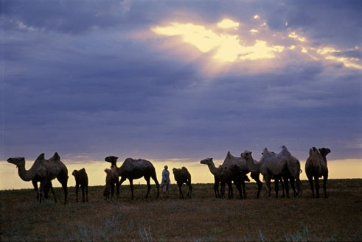
Baybek village.

МБОУ «Байбекская СОШ» имени Абая Кунанбаева Красноярского района Астраханской области
Ученица 10-го класса Тналиева Данагуль
Учитель иностранных языков Ажгалиева Галия Салахадиновна
I live in the small village in the Astrakhan region called Baybek. The Astrakhan region is multinational and hospitable region. Kazakhs, Russian, Kalmyks, Tatars, Nogais and other people make a peaceful friendly and freedoom loving community. Our multinational region preserves and develops its best historical traditions in industrial and cultural spheres.
Baybek is located in the steppe. It’s a kazakhish village. Our village has its unique local colour. The legend says that there lived a rich man – Baybek, so now it’s a name of our village.
There is an ethnographical museum in Baybek. It’s one and only ethnographical museum in the south of Russia. The museum fund comprises a lot of items: ethnographical documents, religious items, posters, materials on the history, social, cultural settings in Baybek. And here you can see the whole mode of Kazakhs’ life in ancient times. Real Kazakh is not a Kazakh without his national musical instrument - dombra.
Earlier Kazakhs lived in yurta, it was round and was made from camel’s or sheep’s wool,nowadays women knit socks , pullovers and sew blankets from this wool – there`s healthy in it. In spring when nature is in blossom we celebrate our traditional holiday – Nauruz- people make yurta, wear national costumes and play dombra, dance, sing and cook traditional dishes.If you visit Baybek, you will see a lot of exotic animals: camels, horses, wolves, foxes, cows, sheep.
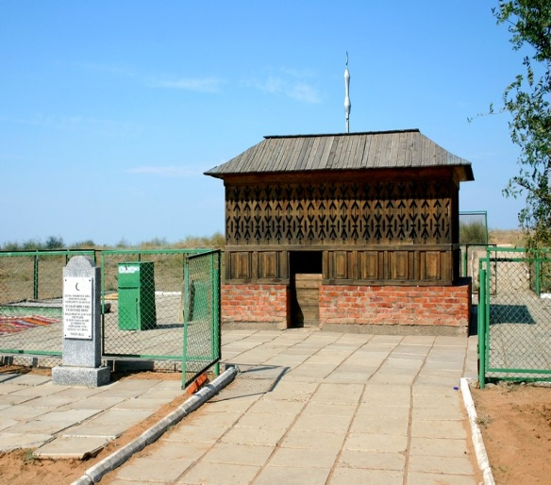
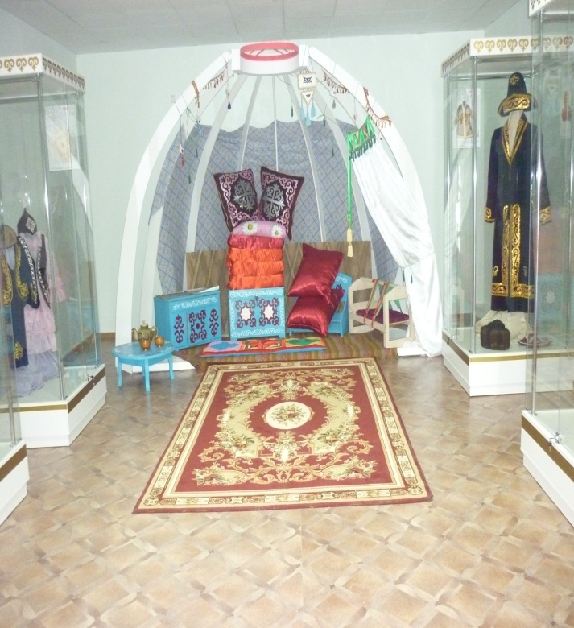
Another unique place in our village is a tomb of two personalities. It`s a memorial called “Said – Baba and Bukey – chan”. Said – Baba was a healer of people. He was well-educated. He got his education in Egypt, gathered his experience in India and Asia. Then he came back to his homeland and began to cure people. For 200 years people have been visiting this sacred place.
