Zoya

Kosmodemyanskaya.
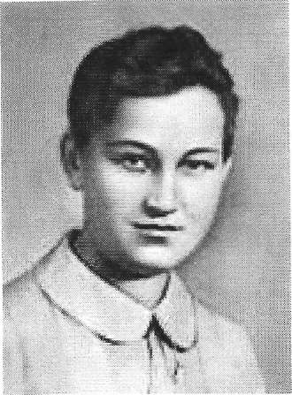

Made by
Malachilaeva P. and Wedenyapina Marie, school № 684 11 A form.
October, 2011 year.
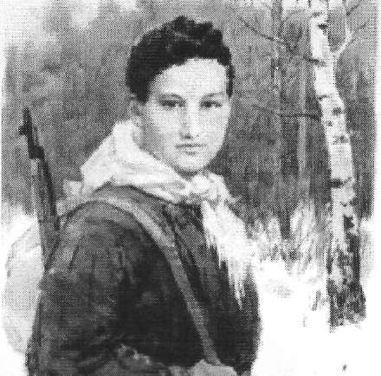

ZOYA

KOSMODEMYANSKAYA
One of the most enduring tales of heroism from the days of World War II is the tale of the Soviet partisan Zoya Anatolyevna Kosmodemyanskaya. Zoya was 17 at the time that she joined the partisan resistance movement in the western USSR. Like many of her comrades, she was involved in sabotage and reconnaissance missions behind enemy lines. In 1941, during a night mission in German-occupied territory, Zoya was captured with two of her comrades. Some accounts suggest she was apprehended while burning stables that had been commandeered by the Nazis. She was taken to the village of Petrischevo where she was tortured relentlessly by her captors who had hoped to gain intelligence that could be used against resistance forces. Despite severe torture and abuse, Zoya refused to share any information with her captors, identifying herself only with the pseudonym "Tanya." Zoya was ultimately sentenced to execution when the Nazis found they could extract no information from her. Zoya was led to the gallows with a placard around her neck which read "incendiary of homes". Before she was executed, she spoke bravely to the townspeople who had been rounded up to witness the execution:
"Here comrades! Why do you look so gloomy? Fight on, fight on!"
...and to her captors, she levelled a warning:
"There are two hundred million of us! You can 7 hang us all!"
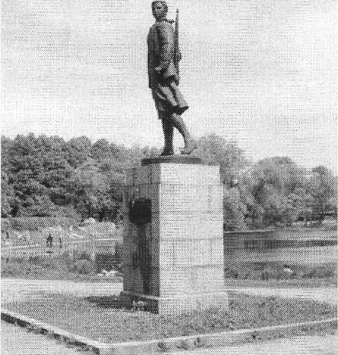
Zoya was hanged before the villagers that had been forced to witness the spectacle. Her corpse was bayoneted by the Nazis as it hung from the billet. The Germans would not allow the villagers to remove her body for some time after the execution. Instead, they displayed her body as a warning to others who might have considered aiding the partisans. She was buried months later following the beginning of the Soviet counter-offensive. Zoya's identity became known over the course of time in the months following her death. She was first identified as "Tanya" by villagers who shared the story with a newspaper correspondent. Zoya's brother later confirmed her true identity after reviewing Soviet newspaper accounts of the incident at Petrischevo. Her body was exhumed from Petrischevo and she was returned to Moscow for burial. On February 16, 1942, Zoya Kosmodemyanskaya was posthumously awarded the title of "Hero of the Soviet Union." She was the first woman to receive this distinction. The Germans had documented Zoya's execution by taking photographs beforehand and afterward. These photos were later found on the body of a dead German officer and shortly thereafter, the rest of the world became eyewitnesses of Zoya's fate. The Nazi regiment responsible for Zoya's murder was destroyed by Red Army forces under the command of General Poketkin in late 1942. Zoya's brother Alexander Kosmodemyanskay (Shura) also received posthumous recognition as a Hero of the Soviet Union. He was killed in combat near Koenigsberg near the end of World War II. Lyubov Timofeyevna Kosmodemyanskaya, mother of Zoya and Shura, memorialized her children with her book, The Story of Zoya and Shura .

Tributes
Although post-Soviet revisionism has included attempts to cast some doubt on the heroic story of Zoya Kosmodemyanskaya, her story is revered by many to this day. Monuments to Zoya still stand in St. Petersburg, Tambov, Dorokhov, and Petrischevo. Her grave is in Moscow.
The 1944 Lev Arnshtam film "Zoya" tells the story of her arrest and execution. The score for the film was composed by Dmitri Shostakovich. The asteroids 1793 Zoya and 2072 Kosmodemyanskaya were named in tribute to Zoya Kosmodemyanskaya. In the 2002 book "Zoya's Story: An Afghan Woman's Struggle for Freedom," the narrator tells of her decision to use the name "Zoya" as one of her pseudonyms when she joined The Revolutionary Association of the Women of Afghanistan in the struggle against fundamentalism. She cites the story of Zoya Kosmodemyanskaya as an inspiration in the struggle against oppression. There's street named in tribute to Zoya Kosmodemyanskaya.

