The 15 of May

Test
Choose the correct form of the verb.

1) I … to the park yesterday, but today I want … to the zoo.
a) go, to go
b) went, to go
c) went, going

2) We usually … to the cinema at the weekend
a) to go
b) are going
c) go

3) He … a yellow T-shirt and a blue jeans on yesterday
a) have
b) had
c) has

4) Pam … a new beautiful clothes.
a) bought
b) to buy
c) buy

5) What did you … when it’s cold?
a) to put on
b) putted on
c) put on

6) I didn’t … his new raincoat. Did you?
a) see
b) saw
c) seed

7) When did you … him my new address?
a) gave
b) to give
c) give

8) He … in the park last night.
a) walked
b) walk
c) will walk

9) He… in the park every day.
a) walk
b) walks
c) walked

10) Mr Elephant … to Mrs Lions shop and … new clothes for his little Baby Elephant.
a) go, buy
b) to go, to buy
c) went, bought

2. Choose the correct sentence
1.


- He has green trousers and a yellow hat on
- He has an orange shirt, yellow trousers and a blue hat on.
- He has blue jeans and a green T- shirt on.

2.
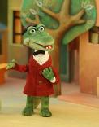
- Gena has a white shirt, a red coat and a brown hat on.
- Gena has a green coat and a white hat on.
- Gens has a yellow T- shirt and blue jeans on

3.

a) The wolf has a brown raincoat and green boots on.
b) The wolf has a red sweater, a green hat and purple trousers on.
c) The wolf has a yellow sweater and green trousers on.

4.

- Homer has a white T-shirt and brown trousers on.
- Homer has a blue T-shirt and white trousers on.
- Homer has a white T-shirt and blue trousers on.

5.
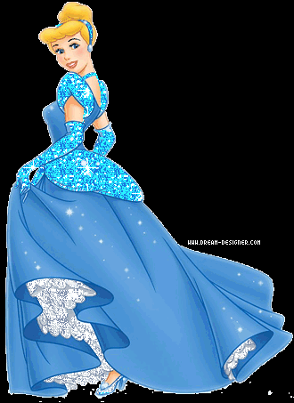
a) Cinderella put a nice red dress on.
b) Cinderella put a nice blue dress on.
c) Cinderella put a yellow dress on.

