Hello,

This is my  (…………..) holiday.

It’s (…………..) and (…………….) .

I’m wearing my yellow 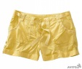 (……………) and (……………).

How about you? Is it hot? Is it sunny?

See you soon

Chuckles