Муниципальное общеобразовательное учреждение
«Лицей г.Козьмодемьянска»

We are going to Australia!
/Методическая разработка урока английского языка в 9 классе
по УМК New Millennium, авторы: О.Л.Гроза, О.Б.Дворецкая и др./

Выполнил: Шиборин Г.В., учитель английского языка высшей квалификационной категории

Козьмодемьянск
2010
Цель: Развитие познавательной и коммуникативной деятельности учащихся, мотивация учащихся к иноязычному общению
Задачи:
- развивать и совершенствовать виды деятельности учащихся (аудирование, чтение с охватом содержания, поисковое чтение, говорение в монологической и диалогической речи, письмо), анализировать учебный материал по страноведению; научить пользоваться ИТ (представление презентации) на уроке,
- расширить кругозор учащихся в области страноведения, привить интерес к страноведению и англо-говорящим странам и их культурам; привить навыки пользования компьютером
- воспитывать чувство толерантности учащихся к представителям других культур и народов
Тип: вводный урок-путешествие с компьютерным сопровождением
Аппаратное обеспечение: локальная сеть, выход в Интернет, мультимедийный компьютер, интерактивная доска
Программное обеспечение: универсальное ПО, ресурсы сети Интернет
Основные и дополнительные источники (традиционные, ОЭР на CD-ROM, ресурсы сети Интернет)
Материалы, используемые при подготовке к уроку:
1. Интернет-ресурсы сайтов
http://australia-ru.com
www.world-australia.info
www.australia.mid.ru
www.australianembassy.ru
www.nota.triwe.net/teachers/open/australia.htm
www.lonelyplanet.com/destinations/australasia/australia
www.pwc.com/extweb/pwclocations.nsf/
www.ucheba.ru/referats/16577.html
festival.1september.ru/index.php?numb_artic=411326
vector-images.com/heraldry.php?id=189
www.kremlin.ru/eng/events/articles/2007/09/143433/143452.shtml

2. Материалы учебника "New Millennium" для 9 класса авторов О.Л.Гроза, О.Б.Дворецкая и др.
Оснащение урока и материалы, используемые на уроке: Компьютерный класс с выходом в Интернет, отдельные страницы сайтов, презентация,
Запись на доске: Theme: We are going to Australia.
Key words:
Proper names:
Plan:
A glimpse of Australia
The history of Australia
Read & match
Vocabulary
Read and answer the questions
Conclusion
Ход урока:

1.Организационный момент.
Сообщение учащимся о целях и задачах урока (начало представления презентации)
Good morning, children. Let's begin our lesson. Today we have an unusual lesson. We will use information technologies at our lesson.
I’d like to call your attention to some information about one of the English-speaking countries.
The aim of our lesson is to get to know more about it using Internet and other technologies.
2. Основная часть урока We are going to Australia!
2.1 Представление слайдов презентации
Слайд 1.
English is spoken in many countries of the world. Do you know in what countries English is the national language? (…)
First of all it is Great Britain, and then you should remember about the United States of America, Canada, Australia and New Zealand.
Слайд 2.
Today we shall speak about one of the English-Speaking Countries. Look at this picture and answer my questions:
- What country is it?
- Is it big or small?
- Is this an island or a continent?
- What oceans is this country washed by?

Well, let's speak about Australia.
Слайд 3.
The official name of Australia is the Commonwealth of Australia.
Слайд 4.
The Commonwealth of Australia & its territories
Слайд 5.
Read the information on the screen & say if it’s an island or a continent.
Слайд 6.
The history of Australia began many years ago.
Let's read the text about the history of Australia and then answer some questions (работа с раздаточным материалом - текст для чтения с охватом содержания)
Слайд 7.
History of Australia.
The east coast of Australia was discovered by captain Cook in 1770. It was then first used as a colony for convicts (каторжник). Other settlements of a few three settlers began to appear. Of these settlements Sydney was the most important; but other smaller settlements for convicts were in Tasmania, at Brisbane, and on the Swan River in Western Australia.
The early settlers were very cruel (жестокий) to the aborigines. They killed or drove them away from their lands. The discovery of gold in 1851 brought many people to Australia and the character of the colony began to change. But still, the raising (разведение) of sheep was for a long time the most important occupation for the Australians.
Towards the end of the 19th century, the Australian colonies began to discuss some form of union. They formed a federation, the new constitution was introduced on January 1, 1901; and the birth of the new nation was celebrated.
Слайд 8.
Answer the following questions.
1. What part of Australia was first used as a colony? (The east coast of Australia)
2. How did the early settlers behave towards the aborigines? (They killed or drove them away from their lands)
3. Why did very many people go to Australia after 1851? (because of the discovery of gold)
4. When was the new nation born in Australia?
Слайд 9.
Слайд 10. There are 5 big cities in Australia: Sydney, Melbourne, Adelaide, Perth and Brisbane.

Слайд 11. Read the texts from travel booklets, match the texts and the phrases and say which of the places give a good opportunity (работа с раздаточным материалом - тексты A, B, C для поискового чтения):

- to enjoy the beauty of nature
- to see the art of native Australians
- to enjoy good music
- to visit a museum
- to do sports
- to find something to do on rainy days

A
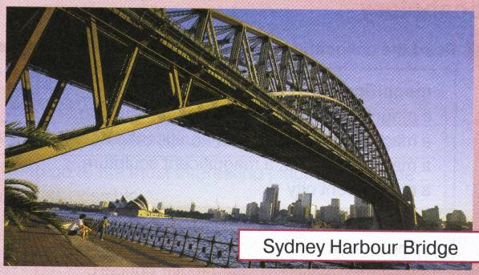
Visit the sunniest city in Australia
with only 23 days a year without sun!
Sydney is Australia's oldest and largest city with a population of around 3,986,700.
A full range of tourist attractions include the magnificent Botanic Gardens, Sydney Harbour Bridge, and of course the world-famous Sydney Opera House and two thousand Aboriginal rock drawings!
Make a reservation now!
B
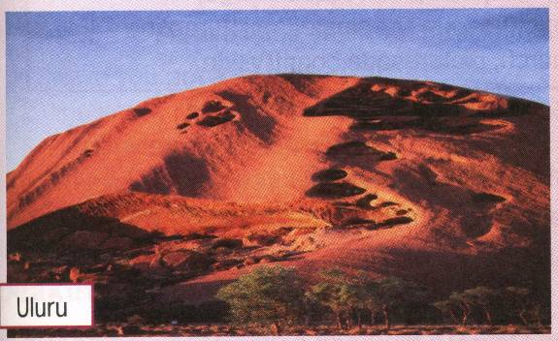
No visit to Central Australia is complete without seeing Australia's most famous landmark — Uluru (previously called Ayers Rock). The world's largest rock mass, Uluru, rises out of the middle of the country and is spectacular at any time of the day.
Uluru is always impressive, but never more so than during sunset. No matter how many pictures you've seen of it, nothing prepares you for the experience of being there.
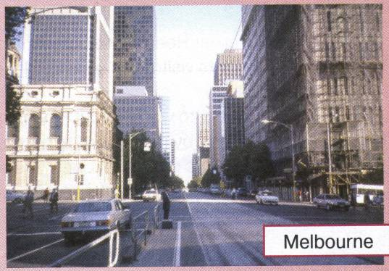
C
Melbourne, the capital of Victoria, is the second largest city in Australia. It has a population of just over three million people, and is a picturesque place with so much to offer the visitor.
Being a wonderfully diverse place, Melbourne offers everything for the tourist from museums and galleries to tennis, fishing and windsurfing.
You can order a package tour or book your own accommodation and choose from a full range of apartments, hotels, motels, bed and breakfasts and hostels.
Слайд 12.
Now let’s check up

2.2. Работа с учебником.
Now let’s work with our books and do ex.3 at p.67. (грамматика: порядковые числительные с превосходной степенью сравнения прилагательных)
- Read the first two sentences in text A and say:
— How are the underlined phrases the same and different?
— Can you find similar examples in Text B?
— What are the two ways of saying this in English: Сидней - самый красивый город в Австралии?
- Read the first sentence in text C and answer the questions:
— How can it help you say in English: Брисбен - третий по величине город в Австралии?
— What is the other way of expressing this idea?
- In pairs look at the map and ask and answer each other’s questions about Australia. Use all new phrases you have learnt so far (e.g.: - What’s the country’s smallest territory? - The Australian Capital Territory).

2.3. Работа с лексикой.
a) Read the collocations with the words in texts A, B & C and answer the questions below:
magnificent
a magnificent view, a magnificent
mountain, a magnificent building,
a magnificent dinner, a magnificent
tree, a magnificent sculpture,
a magnificent city
impressive
an impressive view, an impressive
show, an impressive essay, an
impressive building, an impressive
knowledge, an impressive result
spectacular
a spectacular view, a spectacular
concert, a spectacular show, a
spectacular building, a spectacular
picture, a spectacular film, a
spectacular success
picturesque
a picturesque view, a picturesque
landscape, a picturesque village,
a picturesque spectacle, a
picturesque church, picturesque
countryside
Which of these words would you use to describe:
something | that is pretty and interesting especially in an old-fashioned way?
something | that is good, important, that produces a great effect on you?
something | that is great, good, beautiful because of being big?
something | that is very exciting to look at?

b) Replace the underlined phrases in the sentences with the words or phrases in bold from texts A, B & C
1 The Great Barrier Reef is one of the main places that many tourists visit.
2 Sydney offers its visitors all sorts of places to stay: hotels, motels, hostels and apartments.
3 If you don't want to worry about anything, we advise you to book a completely planned holiday arranged by a company at a fixed price, which includes travel, hotels, meals etc.
4 Being the Olympic capital, Sydney offers opportunities to do all kinds of sport.
5 We advise all travellers to make an arrangement (preparation) for a seat on a plane, bus or train to be kept for you as early as possible.

And now I want you to read one more text and find the answers to some questions about what factors explain the following peculiarities of Australia. The seasons are the other way round in Australia. Why? — Let’s check up! etc.
Answer the questions you can see on the slides.
Слайд 13-16.

3. Заключительная часть урока.
Подведение итогов.
Let’s analyze what we have learnt about Australia at our lesson.
- the official name of the country
- its history
- cities and territories
- how to use numerals with superlatives
- new words and to use them
Was the lesson interesting for you?

Домашнее задание:
Your hometask is to find information about Australia while doing ex.1-2 at p.36 (workbooks, U.5, L.1-2).
Подведение итогов урока.
I like your activity at the lesson very much. You marks for the lesson are:

