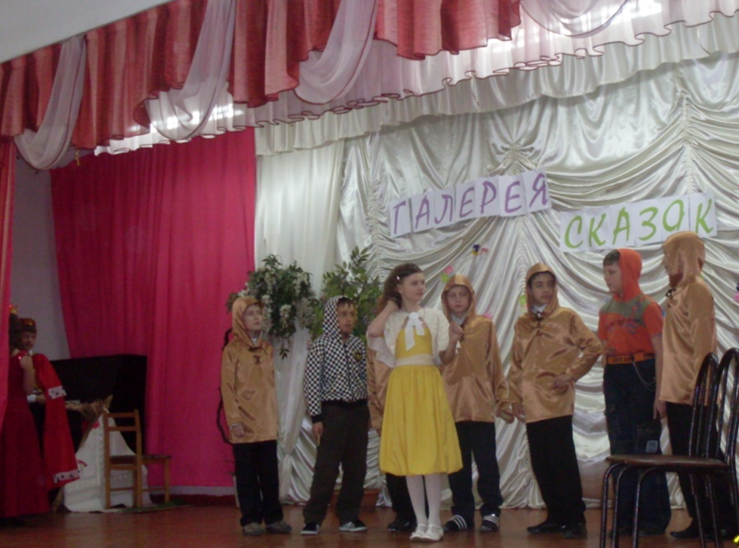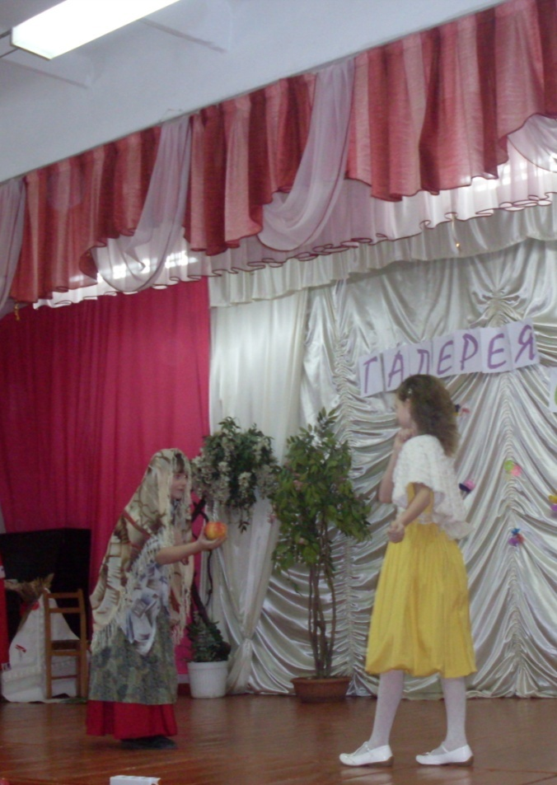**Сценарий сказки «Красавица и чудовище»**

**Действующие лица:**

*Купец*

*Чудовище-Заколдованный Принц*

*1 дочь*

*2 дочь*

*3 дочь – Красавица Beauty*

*Жители восточного города:*

*1 торговец*

*2 торговец*

*Танцовщицы*

*На сцене купец и его три дочери (на экране красивый дом)*

*Купец:* What present would you like, my dear daughter?

*1 дочь:* Please bring me a brocade dress

*Купец:* OK, my dear. *(спрашивает вторую дочь)* And what present would you like, my dear daughter?

*2 дочь:* Could you bring me a pearl necklace, dear father!

*Купец:* All right, my dear. *(спарашивает третью дочь)* And what present would you like, my dear Beauty?

*3 дочь:* All I'd like is a rose you've picked specially for me!

*Купец:* I’ll try! Good by, my lovely daughters!

*Дочери:* Good bye, father! Come sooner!

*Базар на востоке (звучит восточная музыка, на экране – восточная страна)*

1Торговец: Beautiful dresses for princesses!

*Купец:* I want to buy this brocade dress!

*1Торговец:* A very nice brocade dress!

*2 Торговец:* Gold rings, bracelets, earrings, neckасеs

*Купец:* I want to buy this pearl necklace!

*2 Торговец:* It’s the best pearl necklace in the world!

*Начинается буря (на экране – бурное море)*

*Купец:* I hope I'll find shelter there for the night. Hey, is anybody here? *(садится за стол, кушает)*Thank you, master! *(Гуляет по саду и видит цветок, срывает его)*

*Чудовище (выскакивает):* Ungrateful man! I gave you shelter, you ate at my table and slept in my own bed, but now all the thanks I get is the theft of my favorite flowers! I shall put you to death for this slight!

*Купец (падает на колени перед чудовищем)* -Forgive me! Forgive me! Don't kill me! I'll do anything you say! The rose wasn't for me; it was for my daughter Beauty. I promised to bring her back a rose from my journey!"

*Чудовище:* I shall spare your life, but on one condition, that you bring me your daughter!"

*Дом. Дочери встречают отца*

*Красавица:* Dear father, I'd do anything for you! Don't worry, you'll be able to keep your promise and save your life! Take me to the castle. I'll stay there in your place!" (Купец обнимает дочь) Good bye sisters!

*Чудовище:* Dear Beauty! You are so wonderful! Don’t be afraid! Will you merry me?

*Красавица:* I really can't say yes… I'd so much like to...

*Чудовище:* I quite understand! And I'm not offended by your refusal!" *(вздыхает и дарит ей зеркало)*

You won't feel so lonely now,"

*Она смотрит в зеркало и плачет*

*Чудовище:* "What's wrong?"

*Красавица:* "My father is gravely ill and close to dying! Oh, how I wish I could see him again, before it's too late!"

*Чудовище:* No! You will never leave this castle!" *(она плачет, он соглашается)* If you swear that you will return here in seven days time, I'll let you go and visit your father!"

*Красавица:* I swear! I swear I will! How kind you are! You've made a loving daughter so happy!"

*Красавица:* Oh, dear father! How are you!

*Купец:* Oh, little Beauty! I’m so happy to see you!

*Сестры:* How is your life? Is the Beast really auful?

*Красавица:* No. The Beast is really good and kind to me.

*Купец:* Glad to hear that! Now I’m well.

*(Голос из-за кулис)* Come back! Come back to me!

*Красавица:* Hurry! I must hurry! (Бежит в сад) Don't die! Don't die! I'll marry you . . ."

*Чудовище в виде прекрасного принца:* How I've been longing for this moment! I was suffering in silence, and couldn't tell my frightful secret. An evil witch turned me into a monster and only the love of a maiden willing to accept me as I was, could transform me back into my real self. *(Видит красавицу)* My dearest! I'll be so happy if you'll marry me."

*Красавица:* Of course, I’ll merry you! *(танцуют менуэт, к ним присоединяются все участники спектакля )*