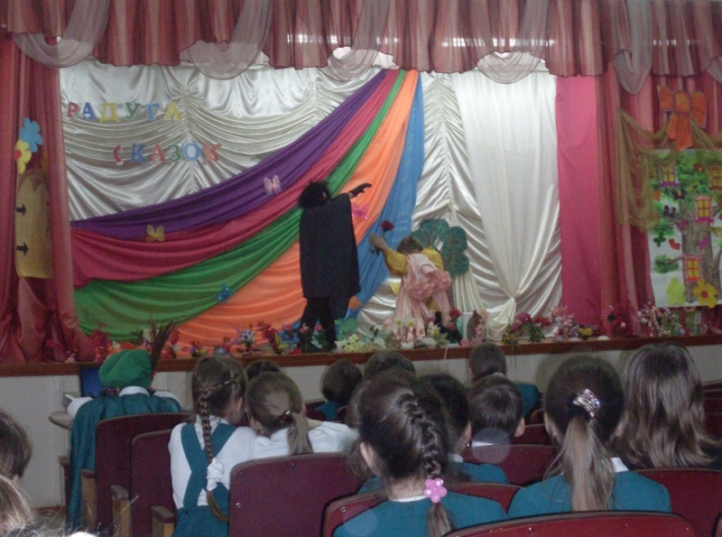

Сценарий сказки «Белоснежка и семь гномов»

Narrator:
Once upon a time there lived a Queen. One day a little daughter was born to her. She was named Snow White. The princess had skin as white as snow, lips as red as a rose, and hair as black as ebony.
Soon the good Queen died. The King married again. The new Queen was very beautiful, but cruel and selfish. She spent a lot of time looking in her Magic Mirror.

Scene 1.

Setting:
A room in the palace

Queen:
Magic Mirror in my hand,
Who’s the fairest in the land?

Magic Mirror:
You, who hold me in your hand,
You are the fairest in the land.

Narrator:
The Queen was very pleased to hear that. She knew that the Magic Mirror always spoke only the truth.
But Snow White grew up and she became very pretty. So one day …

Queen:
Magic Mirror in my hand,
Who’s the fairest in the land?

Magic Mirror:
You, who hold me in your hand,
You were the fairest in the land;
But, today, I’ll tell you true
Snow White is more fair than you!

Narrator:
The Queen became very angry when she heard the Magic Mirror’s words. She turned green and yellow with envy. She sent for one of the n\huntsmen who lived near the forest.
Queen (to the huntsman):
Let me never see this girl. Take her to the forest, kill her and bring me her heart.

Huntsman:
Yes, Your Majesty!

Queen:
Here’s a bag of gold for your work. (throws it to him)

Scene 2.

Setting: In the forest.

Narrator:
The Huntsman took little Snow White deep in the forest. The he took out his knife. He was ready to kill the poor girl.

Snow White:
Oh, dear Huntsman, leave me alive! Don’t kill me! I’ll run far in the forest and never come home again! I promise!

Huntsman:
Well, run away then, poor child I will not hurt you. (To himself) I cannot do such an awful thing. I will trick the wicked Queen. I’ll give her the heart of some wild animal that I will kill.

Narrator:
And he did this. He left poor Snow White all alone in the dark forest. She was so frightened and did not know what to do and where to go. She ran and ran and became very tired. Suddenly she saw a little house in front of her.

Scene 3.

Setting: In the little house.

Snow White:
I’ll go inside it. (She pushes the door and opens it)
Oh, how small it looks! And how neat, clean and tidy it is! And how many different little things are here! One, two, three, four, five, six, seven beds, seven little beds, seven plates, cups, knives and forks on the table. I’m so hungry and thirsty. (She sits at the table, eats a bit of bread and some porridge out of each plate, and drinks some milk out of each cup.)
Oh, I’m so sleepy!
(She tries to sleep in each of the beds. Finally she finds the most comfortable and falls asleep at once.)

Narrator:
Soon it became quite dark. The owners of the little house came back. They were seven little dwarfs. They worked hard every day digging ad searching for the gold in the mountains. They entered the room and understood that somebody had been in their house, for the things were in disorder.

(The Dwarfs dance.)

The First Dwarf:
Who has been sitting on my chair?

The Second Dwarf:
Who has been eating off my plate?

The Third Dwarf:
Who has been eating my porridge?

The Fourth Dwarf:
And who has been eating my bread?

The Fifth Dwarf: Who has been using my fork?

The Sixth Dwarf:
Who has been cutting with my knife?

The Seventh Dwarf:
And who has been drinking out of my cup?

The First Dwarf: Who has been lying on my bed?

All the rest Dwarfs (together): Someone has been lying on my bed.

(The Seventh Dwarf sees Snow White sleeping in his bed. He calls his brothers to come up and look.)

All: What a beautiful girl she is!

(Snow White awakes. She is quite frightened when she sees the seven little men. But soon she understands that they are friendly.)

The Dwarfs:
Don’t be afraid! We won’t hurt you. Believe us! We are your friends!

The First Dwarf:
Dear girl, what is your name? Why have you come to our house?

Snow White:
I’m a princess. My name is Snow White. My mother died when I was a child. And my stepmother wanted to kill me. I can’t go home. May I stay with you, dear friends?

The Second Dwarf:
Certainly, you may. And we’ll take care of your. You’ll become our sister.

The Third Dwarf:
If you stay with us will you look after us? Will you cook, make the beds, wash and keep everything neat and clean while we are working?

Snow White:
With great pleasure!

Narrator:
And the Snow White stayed with the seven little dwarfs and kept their house tidy. Every morning the dwarfs went into the mountains. In the evening they came back home. Snow White had the house clean and the supper ready. But for the whole day she was left alone. The dwarfs worried about the girl. So when they went away they warned her about her stepmother.

One of the Dwarfs:
Dear girl, you must be on your guard against your stepmother.
She will soon learn that you live here. Take care and don’t let anybody come into the house.

Scene 4.

Setting: A room in the palace.

Queen:
Magic Mirror in my hand,
Who’s the fairest in the land?

Magic Mirror:
You, who hold me in your hand,
You were the fairest in the land;
But, today, I’ll tell you true
Snow White is more fair than you!
Among the forest, darkly green,
She lives with dwarfs - the hills between.

Narrator:
The Queen was astonished. But she knew that Magic Mirror always spoke the truth. So she understood that the Huntsman had deceived her and the Snow White was still alive.
She made a poisoned apple, the dressed up as on old peasant woman and hurried to the house where The Snow White lived.

Scene 5.

Setting: In the forest.
(The Queen finds the house and knocks the door)

Snow White:
Who is there?

Queen:
I want to give you an apple, dear girl.

Snow White:
Oh, sorry, old lady I cant’ open you the door.

Queen:
Why? Are afraid of me? Look, the apple is so ripe and tasty! I’ll cut the apple into two halves. You’ll eat the red part and I’ll eat the white.

Narrator:
Only the red part was poisoned. Snow White stretched out her hand and took the poisoned half of the apple.
(Snow White takes a bite of the apple and falls down as if dead on the floor)

Queen:
White as snow, red as blood! The dwarfs will never wake you up!

Scene 6.

Setting: A room in the palace.
(The Queen comes back and wants to talk to the Magic Mirror)

Queen:
Magic Mirror in my hand,
Who’s the fairest in the land?

Magic Mirror:
You, who hold me in your hand,
You are the fairest in the land.

Scene 7.

Setting: In the little house in the forest.
(The seven Dwarfs come back .They see Snow White lying on the floor)

The First Dwarf:
The wicked stepmother has found her. Our dear girl is dead.

The Second Dwarf:
But her cheeks are so rosy!

The Third Dwarf:
And she looks as if she is not dead!

The Fourth Dwarf:
We cannot bury her.

Narrator:
And the Dwarfs began to make a glass case for Snow White. For a long, long time Snow White lay peaceful in the glass case looked as if she was asleep. The dwarfs took guard over the case in turn.
One day a King’s son came riding by.

Prince: (addressing the Fifth Dwarf who was on guard on that day)
Who is this beautiful girl?

The Fifth Dwarf:
She is the daughter of our King. Her name is Snow White. Her stepmother killed her. And who are you, noble man?

Prince:
I’m the prince and my country is not far from here. May I have a look at the King’s daughter?

The Fifth Dwarf:
Yes, you may.

Narrator:
The Prince looked at Snow White. She was so lovely. The Prince fell in love at once. He opened the glass case. Then he kissed the beautiful girl. The witch’s spell was broken. Snow White came alive.

(All the rest Dwarfs appear on the stage)

All the Dwarfs (together):
How happy we are that you are alive, dear Snow White!

Prince:
I love Snow White and I want to take her to my palace.

The Dwarfs: We are happy to hear that! But promise that you will come back and see us often.
We’ll miss you so much, Snow White.

Snow White:
I promise, I promise. I’ll never forget you, dear dwarfs!

They sing a song: The more we are together, together, together
The more we are together the happier we are
For your friend is my friend and my friend is your friend
The more we are together the happier we are.

Scene 8.
Setting: The room in the palace.

Queen:
Magic Mirror in my hand,
Who’s the fairest in the land?

Magic Mirror:
You, who hold me in your hand,
You were the fairest in the land;
But, today, I’ll tell you true
Snow White is more fair than you!
And she lives happily with her prince
Far away from you!

