A place where children go to learn things  A room in a school where students have lessons  Someone whose job is to teach in a school, college, etc.  Someone who is in your class at school or college  A book about a particular subject, written for students  Classes at school where children do exercise and play sport  A time when you do not have to go to work or school | A place where children go to learn things  A room in a school where students have lessons  Someone whose job is to teach in a school, college, etc.  Someone who is in your class at school or college  A book about a particular subject, written for students  Classes at school where children do exercise and play sport  A time when you do not have to go to work or school | A place where children go to learn things  A room in a school where students have lessons  Someone whose job is to teach in a school, college, etc.  Someone who is in your class at school or college  A book about a particular subject, written for students  Classes at school where children do exercise and play sport  A time when you do not have to go to work or school
A place where children go to learn things  A room in a school where students have lessons  Someone whose job is to teach in a school, college, etc.  Someone who is in your class at school or college  A book about a particular subject, written for students  Classes at school where children do exercise and play sport  A time when you do not have to go to work or school | A place where children go to learn things  A room in a school where students have lessons  Someone whose job is to teach in a school, college, etc.  Someone who is in your class at school or college  A book about a particular subject, written for students  Classes at school where children do exercise and play sport  A time when you do not have to go to work or school | A place where children go to learn things  A room in a school where students have lessons  Someone whose job is to teach in a school, college, etc.  Someone who is in your class at school or college  A book about a particular subject, written for students  Classes at school where children do exercise and play sport  A time when you do not have to go to work or school

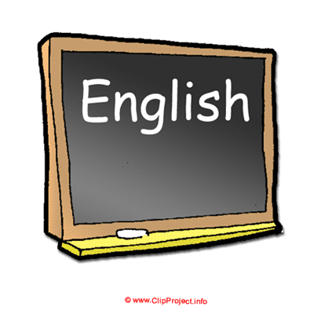
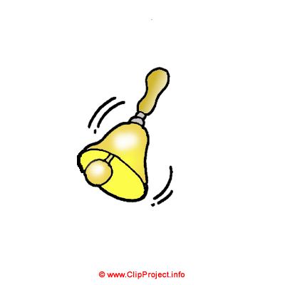
Урок английского для детей :)
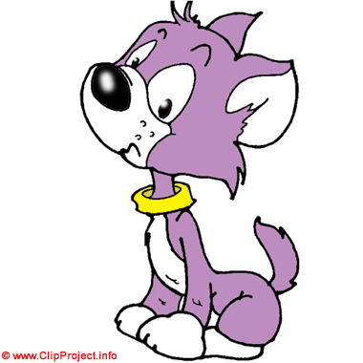
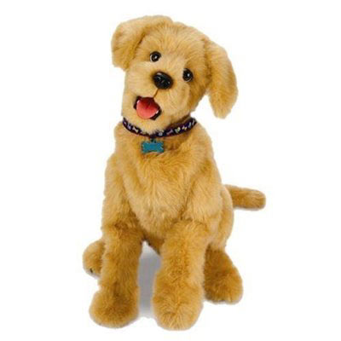
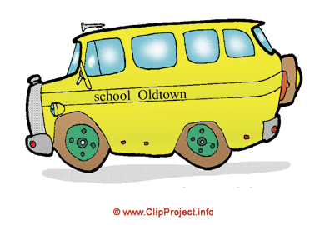
Громким эхом прозвенел
На урок веселый bell.
Будет очень интересен
Самый первый English lesson.
Будем новые слова
Изучать как дважды два.
Ты запомнишь без забот
По-английски слово – word.
Самый лучший в мире друг
Без сомненья, это book.
Жажду знаний утолит,
Если будешь много read.
Солнце встанет в ранний час,
Это утренний sunrise.
Просыпайся поскорей,
Наступает новый day.
С ветерком прокатит нас,
По дорожке желтый bus.
За окошко посмотри –
Там растет большое tree.
Он прыгучий и смешной,
Настроенье сразу joy.
Укатился вдруг под стол
Попрыгунчик, круглый ball.
Весельчак и хулиган,
Очень любит быстро run.
Только выйдешь на порог,
И залает громко dog.
Высоко он может jump,
И когтями цап-царап.
В шубку теплую одет,
Наш домашний толстый cat.
Вот и время nine o'clock,
Подошел к концу урок.
Ты слова запоминай,
До свидания, good bye!

