Card 1.
Task 1. Try to make the words using the first letter and number of words.
1. C-7- _________________________
2. M-6- _________________________
3. S-6- _________________________
4. I-11- _________________________
5. P-6-__________________________
6. K-7- _________________________
7. U-10- ________________________
8. S-6-_________________________

Task 2. Fill in the following words in the text.
Climate, capital, places, President, was founded, are proud, area.
The ______________ of Russia is over 17 million square kilometers. There are many seas and forests in Russia. The _______________ of our country is different. It is cold in the North of Russia and it is warm in the South of Russia. The ______________ of Russia is Moscow. It stands on the Moskva River. Moscow ________________ in 1147 by Yuri Dolgoruky. There are many interesting _______________ in Moscow: Red Square, the Kremlin, the Tretyakov Gallery, the Moscow Metro and many other interesting places. The head of Russia is the ________________. The people of Russia ______________ of their capital.
Task 3. Try to make the text complete and retell it to your classmates.
Red Square is the heart of Moscow. It is _____1____ square in our country. This square ______2_____ near the Kremlin. The Kremlin is _____3_____ historical centre of Moscow. | 1. beautiful  2. situate  3. old | 1.  2.  3.
The Moscow University is one of _____4______ buildings in Moscow. It ____5______ in 1755 by the great scientist Mikhail Lomonosov. It is one of ___6____ Universities in Moscow. It is very difficult to enter the University at the present time. | 4. high  5. found  6. good | 4.  5.  6.

Task 4. Try to choose the right variant.
- The capital of Russia is…
a)Moscow b)Washington c)London
- Moscow was founded by Yuri Dolgoruky in …
a) 1147 b) 1148 c) 1149
- There are many interesting places in Moscow:
a) Red Square b) the Kremlin c) The Tretyakov Gallery d)the British museum
- The Bolshoi Theatre is one of the famous theatres in…
a) Moscow b) Washington c) London
- The State Moscow University was founded in …
a) 1755 b) 1756 c) 1757
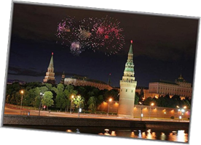
- The 22nd Olympic Games were held in Moscow in 19…
a) 1980 b) 1981 c)1982
The key:
1 | 2 | 3 | 4 | 5 | 6

Card 2.
Task 1. Try to make the words using the first letter and number of words.
1. C-7- _________________________
2. M-6- _________________________
3. S-6- _________________________
4. I-11- _________________________
5. P-6-__________________________
6. K-7- _________________________
7. U-10- ________________________
8. S-6-_________________________

Task 2. Fill in the following words in the text.
Capital, climate, President, are proud, was founded, area, places.
The _________________ of Russia is over 17 million square kilometers. There are many seas and forests in Russia. The _________________ of our country is different. It is cold in the North of Russia and it is warm in the South of Russia. The _________________ of Russia is Moscow. It stands on the Moskva River. Moscow __________________ in 1147 by Yuri Dolgoruky. There are many interesting __________________ in Moscow: Red Square, the Kremlin, the Tretyakov Gallery, the Moscow Metro and many other interesting places. The head of Russia is the __________________. The people of Russia ____________________ of their capital.
Task 3. Try to make the text complete and retell it to your classmates.
The Moscow Metro _____1_____ on the 15th of May, 1935. It has 200 stations now. Our metro is ____2_____ and convenient. Russian people like to ____ 3_____ the metro very much. | 1. found  2. beautiful  3. use | 1.  2.  3.
There are many galleries in our country. The Tretyakov Gallery is one of ______4______ Galleries in Russia and in the world. This gallery ______5______ in the centre of Moscow. It ____6_____ by Peter Tretyakov. We can see many pictures by Serov, Repin, Levitan and others in this gallery. | 4. famous  5. situate  6. found | 4.  5.  5.

Task 3. Try to choose the right variant choosing The Present Simple or the Present Progressive.
1. Moscow … on the Moskva River.
a) stands b)stand c) is standing
2. Red Square … a beautiful square in the centre of Moscow.
a) to be b) is c) be
3. The Kremlin … the home of the Russian President.
a) is b) to be c) be
4. The 22nd Olympic Games … in Moscow in 1980.
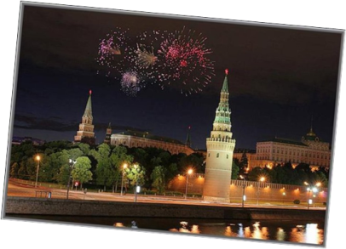
a) were held b) was held c) hold
5. The flag of Russia … of 3 stripes: white, blue and red.
a) consists b) consist c) is consisted
6. We … of our capital.
a) are proud b) is proud
The key:
1 | 2 | 3 | 4 | 5 | 6

