Масифулина Андриана Андреевна

Учитель английского языка

МБОУ «СОШ № 2»,

г. Альметьевск Республики

Татарстан.

Класс: 9

**УРОК АНГЛИЙСКОГО ЯЗЫКА В 9 КЛАССЕ**

**Тема:** Английский язык и мое будущее

**Цели: -** формировать у учащихся мотивацию к изучению иностранного языка;

- совершенствовать речевую культуру учащихся, речевую наблюдательность;

- развивать умение работать в группе, коммуникативные умения: вести диалог, проявлять заинтересованность, внимание к собеседнику;

- расширять лексический запас учащихся, их кругозор с помощью большого количества информации. Способствовать развитию творческих способностей учащихся.

**Оборудование:** интерактивная доска, рекламные проекты, компьютер.

1. **Организационный момент.**

- Good morning! I’m very glad to see you. Take your seats, please, and get ready for the lesson.

**Слайд 2.**

* Who is on duty, today?
* What day is it today?
* What date is it today?
* What is the weather like today?
* Who is absent?
* Ok. Good. Take your seat, please.
* Today we’ll speak about why you learn English and the influence of the English language on your future profession. It’s a revision lesson. Lesson of your presentation.

**Слайд 3.**

1. **Warning-up.**

**( Для настройки учащихся на беседу по теме используется высказывание).**

**- To begin with, let’s try to explain the following expression.**

**Слайд 4.**

- Do you share this opinion?

- How do you understand it? Explain, please. One sentence.

- It is easy or difficult to choose a profession?

- There is a good saying in the story “The happy man” by Somerset Maugham.

**Слайд 5.**

* Do you understand this saying?
* Let’s read and translate.
* Everything is in your hands.

1. **Развитие речевых навыков.**

**Слад 6.**

-Why do you learn English?

- Give your reasons …

- Look at the black-board. Read. You’ve just said about it. Any additions?

- Ok. Good.

**IV. Развитие лексических навыков.**

**-** Now, let’s revise some profession. Look at the board.

**-** Listen and repeat.

**Cлайд 7.**

* You have 3 minutes. So, your time is up.
* Now, let’s check it up.

**Слайд 8.**

**Слайд 9.**

1. **Проверка домашнего задания.**

* And now, it’s time to check up your home task. At home you should have prepared an advertisement- project about your future business.
* This is our honorable jury. They will judge you and choose the best work.
* We are ready to listen to you. Welcome.

( Учащиеся выходят к доске)

**Слайд 10.**

**The 1st group: “Tourist agency”**

We worked out the advertisement project of the tourist agency “Dream”. We would like to prove that it is necessary to learn English. The problem of foreign languages is very important today. Today English is the language of the world.

Today travel agents offer all kinds of holidays to all kinds of people. We agree with the view that international tourism is a good thing. 1st, it is wonderful to discover new places. 2nd, it teachers people about history. 3d, it teachers them to be understanding. Besides, tourism is the basis of the biggest business in the world.

That is why we made up our mind and opened our own tourist agency.

We’d like to show our staff to you.

( показывают и рассказывают о работниках)

We can offer you to have a rest abroad. We can advise you to visit the following countries and cities.

( показывают странны и называют города)

You will live in English families and speak English at breakfast and dinner, at the lesson in international groups, during the tours and in the cinemas and disco.

**........ ……. …….**

Choose our tourist agency! We can realize your dreams.

**Слайд 11.**

**The 2nd group: “Private school “Foreign language First”**

We worked out the advertisement project of the private school “Foreign language First”.

Every one of us knows the importance of knowing foreign languages. If you want your dreams to come true and get everything you need, you should know foreign language. Knowing foreign language you can get a well-paid job, have a successful career, open your own business, and be a better learner of your own language and culture. It is also a good exercise for the intellect. But if you don’t know foreign language, don’t worry. We can help you. You can choose the language you want to learn. Look at our staff.

(показывают и рассказывают о работниках)

After finishing our school with excellent marks, we send you abroad to practice your knowledge in foreign language you’ve learnt.

(показывают страны и называют города)

If you are ready and want to learn foreign language. Welcome.

We are waiting for you. Think about your future. Don’t waste time. Remember, your destiny depends on you.

**Слайд 12.**

**The 3d group: Clothes shop “Free Style”**

We worked out the advertisement project of the Clothes shop “Free Style”.

We traveled a lot, visited different country and cities, got to know more about cultures and way of living abroad.

And then a good idea came to our mind: why shouldn’t we open our business? We know English quite well, it can help us.

Clothes are the 1st thing that people pay attention to. And is why we opened the clothes shop. We named it “Free Style” because we are for a free style. Put on clothes you want. Sometimes it is very difficult for teenagers to find the clothes they want, and we took it into consideration. Look at our staff.

(показывают и рассказывают о работниках)

You can see a good selection of different kinds of clothes at our shop.

(показывают одежду) We also have a discount.

We are waiting for you. Make your choice, make your life.

* Thank girls. Now let’s listen to our jury.

(Жюри высказывают свое мнение и объявляют места я награждаю учащихся дипломами)

- Now look at the b/b. Make up a dialogue.

**Слайд 13.**

**Слайд 14.**

**Слайд 15.**

* Our lesson comes to the end. Open your diaries and write down your home task.

**Слайд 16.**

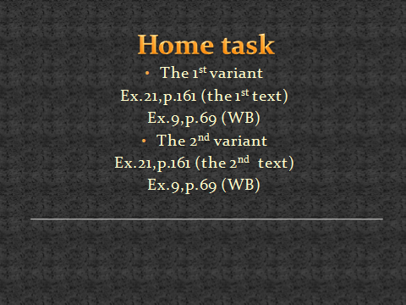

**Слайд 17.**

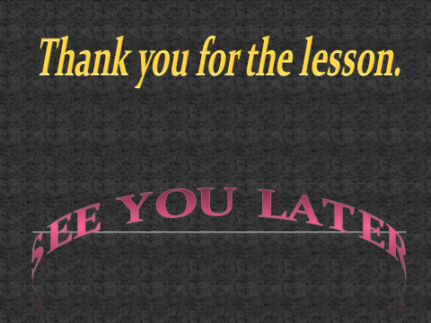

* You may go and have a rest.