**Сабақтың тақырыбы:Abai, a great Kazakh poet.**

**Сабақтың мақсаты:** Жаңа лексикалық сөздермен таныстыру,

Ұлы Абай поэзиясын қастерлеуге тәрбиелеу.

Оқушылардың мәдени, әдеби ой-өрісін дамыту,

шет тілдерді үйренуге қызығушылықтарын арттыру.

**Сабақ әдісі:** Презентация, түсіндірмелі- иллюстративтік;

**Сабақ типі:** Жаңа білімді меңгерту.

**Көрнекілігі:** Тақырыптық суреттер, слайдтар.

**Пән аралық байланыс:** Қазақ тілі, орыс тілі

***Сабақ барысы:***

***I.Ұйымдастыру****.*

Gоod morning pupils! What date is it today ? Тoday is …..

What day is it today? Who is on duty today? Who is absent today?

**II. *Сабақтың тақырыбымен, мақсаттарымен таныстыру.***

Brainstorming:

Look at this portrait! Do you know this person? Have you seen him before?

Yes, you are right. This is the great poet Abai Kunanbaev.

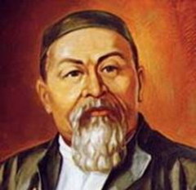 slide 1

*Today the theme of our lesson is “***Abai, a great Kazakh poet.***”.*

***ІІІ.Жаңа сабақ. Presentation.***

Abaі was born in the selo of Karauyl, in Abai District,East ; the son of Qunanbay and Uljan, Qunanbay's second wife, they named him Ibrahim, but because of his brightness, he soon was given the nickname "Abaі" (meaning "careful"), a name that stuck for the rest of his life.

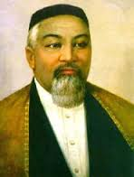 slide 2

His father's economic status enabled the boy to attend a Russian school in his youth, but only after he had already spent some years studying at a madrasah under Mullah  Ahmet Ryza.

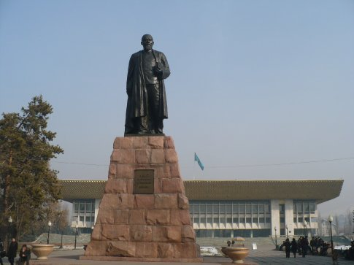 slide 3

A statue of Abai Kunanbaev, a famous Kazakh writer and poet, in front of the theatre.

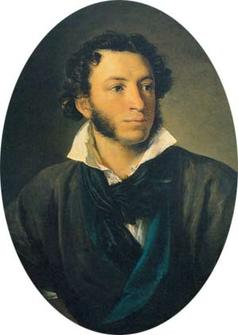 slide 4

[Alexander Pushkin](http://en.wikipedia.org/wiki/Alexander_Pushkin).

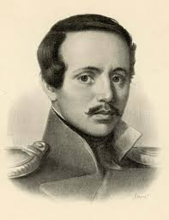 slide 5

[Mikhail Lermontov](http://en.wikipedia.org/wiki/Mikhail_Lermontov)

At his school in Semipalatinsk Abay encountered the writings of great Russian poets Alexander Pushkin  and  Mikhail Lermontov.

***IV.Оқулықпен жұмыс.***

1.Open your books on page 48, exercise 1. Read the sentences to know how to understand and use the words below.

2. Read the text about Abai and be ready to discuss it.

3.Questions for discussion:

- What is Abai Kunanbaev famous for?

- When and where was he born?

- Who were his parents?

- When did he go to school?

- What did he learn there?

- What impression did the Russian writers make on him?

- What poems written by Abai do you know?

- What makes Abai so very much popular with people all over the world?

***V.Пысықтау.***

1.Make up the following statement from Abai`s Book of Words putting the words in the right order:

***queen, language, of, the, word, the, of, sovereign, Poetry, is, the.***

The right answer: Poetry is the queen of language, the sovereign of the word.

2. Translate this statement into the Russian and Kazakh.

***VI. Бекіту.***

**Choose the correct number:**

1.Abai was born in ----

a) 1845

b) 1758

c) 1847

2.Abai went to school at the age of ---

a) 7

b) 9

c) 8

3.Abai died in 1904 at the age of ---

a) 45

b) 59

c) 84

**Combine the two sentences into one using ‘if’- clause:**

1.Abai entered the Russian school in Semei. He translated the works of Russian poets into Kazakh.

2.The Words of Abai are translated into many foreign languages. His poetry is very popular nowadays.

**Keys:**

1.If Abai didn`t enter the Russian school in Semei he wouldn`t translate the works of Russian poets into Kazakh.

2. The Words of Abai won`t be translated into many foreign languages if his poetry is not very popular nowadays.

***VII.Сабақты қорытындау, үйге тапсырма беру.***

Well done! Thank you for your active participations, for your excellent answers!

Home task is to write an Essay about the great Kazakh poet Abai Kunanbaev.