PLAN
Date: 17. 03. 2014
Class: 8
Unit: 5
Lesson: 2
Topic: Changing times, changing styles. «The London Museum»
Aim: Activization of the vocabulary on the topic
Objectives: By the end of the lesson students will be able to: use the vocabulary in describing the museum of London; to find information in the text; to practice dialogue speech and monologue speech; to work in groups, pairs; to respect the culture of other countries; to have cultural information about other countries.
Equipment: dictionaries, computer, projector, internet, hand outs, flashcards, costumes, sweets, map, badges.
Time | Stages | Patterns of interaction
3-5  2  5  5  3  5-7  2 | Slide 1 (divide into two groups by sweets)  Hello! How are you? Are you OK?  At the beginning of our lesson I want to switch on the video, try to guess the topic of the lesson. (slide 2) - You are right! We will talk about the museum of London.  What are your own aims on the topic? (bd)  We are going to travel to Britain. What’s the capital of Great Britain?  Where is London? (We pronounce a) Show it at the map, please.  What sights in London do you know? (museum)  There are museums in all big cities.  We are to talk about Madam Tussaud’s museum (slide 3).  Answer the questions on the museum, please. (slide 4- answers bd)  - Who are the figures of Madam Tussaud's museum?  - Where in London is it situated?  - When it was opened?  - How many figures are in the museum?  - Can the characters talk?  - What’s the price of a ticket to the museum?  - What is “animatronics”?  Read the text and find answers in your groups. Fill in the table. Each of you is responsible for definite question (cards of numbers). You will have 5 minutes.  1. Who are the figures of Madam Tussaud's museum? 2. Where in London is it situated? 3. When it was opened? 4. How many figures are in the museum? 5. Can the characters talk? 6. What’s the price of a ticket to the museum? 7 What is “animatronics”?  (cut )  You may use dictionaries, Google translator.  Madam Tussaud's  Madam Tussaud's is the most popular wax (воск) museum in the world. It was opened in eighteen thirty five. There are more than thousand wax models of the famous and infamous, both living and dead, from every walk of life.  Elvis Presley, the Beatles, Marilyn Monro, Michael Jackson, Lady Gaga, Charlie Chaplin, the British Royal family (Kate Middleton, Prince William, Elizabeth II), Bill Clinton, Barak Obama... There is no other place where you can see all famous people at once, even if they are only wax figures.  The museum is situated in Marylebone Road, not far from the street which is famous as the home of the first great detective in fiction, Conan Doyle's Sherlock Holmes.  There's usually a long queue (очередь) in front of the museum. No wonder! Many tourists would consider their trip to London worthless if they didn't visit the famous Madam Tussaud's. There are several halls at Madam Tussaud's. Highlights include the Grand Hall, the Chamber of Horrors and "The Spirit of London" exhibition.  The wax figures are standing and sitting, and sometimes even moving and talking. They are extremely realistic and when they look at you, their eyes sparkling (сверкают), you often feel uncomfortable in their company. Computer controlled figures (they are called audio animatronics) are especially popular with the visitors. The price of tickets is from twenty five till forty pounds.  New models are being produced all the time while the old ones are quietly removed from display. Over the years hundreds of famous persons have made their way to Madame Tussaud's studio. Most people agree to be portrayed, but some refuse. Mother Teresa was one of the few who declined, saying her work was important, not her person.  Find a person with the same question and discuss together. Study each other.  Check up your answers. (slide 5). Pronounce the answers.  Return to your groups. Prepare the describing the Madam Tussaud’s museum, using the plan. (slide 6), 2 cards:  - Madam Tussaud's is …  - It was …  - There are …  - We can see …  - The museum is …  - The figures …  - …  Listen to another group and find the mistakes. If you notice the mistake, take a card (hare) to yourselves (you may write on the card the mistake. (Red) Yellow-mistake  Appreciate another’s group work. Cards.  Your homework is to write about a museum, 12 cards.  What about your aims? (bd)  (Slide 7) Choose “dollar” - your attitude to the lesson. 100- it was comfortable and understandable at the lesson, 50 –sometimes difficult, but understandable, 0-it was difficult and not understandable.  Would you like to visit the Madam Tussaud’s Museum?  I have a surprise for you. Shut your eyes, please. You may take photos near the figures.  Thank you for your work. Good bye. (slide 8) | T-Cl  Ps-T  T-Cl  Ps-T  Gr. w.  P1-p2  Pair1-pair2-pair3  Gr.w  Gs-T  Ps-T  T-cl
Answer the questions:
Who are the figures of Madam Tussaud's museum?
Where in London is it situated?
When it was opened?
How many figures are in the museum?
Can the characters talk?
What’s the price of a ticket to the museum?
What is “animatronics”?
Fill in the table:
1. Who are the figures of Madam Tussaud's museum? | 2. Where in London is it situated? | 3. When it was opened? | 4. How many figures are in the museum? | 5. Can the characters talk? | 6. What’s the price of a ticket to the museum? | - What is  “animatronics”?

Fill in the table:
1. Who are the figures of Madam Tussaud's museum? | 2. Where in London is it situated? | 3. When it was opened? | 4. How many figures are in the museum? | 5. Can the characters talk? | 6. What’s the price of a ticket to the museum? | - What is  “animatronics”?

Madam Tussaud's
Madam Tussaud's is the most popular wax (воск) museum in the world. It was opened in eighteen thirty five. There are more than thousand wax models of the famous and infamous, both living and dead, from every walk of life.
Elvis Presley, the Beatles, Marilyn Monro, Michael Jackson, Lady Gaga, Charlie Chaplin, the British Royal family (Kate Middleton, Prince William, Elizabeth 2), Bill Clinton, Barak Obama... There is no other place where you can see all famous people at once, even if they are only wax figures.
The museum is situated in Marylebone Road, not far from the street which is famous as the home of the first great detective in fiction, Conan Doyle's Sherlock Holmes.
There's usually a long queue (очередь) in front of the museum. No wonder! Many tourists would consider their trip to London worthless if they didn't visit the famous Madam Tussaud's. There are several halls at Madam Tussaud's. Highlights include the Grand Hall, the Chamber of Horrors and "The Spirit of London" exhibition.
The wax figures are standing and sitting, and sometimes even moving and talking. They are extremely realistic and when they look at you, their eyes sparkling (сверкают), you often feel uncomfortable in their company. Computer controlled figures (they are called audio animatronics) are especially popular with the visitors. The price of tickets is from twenty five till forty pounds.
New models are being produced all the time while the old ones are quietly removed from display. Over the years hundreds of famous persons have made their way to Madame Tussaud's studio. Most people agree to be portrayed, but some refuse. Mother Teresa was one of the few who declined, saying her work was important, not her person.

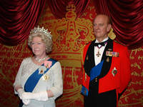

Describe Madam Tussaud’s museum, using the plan:

Madam Tussaud's is …

It was …

There are …

We can see …

The museum is …

The figures …

…

1 | 2 | 3
4 | 5 | 6
7

1 | 2 | 3
4 | 5 | 6
7

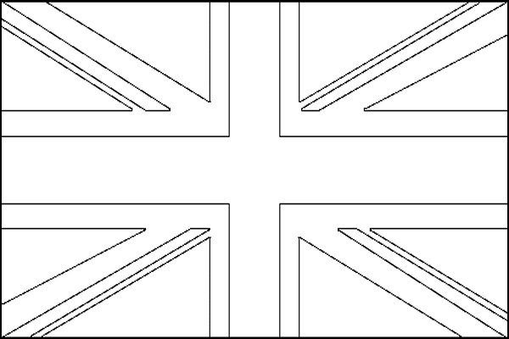 | Julia
Semen | Nastya
Alexandra | Vanya
Natasha | Karina
Nastya | Alex
Olga | Nastya
Stas | Roma
Dasha | Regina
Nikita | Ira
Julia S.

Describe the museum:
Madam Tussaud's is …
It was …
There are …
We can see …
The museum is …
The figures …
…
Describe the museum:
Madam Tussaud's is …
It was …
There are …
We can see …
The museum is …
The figures …
…
Describe the museum:
Madam Tussaud's is …
It was …
There are …
We can see …
The museum is …
The figures …
…
Describe the museum:
Madam Tussaud's is …
It was …
There are …
We can see …
The museum is …
The figures …
Describe the museum:
Madam Tussaud's is …
It was …
There are …
We can see …
The museum is …
The figures …
…
Describe the museum:
Madam Tussaud's is …
It was …
There are …
We can see …
The museum is …
The figures …
…
Describe the museum:
Madam Tussaud's is …
It was …
There are …
We can see …
The museum is …
The figures …
…
Describe the museum:
Madam Tussaud's is …
It was …
There are …
We can see …
The museum is …
The figures …

