Group 1.
Task 1.
1. C-11- _________________________
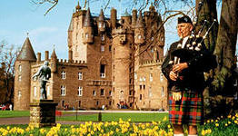
2. M-8- _________________________
3. B-4- __________________________
4. T-5- __________________________
5. D-8-__________________________
6. M-6- _________________________
7. S-5- __________________________
8. P-10-_________________________
9. G-5- __________________________
10. S-6- _________________________

Task 2. Fill in the text missing information.
Scotland is a country in the _____________ ________________ to the North of England. Its symbol is a ________________, its patron is ________________. The country is divided into _____________ and ______________. Most of the _____________ is concentrated in Lowlands, in the _________ Valley. ______________ is the largest and busiest town, _______________ is its capital. Glasgow and Edinburgh are the two greatest centers of______________. There is only ______ _________ between them.
Task 3. Make a dialogue about Scotland.

Group 2.
Task 1.
1. C-11- _________________________
2. M-8- _________________________
3. B-4- __________________________
4. T-5- __________________________
5. D-8-__________________________
6. M-6- _________________________
7. S-5- __________________________
8. P-10-_________________________
9. G-5- __________________________
10. S-6- _________________________
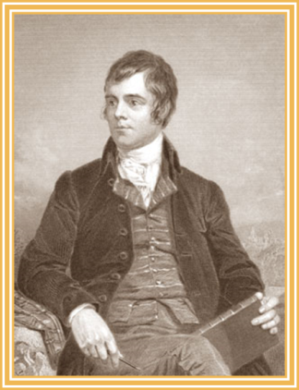

Task 2. Fill in the text missing information.
folk songs, Scotland, national poet, Burns' Night, Robert Burns, Scottish language.

_____________ is the greatest Scottish poet Robert Burns was a poet and a lyricist.
He is widely regarded as the ____________ ________ of ____________, and is the best-known of the poets who have written in the ____________ ____________, although much of his writing is also in English. Burns also collected _________ __________ from across Scotland, often revising or adapting them. ___________ ____________ is celebrated on 25 January with Burns' Suppers around the world.

Task 3. Make a dialogue about Scotland.

