Group 1.
Task 1.
1. C-11- _________________________
2. M-8- _________________________
3. B-4- __________________________
4. T-5- __________________________
5. D-8-__________________________
6. M-6- _________________________
7. S-5- __________________________
8. P-10-_________________________
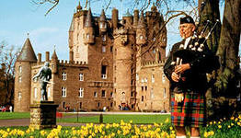
9. G-5- __________________________
10. S-6- _________________________

Task 2. Fill in the text missing information.
Scotland is a country in the _____________ ________________ to the North of England. Its symbol is a ________________, its patron is ________________. The country is divided into _____________ and ______________. Most of the _____________ is concentrated in Lowlands, in the _________ Valley. ______________ is the largest and busiest town, _______________ is its capital. Glasgow and Edinburgh are the two greatest centers of______________. There is only ______ _________ between them.
Task 3. Make a dialogue about Scotland.

Group 3.
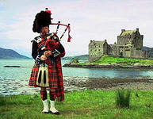
Task 1.
1. C-11- _________________________
2. M-8- _________________________
3. B-4- __________________________
4. T-5- __________________________
5. D-8-__________________________
6. M-6- _________________________
7. S-5- __________________________
8. P-10-_________________________
9. G-5- __________________________
10. S-6- _________________________

Task 2. Fill in the text missing information.

The climate in Scotland is __________ and ___________ in the west and a little __________ in the east. The Highlands have heavy _____________. The common British trees such as _______, ________ and ___________. Silver birches grow in the _______________, while in the drier east grows the _________ ______.
In the Highlands are _______ _______, and the ________ _________and _________ ____________, two of the rarest animals in great Britain. Many ___________ are found in the coast.

Task 3. Make a dialogue about Scotland.

