
Are you expert of the Olympic games?

1. How often do the Olympic Games take place?
a) every year
b) every two years
c) every four years

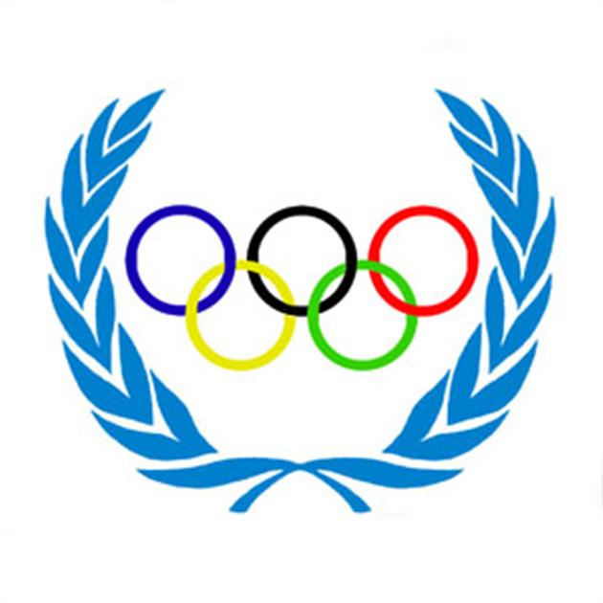
2. Where and when were the first Modern Olympic Games held?
a) in 1890, Paris
b) in 1896, Athens
c) in 2000, Athens

3. Where did the Olympic Games 2010 take place?
a) Bejing, China
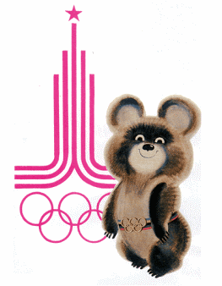
b) London, Great Britain
c) Vancouver, Canada

4. What Russian city hosted 1980 Olympics?
a) Moscow
b) St. Petersburg
c) Sochi

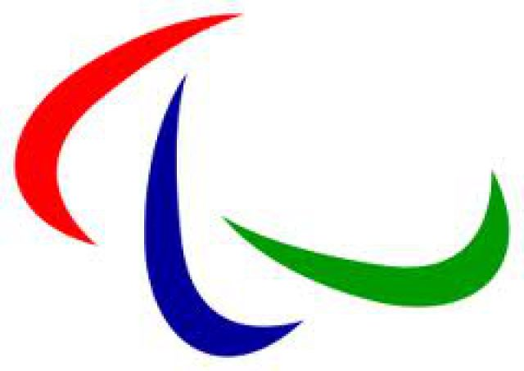
5. Paralympic games are the games for...
a) children under fifteen
b) sportsmen with disability
c) olympic champions

6. What continent has never hosted the Olympics?
a) Africa
b) Australia
c) South America

7. What country is the Motherland of bobsleighing?
a) America

b) England
c) Australia

8. What city will host the winter Olympic Games 2018?
a) Pyeongchang, China
b) Pyeongchang, South Korea
c) Youngpyong, South Korea

9. What city will host the summer Olympic Games 2016?
a) Tokyo, Japan
b) Rio de Janeiro, Brazil
c) Athens, Greece

