FRIENDS.
“Joey learning French.”

Before you watch.
- Answer these questions.
- Who usually has an audition?
- What should an actor have to get a good part in?
- Should people lie on their resume?

- Try this.
- According to 1) job
- Have 2) riding
- Sounds 3) simple
- Good 4) an audition
- Feel 5) same to me
- Regional 6) my resume
- Horseback 7) badly
- Pretty 8) dialect

1____3.____4.____5.____6.____7.____8.____

While you watch.

- Watch I, II, III, IV, V sequences and give short answers to these questions.
- Does Joey need to speak French?______________________
- Does Joey speak fluent French?_______________________
- Who tried to taught him French?______________________
- Was Joey pretty good?____________________
- Can he really speak French?_________________

- Correct yourself ex.2.
1____3.____4.____5.____6.____7.____8.____

- Watch VI, VII sequences and try to translate these phrases.
- Regional dialect __________________________________
- Retarded ________________________________________
- Good job! _______________________________________
- Buddy __________________________________________
- Great ___________________________________________
- Tap dance _______________________________________
- Drink a gallon of milk _____________________________

After you watch.
1. Match these words for the characters.

INPATIENT RETARDED FLUENT FRENCH AWFUL FRENCH

2. Number the sequences in the order in which you see them.

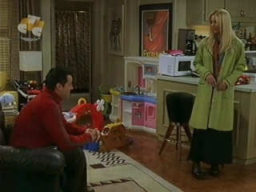

Your homework.

- Translate all the phrases ex.2, p.1 into Russian in written form.
- Give a short summary of the story.

