Сценарий литературной гостиной
Good afternoon ladies and gentlemen. We are glad to see all of you here. Today we are going to talk about the greatest writers and poets of the foreign literature. A book is one of the greatest wonders of the world. It gives us opportunity to imagine the future, to look into the past. Literature helps us feel the beauty of the language, understand different countries and their mentality.
Poetry is one of the oldest flowers of this world. Poetry stretches the imagination in a way that no other art form can. It can move human mind through emotions easily and fast.

1) So we shall start our meeting with the greatest poems of English writers.
Kipling was one of the most popular writers in England, in both prose and verse. Irina Bikova and Gena Chumachenko will perform a poem by Rudyard Kipling "If".
If by Rudyard Kipling
If you can keep your head when all about you
Are losing theirs and blaming it on you;
If you can trust yourself when all men doubt [da4t] you,
But make allowance [q'laVqns] for their doubting too;
If you can wait and not be tired by waiting,
Or, being lied about, don't deal in lies,
Or, being hated, don't give way to hating,
And yet don't look too good, nor talk too wise;
If you can dream - and not make dreams your master;
If you can think - and not make thoughts your aim;
If you can meet with triumph and disaster
And treat those two imposters [Im'pPstqs] just the same;
If you can bear to hear the truth you've spoken
Twisted by knaves to make a trap for fools,
Or watch the things you gave your life to broken,
And stoop [stu:p] and build 'em up with wornout tools;
If you can make one heap [hi:p] of all your winnings
And risk it on one turn of pitch-and-toss,
And lose, and start again at your beginnings
And never breath a word about your loss;
If you can force your heart and nerve and sinew ['sInju:]
To serve your turn long after they are gone,
And so hold on when there is nothing in you
Except the Will which says to them: "Hold on";
If you can talk with crowds and keep your virtue ['vE:tSu:],
Or walk with kings - nor lose the common touch;
If neither foes [fqVz] nor loving friends can hurt you;
If all men count with you, but none too much;
If you can fill the unforgiving minute
With sixty seconds' worth of distance run -
Yours is the Earth and everything that's in it,
And - which is more - you'll be a Man my son!

Kristina Atamanova will tell us another poem by Rudyard Kipling, called "Six serving man".
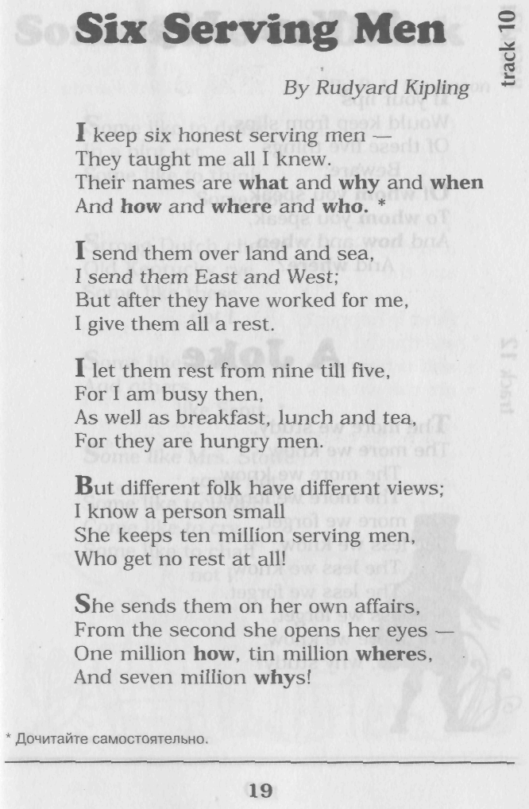
She walks in beauty, like the night
Of cloudless climes and starry skies;
And all that's best of dark and bright
Meet in her aspect and her eyes:
Thus mellow'd to that tender light
Which heaven to gaudy day denies.
One shade the more, one ray the less,
Had half impair'd the nameless grace
Which waves in every raven tress,
Or softly lightens o'er her face;
Where thoughts serenely sweet express
How pure, how dear their dwelling-place.
And on that cheek, and o'er that brow,
So soft, so calm, yet eloquent,
The smiles that win. the tints that glow,
But tell of days in goodness spent,
A mind at peace with all below,
A heart whose love is innocence!
Is not it a perfect poem.
Lord Byron was an English poet and a leading figure in the Romantic movement.
Alexandra Roschkowa recite a poem by Lord Byron "It is the Hour"
It is the hour when from the boughs
The nightingale's high note is heard;
It is the hour -- when lover's vows
Seem sweet in every whisper'd word;
And gentle winds and waters near,
Make music to the lonely ear.
Each flower the dews have lightly wet,
And in the sky the stars are met,
And on the wave is deeper blue,
And on the leaf a browner hue,
And in the Heaven that clear obscure
So softly dark, and darkly pure,
That follows the decline of day
As twilight melts beneath the moon away.

William Shakespeare is often called England's national poet and the "Bard of Avon". Valera Ulanow will tell us the 18th Sonnet. The floor is yours.
Shall I compare thee to a summer's day?
Thou art more lovely and more temperate:
Rough winds do shake the darling buds of May,
And summer's lease hath all too short a date;
Sometime too hot the eye of heaven shines,
And often is his gold complexion dimmed;
And every fair from fair sometime declines,
By chance or nature's changing course untrimmed:
But thy eternal summer shall not fade,
Nor lose possession of that fair thou ow'st,
Nor shall Death brag thou wand'rest in his shade,
When in eternal lines to time thou grow'st.
So long as men can breathe or eyes can see,
So long lives this, and this gives life to thee.

2) And now let's move to Mark Twain. He is most noted for his novel The Adventures of Tom Sawyer and its sequel, Adventures of Huckleberry Finn. We will see an abstract from Tom Sawyer. So you are welcome.

And now let's plunge into Spanish Literature. The Spanish language is one of the most beautiful and passionate languages in the world. Federico García Lorca was a Spanish poet, dramatist and theatre director. The language of his poetry is wonderful.

3) What is a youth?
Impetuous fire.
What is a maid?
Ice and desire.
The world wags on
A rose will bloom,
It then will fade
So does a youth.
So does the fairest maid.

How beautiful and how sad the story of Romeo and Juliet is.
Please welcome Daria Ignateva and Leonid Mayorov. An abstract from Romeo and Juliet. The balcony scene.

4) Und nun die Deutsche Sprache.
Johann Wolfgang von Goethe ist der gröβte deutsche Dichter. Wir kennen Goethe als Schöpfer vieler poetischer, prosaischer und wissenschaftlicher Schriften.

Gefunden
Ich ging im Walde
So für mich hin,
Und nichts zu suchen,
Das war mein Sinn.

Im Schatten sah ich
Ein Blümchen stehen,
Wie Sterne leuchtend,
Wie Äuglein schön.

Ich wollt’ es brechen,
Da sagt’ es fein:
Soll ich zum Welken,
Gebrochen sein?

Ich grub’s mit allen
Den Würzeln aus,
Zum Garten trug ich’s
Am hübschen Haus.

Und pflanzt’ es wieder
Am stillen Ort;
Nun zweigt’ es immer
Und blüht’ so fort.

5) And now Robert Burns . He is widely regarded as the national poet of Scotland and is celebrated worldwide.

6) Miguel de Cervantes Saavedra was a Spanish novelist, poet, and playwright. His magnum opus, Don Quixote, considered to be the first modern European novel, is a classic of Western literature, and is regarded amongst the best works of fiction ever written.

7) Thomas Stearns Eliot was a publisher, playwright, literary and social critic and one of the most important English-language poet of the 20th century". The Naming of Cats is probably one of the most well-known poems. So welcome our cats.

The naming of Cats.

The naming of cats is a difficult matter ['mxtq],
It isn’t just one of your holiday games
You may think at first I’m as mad as a hatter ['h1tq]
When I tell you a cat must have three different names.

First of all, there’s the name that the family use daily
Such as Peter ['pi:tq], Augustus ['O:gAstqs], Alonzo or James,
Such as Victor or Jonathan ['dZPnqT(q)n], George or Bill Bailey ['beIlI] –
All of them sensible, everyday names.

There are fancier ['fxnsIq] names if you think they sound sweeter
Some for the gentlemen, some for the dames [deImz]
Such as Plato ['pleItq4], Admetus[xd'mItqs], Electra [I'lektrq], Demeter [di:'mi:tq] –
But all of them sensible, everyday names.

But I tell you a cat needs a name that’s particular
A name that’s peculiar, and more dignified ['dIgnIfaId]
Else how can he keep up his tale perpendicular ["p3:pFn'dIkj4lq]
Or spread out his whiskers ['wIskqz], or cherish ['tSerIS] his pride?

Of names of this kind, I can give you a quorum ['kwO:rqm]
Such as Munkustrap['mAnkq"strep], Quaxo['kwxksqu], or Coricopat ['kOrIkq"pet],
Such as Bombalurina['bOm"bxlq'ri:nq], or else Jellylorum['GelIlorqqm] –
Names that never belong to more than one cat.

But above and beyond there’s still one name left over
And that is the name that you never will guess;
The name that no human research [rI'sq:tS] can discover
But the cat himself knows, and will never confess.

When you notice a cat in profound [prq'fa4nd] meditation ['medI'teIS(q)n]
The reason, I tell you, is always the same:
His mind is engaged in a rapt [r1pt] contemplation ["kPntqm'pleIS(q)n]
Of the thought [TO:t], of the thought, of the thought of his name.
His ineffable [In'efqb(q)l], effable ['efqb(q)l], effanineffable
Deep and inscrutable [In'skru:tqb(q)l] singular name.

