Healthy Living Guide
The greatest is . Some care about their , others don’t. can have good and bad habits. 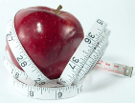 , eating wholemeal 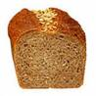, , eating low fat food is good for your . Physical inactivity, eating 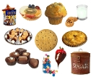, , , are bad habits. It’s very important to care about your . Of course, too much or too little, snacking and skipping , make you unhealthy too. 7 or 8 hours, getting up early, eating , a healthy is really good for your . Many in GB and Russia think more about their . They attend fitness clubs, eat more and . Some of them count they eat every day. Some bad habits are really deadly. causes a . It makes your 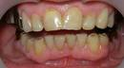 yellow, 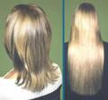 and clothes smell. causes a , 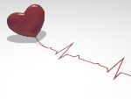disease and slow reactions. It also makes your speech unclear. As for , it causes 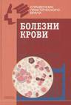, cancer and loss of memory. A lot of measures are taken against bad habits. You can be put into for , and sacked from for and . is banned in , on the underground and in and ads. Bad habits affect the whole family, around you, your knowledge and your social controls. If you want to be healthy some English proverbs саn help you: «Early to 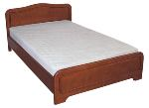 and early to rise, keeps a man healthy, wealthy and wise», «An a day keeps a away », «Good friends are good for your », «A merry is a good medicine».

