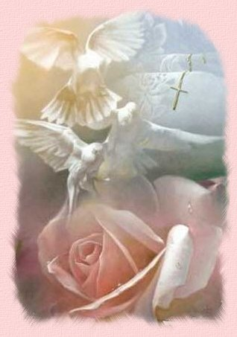  Peace is our gift to each other. | Peace is not just the absence of war...Like a cathedral, peace must be constructed patiently and with unshakable faith.
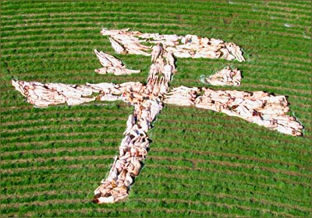  Peace is not the absence of conflict but the presence  of creative alternatives  for responding to conflict -- alternatives to passive  or aggressive responses, alternatives to violence. | 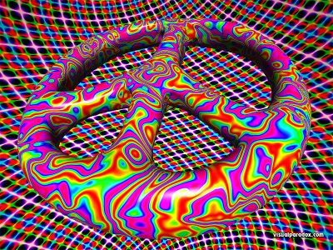  Peace is not merely a distant goal that we seek,  but a means by which we arrive at that goal.

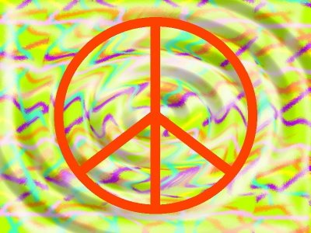  Peace is envisioning a solution to the unsolvable. It means thinking the unthinkable, that we might just call a halt, yesterday to war. | 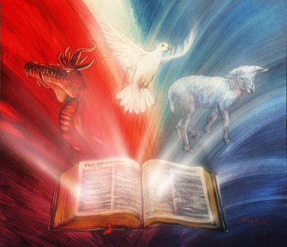  Five enemies of peace inhabit with us - avarice, ambition, envy, anger,  and pride; if these were to be banished, we should infallibly enjoy  perpetual peace.
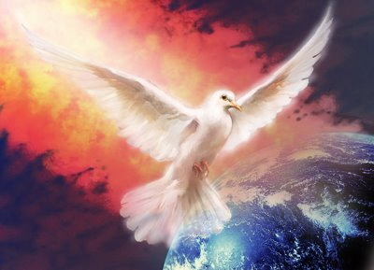  Living the truth in your heart without compromise brings kindness into the world. Attempts at kindness that compromise your heart cause only sadness. | 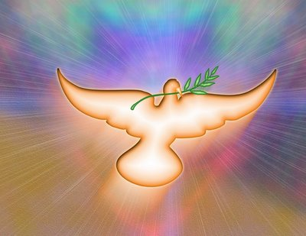  Peace must begin within self before there can come action or self application in a way to bring peace - even in thine own household, in thine own vicinity,  in thine own state or nation.

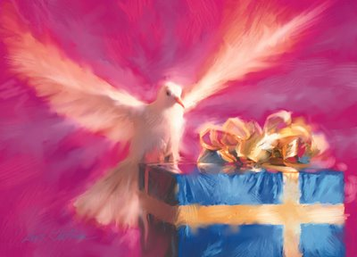  Peace, like charity, begins at home. | 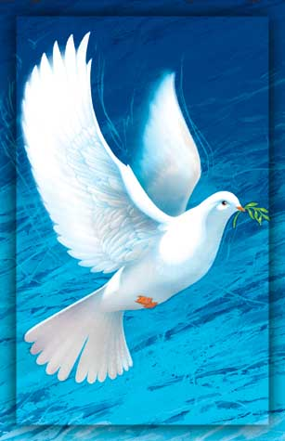  Only when peace lives in each of us, will it live outside of us.  We must be like wombs for a new harmony. When it is small, peace is fragile. Like a baby, it needs nurturing attention.  We must protect peace from violence and perversion if it is to grow.
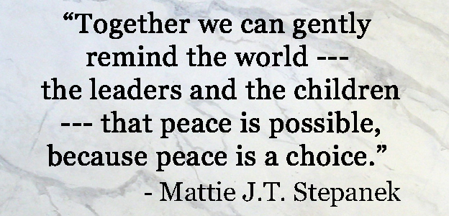 | 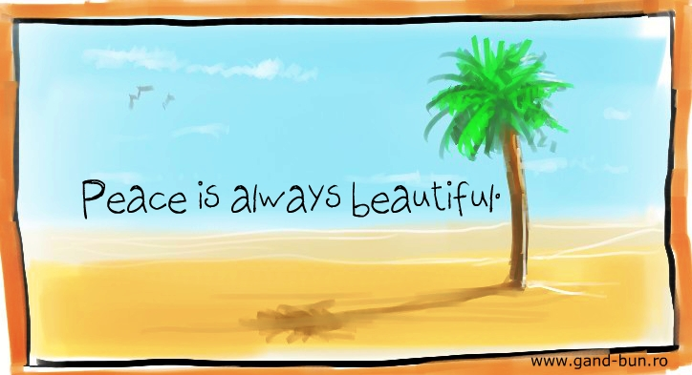

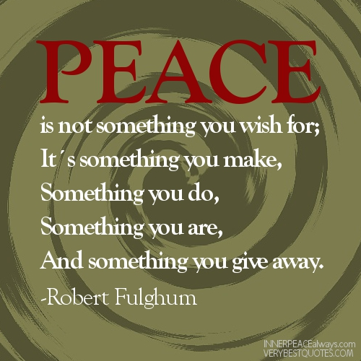 | 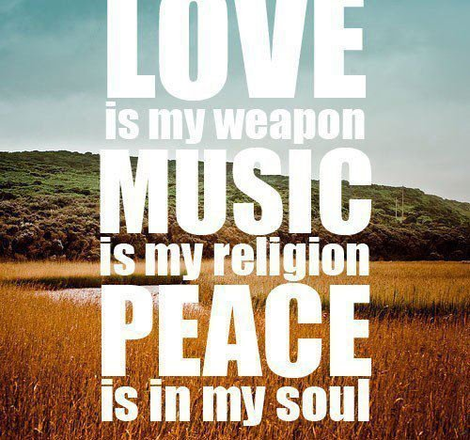
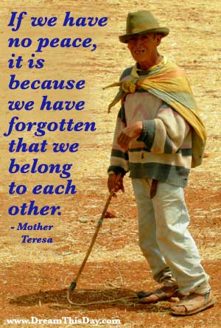 | 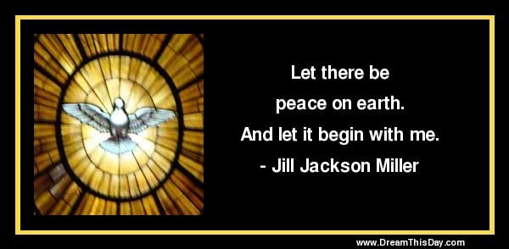

If we have no peace, it is because we have forgotten that we belong to each other.  Mother Teresa  There was never a good war or a bad peace.  Benjamin Franklin  Imagine all the people  Living life in peace.  You may say I'm a dreamer,  But I'm not the only one.  I hope someday you'll join us,  And the world will be as one.  John Lennon  I greet you all in the name of peace, democracy and freedom for all! I stand here before you not as a prophet but as a humble servant of you, the people. Your tireless and heroic sacrifices have made it possible for me to be here today. I therefore place the remaining years of my life in your hands.  Nelson Mandela  There is no way to peace. Peace is the way.  A.J. Muste  War makes good history but peace is poor reading.  Thomas Hardy  I prefer the most unfair peace to the most righteous war.  Cicero  If humanity is to progress, Gandhi is inescapable. he lived, thought, and acted, inspired by the vision of humanity evolving toward a world of peace and harmony. We may ignore him at our own risk.  Martin Luther King, Jr.  Peace be with you.  The Bible  All who affirm the use of violence admit it is only a means to achieve justice and peace. But peace and justice are nonviolence...the final end of history. Those who abandon nonviolence have no sense of history. Rathy they are bypassing history, freezing history, betraying history.  André Trocmе  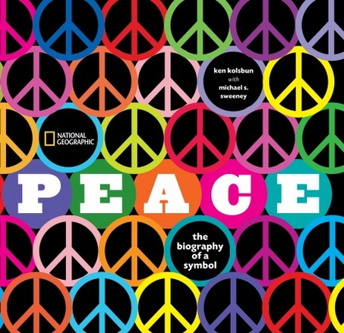 | All we are saying is give peace a chance...  John Lennon  Glory to God in the highest, and on earth peace, good will toward men.  Bible  Luke 2. 14  If the human race wishes to have a prolonged and indefinite period of material prosperity, they have only got to behave in a peaceful and helpful way toward one another.  Winston Churchill  If we wish to create a lasting peace we must begin with the children.  Mahatma Gandhi  Peace will not come out of a clash of arms but out of justice lived and done by unarmed nations in the face of odds.  Mahatma Gandhi  Peace is not only better than war, but infinitely more arduous.  George Bernard Shaw  I like to believe that people in the long run are going to do more to promote peace than our governments. Indeed, I think that people want peace so much that one of these days governments had better get out of the way and let them have it.  Dwight D. Eisenhower  And I shall have some peace there, for peace comes dropping slow,  Dropping from the veils of the morning to where the cricket sings;  There midnight's all a glimmer, and noon a purple glow,  And evening full of the linnet's wings.  William Butler Yeats  If we are to teach real peace in this world, and if we are to carry on a real war against war, we shall have to begin with the children.  Mahatma Gandhi  In peace sons bury fathers, but war violates the order of nature, and fathers bury sons.  Herodotus  The collection of  QUOTATIONS  ABOUT  PEACE  

