The Product of the Project

1.Introduction …………………………………………………………….3

2.The main part

2.1.Olive branches. ……………………………………………………………… … .…..7
2.2. The Ankh Cross………………………………………………………………………8

2.3. V-Sign………………………………………………………………………………...9
2.4. BloodStones………………………………………………………………………….10

2.5. Peace Pipe……………………………………………………………………………11

2.6. Banner of Peace and the CND Symbol……………………………………………....12

2.7. Dove………………………………………………………………………………….13

2.8. Colour………………………………………………………………………………...15

2.9. Rainbow…………………………………………………………………………. ….16
3.Conclusion…………………………………………………...…………...19

Appendix

References………………………………………………………...30

1.Introduction.
SINCE THE END of the Second World War in 1945 there have been some 250 major wars in which over 50 million people have been killed, tens of millions made homeless, and countless millions injured and bereaved.
In the history of warfare the twentieth century stands out as the bloodiest and most brutal - three times more people have been killed in wars in the last ninety years than in all the previous five hundred.

Recent evolution in the number of violent conflicts, by type of conflict.
(including inter-state wars, intra-state wars (civil wars) and colonial wars )
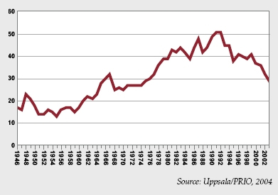

Nowhere to hide……..
No part of the world has escaped the scourge of war. There is nowhere that modern weapons or armies cannot reach. Anywhere in the world you can find people who will use guns to get their own way. From under the ocean a missile can fly out beyond the atmosphere and come down to destroy a city on the other side of the world; while a tiny butterfly-like object (an anti-personnel mine) can blow up the child who picks it up thinking it's a toy.
The destructive power of weapons has grown enormously during the twentieth century. Unfortunately, people's ability to resolve conflict has not made the same strides.
Expenditure on defense has also grown steadily. But despite this massive increase most people don't feel much more secure. Wars have not brought peace. The desire to invent ever more effective weapons to defend or deter has absorbed an ever-growing amount of money; but it's done nothing to prevent war. What has happened is that weapons are indeed more expensive and more destructive; but resources for the things that people really need (such as an adequate health service in Britain, or easy access to clean water in many parts of the Third World) have been reduced. In some parts of the world military expenditure has itself become the source of conflict: scarce resources are used to buy weapons and maintain the armed forces while much of the population lives in appalling poverty.
The nature of warfare has also changed. From the set-piece battles of the earlier centuries, the blood and mud of the trenches in the First World War, and the fast-moving mechanized battlefields of World War Two, to the high-tech 'surgical' computer-guided action in Iraq and Kuwait, war as seen through our television screens appears to have become a well-ordered, almost bloodless, affair.
Nothing could be further from the truth.
During the twentieth century the proportion of civilian casualties has risen steadily. In World War Two two-thirds of those killed were civilians; by the beginning of the 1990s civilian deaths approached a horrifying 90 per cent. This is partly the result of technological developments, but there is another major reason.
Many modern armed conflicts are not between states but within them: struggles between soldiers and civilians, or between competing civilian groups. Such conflicts are likely to be fought out in country villages and urban streets. In such wars, the 'enemy' camp is everywhere, and the distinctions between combatant and non-combatant melt away into the fear, suspicion and confusion of civilian life under fire.
Many contemporary struggles are between different ethnic groups in the same country or in former States. When ethnic loyalties rule, other moral codes are often abandoned. It becomes horribly easy to proceed from neighborhood hostility to 'ethnic cleansing' and genocide. After that, killing adults is not enough; future generations of 'the enemy ' - their children - must also be eliminated. Women and children are then not just caught in the crossfire, they become targets as well. As one political commentator put it (in a 1994 broadcast before violence erupted in Rwanda), 'To kill the big rats, you have to kill the little rats.'
Behind many of today's armed conflicts lies a long history of wars which ended, maybe, with winners and losers, but rarely with solutions to the problems which caused war in the first place. (The wars in former Yugoslavia, and in the territories that used to be part of the Soviet Union, are obvious examples.)
Why war?
Wars don't happen by accident. To wage war, you need weapons, many of which take a lot of time, money and people to produce. Weapons make people feel more important and powerful (and more dangerous). Many political and military leaders therefore feel they must have the most powerful weapons possible.
Furthermore, the military are often dissatisfied with what weapons they have. They want something 'better', and certainly better than the weapons the 'other side' has. To get money from government to upgrade their weapon resources, military representatives may exaggerate the 'strength' of a potential 'enemy'. Without a threat, after all, there is no real justification for having big, expensive weapons; so sometimes a 'threat' will be imagined or invented.
This competitive upward spiral, as one side tries to outdo the other in ever more destructive weapons, is called 'the arms race'. The armed forces, politicians, industry and workers become entwined in what an American President called 'the military industrial complex'. Armed forces get the fighting equipment they want; politicians gain prestige (punching above one's strength, as a recent Foreign Minister described it); companies and shareholders make a lot of money; and there are jobs for hundreds of thousands of people.
Wars don't happen by accident. As well as weapons, wars need people who are prepared to use them: to kill, and to be killed. Certainly there are people who don't need persuading. But more often people fight because it's what they're paid to do: they work for the armed services or as mercenaries. Certainly there are people who, however reluctantly, choose to go to war because they believe it's the right thing to do. (Unfortunately, sometimes they believe it's the only thing to do). But more often people are forced - 'conscripted' - into the armed services by their government, and have no choice in the matter.
In fact, organized war is not a natural activity. One commentator described it as 'a highly planned and co-operative form of theft and murder, which began over ten thousand years ago when those who learned to grow wheat and save the surplus were robbed by nomads of the things they could not provide themselves.' Men began to use spears to kill people as well as animals: the arms race was already under way. Ten thousand years ago people may not have known what else to do; today we don't have that excuse.
All in a day's work.
Since the beginning of history people have got angry, had disagreements and punch-ups, and even killed each other. This we have in common with a few other animal species. But it's very different from war.
War is an activity that needs preparation, organization, planning and calculation, like farming, or education, or building. It has little to do with aggressive moods or eruptions of anger. There is no baring of teeth in the chemical weapons laboratory. Designing a nuclear bomb that can kill millions of people is a long-term project, requiring skill, imagination, quiet concentration, and a lot of taxpayers' money. The hundreds of thousands of people employed in armaments factories in Britain alone don't go to work in the morning red with fury and ready to slay 'the enemy'. Most of them are loving parents who take care of their children, seldom considering that the weapons they help to make might one day kill some other parent's children somewhere else.
Murder, the world over, is a crime punishable by long prison sentences (in some countries by execution). Yet hundreds of thousands of people in the world's armed forces are trained to murder - and murder people they do not even know. Whatever words we use to disguise the fact, war is essentially about murder. To drop bombs on a city, for example, is to murder ordinary citizens, many of them children; the pilot has no personal quarrel with them, but drops the bomb in the name of war - and thereby commits a mass murder
But 'murder' is not a word used when talking about war. That would clearly make war a bad thing - something we should avoid at all cost, ready to lock up anyone who tries it. You can see the problem - 'British soldiers murder 150 Iraqi women and children in liberation of Kuwait' would make a very unusual headline in the daily paper. War transforms murder not only into something acceptable but highly commendable, for which, if you survive, you may receive praise, promotion, and even a medal.
What about peace, then?
Rest in peace is carved on tens of thousands of gravestones up and down the country. People ask to be left in peace and insurance salesmen guarantee us peace of mind. The police attempt to keep the peace; there are peacekeeping forces dotted about the world in blue helmets, surrounded by the horrors of war. People on demonstrations demand peace now and peace with justice; some are accused of disturbing the peace. Some search for inner peace while others insist on peace with honour. The Americans have named a nuclear weapon the Peacekeeper, and the US airforce proudly boasts that Peace is our profession. 'Give peace a chance' goes the song widely adopted by the peace movement; but it's probably not sung during a peace process which is rarely a peaceful activity. Over sixty years ago, people began to take a pledge for peace - there were hundreds of thousands of them, and today the organization those people formed has produced this information sheet. Yet, despite the fact that everyone appears to want peace, it is still in short supply. (It has been calculated that between 3600 BC and today there have been only 292 years of peace; that there have been over 14,500 major wars in which close to 4 billion people have perished. The war dead thus come close to equalling the total population of the world today.)
We can begin to see from the wide and varied use of the word that the nature of peace isn't simple. The truth is that peace needs all the planning, dedication, organization and imagination that people spend on making war. And because it is a positive plan to preserve life rather than waste it, it resembles such activities as farming, education, building, far more than war does (which destroys all three).
The lesson that the communities of the world have yet to understand fully is that security - peace - is not primarily a matter of military preparedness. Peace cannot be enforced where social and economic conditions fail to sustain it; it must, instead be created.
Being peaceful - as 'pacifists' try to be - is all too often associated with being passive and dull, lacking the excitement and drive that conflict can provide. But creating peace is full of interest and adventure, and danger too. It needs bravery, imagination, determination and resourcefulness - so it means using many of the characteristics that people associate with being warlike. It also means that nobody gets killed, or injured, or sick from chemical weapons. It means that whole families, whole communities, don't get wiped out simply for being where they are. It means that people can trade in useful things instead of weapons of destruction. It means that money can be spent on water supplies and medicine, and on protecting the planet instead of laying it waste.
And making peace is a job everybody can do. All you need is the attitude. We’ve tried to do something to keep peace studying different peace symbols, their origin and importance.
2.The Main Part.
2.1. Olive Branches.
The olive tree is native to the Holy Land where it has been cultivated since ancient times. According to historians, the first olive groves took root in the Holy Land and along the coast of the eastern Mediterranean around 4,000 B.C.
The olive tree is a slow growing tree which fills during the first 7 years of it's life. It is especially productive thought out her life. Growing to heights ranging from 10 to 40 feet (3 to 12 meters),
Reaching the age of 200 the trunk disappears, shoots develop at the base of the trunk which eventually grow into a new tree, hence the reputation as the immortal tree.
Between April and June a multitude of small, white perfumed flowers appear in groups under the preceding year's leaves. They only last a few weeks. One olive is born for about 20 flowers. Normally the first flowering only takes place after about 8 years.
The Olive Tree has both sentimental and religious significance to all nations and all religions. In the Old Testament, olive oil was used to anoint prophets and kings, and to light the lamps at the temple of Jerusalem, the house of God. For nourishment, healing, cleansing, lighting, and symbolic purposes, olive oil was important.
Later in the New Testament, Jesus Christ was described as the "Anointed One" the Messiah, Christians were called Nozreem or Masseheen, which in Aramic and Arabic means anointed with olive oil. Jesus told the story of the Good Samaritan who used oil for healing.
In the Book of Genesis the dove sent out from the ark by Noah returned with an olive branch(Genesis 8:11). Here it became the great symbol of peace, indicating the end of God’s anger.
The olive Tree plays a significant role in the life of the people of the Holy Land from the olive tree the people of the Holy Land get their olives and from the olives the source of Jared olives and olive oil from the olive oil they make their soap from the trimming of the olive tree the olive wood artists make their arts and from the left over they light fire to cook and for heat. The wood shavings are given to the animal farmers for use to put on the floors of their farms to keep it clean. And these days due to the rareness of olive wood the people of the Holy Land invented a new heaters that work with the wood shavings
Since the days of Noah, the olive branch has been a symbol of peace and goodwill. Unfortunately, in recent years, the war in the Holy Land has often led to the uprooting of olive tree orchards more than 50,000 olive trees have been uprooted and destroyed, the sole source of income for many farmers. The olive tree have traditionally symbolized the spirit of the Holy Land farmers and their connection to the Holy land a connection that has remained strong, despite years of war and political unrest.
2.2.The Ankh Cross.
The Ankh was, for the ancient Egyptians, the symbol (the actual Hieroglyphic sign) of life but it is an enduring icon that remains with us even today as a Christian cross. It is one of the most potent symbols represented in Egyptian art, often forming a part of decorative motifs.
The Ankh Cross Also known as : The Asante Cross (crux ansata) ; The Egyptian Cross
The Ankh Cross is a looped Tau Cross and an ancient Egyptian hieroglyph meaning life.
One theory to connect this hieroglyph to life, is from the symbolic representation of a sandal's thong with a loop going around the ankle. In ancient Egyptian, sandal thong and life had the same pronunciation (homophony). Deciding on a hieroglyph for sandal thong was relatively easy; they simply drew what they saw. But deciding on something for the less tangible life, was a challenge. So they used the hieroglyph that had the same sound. This occurs frequently in non-phonetic languages and is known as the Rebus Principle. (The English word ankle is derived from Indo-European ank.)
Another theory goes that the Ankh symbol is a sketch of the womb, in addition to being a sketch of the sexual union of male and female genitalia. By extension, we imagine zest, energy, reproduction, regeneration, and immortality.
For many civilizations using this symbol, the loop represented the sunand it was held by many gods including Atum, the sun-god of Heliopolis. The loop is also a perfect symbol that has neither beginning nor end, so it represents the eternal soul.
The entire symbol is also a key, to unlock hidden mysteries in the Kingdom of the Dead and was often used in funeral rites. The symbol also represents the Tree of Life, with its trunk and foliage.
Early Christians adopted this symbol because of its resemblance to the cross. In particular, it was adopted by the Coptic Church of Egypt.
The Peace Prayer.
Lead me from death to life, from falsehood to truth.
Lead me from despair to hope, from fear to trust.
Lead me from hate to love, from war to peace.
Let peace fill our hearts, our world, our universe.
Peace. Peace. Peace.
2.3. V-Sign.
What we achieve inwardly will change outer reality.
The V- sign is a hand gesture in which the first and second fingers are raised and parted, whilst the remaining fingers are clenched. Originally considered a "Victory" sign (for V as in victory), it can also carry connotations of "Peace" and "Defiance."
In the UK, if the hand is held out with the palm towards the person performing the gesture (a peace sign reversed), this is considered to be insulting, similar in severity to the insulting gesture commonly known as "the finger'.
In United States culture, it is now probably most frequently seen as a gesture of peace, a connotation that became popular during the peace movement of the 1960s.
In Asia, the gesture is often used by persons posing in photographs, with no particular meaning. This usage of the gesture has become widely seen outside Asia through its use in Japanese anime and manga. (Some have suggested that it is used by the Japanese to represent "peace" in the aftermath of nuclear bombing.)
Origin of V- sign.
It has long been told that the famous "two-fingers salute" and/or "V sign" derives from the gestures of Welsh archers who used the English longbow, fighting alongside the English at the Battle of Agincourt during the Hundred Years War. The myth claims that the French cut off two fingers on the right hand of captured archers and that the gesture was a sign of defiance by those who were not mutilated.
World peace will never be stable until enough of us find inner peace to stabilize it.
This may have some basis in fact - Jean Froissart (circa 1337-circa 1404) was a historian as the author of The Chronicle, a primary document that is essential to an understanding of Europe in the fourteenth century and to the twists and turns taken by the Hundred Years' War. The story of the English waving their fingers at the French is told in the first person account by Froissart, however the description is not of an incident at the Battle of Agincourt, but rather at the siege of a castle in another incident during the Hundred Years War. Also, Froissart is known to have died before the Battle of Agincourt. Like many social memes it is difficult to ever know for sure where they began but this story has become a part of western myth.
2.4. BloodStones.
Jasper is an ornamental rock made up of microcrystalline Quartz. Jasper is opaque and may come in a variety of colors such as shades of red, yellow, green, grayish, and brown. It may also come in combinations of these colors with very decorative bands. It may also contain impurities and other elements. A variety of green Jasper that contains iron oxide, which gives it red spots, is known as Bloodstone.
Jasper is generally polished to give it extra shine. Since it can come as large stones and is relatively soft, it is easy to carve into decorative shapes and figures. Jasper is known by many names that are descriptive of its colors or bands. Leopard Jasper has a tan color with spots. Green Jasper comes in light to dark green.
Some forms of Jasper have been ground up and used as medicine. It has a hardness rating of 6.5 - 7.0 Mohs.
Jasper is found worldwide and is one of the starsign stones for Virgo.
Picture of Yellow Jasper : A strong protection gemstone, jasper sustains and supports during times of stress. Jasper is one of the oldest known gemstones. It is mentioned in the Bible several times. Jasper is a strong securing gemstone. It is a stability gemstone. It is a powerful protection against things that are not good for you and it eases emotional stresses, making it a wonderful gemstone to have in your home.
Bloodstone, green jasper dotted with bright red spots of iron oxide, was treasured in ancient times and long served as the birthstone for March. This attractive chalcedony quartz is also known as Heliotrope because in ancient times polished stones were described as reflecting the sun: perhaps the appearance of the gem reminded the ancients of the red setting sun reflected in the ocean.
Medieval Christians often used bloodstone to carve scenes of the crucifixion and martyrs, leading it to also be dubbed martyr's stone. The legend of the origin of bloodstone says that it was first formed when some drops of Christ's blood fell and stained some jasper at the foot of the cross. A beautiful example of carved bloodstone with the seal of the German Emperor Rudolf II can be seen at the Louvre museum in Paris.
Even today, finely powdered bloodstone is used as a medicine and aphrodisiac in India. Perhaps that explains why today it is difficult to find fine specimens of bloodstone on the market. Bloodstone is mined in India, Australia, and the United States.

2.5. Peace Pipe.
The smoking of the peace pipe is an extremely spiritual process and the pipe itself is considered to be a spiritual instrument. The peace pipe ceremony begins many ways, depending of the tribal traditions. In one ceremony the beginning is the purification of the pipe. A ceremony can come before the pipe, or the peace pipe ceremony begins with the loading of the pipe. The ceremony itself is usually similar among tribes. Tobacco is the only substance used. Once the pipe is loaded, the individual acknowledges the four directions, Mother Earth, and Father Sky. The pipe holder faces a direction, sprinkles a portion of tobacco on the ground, and then places the rest into the pipe. The sprinkling of tobacco on the ground represents the giving back to Mother Earth. The Native Indians lived and worked with and on the earth.
A peace pipe, also called a calumet or medicine pipe, is a ceremonial smoking pipe used by many Native American tribes, traditionally as a token of peace.
A common material for calumet pipe bowls is red pipe stone, a fine-grained easily-worked stone of a rich red color of the Coteau des Prairies, west of the Big Stone Lake in South Dakota. The quarries were formerly neutral ground among warring tribes; many sacred traditions are associated with the locality.
Several Native tribes make ceremonial pipes. The types of stones used varied by tribe and locality. Some of the known types of pipe stone and pipe materials are:
Clay Pipes - The Cherokee and Chickasaw both fashioned pipes made from fired clay that also employed small reed cane pipestems made from river cane. These pipes were made from aged river clay hardened in a hot fire.
Red Pipestone - is an iron rich, reddish, very hard quartzite slate typically excavated from below ground water level, as the stone weathers rapidly when exposed to the weather and the outside air. Red Pipestone was used by the Eastern Tribes, Western and Great Basin Tribes, and the Plains Tribes with sources of the stone in Tennessee (South Central), South Dakota (Pipestone), and Utah (Delta, Uinta). Catlinite from South Dakota is harder than that found at other locales, and has been widely commercialized and promoted for tourism, which explains the popular myth that all pipestone came from South Dakota in ancient times.
Blue Pipestone - Also a form of Catlinite, blue pipestone was used almost predominantly by the Plains Tribes for ceremonial pipes. Deposits of the stone are also found in South Dakota. The use of blue pipestone coincided with the arrival of the Horse by the Plains Tribes.
Bluestone - a hard, greenish-blue Quartzite stone from the Southern Appellation Mountains. After being worked, it takes on a decided greenish cast. This stone was used by several Eastern Woodlands tribes for pipemaking. Cherokee, Creek, and Chickasaw made pipes from Bluestone. Several ancient Mississippian pipes have been discovered made from Bluestone.
Salmon Alabaster - the Uncompahgre Ute made beautiful ceremonial pipes from Salmon Alabaster mined in central Colorado.
Green Pipestone - A breathtaking white on green marbled cupric pipestone found in Wyoming and South Dakota used by the Shoshone, Ute, and Plains Tribes for personal and ceremonial pipes. This stone was also used to carve effigy's and sacred carvings and religious items.
Black Pipestone (South Dakota) - a soft, brittle, white on black marbled pipestone found in South Dakota and used by the Plains Tribes for ceremonial pipes.
Black Pipestone (Uinta) - an extremely hard black quartzite slate which has undergone metamorphic compression from the Southeastern drainage of the Unite Mountains in Utah and Colorado. This stone was used by the Great Basin Tribes for war clubs and beautiful pipes that are jet black with a high gloss when polished. Stones were always selected which had tumbled down creeks and drainages since these stones typically contained no cracks or defects.
Native Americans who learned the use of the bow and arrow rapidly advanced the concept in early pipemaking and employed bow drills that used hard, white quartz points which, when combined with water, could bore out even the hardest of pipestones.
Pipes were shaped and roughed with hard sandstones and bow stone saws, and polished with water, then sanded with progressively finer and finer abrasive grit and animal hide, and the stone was finally rubbed with fat or facial oils to complete polishing. Stone saws used to slab and cut pipestone into rough shapes for pipemaking were quite ingenious. Early Native Americans employed moistened rawhide strips rolled in crushed white quartz and stretched with a bow handle. The efficiency in cutting and slabbing a large piece of red pipestone is quite surprising with these seemingly primitive tools.
2.6.Banner of Peace. The CND Symbol.
The symbol for the Banner of Peace can be found in many cultures and numerous philosophical systems. It can be found on the coat of arms of the Popes, on Ethiopian and Coptic antiquities, and stone age amulets. It also appears on Tibetan rings, Buddhist banners, the Temple of Heaven in Peking and in the oldest of Indian symbols, the Chintamani, the sign of happiness. Found in all cultures, the Banner of Peace is the perfect symbol to bring all peoples together in peace.
The Banner of Peace
In 1935 in Washington, D.C., 22 nations signed the Roerich Peace Pact, affirming the principle of Peace through Culture and flying the Banner of Peace in times of war. In 1995 the World Thirteen Moon Calendar Change Peace Movement adopted this Banner as one of its official standards.
The three circles represent science, art, and spirituality, while the unifying circle represents the unity of human culture synchronized in Natural Time.
International Public & Cultural Space Project - "The Banner of Peace" - is carried out by Russian and international non-governmental organizations with the purpose of advancing the concept of the Culture of Peace and the idea that culture is the basis for uniting countries and nations with different political, religious and philosophic outlooks, traditions and customs.
The Banner of Peace is the symbol of the first international treaty on the protection of world artistic and scientific institutions and historical monuments (the Roerich Pact). The treaty was signed in the White House in the presence of President F.D.Roosevelt by U.S. and 20 other nations in 1935.
The focal element of the Project is the exchange of the Banners of Peace between the Russian and the American people via the Mir Space Station with international crew.
The Banner of Peace in outer space and the exchange of Banners of Peace between peoples through the outer space symbolize the global responsibility for the destiny of mankind and of the planet, partnership of nations in the preservation and development of the world’s cultural values. It is an expression of our gratitude to those who were the first ones to inaugurate the Banner of Peace.
The concept of the Culture of Peace is the philosophy on the eve of new Millennium. Culture is the basis for uniting countries and nations with different political, religious and philosophic outlooks, traditions and customs.
In the new Millennium only partnership and cooperation can be the foundation of a meaningful future for humanity; and Culture is the basis for the building of the common home for humanity on the Earth.
The CND symbol.
One of the most widely known symbols in the world, in Britain it is recognized as standing for nuclear disarmament – and in particular as the logo of the Campaign for Nuclear Disarmament (CND). In the United States and much of the rest of the world it is known more broadly as the peace symbol.
It was designed in 1958 by Gerald Holtom, a professional designer and artist and a graduate of the Royal College of Arts. He showed his preliminary sketches to a small group of people in the Peace News office in North London and to the Direct Action Committee Against Nuclear War, one of several smaller organizations that came together to set up CND.
The Direct Action Committee had already planned what was to be the first major anti-nuclear march, from London to Aldermaston, where British nuclear weapons were and still are manufactured. It was on that march, over the 1958 Easter weekend that the symbol first appeared in public. Five hundred cardboard lollipops on sticks were produced. Half were black on white and half white on green. Just as the church’s liturgical colours change over Easter, so the colours were to change, “from Winter to Spring, from Death to Life.” Black and white would be displayed on Good Friday and Saturday, green and white on Easter Sunday and Monday.
The first badges were made by Eric Austin of Kensington CND using white clay with the symbol painted black. Again there was a conscious symbolism. They were distributed with a note explaining that in the event of a nuclear war, these fired pottery badges would be among the few human artifacts to survive the nuclear inferno.
2.7.Dove.
The dove is associated with hope, peace and purity. It has become popular to release white doves at weddings to symbolize prosperity, fidelity and a happy home life. Doves are sometimes viewed as a triumph of life over death.
Taxonomy Kingdom: Animalia
Phylum: Chordata
Class: Aves
Order: Columbiformes
Family: Columbidae
Subfamily: Columbinae, Otidiphabinae, Gourinae, Didunculinae, Treroninae
The species commonly referred to just as the "pigeon" is the feral Rock Dove.
Pigeons and doves are stout-bodied birds with short necks and short slender bills with a fleshy cere.
The usually flimsy nests are made of sticks, and the two white eggs are incubated by both sexes. Doves feed on seeds, fruit and other soft plantstuffs. Unlike most other birds, the doves and pigeons produce "crop milk", which is secreted by a sloughing of fluid-filled cells from the lining of the crop. Both sexes produce this highly nutritious substance to feed to the young.
This family occurs worldwide, but the greatest variety is in the Indomalaya and Australasia ecozones. It is related to the extinct dodos. The young doves and pigeons are called 'squabs'. A person who keeps pigeons is called a 'pigeon fancier'.
White Doves are a type of pigeon. They are social birds that live in colonies. Peregrine falcons and hawks prey upon them. These birds make a cooing sound. They have a life span of up to 15 years.
Anatomy: The White Dove is from 12 to 14 inches (30 to 35 cm) long.
Diet: Like all pigeons, white doves eat mostly seeds. They drink by sucking up water (very few other birds do this).
Nest and Eggs: Male doves build shallow, saucer-like nests made of sticks and twigs. Nests are usually located on ledges, like seaside cliffs or window sills on skyscrapers. Females lay 1-2 white eggs in each clutch (a set of eggs laid at one time). Both parents incubate the eggs.
Other Meaning for dove.
Doves are often associated with the concept of peace and pacifism. They often appear in political cartoons, on banners and signs at events promoting peace (such as the Olympics, at various anti-war/anti-violence protests, etc.), and in pacifist literature. A person who is a pacifist is sometimes referred to as a dove (similarly, in American politics, a person who advocates the use of military resources as opposed to diplomacy can be referred to as a hawk).
Doves can be trained and often are utilized in magic tricks and animal acts by magicians and showmen.
Doves often are given an association with homosexuality, particularly white doves. The association is derived from the notion of doves equaling peace, and the popular flag with peace symbol in front of the rainbow (a symbol adopted by the gay community). Calling someone dove is a derogatory term for "gayness" or being homosexual.
Dove is sometimes used as a street name for cocaine.
A Dove Bar is a type of ice cream bar, featuring a vanilla ice cream filling with a thin chocolate coating.
Other Meaning for pigeon
A "pigeon" is an English slang word to refer to an uneducated, naive, or unsophisticated person: one that is easily deceived or cheated by underhanded means.
2.8.Colour.
In itself colour can have a profound effect on us on all levels, physical, mental, emotional and spiritual.
We are in a world where colour dominates our lives, from reading signs on the road to seeing if fruit is ripe to eat. It affects our moods - blue is calming - red can make us tense. We use and experience colour everyday in our lives without even appreciating it.
Colour is simply light of different wavelengths. We are surrounded by electromagnetic waves of energy of which colour is a small part. All the electromagnetic rays are invisible to the human eye from the top of the spectrum - cosmic rays - to the bottom - radio waves - with the exception of the middle of the spectrum.
The secondary colours (violet orange and green) are produced when two subtractive primary colours are mixed.
Visible light falls in the middle of the colour spectrum. In physics, the visible spectrum has three primary colours - Red, Green and Blue; chemically, colour is derived from pigments and compounds and the three primary colours here are Red, Yellow and Blue.
The secondary colours (magenta cyan and yellow) are produced when two additive primary colours are mixed.
Any two of these will give a third colour - a secondary colour. The sensory aspect of colour is visual and deals with the physiology and psychology. So here we see the two above systems in the perception of sight and there are then two combinations of three primaries, i.e. Red, Yellow and Blue and Red, Blue and Green. All other colours are derived from these.
Tertiary colours are a combination of primary and secondary colours. They are produced when mixing a primary and secondary colour.
It is not only the plants and trees and their flowers and fruits which give us colour, but also the many wonderful creatures who share this planet with us who contribute to the amazing colour palette, and the planet herself. What more dramatic colours could you ask for than the variations of the blues of the sky, the blue/greens of the oceans, and the reds and oranges of sunsets - to name but a few.
The subject of Nature is enormous and it would be almost impossible to include every aspect of nature and healing.
Importance of Colours
Color plays a vitally important role in the world in which we live. Color can sway thinking, change actions, and cause reactions. It can irritate or soothe your eyes, raise your blood pressure or suppress your appetite.
When used in the right ways, color can save on energy consumption. When used in the wrong ways, color can contribute to global pollution.
As a powerful form of communication, color is irreplaceable. Red means "stop" and green means "go." Traffic lights send this universal message. Likewise, the colors used for a product, web site, business card, or logo cause powerful reactions.
2.9.Rainbow.
All About Rainbow.
People have been asking questions about rainbows since the beginning of time. One question frequently asked is, how far away is that rainbow? How far away are the raindrops that produce it? It is hard to judge how far away a rain cloud is; especially if it's moving. The rainbow's distance extends from the nearest to the farthest raindrops that contribute any part of the colored light. The closest of these raindrops may be miles away. In the case of water spray from a lawn sprinkler in which a rainbow appears, you can reach right in and "touch it"....or so it seems. Many questions are unique to one's cultural history. Where is that pot of gold? That is a good question too.
The idea that a pot of gold can be found at the rainbow's end originated somewhere in old Europe. In Silesia, an obscure area of eastern Europe, it was said that the angels put the gold there and that only a nude man could obtain the prize.
Can you go under a rainbow's arch and come out the other side? Not according to the laws of physics. A rainbow is all light and water. It is always in front of you while your back is to the sun. However, there is an old European belief that anyone passing beneath the rainbow would be transformed, man into woman, woman into man! Do two people ever see the same rainbow? No. As the eyes of two people cannot occupy the same place in space at the same time, each observer sees a different rainbow. Why? Well, because the raindrops are constantly in motion so its appearance is always changing. Each time you see a rainbow, it is unique in its own spectacular way! Many people consider rainbows to be an omen of some kind. It is an ancient desire rooted in our cultural mythologies.
The legends of many cultures see the rainbow as a kind of bridge between heaven and earth. One of the most beautiful sights in nature, the rainbow has become in western culture a symbol of renewed hope; something lucky to look upon. To Iranian Moslems, even the brilliance of the colors in a rainbow have significance. A prominent green means abundance, red means war, and yellow brings death. The Arawak Indians of South America recognize the rainbow as a fortunate sign if it seen over the ocean, while tribes in northeastern Siberia see it as the tongue of the sun. The North American Catawba Indians of the Southeast and the Tlingit of the Northwest both regard it as the bridge between the living and the dead.
Author Donald Ahrens in his text Meteorology Today describes a rainbow as "one of the most spectacular light shows observed on earth". Indeed the traditional rainbow is sunlight spread out into its spectrum of colors and diverted to the eye of the observer by water droplets. The "bow" part of the word describes the fact that the rainbow is a group of nearly circular arcs of color all having a common center.
When light and water meet in the sky on a summer's day, for a few moments, a rainbow will appear. Such a beautiful sight! This phenomena of the atmosphere appears during or immediately following local showers, when the sun is shining and the air contains raindrops. A rainbow can best be seen with polarized sunglasses. We cannot follow the arc of a rainbow down below the horizon, because we cannot see those droplets in the air below the horizon. But the higher we are above the ground, the more of the rainbow circle we would see. That is why, from an airplane in flight, a rainbow will appear as a complete circle with the shadow of the airplane in the center.
The bow is divided into bands displaying the different colors of the spectrum and is formed by the refraction and reflection of the sun's rays in drops of rain. Reflection is simply the return of light waves from the raindrop's surface. Light which appears to be white, is really made up of a mixture of red, orange, yellow, green, blue, and violet light.
When a shaft of sunlight enters a drop of water, a part of it does not pass directly through but is reflected from the inner surface and emerges from the side from which it entered. Moreover, it is refracted both on entering and leaving the water drop. This process, repeated in the same manner for an immense number of drops, produces the primary rainbow, which appears in front of the observer, who has his back to the sun. It has the red band on the outer edge which are long light waves and the blue-to-violet on the inner edge which are short light waves.
Another larger bow is often seem outside the primary rainbow and parallel to it. This secondary rainbow is produced in a similar way, but the sun's light is reflected twice before emerging from the raindrop. For this reason, the color sequence is reversed; red is on the inside edge. And because there is a loss of light with each reflection, it is not as bright as the primary rainbow. The region between the two bows is comparatively dark, for it lacks entirely both the once and the twice reflected rays. There is theoretical evidence for a tertiary rainbow, but it would be so faint as to be rarely seen in nature.

3.Conclusoin.
After everything studied we’ve come to the conclusion that some peace symbols are more famous and wide-spread. And so first of all let us make a short list of all peace symbols in the kind of rating.
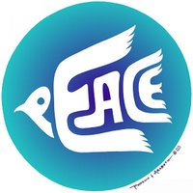
1. Colour
Blue is sometimes cited as the colour of peace as it represents the colour of the sky above and the sea below.
White is more commonly cited as a symbol of peace - because it conceals nothing it is seen as symbolising purity, innocence and truth.
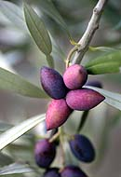
2. Plant
The olive branch has for thousands of years been used as a sign of peace and goodwill. This may be partly due to the fact that in early cultivation of the olive it took decades to bear fruit for harvest, and it was held that anyone who planted olive groves must be expecting a long and peaceful life and must be looking to posterity.
The symbolism is also probably related to the Biblical story of the dove In ancient Greek myth, the olive was a plant of Athene - maiden goddess of wisdom, reason, purity and crafts. She was also a warrior, but only to defend the State and home from outside enemies. The olive was her gift to the people of Athens in a contest with Poseidon - it was of such great value to the people as a source of food, oil and (in turn) wealth from exports that the city came under her patronage and was named for her. This 5th century BC coin from Athens shows Athene wearing an olive wreath on her head, and on the other side her bird - the owl - and her plant - an olive branch.
The olive wreath or crown was the highest award given to a citizen in ancient Greece. The prize was also given to winners at the ancient Olympic Games - a time when wars were suspended between competing states. The symbolism of the olive branch is part of a number of well-known flags and symbols, including:
the United Nations symbol with the world flanked by a wreath of crossed olive branches;
the Great Seal of the USA where the eagle carries in its right talon an olive branch with 13 leaves to represent peace between the original member States (this also appears on the flag of the Virgin Islands);
the flag of the league of Arab States which has an upturned crescent encircled by a gold chain and olive wreath;
the flag of Cyprus which has crossed olive branches beneath a map of the island to represent peace between the Greek and Turkish populations; and
the flag of Eritrea which includes a golden olive wreath and stem, originally inspired by the flag of the United Nations.
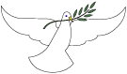
3. Animal
The dove is a universal symbol of peace and innocence. In ancient Greek myth it was a bird of Athene which represented the renewal of life.
In the Bible it was a dove released from the Ark by Noah which returned with an olive branch to show that the Biblical flood was over. Ever since, the dove has symbolised deliverance and God's forgiveness.
According to legend the devil and witches can turn themselves into any bird shape except the dove.
In ancient Japan the dove was sacred to Hackiman the god of war, but it was a dove with a sword which announced the end to war.

4. Gemstone
The bloodstone is cited as a symbol of peace. It is said to have been created from drops of blood which fell from Christ's wound on the Cross onto a green stone.
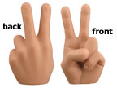
5. Signs
(a) The peace sign or victory salute is made by holding the index and middle fingers in the shape of a V. This sign is said to have begun in Europe during World War II when the
V for victory (victoire in French, vrijheid in Dutch) sign was painted on walls in the dark as a symbol of freedom from occupying forces.
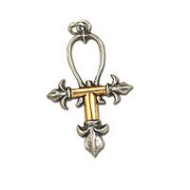
6. Another symbol which has come to be associated with peace is the ankh or cross. This is an ancient symbol which was widespread through Asia but generally associated with Egypt, where the cross represented life and the circle eternity, providing a symbol of immortality. It also represented the union of the important gods Osiris and Isis, linking heaven and earth and initiating the life-giving annual flood of the Nile.
In the late 1960's the symbol was adopted by the 'flower power' generation as a symbol of peace and truth.
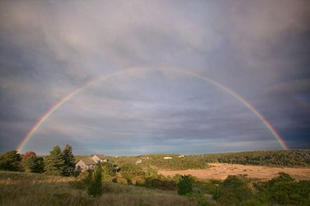
7. Like the ankh, the rainbow has come to be seen by many as a symbol of peace. It has been widely used in the past few decades by popular movements for peace and the environment.
Greek mythology associated the rainbow with Iris, the goddess who brought messages from the gods of Mount Olympus to the mortals below.
In ancient China the colours symbolise the union of yin and yang(making it a common symbol for marriage). It was often drawn as a symbol of the sky dragon, connecting heaven and earth.
The Incas of central America associated it with their sun god.
In Norse mythology it was a bridge built by the gods between earth and their home in Asgard.
In Christian tradition it symbolised God's forgiveness, as it was placed in the sky as the arch of peace after the Biblical flood - a symbol of the covenant between God and mankind.
Thus in a great many cultures the rainbow stands as a symbol of people's hope for a better world - in the sunshine after rain.
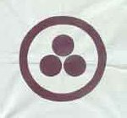
8. The Banner of Peace symbol is being promoted as a universal symbol of peace. The central three circles are taken to represent either past, present and future surrounded by eternity, or religion, science and art encircled by culture. The motif has been found in many cultures around the world over thousands of years. Part of its appeal is that it is owned by no one group or tradition.
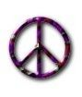
9. Of course a lot of people know this sign, but do not know what it means at all. The well-known Ban the Bomb symbol was designed in 1958 for the Campaign for Nuclear Disarmament (CND). Its shape came from the semaphore for N and D (nuclear + disarmament) enclosed in a circle to represent global and total agreement.

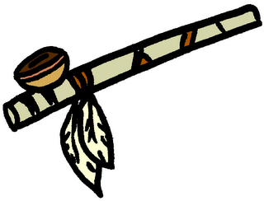
10. Instrument
The Native American pipe of peace, or calumet, stands for reconciliation or purification. Its round bowl represents the centre of the universe, the heart; the smoke the transport to heaven; the canal or stem the spinal column and a channel for the vital spirit.
In conclusion we would like to say that we have managed to achieve the purposes and tasks that we put. Information is useful and provokes interest in the further work now in the field of sociology, makes a person think about the existing relations in the society .
Working at the project we learned a lot of interesting things about the history of the symbols, and of their meaning for humanity as a whole. As the practice shows, during many centuries people tried to co-exist peacefully, and peace symbols have become one of the types of international information, clear and simple for people of different languages.
As it turned out, every country and every nation made its own contribution to the development of peace symbols . A symbol from one or another part of the world, is used by many peoples in its original or modified form. This is the proof of our hypothesis: the spread of information about symbols of peace can contribute to the peaceful resolution of conflicts and has its value everywhere, without paying attention to the location, time or origin.
Appendix.
Olive branch.
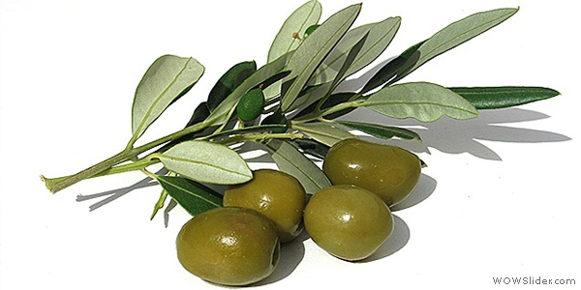
The Ankh cross.
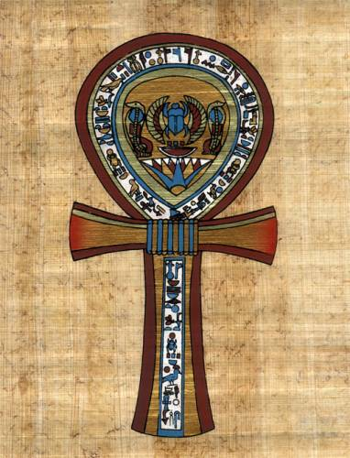
V-sign.
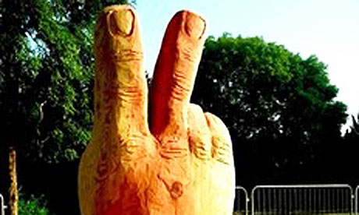

Bloodstones.
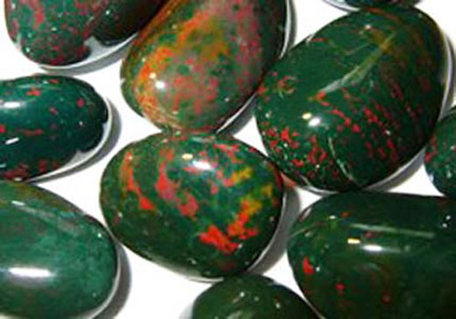
Jasper.
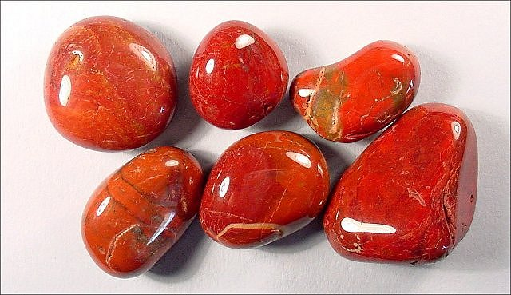

Peace pipe.
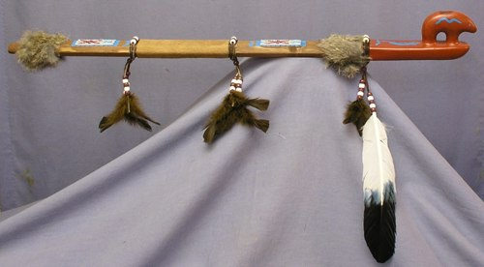

Banner of peace.

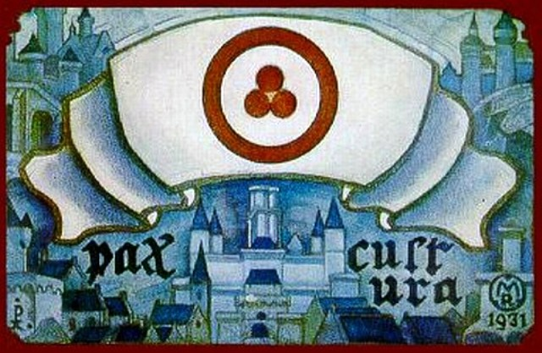

The CDN.

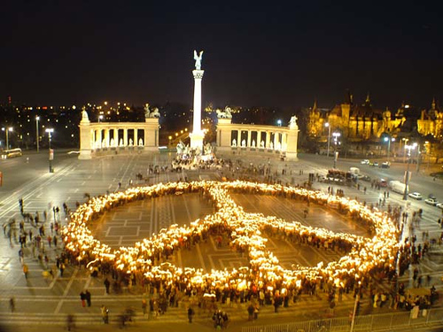

Dove.
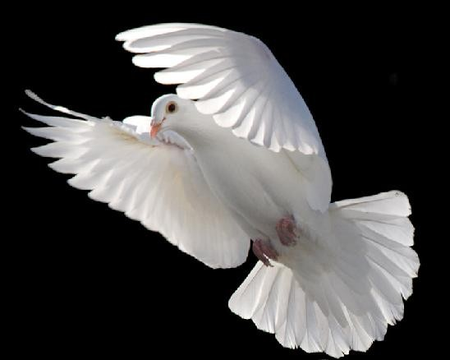

Rainbow.
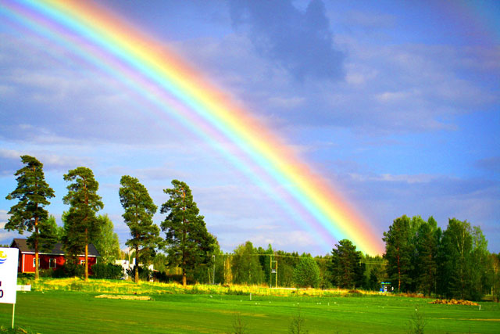

REFERENCES.
- Rupert Graves, The Greek Myths, Harmonsdsworth: Penguin Books, 1962, Section 53.7
- Virgil, Georgics, 2, pp.425ff (trans. Fairclough)
- Ragnar Hedlund, "Coinage and authority in the Roman empire, c. AD 260–295", Studia Numismatica Upsaliensia, 5, University of Uppsala, 2008
- James Elmes, A General and Bibliographical Dictionary of the Fine Arts, London: Thomas Tegg, 1826
- Appian of Alexandria. "Appian's History of Rome: The Spanish Wars (§§91–95)". Livius.org. Retrieved 21 February 2012.
- Nathaniel Hooke, The Roman history: From the Building of Rome to the Ruin of the Commonwealth, London: J.Rivington, 1823
- A. Anselment, ''Loyalist resolve: patient fortitude in the English Civil War'', Associated University Presses, 1988. Google Books.
- ''Catholic Encyclopedia'', Roman Catacombs: Paintings". Newadvent.org. 1 November 1908.
- ''Encyclopædia Britannica'', 1911". Theodora.com. 25 January 2011.
- "Where the stones cry out", The Moslem World, Vol. XII, No.4, October 1922". Archive.org.
- ''The Sousse Catacombs''". Patrimoinedetunisie.com.tn. Retrieved 21 February 2012.
- ''Catholic Encyclopedia'', Dove: As an artistic symbol". Newadvent.org. 1 May 1909. Retrieved 21 February 2012.
- Graydon F. Snyder, "The Interaction of Jews with Non-Jews in Rome", in Karl P. Donfreid and Peter Richardson, Judaism and Christianity in Early Rome, Grand Rapids: Wm B. Ferdman, 1998

