Progress Check Unit 2
1. Complete each sentence with one of the word combinations below.
Official languages | By boat | Is situated | Be successful | success | Round Europe
Was awarded | Collected his thoughts | The rush hours | The only | Foreign languages | collect
1. He can speak three ______________: English, German and Spanish.
2. India ___________ in Asia.
3. If you work hard, you’ll ___________ in your career.
4. There are 15 ___________ in India and thousands of different dialects.
5. English is __________ solution to this communication problem.
6. The famous scientist ____________a Nobel Prize in 1930.
7. He ________ and began his report.
8. Last Summer their family travelled _________ by bus.
9. Try to get to the office before ___________ or you’ll be late for the meeting.
10. The winners will travel __________ from Australia to New Zealand.
11. Will you ___________ the books from Ann, please?

2. Передайте следующие предложения в Passive Voice, обращая внимание на место предлога.
ПРИМЕР: We often speak of her. – She is often spoken of.
1. Nobody lived in that house. _____________________________________________________
__________________________________________________________________________
2. The neighbor asked for the telegram. ___________________________________________
__________________________________________________________________________
3. They often speak about the weather. ___________________________________________
____________________________________________________________________________
4. Tom gave Nick a book for his birthday. _________________________________________
____________________________________________________________________________
5. They water the houseplants regularly. ___________________________________________
__________________________________________________________________________

3. Составьте предложения из слов в Passive Voice: предложения с 1 по 7 в Present Simple, предложения с 8 по 15 в Past Simple.
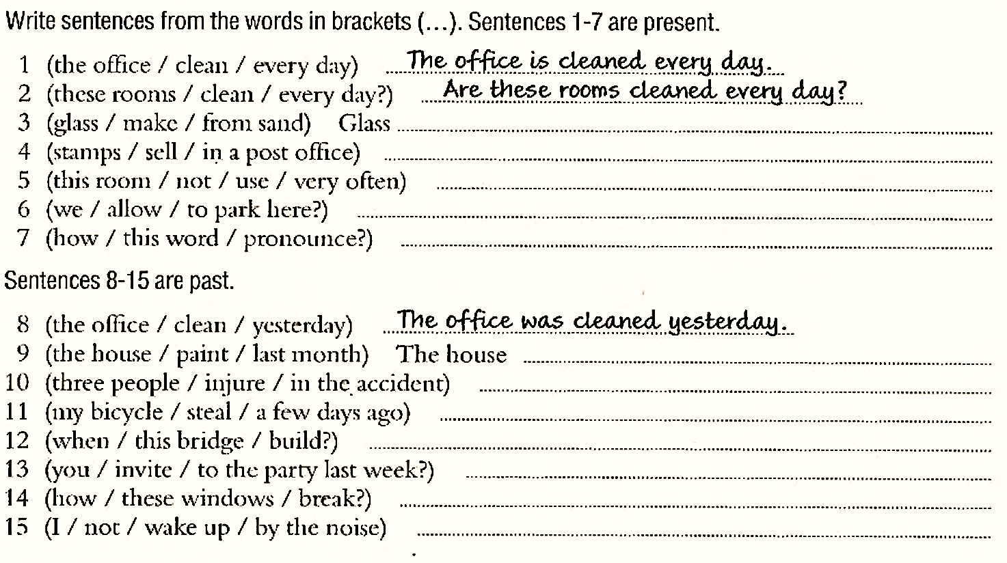

____ / 31

