**Rain Rain**

Rain rain  
falls on the street,  
mud in puddles  
cleaning my feet.

Thunder thunder  
rumble and roar,  
close the windows  
and lock the door.

Clouds clouds  
black and gray,  
heavy with water  
to drop all day.

Sun sun  
is breaking through,  
clouds are moving,  
the rain stops too.

Rainbow rainbow  
across the sky,  
see-through colours  
to tickle my eyes.

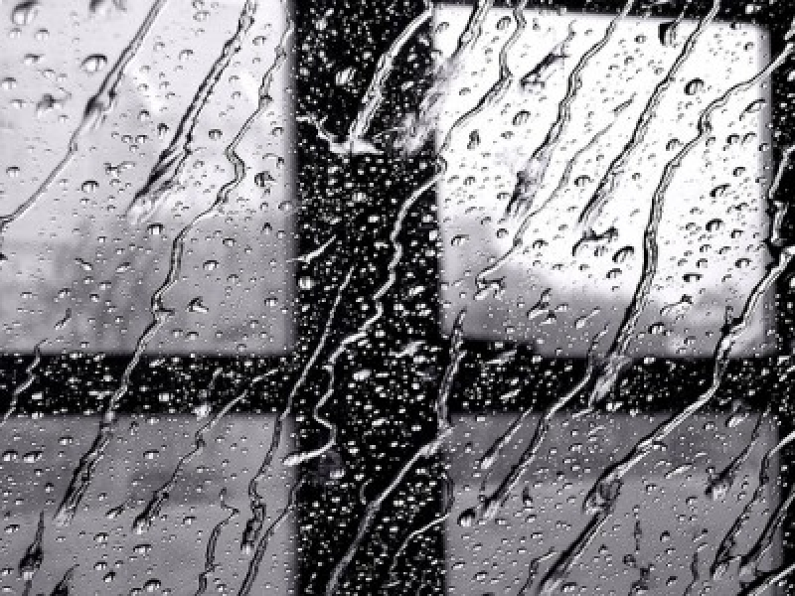

**Rain**

When the rain comes down drip drop drip drop,  
(flutter fingers down in front of you)  
Windshield wipers flip flop flip flop,  
(bend arms in front and move them side to side)  
Boots in puddles plip plop plip plop,  
(move feet up and down)  
I wish the rain would never stop.  
Drip drop drip, (use motions as you say it)  
Flip flop flip,("" )  
Plip plop plip plop, ("")  
PLOP! (do the motions and jump)



**Fun In the Rain**

(to the tune of "Three Blind Mice")

Rain, rain, rain  
Rain, rain, rain  
Dribble, dribble, sploosh!  
Dribble, dribble, sploosh!  
Grab your boots, your coat, and hat,  
Jump in a puddle and go kersplat!  
Stomp about and become a drowned rat,  
Rain, rain, rain  
Rain, rain, rain.



**Rain**

Rain on the rooftops,  
Rain on the trees.  
Rain on the green grass,

But not on me!

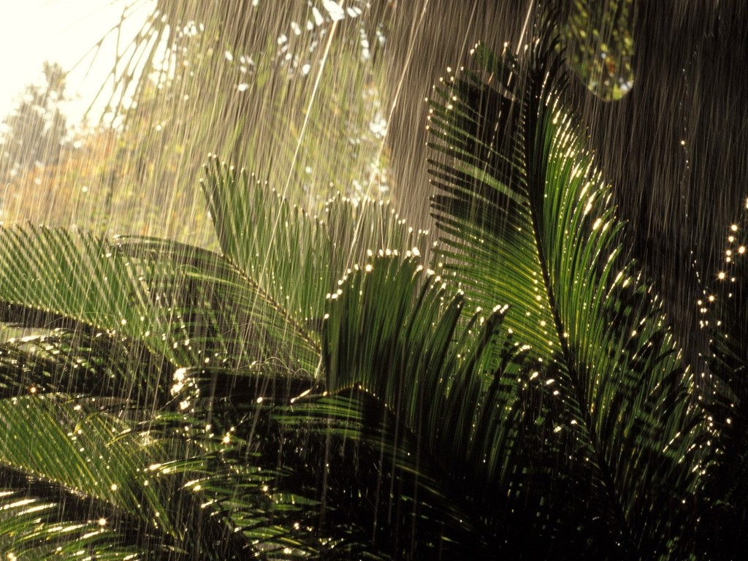

White sheep, white sheep on a blue hill.  
When the wind stops, you all stand still.  
When the wind blows, you walk away slow.  
White sheep, white sheep, where do you go?



**It Rained**

It rained on Bill,  
It rained on Will,  
It rained on Isabella,  
But it didn't rain on ________,

He/She had a huge umbrella.

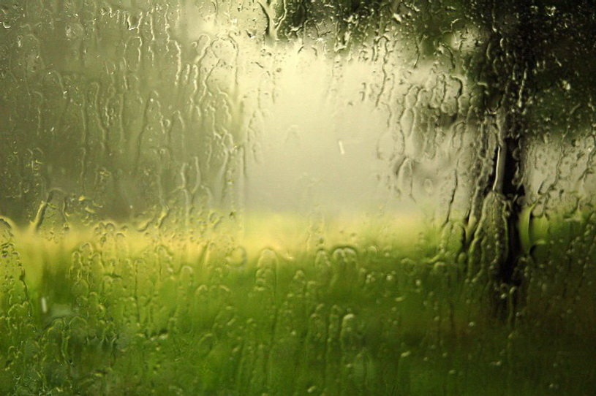

It rains on the duck, cow, and horse.  
It rains on the trees and leaves, of course!  
It rains on a little girl and fella.  
But I'm not wet. I have an umbrella!



**It's Raining, It's Pouring**

It's raining, it's pouring,  
The old man is snoring.  
He bumped his head, and he went to bed,  
And he couldn't get up in the morning.

**Raindrops**

Raindrops are such funny things.  
They haven't feet or haven't wings.  
Yet they sail throughout he air  
With the greatest of ease,  
And dance on the street

Wherever they please.

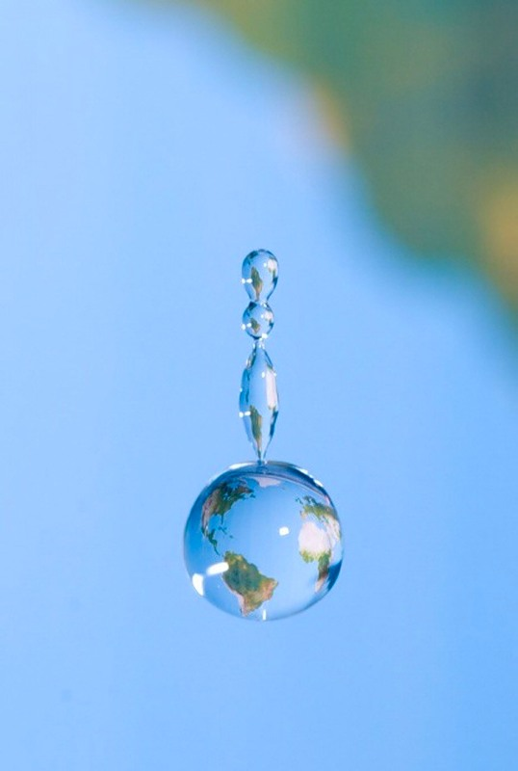

**Let's Count the Raindrops**

Let's count the raindrops  
as they pour:  
one million, two million,  
three million, four.



**Little Raindrops**

This is the sun, high up in the sky.  
A dark cloud suddenly comes sailing by.  
These are the raindrops,  
Pitter, pattering down.  
Watering the flower seeds  
That grow under the ground.



**Raindrops**

Raindrops, raindrops,  
Falling all around,  
Pitter-patter on the rooftops,  
Pitter-patter on the ground.  
Here is my umbrella,  
It will keep me dry,  
When I go walking in the rain,  
I hold it up so high.



One spring day the big round sun  
Winked at a cloud just for fun.  
That dark gray cloud thundered and cried,  
Scattering raindrops on all outside.  
But when the sun peeked out from a sunset low  
Together they both made a gay rainbow!



**Oh, Rainbow**

(to the tune of "Oh, Christmas Tree")

Oh, rainbow, oh, rainbow,  
How lovely are your colours.  
Oh, rainbow, oh, rainbow,  
How lovely are your colours.  
Purple, red and orange, too,  
Yellow, green and blue so true.  
Oh, rainbow, oh, rainbow,  
How lovely are your colours.

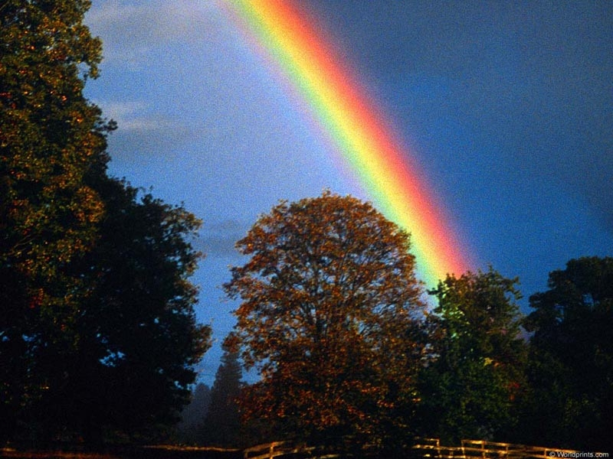

**Rainbow Song**

Red and yellow and pink and green,  
Purple and orange and blue.  
I can sing a rainbow,  
Sing a rainbow,  
You can sing one too!

Listen with your eyes,  
Listen with your eyes,  
And sing everything you see.  
You can sing a rainbow,  
Sing a rainbow,  
Sing a long with me.

Red and yellow and pink and green,  
Purple and orange and blue.  
You can sing a rainbow,  
Sing a rainbow,  
Now you've sung one too!

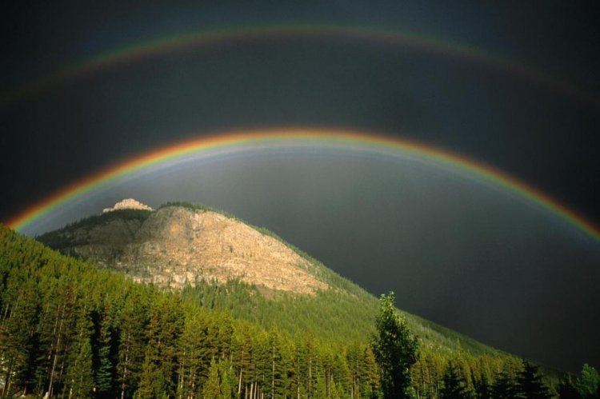

**The Fog**

I like the fog  
It's soft and cool,  
It hides everything  
On the way to school.  
I can't see a house  
I can't see a tree,  
Because the fog  
Is playing with me.  
The sun comes out  
The fog goes away,  
But it shall be back  
Another day.



.

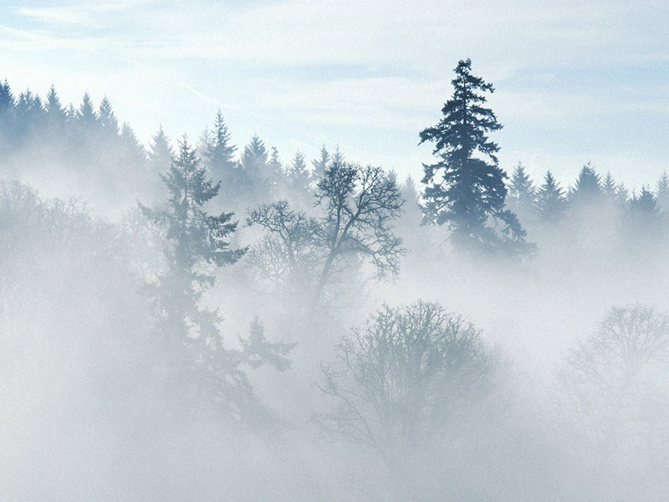

**Thunder and Lightning**

When a storm begins in the clouds,  
It sometimes may look frightening.  
You see a quick electrical spark--  
Flash! goes the lightning!

Long and thin and streaky and fast,  
Its glow is oh so brightening.  
Watch for the electric spark--  
Flash! goes the lightning!

When a storm begins in the clouds,  
It truly is a wonder.  
You hear a rumble loud in the sky--  
Clap! goes the thunder!

Lightning bolts are heating the air,  
Over clouds and under.  
When the air expands enough--  
Clap! goes the thunder.



**Thunder**

(to the tune of Frere Jacques)

I hear thunder, I hear thunder,  
Hark, don't you? Hark, don't you?  
Pitter patter raindrops, pitter patter raindrops,  
I'm wet through.  
So are you.

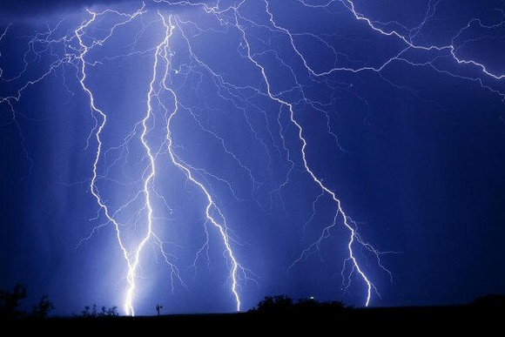

**Clouds are Floating**

Clouds are floating, clouds are floating,  
Up so high, up so high,  
Floating up above us, floating up above us,  
In the sky, in the sky.



**Clouds**

What's fluffy, white, and floats up high,  
Like piles of ice cream in the sky?  
And when the wind blows hard and strong,  
What brings the rain?  
What brings the snow?  
That showers down on us below?

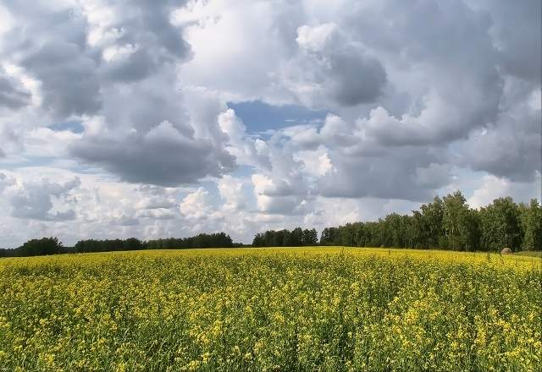

**The Wind**

The wind came out to play one day,  
He swept the clouds out of his way,  
He blew the leaves and away they flew,  
The trees bent low and their branches did too,  
The wind blew the great big ships at sea,  
The wind blew my kite away from me.



**Wind Pictures**

Look! There's a giant stretching in the sky,  
A thousand white-maned horses flying by,  
A house, a mother mountain with her hills,   
A lazy lady posing in her frills,  
cotton floating from a thousand bales,  
And a white ship with white sails.

See the old witch fumbling with her shawl,  
White towers piling on a castle wall,  
the bits of soft that break and fall away,  
Airborne mushrooms with undersides of gray -  
Above, a white doe races with her fawn  
On the white grass of a celestial lawn.  
Lift up your lovely heads and look  
As wind turns clouds into a picture book.



**Mr. Sun**

Oh Mr. Sun, sun, Mr. golden Sun,  
Please shine down on me.  
Oh Mr. Sun, sun, Mr. golden Sun,  
Hiding behind a tree.  
These little children are asking you  
To please come out so  
We can play with you.  
Oh Mr. Sun, sun, Mr. golden Sun,  
Please shine down on,  
Please shine down on,  
Please shine down on me!