Муниципальное бюджетное общеобразовательное учреждение

«Заинская средняя общеобразовательная школа № 2»

Заинского муниципального района Республики Татарстан

Внеклассное мероприятие

ВИКТОРИНА

How much do you know about English-speaking countries?

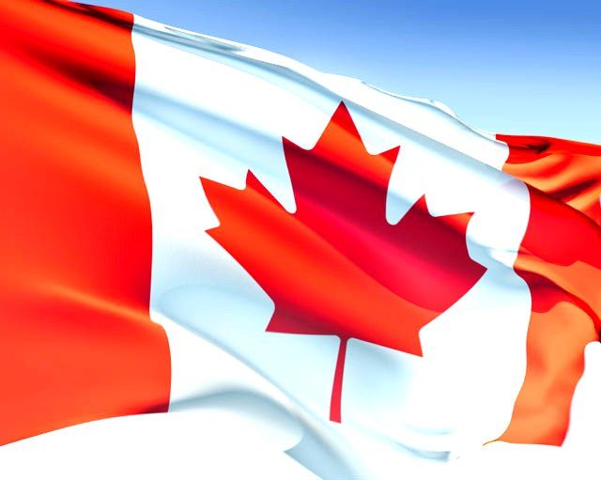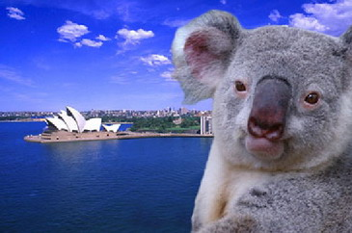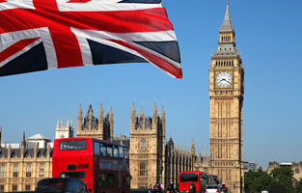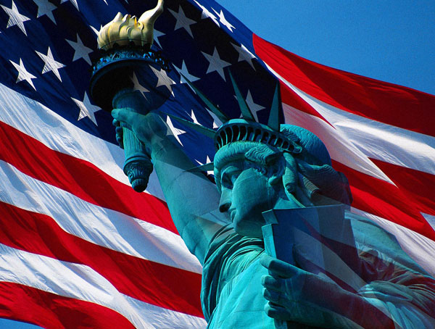

Учитель: Маркелова Инна Сергеевна

г. Заинск 2013

***Цели:***

1. Обобщить страноведческие знания учащихся, полученные на уроках английского языка.

2. Воспитывать интерес к изучению предмета.

3. Развивать неподготовленную речь учащихся.

***Образовательные задачи:***

Проконтролировать степень усвоения основных умений и навыков, изученных и сформированных на предыдущих уроках.

***Развивающие задачи:***

1. Развивать умение работать в коллективе и принимать совместное решение;
2. Развивать положительные личностные качества (ответственность, доброжелательность, чувство взаимопомощи).
3. Развивать и тренировать внимание, память, мышление.

***Воспитательные задачи:***

Воспитывать уважение к культуре своей страны и стран изучаемого языка

***Лингвострановедческие задачи:***

1. Формировать интерес к странам изучаемого языка
2. Познакомить с различными историческими данными данных государств.

**ХОД МЕРОПРИЯТИЯ**:

ВИКТОРИНА

**Introduction**

Good afternoon, children and our guests! I’m very glad to see you here. Now we shall organize a competition. Two teams will take part in a game of the most quick-witted and the cleverest. (Презентация команд)

(Проигрывание отрывков из гимнов Австралии, Англии, Америки и Канады)

**Answer the questions about the UK**

And now we come to the 1st contest of the game. I will read the questions and you must answer them . You have 20 sec for each question.

**I ТУР**

**ВОПРОСЫ ДЛЯ ПЕРВОЙ КОМАНДЫ:**

1)The legionnaires from this country under the leadership of Julius Caesar built a large wall to mark the border between England and Scotland.

(Italy)

2) This country has the fourth largest nation in the world.

(The USA)

3) It is the world’s largest island and its smallest continent.

(Australia)

4) This country is situated on the British Isles.

(England)

5) What countries does the United Kingdom consist of?

(England, Scotland, Wales, Ireland)

6) What is the currency of the country?

(Pound)

7) What is the capital of Scotland?

(Edinburgh)

8) What is the emblem of England?

(Rose)

9) What is the name of the most famous clock in Britain?

(Big Ben)

10) What is Wimbledon associated with?

(Tennis)

11) What river is London situated?

(Thames)

**I ТУР**

**ВОПРОСЫ ДЛЯ ВТОРОЙ КОМАНДЫ:**

1) It is the symbol of Paris.

(The Eiffel’s tower)

2) This monument is very dangerous for us because it can fall.

(The Pizza’s tower)

3) It is the Druid’s calendar.

(Stonehenge)

4) It is the present from France to America.

(The Statue of Liberty)

5) A lot of people go to Africa to see …

(Pyramids)

6) It is the heart of Russia.

(The Kremlin)

7) What is the Union Jack?

(flag)

8) Who is the head of the state in the U.K.?

(Oueen)

9) What is the capital of Wales?

(Cardiff)

10) Where does the queen live

(Buckingham Palace)

11) Where is an exhibition of wax figures?

(Madame Tussaud's)

**II ТУР**

**ВОПРОСЫ ДЛЯ ПЕРВОЙ КОМАНДЫ:**

|  |
| --- |
| 1. How are the Native Americans called? (Indians) |
| 2. When is the Thanksgiving Day celebrated? (4 Thursday of November) |
| 3. How many states are there in America? (50) |
| 4. Who fought against racial discrimination in the 1960’s? (Martin Luther King) |
| 5. When do Americans celebrate Independence Day? (4 July) |
| 6. What is the tallest building in the world? (Empire State Building) |
| 7. What is the national sport in America?(baseball) |
| 8.Where is the residence of the American President? (White House) |
| 9. What does Washington, D.C. mean? (District of Columbia) |
| 10. What was the first university in America? (Harvard) |
| 11. Who was the youngest President? (Kennedy) |
| 12. When is Christmas celebrated? (25 December) |
| 13. Who invented the telephone? (Alexander Bell) |

**II ТУР**

**ВОПРОСЫ ДЛЯ ВТОРОЙ КОМАНДЫ:**

|  |
| --- |
| 1. Who discovered America? (Columbus) |
| 2. What tradition did pilgrims start to celebrate? (Thanksgiving Day) |
| 3. Who was the first president of the United States? (George Washington) |
| 4. What is the official national symbol of the USA? (eagle) |
| 5. How many stripes are there on American flag? (13) |
| 6. What is a traditional meal on Thanksgiving Day? (turkey) |
| 7. What are the colors of the American flag?(Red, white, dark-blue) |
| 8. Where is the Statue of Liberty situated? (New York) |
| 9. Where is Hollywood, the center of the US film business? (Los Angeles) |
| 10. On what day will you see many Jack - 0’ – lanterns? (Halloween ) |
| 11. The statue of Liberty was a gift from…what country? (France) |
| 12. Where is Capitol situated? (Washington) |
| 13.Who built the first car (Henry Ford) |

**III ТУР**

**Look at the pictures and name the places**

* Now look at the pictures and name the places.
* Why are these places famous?

**1 команда:** Big Ben, Empire State Building, Tower of London

**2 команда:** The Statue of Liberty, The White House, Westminster Abby

**(Приложение 1 - фотографии)**

**IV ТУР**

**Расставить праздники в том порядке, в котором их отмечают в Англии.**

1. Halloween

2. Christmas

3. St. Valentine’s Day

4. Easter

5. New Year’s Day

6. Independence Day

7. St. Patrick’s Day

8. Thanksgiving Day

(5, 3, 7, 4, 6, 1, 8, 2)

**(Приложение 2 – названия праздников)**

**Заключительный этап**

Подведение итогов урока.

Награждение команды победителя.