Открытый урок « Рождество»
4 класс
Цель урока:
систематизация знаний о социокультурной специфике стран изучаемого языка и культурных особенностях носителей языка, их привычках, традициях.
Задачи:
- Обобщение лексико-грамматический материал по теме "Обычаи и традиции англоговорящих стран"
- Совершенствование речевых навыков и умений
- Воспитание толерантности по отношению к иным языкам и культуре
- Развитие познавательного интереса к иностранному языку
- Систематизация страноведческого материала и расширение лингвистического кругозора учащихся
- Развитие творческой деятельности учащихся

Оснащение урока:
Мультимедийная установка, презентация, ненаряженная елка, новогодние игрушки, леденцы, две пары рукавиц, коробки с подарками
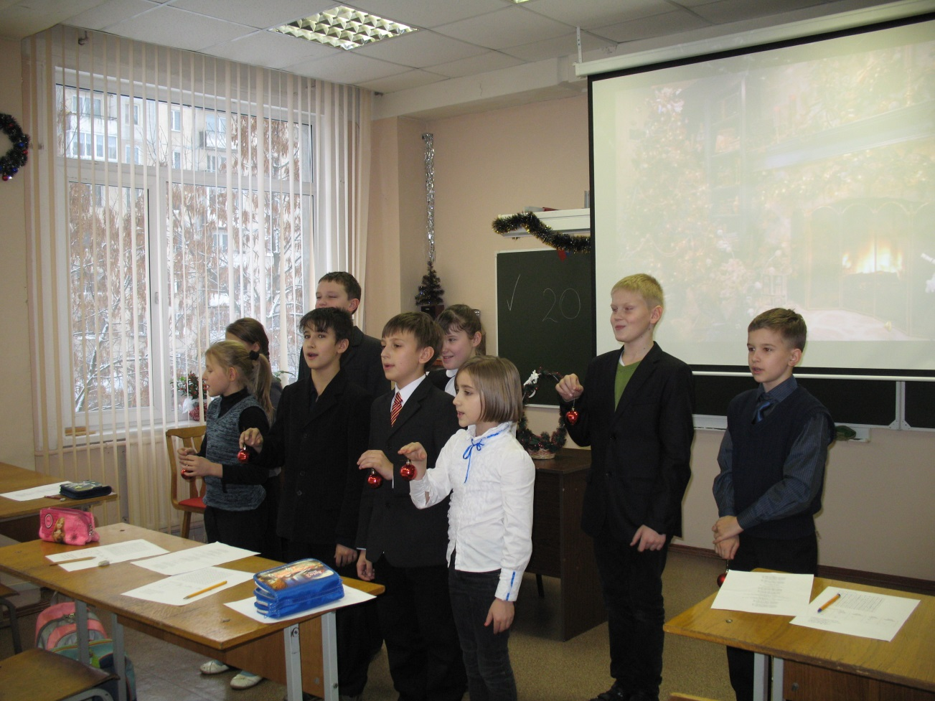

План урока:
- Greeting
- Teacher: Today we’ll speak about Christmas. When do British people celebrate Christmas? ( слайд 1 )
- Teacher : Some words from the history of the holiday. It is a religious holiday. It is a birthday of Jesus Christ. On this day people sing special songs- carols. Let’s listen to one of them “Silent Night” ( слайд 2 )
- Teacher :Before our celebration let’s repeat Christmas words
Christmas food ( слайд 3 )
Christmas decorations ( слайд 4 )
(Children read the words) ( слайд 5 )
- Teacher: Look around. Our room is decorated, but our poor Christmas tree has no any decorations. Here there are a lot of toys. You will do the exercise and if you answer correctly you will put a toy on the tree. Ex. 1 word searching ( слайд 6)
С | H | R | I | S | T | M | A | S | E | O
B | O | W | W | R | E | A | T | H | L | C
E | S | T | O | C | K | I | N | G | F | A
L | T | R | W | T | U | R | K | E | Y | N
L | A | E | P | U | D | D | I | N | G | D
A | R | E | I | N | B | A | N | G | E | L
S | A | N | T | A | C | L | A | U | S | E
O | C | R | A | C | K | E | R | X | L | G
N | B | A | R | E | I | N | D | E | E | R
C | A | N | D | Y | C | A | N | E | I | U
A | L | P | R | E | S | E | N | T | G | M
T | L | G | A | R | L | A | N | D | H | G
G | I | N | G | E | R | B | R | E | A | D
- Teacher: Christmas tree is very important for the holiday. Look at the tree and count the toys. My question will begin with the words “ How Many…”. Your answers will begin with the words “ There is..” “ There are..” ( слайд 7 )
How many big stars are there on the tree? (1)
How many small stars are there on the tree? (6)
How many stars are there on the tree? (7)
How many gingerbreads are there on the tree? (2)
How many red and blue balls are there on the tree? (6)
How many yellow and green balls are there on the tree? (4)
How many balls are there on the tree? (10)
How many candy canes are there on the tree? (4)
How many bows are there on the tree? (9)

- Teacher: To make a holiday merry people play different games. We’ll play too.
Listen to the rules of the game: Divide into two groups. You have to put on mittens, take a candy, pop the candy into your mouth, put the paper into the bag, give the mittens to the next player. The team who finishes first wins. Start with the music. ( Jingle Bells) ( слайд 8 )
- Teacher: Who lives in this house? What room is it? What is there in the room? ( слайд 9)
- Teacher: We like to get and give presents. We usually put them into the boxes. Boxes can be different: square and round. We can put a bow on it. ( слайд 10) Look. I have four boxes: 2 square and 2 round. I don’t remember who gave them. I’ll read you the sentences and you put a * in the table. The Christmas Presents Mix-up ( слайд 11)
 | Square  with a bow | Square  without a bow | Round  with a bow | Round  without a bow
Kate | *
Kelly |  | *
Lisa |  |  |  | *
Meg |  |  | *

Kelly put her present in a beautiful red round box.
Meg’s present is in square box with red roses and a red bow.
Kate put her present in a small box with a red bow.
Liza didn’t put a bow on her box.

- Teacher: Before Christmas we usually send Christmas cards and write wishes. ( слайд 12 ) Our wishes are wrong ( слайд 13 )
Christmas Merry and a New Happy Year
Christmas wishes for BEST
New in the luck Year Good
Put the words in the correct order.
- Teacher: And now let’s sing a song “We wish you a merry Christmas”. ( слайд 14)

