Урок английского языка в 6-м классе по теме "Еда"
Цели урока:
- ознакомить учащихся с употреблением местоимений SOME и ANY с названиями продуктов;
- систематизировать знания учащихся по теме «Еда»;
- выработать ЗУН в области устной и письменной речи по теме.
Задачи урока:
1. Образовательные:
- формирование лексических умений и навыков в устной речи;
- формирование грамматических навыков (употребление местоимений SOME и ANY в речи);
- отработка произносительных навыков.
2. Развивающие:
- продолжать развивать умение общаться на иностранном языке;
- строить высказывание по образцу и самостоятельно;
- развивать навыки аудирования и чтения.
3. Воспитывающие:
- прививать любовь и интерес к иностранному языку;
- воспитывать умение работать в парах, группах, самостоятельно;
- воспитывать умение вежливо обращаться с людьми.
Оснащение урока: компьютер, мультимедийный проектор, экран, дидактический материал (таблица с буквами, текст «I’m hungry»).

Ход урока

I. Приветствие.
– Good morning, children!
– Good morning, …
– How are you?
– We are fine, thank you. And how are you?
– I’m OK, thanks.

II. Сообщение цели урока.
T: Today we are going to speak about FOOD. First of all we’ll take the pronouns SOME and ANY. We’ll sing , work with a text, listen to it, answer the questions, read the text in groups. After that we’ll do a puzzle.
And now let’s start our work.

III. Фонетическая зарядка.
T: Look at the blackboard, repeat after me.
Newspaper, question, omelette, sandwiches, tomato, carrot, cucumber, apple, orange, grapefruit, sausage, chicken, meat, ham, sweets, chocolate, sugar, etс.

IV. Речевая зарядка.
Teacher: | Pupils:
What is the date today? | Today is the … of December.
What day is it today? | It is … today.
Who is absent today? | … is (are) absent.
What is the weather like today? | It is warm (cold) today.
Do you like the weather? | Yes, I do. I like the weather.
Is it autumn now? | No, it isn’t. It is winter now.
What is your favorite season? | I like … , because it is … in … (I can swim, I can ski and skate …)
Now ask each other questions, please.

V. Ознакомление с местоимениями SOME и ANY.
T: Now look at the screen, please.
Сегодня, ребята, мы с вами познакомимся с неопределён-ными местоимениями SOME и ANY.
Местоимение SOME (несколько, какое-то количество) употребляется в утвердительных предложениях.
Например:
I have some friends. – У меня есть несколько друзей.
I have some coffee. – У меня есть (какое-то количество) кофе.
В вопросительных и отрицательных предложениях SOME обычно заменяется на ANY.
Местоимение ANY в вопросительных предложениях переводится как сколько-нибудь, какой-нибудь.
Например:
Do you have any books? – У тебя есть (какие-нибудь) книги?
Do you have any coffee? – У вас есть (сколько-нибудь) кофе?
В отрицательных предложениях местоимение ANY переводится как никакой.
Например:
I don’t have any friends. – У меня нет (никаких) друзей.
I don’t have any coffee. – У меня нет (никакого) кофе.
Now look at the sentences and fill in the gaps with SOME and ANY.
- They have … milk.
- My aunt doesn’t read … newspapers.
- Do you have … questions?
- We need … eggs and … milk.
- He doesn’t have … water.
- I have … potatoes.
- Do you buy … butter?
- Kate doesn’t have … water in the jug.

VI. Музыкальная пауза с физкультминуткой.
T: Are you tired, children? I’d like you to sing a song . Let’s sing “In ten years” Приложение 1

VII. Тренировка навыков аудирования.
- Before listening to the text we must take some new words, otherwise it will be difficult for us to understand it. Look at the blackboard, read and repeat after me:
to be hungry – быть голодным
to go shopping – ходить за покупками
food – еда
to have a snack – перекусывать
guys – зд. Ребята
- You have to listen to the text very attentively, because you will answer the questions. Read them after me, please. Translate them.
а) Why can’t the children make an omelette?
b) Why can’t they make ham and cheese sandwiches?
c) Why can’t they make fish and chips?
- And now the text “I’m hungry”. Приложение 2

VIII. Тренировка навыков чтения.
Please, take the sheets of paper with the text. Read it in groups. Choose roles for yourselves. And then you will read it aloud.

IX. Повторение лексики по теме «Еда».
So, the children and Betsey are going to the shop. What will they buy in the shop? Look at the puzzle and find the words connected with our topic. They go across, down, up and at the angle. Приложение 3

X. Составление диалогов по образцу.
Dear friends, can you tell me, what polite words do you know? We have to use them when we go to the shop.
Now I’ll give you a dialogue as an example. You will make up your own dialogues changing the underlined words. Приложение 4

XI. Итоги урока.
- Hometask: ex. A,B p.102.
- Marks to the pupils.

Приложение 1
In ten years
In ten years
What will happen to me?
In ten years
Where will be?
Will I be happy?
Will I be alone?
Will I travel round the world?
Will I stay at home?

In ten years you’ll be twenty-one,
You’ll travel round the world and you’ll have fun.
You’ll go to Scotland and you’ll go to Spain.
You’ll travel by car, by bus and by plane.

In ten years you’ll be a famous star.
You’ll have a small dog and a very big car.
You’ll buy a nice house with a swimming pool.
And your friends will stay “She’s really cool!”

In ten years you’ll be twenty-two.
You will be a vet and you’ll work at the zoo.
You’ll love your job and you’ll never be late
And a big orange tiger will be your best mate.

Приложение 2
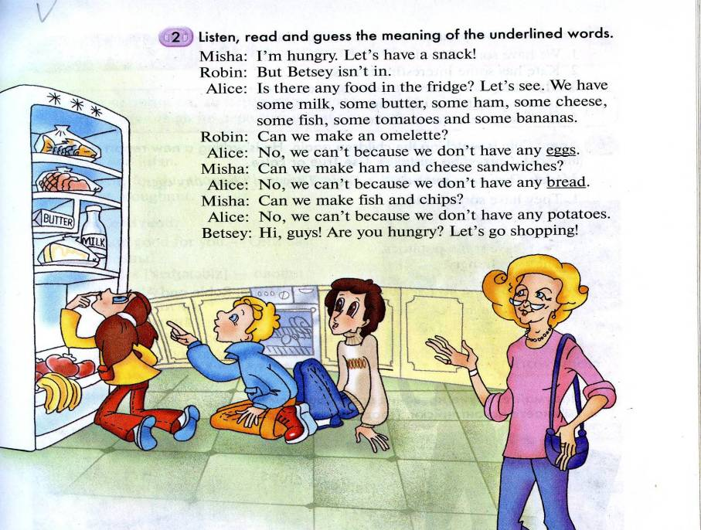

A | C | T | S | D | E | C | F | O | S
T | G | A | E | H | I | U | K | N | A
R | O | E | L | L | O | C | M | I | U
E | H | M | B | T | N | U | P | O | S
P | A | R | A | L | E | M | O | N | A
P | M | T | T | T | S | B | T | U | G
E | O | V | E | W | O | E | X | Y | E
P | Z | A | G | C | A | R | R | O | T
L | M | N | E | O | R | A | N | G | E
K | H | O | V | A | P | P | L | E | F
C | H | E | E | S | E | M | E | A | T
R | I | C | E | B | u | T | T | E | R
J | U | I | C | E | S | W | E | E | T
M | U | S | H | R | O | O | M | S | A
T | G | A | E | H | I | U | K | N | A
Приложение 3
Do the crossword

Приложение 4

- Good afternoon! I’d like to buy 200 grams of butter and a pint of milk, please.
- Here you are. What else?
- A kilo of oranges, please. How much will that cost?
- Three pounds fifty.
- Thank you.

