Проект: Австралия

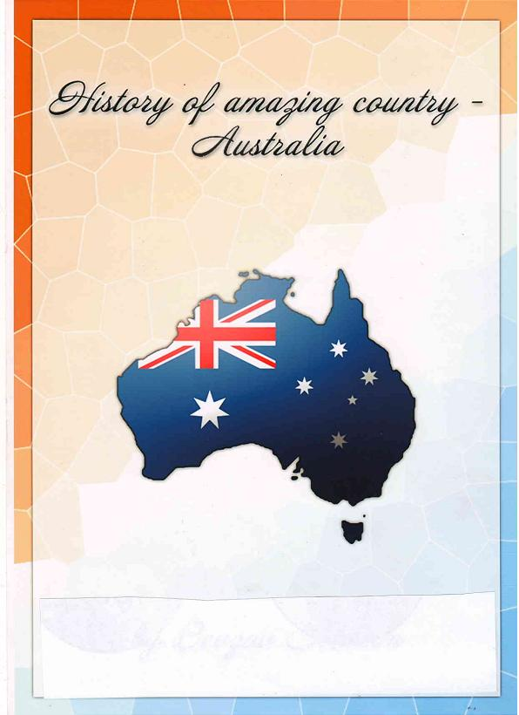

General Information about Australia
Australia is situated in the south-west of the Pacific Ocean. The area of this country is 7,7 million square kilometres. The population of the country is about 20 million people. The capital is Canberra. The population of Canberra is about 300 thousand people. Official language is English. Australia is the largest island in the world and it is the smallest continent.
The Commonwealth of Australia is a self-governing federal state. It has got 6 states: New South Wales, Victoria, Queensland, South Australia, Tasmania and 2 internal territories.
Australian national flag consists of 5 white stars of the Southern Cross
and the white Commonwealth star (the large seven pointed star)
on a blue background with a Union Jack in canton.
The small Union Jack represents the historical link with Britain,
and the large seven-pointed star represents the six states and the
Territories, and the small stars form the Southern Cross - a prominent
feature of the southern hemisphere night sky.
A distinctive Australia flora and fauna is reflected in the country's
coat-of-arms by the symbols of Australia's endemic animals; kangaroo
and emu and twig of wattle (a kind of acacia).
Australia officially adopted green and gold as its national
colours in 1984. The Australia national anthem
was adopted in the 1970ties. It is used on the all official and
ceremonial occasions.

Terra Incognita (Unknown Land)
It is supposed that Australia's native inhabitants, the Aborigines, arrived in Australia at least 40,000 years ago. The first Europeans visited the shores of Australia in 1606. The Spanish ship of Luis Vaes de Torres sailed through the strait which now bears his name and separates Australia and Papua New Guinea. In the same year the
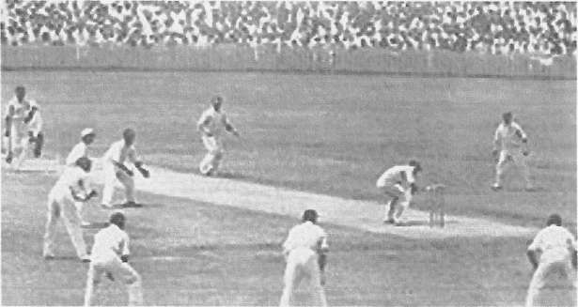

Sport in Australia
Cricket has been an important part of Australia's sporting culture since the 19th century
Around 24% Australians over the age of 15 regularly participate in organised sporting activities in Australia. Australia has strong international teams in cricket, field hockey, netball, rugby league and rugby union, having been Olympic or world champions at least twice in each sport in the last 25 years for both men and women where applicable. Australia is also powerful in track cycling, rowing, and swimming, having consistently been in the top-five medal-winners at Olympic or World Championship level since 2000.Swimming is the strongest of these sports; Australia is the second-most prolific medal winner in the sport in Olympic history.
Nationally, other popular sports include Australian rules football, horse racing, surfing, soccer, and motor racing.
Sport
Australia has participated in every summer Olympics of the modern era,and every Commonwealth Games. Australia hosted the 1956 Summer Olympics in Melbourne and the 2000 Summer Olympics in Sydney,and has ranked among the top six medal-takers since 2000. Australia has also hosted the 1938,1962, 1982, and 2006 Commonwealth Games.Other major international events held in Australia include the Australian Open tennis grand slam tournament, international cricket matches.
First European Settlement
It is probably due to its geographical position that Australia was the last continent to be inhabited by the white man. It was just a little over 390 years that the Australian continent was discovered. The first landing by Europeans took place in 1606. More than a century and a half later an expedition headed by the British explorer James Cook added the land to the possessions of the British crown. Until the name "Australia" (meaning "South Land") became generally accepted for the continent, it had been referred to as New Holland, New South Wales, or Botany Bay. During the War of Independence (1776) the former British colonies in America declared themselves independent. Britain tried to make up for this loss by the seizure of new territories. Besides, the convicts could no longer be transported to the American colonies (which had served this purpose for over hundred years) and British jails were more than badly overcrowded.
The first contingent of the convicts and their guards landed where Sydney stands today, on January 26,1788. It was the so-called "First Fleet" and these people were called "first fleeters" Now, Australia Day, January 26, commemorates the landing. Gradually more and more people arrived (they were convicts as well as free settlers) and a number of settlements were founded along the southern and eastern coasts. For the first few years, the colonists were almost entirely dependent on food supplies from overseas but gradually the land around the settlements was brought under cultivation. Soils were generally poor and crop yields low, but better agricultural land was soon found near Parramatta, to the west. Exploratory voyages were also made along the east coast. The boldest was that of Captain Matthew Flinders who, in 1802-1803 circumnavigated the continent.
Australia Day is a very important holiday for the Australians, another equally important holiday is called Anzac Day.
Creation of The Commonwealth of Australia
In 1901 the separate colonies in Australia merged together and became the States of the Commonwealth of Australia, which acquired the status of dominion of Great Britain. The Commonwealth of Australia - a federation of the 6 former colonies as states - was declared to come into being on January 1,1901. The first Governor - General, the Earl of Hopetoun, convened the first Parliament of the Commonwealth of Australia on
April 29,1901. It was opened in Melbourne on May 9 by Duke of Cornwall and York, son of King Edward VII. Sir Edmund Barton was the first Prime Minister. The constitution provided for Federal Parliament to sit in Melbourne until a federal capital territory was selected and established. The present Australian Capital Territory was ceded from New South Wales to become federal territory in 1911, and the future capital was named Canberra in 1913. The first Federal Parliament to meet in Canberra was opened by the Duke of York, later King George VI, on
May 9,1927. Though Australia now is an independent state, according
to the Constitution the head of the state is the Monarch of Great
Britain, represented by the Governor-General. His duties include
assenting to bills, opening, proroguing and dissolving Parliament and
commissioning the Prime Minister to form a government.
Governor-General's residence Jarralumla is in Canberra.
The Commonwealth of Australia is composed of 6 states
and 2 territories: the State of New South Wales with its
capital in Sydney, the State of Victoria with its capital in Melbourne,
the State of Queenland with its capital in Brisbane,
the Sate of Western Australia with its capital in Perth,
the State of Tasmania with its capital in Hobart, Australian
Capital Territory with its Federal Capital in Canberra,
and Northern Territory with its capital in Darwin.
New Crown Colonies
Great Britain was on the verge of loosing 13 rebellious American Colonies in 1770. At that time Captain James Cook who led a scientific voyager planted the British ensign on a continent that would soon provide a vast new colony: Australia.
The will to establish new crown colonies was insistent even before the old ones mere lost. The Parliament debated the site as early as 1779. Only 18 years after Captain James Cook had landed in Botany Bay, Captain Arthur Philip arrived in Sydney Cove to begin the first settlement. In many ways, America and Australia have had corresponding histories of exploration, colonization, immigration, and growth. Both began with settlements on the fringes of huge continents, gradually pushing inward to cultivate a wilderness interior. And both developed a frontier ethos of independence. As the convicts earned their freedom, they went into the outback and staked claims on land. These men, known as Squatters, raised sheep or cattle, depending on the type of land they found for themselves. Other convicts however reverted to their criminal ways
and became outlaws, raiding the towns and stealing from the squatters. The early part of Australian history is filled with the tales of the settlers. These bushrangers often became folk-heroes in the tradition of Robin Hood and Dick Turpin in England, and Jesse James in the United States. Many poems and songs were written about them and at one time it was a criminal offence to sing or recite these ballads which glorified crime. Nonetheless, every Australian today knows the stories of the famous bushrangers. These ballads and songs started the tradition of Australian "yarn" and its heroes, Dad's Dave among them.
The hard rough life in the outback was no place for women. The Squatters searched the towns for wives to take to their stations. It wasn't very pleasant prospect for a new bride, but some girls were lucky enough to undertake the adventure. The image of a typical Australian was a tall, thin and blond man who was called a "Cornstalk", sometimes wearing a cabbage tree hat. Australians celebrated their bicentennial beginning Jan. 26,1988 and continuing all next year. On that date in 1788,11 ships arrived from Britain, and 1.030 settlers, including 776 convicts, began their new life in waterfront section of Sydney called "the Rocks".
Australia's Ties With Great Britain And The USA
Initially, Britain and the Commonwealth countries were the central elements of Australia's foreign policy and activity. Later, closer relations were also developed with the USA, partly because of the vital role it played in the Pacific during and after World War II. Australia can seem quite British at times and somewhat American at others. Political, legal, and educational institutions derive from Britain. Each state capital is named after a colonial politician (Perth, Brisbane, Sydney, Hobart, Melbourne) or British royal figure (Adelaide). Dry and witheringly hot towns bear names from England's green and pleasant land. The representative of the England queen is the formal head of the governmental structure.
Only since 1984 has required that a civil servant in Australia be an Australian - previously it was sufficient to be British. American influence comes in culture, technology, defense arrangements, and business. Books from USA have made a major advance in Australian intellectual circles since the 1960s. American ideas of management and problem-solving are becoming more and more popular.
Significantly, Australian dollar was introduced in 1966. In the past some Australians often felt that Australian culture, products, accents, lifestyles compared unfavorably with Britain and the USA. This attitude has changed. A strong sense of distinct Australian identity has grown with the growing recognition in the world of Australian films, literature and arts.
Gallery
Here you can see some australian symbolics architecture, animals and others

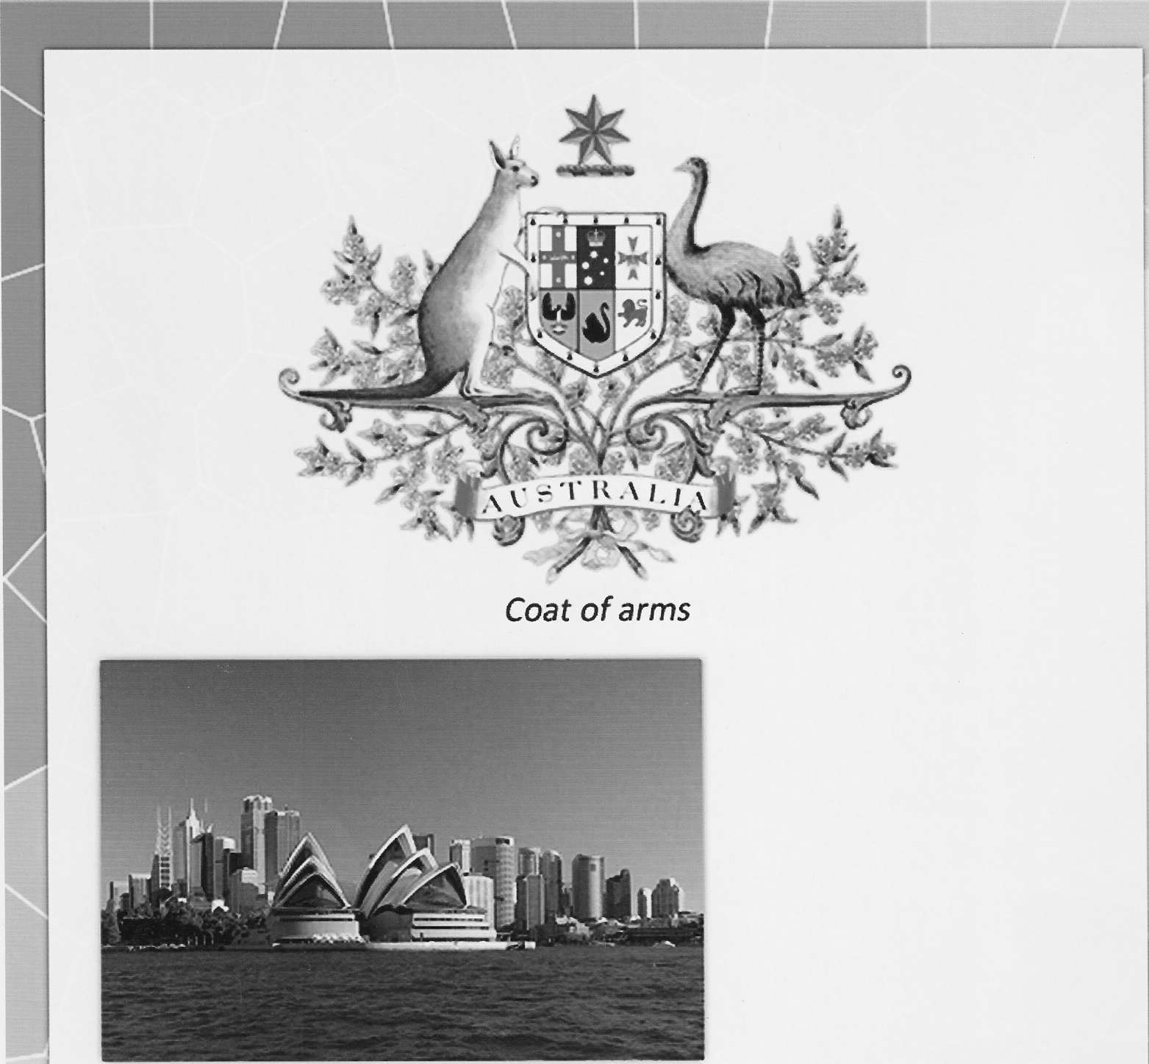

7
Sydney opera house and skyline
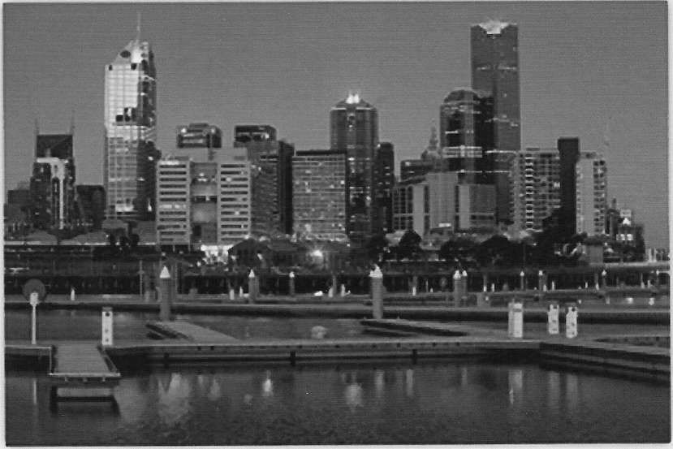

Melbourne docklands twilight
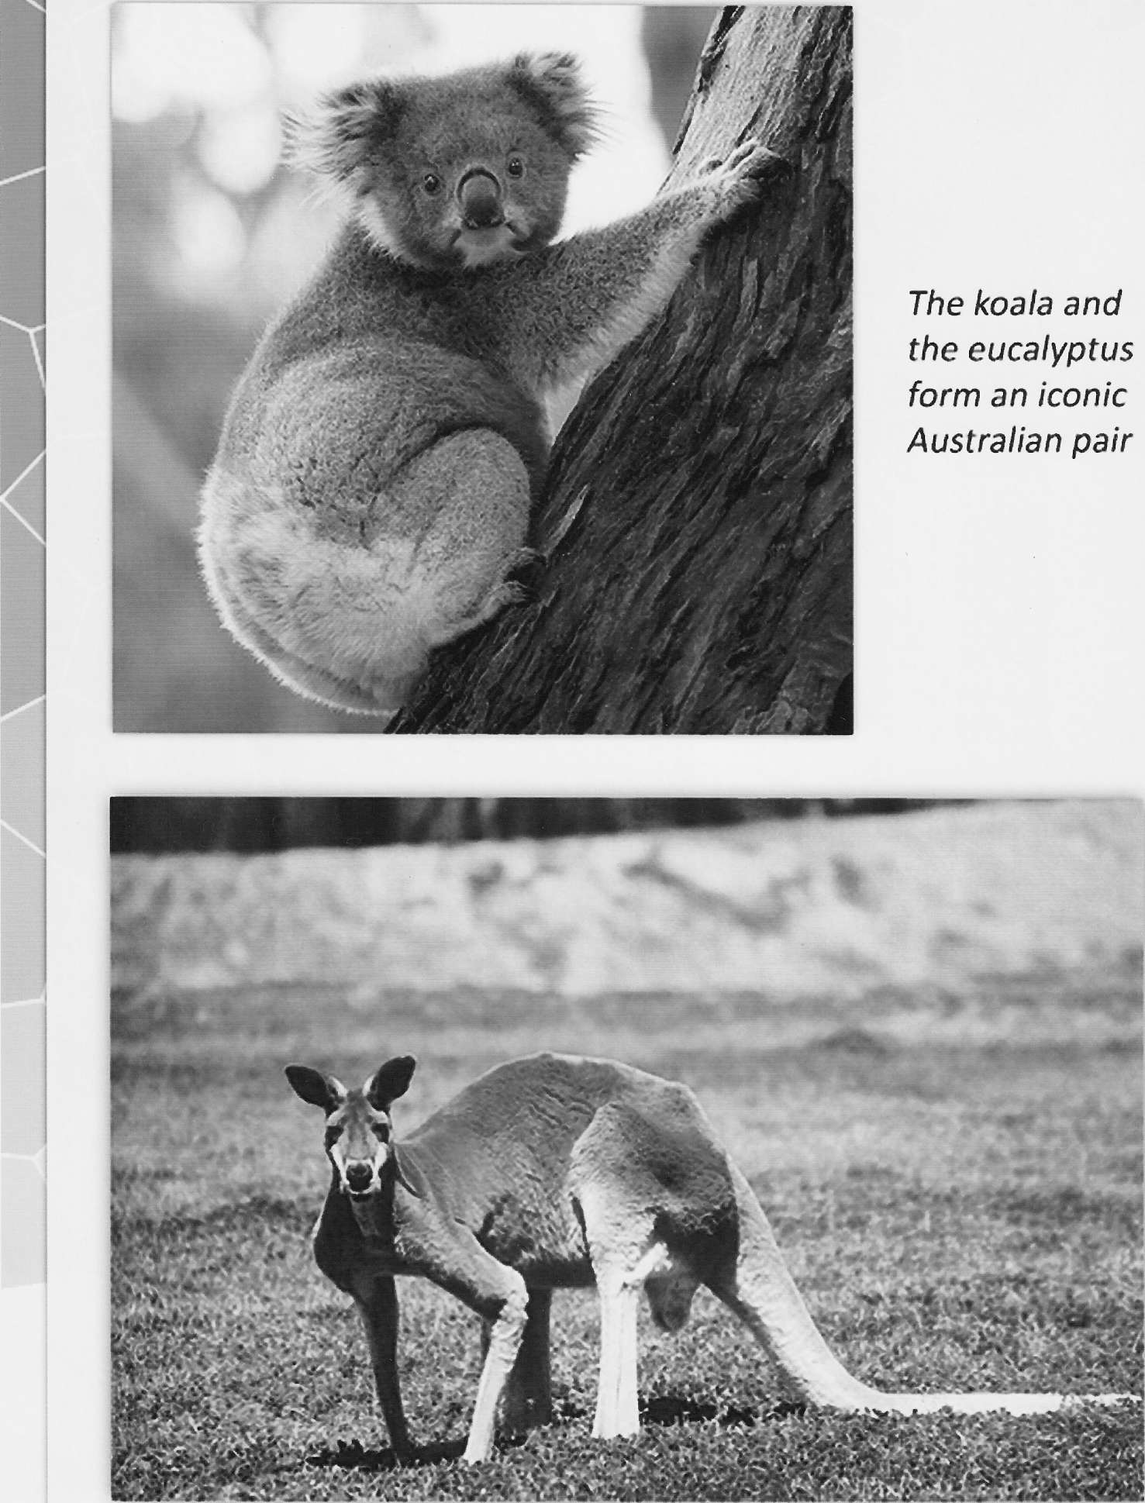

A male Red Kangaroo seen at Taronga Western Plains Zoo
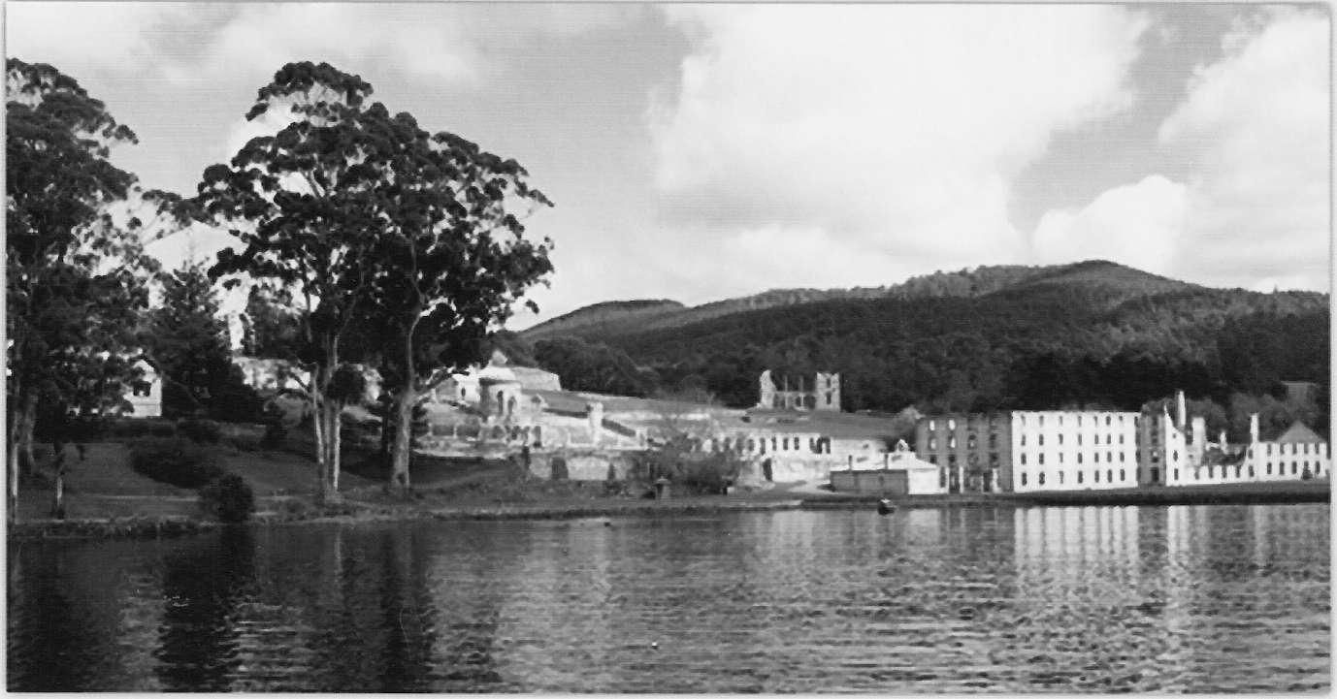

Port Arthur, Tasmania was Australia's largest gaol for transported convicts
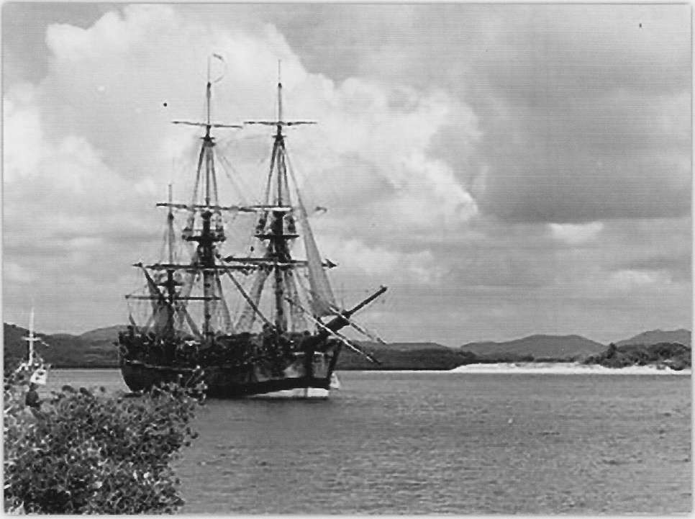

The Endeavour copy of James Cook

Australia

Flag Coat of arms
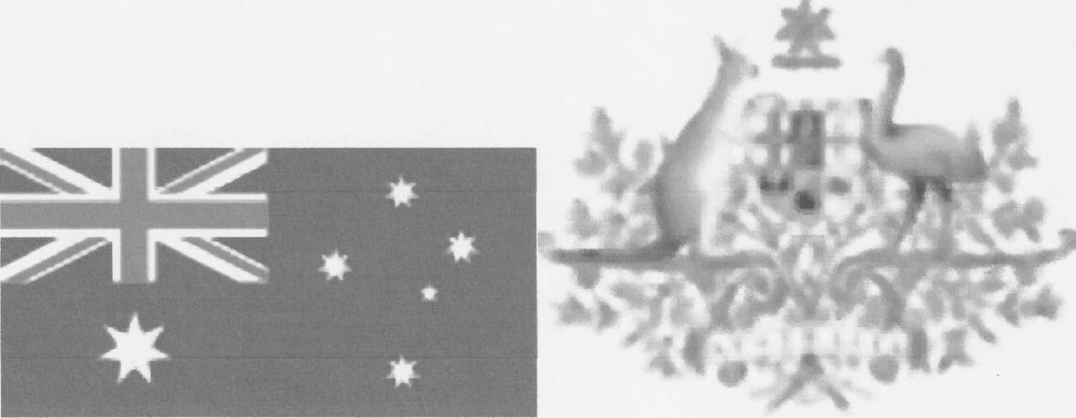

Anthem: Advance Australia Capital Canberra Largest city Sydney.Official language English
Government: Federal parliamentary democracy and constitutional monarchy Monarch Queen Elizabeth II Governor-General Quentin Bryce Prime Minister Julia Gillard Independence from the United Kingdom Constitution 1 January 1901 Statute of Westminster 11 December 1931
Statute of Westminster Adoption Act 9 October 1942 (with effect from 3 September 1939)
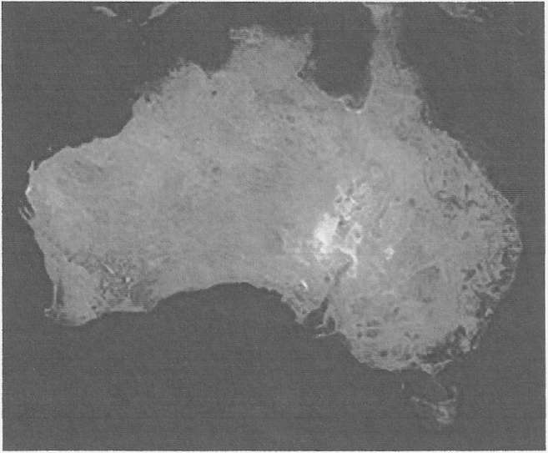

States and territories of Australia
Australia has six states—New South Wales, Queensland, South Australia, Tasmania, Victoria, and Western Australia—and two major mainland territories— the Northern Territory and the Australian Capital Territory . In most respects these two territories function as states, but the Commonwealth Parliament can override any legislation of their parliaments. By contrast, federal legislation overrides state legislation only in areas that are set out in Section 51 of the Australian Constitution; state parliaments retain all residual legislative powers, including those over schools, state police, the state judiciary, roads, public transport, and local government, since these do not fall under the provisions listed in Section 51.
Each state and major mainland territory has its own parliament—unicameral in the Northern Territory, the ACT, and Queensland, and bicameral in the other states. The states are sovereign entities, although subject to certain powers of the Commonwealth as defined by the Constitution. The lower houses are known as the Legislative Assembly (the House of Assembly in South Australia and Tasmania); the upper houses are known as the Legislative Council. The head of the government in each state is the Premier, and in each territory the Chief Minister. The Queen is represented in each state by a Governor; and in the Northern Territory, the Administrator. In the Commonwealth, the Queen's representative is the Governor-General.
States and territories

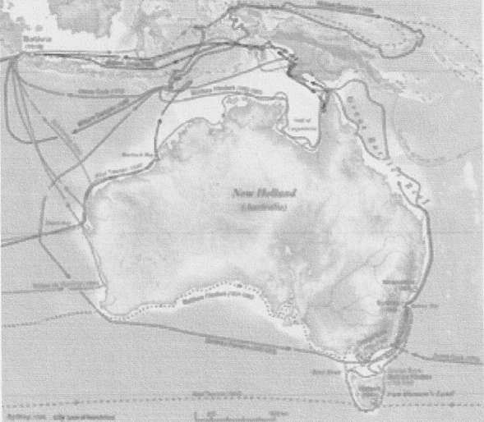

Geography of Australia, Climate of Australia, and Geology of Australia
Climatic zones in Australia, based on the Kdppen climate classification.
Australia's landmass of 7,617,930 square kilometres (2,941,300 sq mi) is on the Indo-Australian Plate. Surrounded by the lndian and Pacific oceans, it is separated from Asia by the Arafura and Timor seas. The world's smallest continent and sixth largest country by total area, Australia—owing to its size and isolation—is often dubbed the 'island continent and variably considered the world's largest island. Australia has 34,218 kilometres (21,262 mi) of coastline (excluding all offshore islands) and claims an extensive Exclusive Economic Zone of 8,148,250 square kilometres (3,146,060 sq mi). This exclusive economic zone does not include the Australian Antarctic Territory
Australia, as seen from space.
Geography and climate
The Great Barrier Reef, the world's largest coral reef, lies a short distance off the north-east coast and extends for over 2,000 kilometres (1,240 mi). Mount Augustus, claimed to be the world's largest monolith,[114] is located in Western Australia. At 2,228 metres (7,310 ft), Mount Kosciuszko on the Great Dividing Range is the highest mountain on the Australian mainland, although Mawson Peak on the remote Australian territory of Heard Island is taller at 2,745 metres (9,006 )
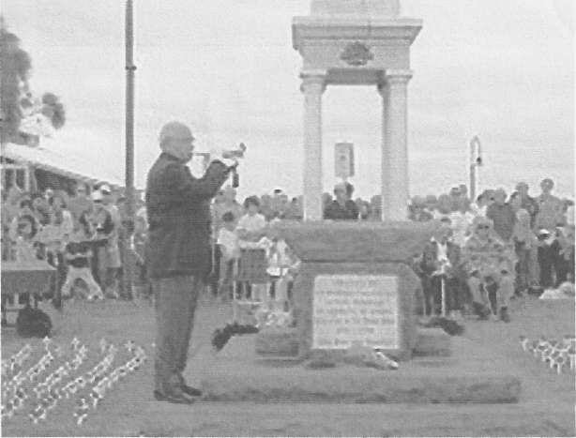
Environment of Australia
The koala and the eucalyptus form an iconic Australian pair
Although most of Australia is semi-arid or desert, it includes a diverse range of habitats from alpine heaths to tropical rainforests, and is recognised as a megadiverse country. Because of the continent's great age, extremely variable weather patterns, and long-term geographic isolation, much of Australia's biota is unique and diverse. About 85% of flowering plants, 84% of mammals, more than 45% of birds, and 89% of in-shore, temperate-zone fish are endemic. Australia has the greatest number of reptiles of any country, with 755 species.
Australian forests are mostly made up of evergreen species, particularly eucalyptus trees in the less arid regions, Wattles replace them in drier regions and deserts as the most dominant species. Among well-known Australian fauna are the monotremes (the platypus and echidna); a host of marsupials, including the kangaroo, koala, and wombat, and birds such as the emu and the kookaburra.Australia is home to many dangerous animals including some of the most venomous snakes in the world. The dingo was introduced by Austronesian people who traded with Indigenous Australians around 3000 ВСЕ. Many plant and animal species became extinct soon after first human settlement,including the Australian megafauna; others have disappeared since European settlement, among them the thylacine.
Environment

Religion
Religion in Australia
Australia has no state religion. In the 2006 census, 64% of Australians listed themselves as Christian, including 26% as Roman Catholic and 19% as Anglican. About 19% of the population cited "No religion" (which includes humanism, atheism, agnosticism, and rationalism), which was the fastest-growing group from 2001 to 2006, and a further 12% did not answer (the question is optional) or did not give a response adequate for interpretation. The largest non-Christian religion in Australia is Buddhism (2.1%), followed by Islam (1.7%), Hinduism (0.8%), and Judaism (0.5%). Overall, fewer than 6% of Australians identify with non-Christian religions. Weekly attendance at church services in 2004 was about 1.5 million: about 7.5% of the population.
Religion does not play a central role in the lives of much of the population.
Education
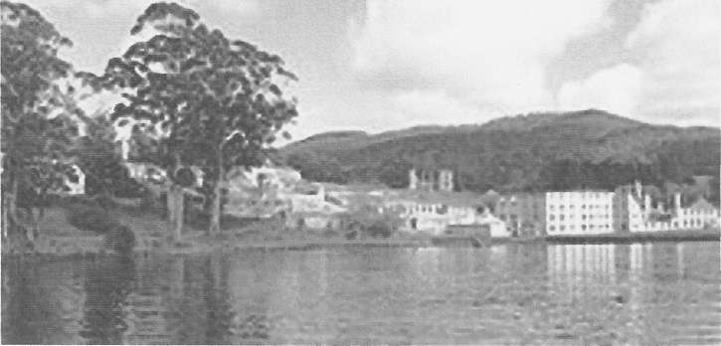

Education in Australia
School attendance is compulsory throughout Australia. All children receive 11 years of compulsory education from the age of 6 to 16 (Year 1 to 10), before they can undertake two more years (Years 11 and 12), contributing to an adult literacy rate that is assumed to be 99%. A preparatory year prior to Year 1, although not compulsory, is almost universally undertaken. In the Programme for International Student Assessment, Australia regularly scores among the top five of thirty major developed countries (member countries of the Organisation for Economic Co-operation and Development). Government grants have supported the establishment of Australia's 38 universities; all but one is public. There is a state-based system of vocational training, known asTAFE Institutes, and many trades conduct apprenticeships for training new
Indigenous Australians experience higher than average rates of imprisonment and unemployment, lower levels of education, and life expectancies for males and females that are 11-17 years lower than those of non-indigenous Australians. Some remote Indigenous communities have been described as having "failed state"-like conditions.
In common with many other developed countries, Australia is experiencing a demographic shift towards an older population, with more retirees and fewer people of working age. In 2004, the average age of the civilian population was 38.8 years.A large number of Australians live outside their home country.

Sydney
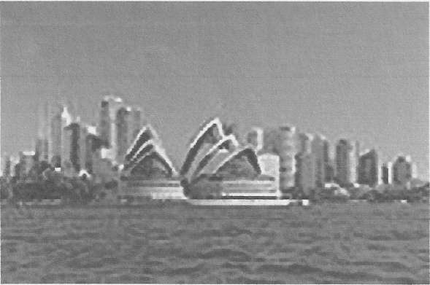

Melbourne
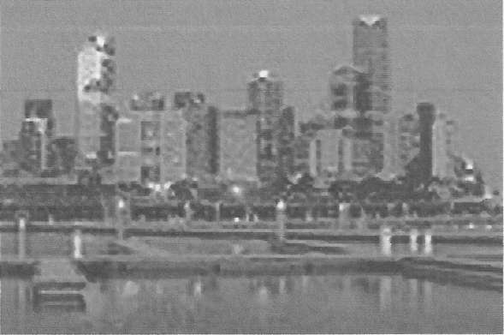

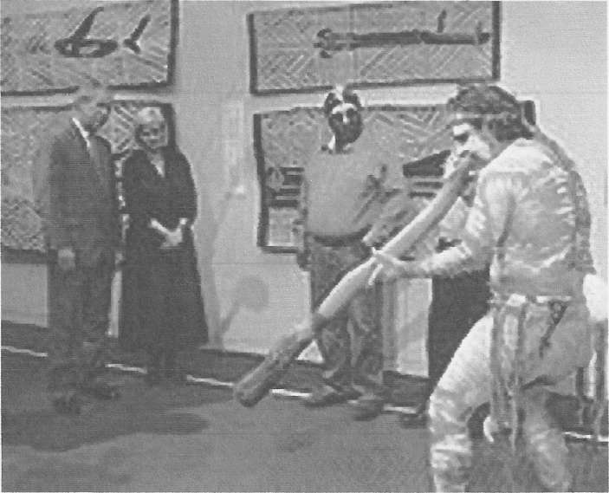

Culture of Australia
The Royal Exhibition Building in Melbourne was the first building in Australia to be listed as a UNESCO World Heritage Site in 2004.
Art
Visual arts of Australia
Sunlight Sweet by Australian landscape artist Arthur Streeton.
Culture
Australian visual arts are thought to have begun with the cave and bark paintings of its Indigenous peoples. The traditions of Indigenous Australians are largely transmitted orally and are tied to ceremony and the telling Dreamtime stories.From the time of European settlement, a theme in Australian art has been the natural landscape, seen for example in the works of Albert
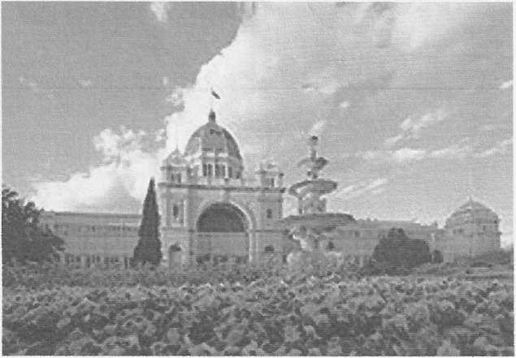

Government of Australia, Politics of Australia, and Monarchy in Australia
Parliament House, Canberra was opened in 1988, replacing the provisional Parliament House building opened in 1927.
Australia is a constitutional monarchy with a federal division of powers. It uses a parliamentary system of government with Queen Elizabeth II at its apex as the Queen of Australia, a role that is distinct from her position as monarch of the other Commonwealth realms. The Queen resides in the United Kingdom, and she is represented by her viceroys in Australia, (the Governor-General at the federal level and by the Governors at the state level), who by convention act on the advice of her Ministers. The Governor-General's powers are not delegated by the Sovereign but conferred in right by the Constitution of Australia. The most notable exercise of the Governor-General's reserve powers outside a Prime Minister's request was the dismissal of the Whitlam Government in the constitutional crisis of 1975.
The federal government is separated into three branches:
The legislature: the bicameral Parliament, comprising the Queen (represented by the Governor-General), the Senate, and the House of Representatives;
The executive: the Federal Executive Council, in practice the Governor-General as advised by the Prime Minister and Ministers of State;
The judiciary: the High Court of Australia and other federal courts, whose judges are appointed by the Governor-General on advice of the Council.
Politics

