**Итоговое тестирование по теоретическому материалу за курс 7 класса**

**Вариант 2**

|  |  |  |  |  |  |  |  |  |  |  |  |  |  |
| --- | --- | --- | --- | --- | --- | --- | --- | --- | --- | --- | --- | --- | --- |
| **1** | **2** | **3** | **4** | **5** | **6** | **7** | **8** | **9** | **10** | **11** | **12** | **13** | **14** |
|  |  |  |  |  |  |  |  |  |  |  |  |  |  |

|  |  |  |  |  |
| --- | --- | --- | --- | --- |
| **Оценка** | **2** | **3** | **4** | **5** |
| **Количество правильно**  **выполненных** | <7 | 7-9 | 10-12 | 13-14 |

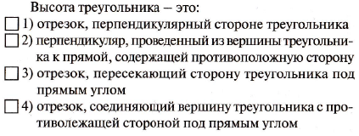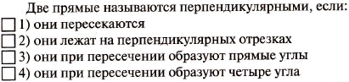**1. 5.**

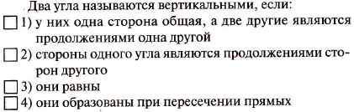**2.**

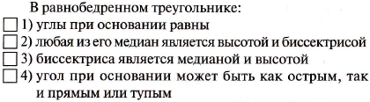 **6.**

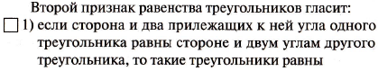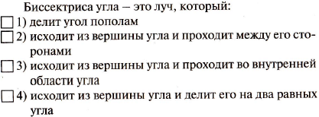**3. 7.**

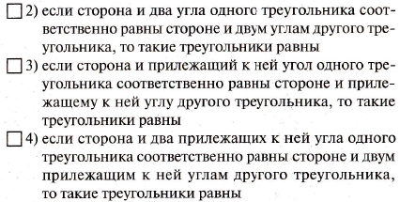

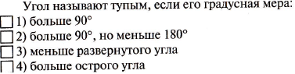**4.**

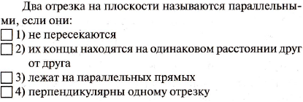

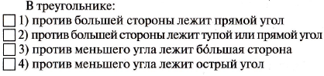**8. 12.**

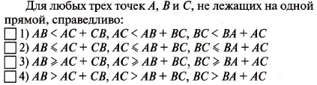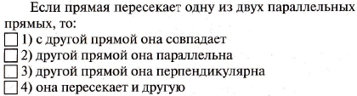**9. 13.**

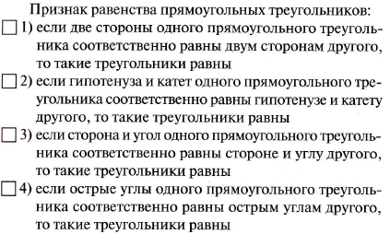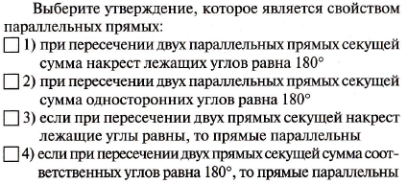**10. 14.**

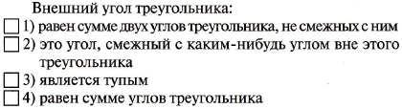**11.**