HYDROCARBONS

Hydrocarbons, as the name suggests, are organic compounds containing carbon and hydrogen. They are extracted from petroleum, natural gas and coal. For this reason organic chemistry is very much related to the petroleum chemistry.

Hydrocarbons can be classified as aliphatic and aromatic.

Aliphatic hydrocarbons have straight or branched structures. They are classified as saturated or unsaturated according to the type of bonding in their structures.

Aromatic hydrocarbons contain the benzene ring structure. So it can be classified as follows:

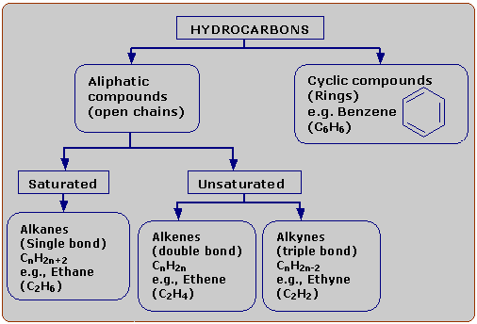

NATURAL SOURCES OF ORGANIC COMPOUNDS

Fossil fuels are energy-rich, combustible forms of carbon or compounds of carbon formed by the decomposition of biomass buried under the Earth over millions of years
Types of fossil fuels
- Natural gas
- Coal
- Petroleum

Fossil Fuels - Natural Gas
Mixture of gaseous hydrocarbons with low molecular weights Main constituent is methane.
The composition of natural gas is chiefly methane (>90%) with traces of ethane, propane, butane, isobutene, and also nitrogen and carbon dioxide.
Uses
- Domestic and industrial fuel.
- In the manufacture of Carbon black - Filler in rubber industry
- In the manufacture of Hydrogen - Raw material in the production of ammonium fertilizers
- In the manufacture of acetylene, methyl alcohol, formaldehyde, formic acid, and many other organic compounds

Fossil Fuels - Coal
Coal is a fossil fuel mined from ancient deposits
It is a black mineral of plant origin which is chemically, a complex mixture of elemental carbon, compounds of carbon containing hydrogen, oxygen, nitrogen and sulfur.
Coal is believed to have been formed about 300 million years ago under the Earth by a process called carbonization.

Carbonization is the process of slow conversion of vegetable matter to coal under the Earth due to the action of high pressure, high temperature, anaerobic bacteria and absence of oxygen.

Types of coal
Depending upon the extent of carbonization, coal can be classified into four types as follows:
Type of coal | Carbon content | Commonly known as
Peat | 11% | ---
Lignite | 38% | Soft coal/ Brown coal
Bituminous | 65% | Household coal
Anthfacite | 96% | Hard coal

Peat is the first stage in the conversion of vegetable matter to coal while anthracite is the last.
The process of heating coal in the absence of oxygen to obtain useful products is called destructive distillation of coal.

Products formed and their uses
Coal tar contains hundreds of organic compounds, such as benzene, its derivatives, phenol, aromatic alcohols, naphtaline, different heterocyclic compounds.
Liquor ammonia contains aqueous ammonia, phenol, hydrogen sulfide and others

Product | Formed/collected in | Uses
Coal Tar (complex  mixture of carbon  compounds) | Bottom of the test tube B.  Liquid residue insoluble in  water | Can be distilled to obtain:  benzene – solvent  toluene – manufacture of  explosive TNT  naphthalene – insect repellent
Coal gas  (CH₄ + CO+ H₂) | Combustible gas insoluble in  water  Escapes through the side tube | Industrial fuel
Liquor ammonia  (NH₄OH) | Soluble in water present  in test tube | Manufacture of nitrogenous  fertilizers
Coke (98%) | Solid residue left behind in  test tube A | Reducing agent in metallurgy  manufacture of water gas  and producer gas- industrial fuel

Flow chart of the process taking place in a coking plant (same as destructive distillation)
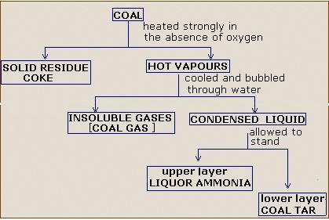

Uses of coal
- On destructive distillation, coal yields useful products like coal gas, coal tar, ammonia and coke
- Generation of electricity
- Domestic fuel for cooking and heating
- Manufacture of synthetic petroleum and natural gas
- To heat water in steam engines and boilers
Coal is thus regarded as the backbone of our national economy.

Fossil Fuels – Petroleum
Petroleum is a dark, viscous, foul smelling liquid, a mixture of solid, liquid and gaseous hydrocarbons with traces of salt, rock particles and water.
Complex mixture of hydrocarbons, chiefly alkanes
Petroleum occurs in nature, trapped between two layers of impervious (non-porous) rocks, usually under the sea. Natural gas collects above the surface of petroleum
Petroleum is brought to the surface by drilling a hole in the Earth's crust and sinking pipes deep down through the impervious cap rock. Natural gas first comes out under high pressure. Then, petroleum is pumped out, collected in tanks and transported, for further processing.

Refining of petroleum is a separation of petroleum into simpler fractions after the removal of unwanted materials.
Fractional distillation is a physical method of separation components of a mixture in a fractionating column based on the difference in the boiling points of the various fractions of petroleum.
The fractionating column is a tall steel tower attached to an electrically heated furnace. Throughout the length of the tower, there are trays with raised holes covered with loose fitting caps called the bubble caps. These caps allow the vapors to rise up and not descend down. The tower has outlet pipes at various levels along its length.
- Crude petroleum is pumped into the furnace where it is heated to a temperature of about 400ºC. Petroleum is converted to vapors in the furnace.
- The vapors of petroleum are fed into the fractionating column from the bottom
- As the vapors enter the column, they rise up and gradually get cooled
- At the bottom of the furnace, the temperature is about 400ºC. Here, the component that has a boiling point close to 400ºC condenses (liquifies) first and is collected on the tray. From the tray it is let off through the outlet pipe
- The remaining vapors rise up through the bubble caps
- When the vapors reach a particular height in the tower, the fraction that has a boiling point close to the temperature at that height condenses on the tray. The remaining vapors continue to rise upwards.
- Like this, at different levels in the tower, different fractions get condensed, collect on the trays and flow out of the outlet pipes.

The following table shows the boiling ranges and uses of some fractions of petroleum:
Fractions | Boiling range | Uses
Petroleum gas | < 40⁰C | - domestic fuel  - production of H₂  - production of carbon block
Petrol | 40-170⁰C | 1. fuel for light motor vehicles  2. solvent for dry cleaning
Kerosene | 170-250⁰C | 1. domestic fuel  2. illumination lamps  3. aviation fuel (for aeroplane) (purified)
Diesel | 250-350⁰C | 1. fuel for HM vehicles (Lorry, Bus)  2. generating electricity
Fuel oil | 350-400⁰C | 1. industrial fuel  2.fuel for ships
Lubricating oil  (Residual oil) | >400⁰C | 1. for lubricating machine parts
Paraffin wax  (Residual oil) | >400⁰C | 1. fuel in candles  2. shoe polish

Rectification gas (petroleum gas) – a mixture of low molecular hydrocarbons, mainly propane and butane, boiling point until 40 ⁰C
Gasoline fraction (petrol) – hydrocarbons from C₅H₁₂ to C₁₁H₂₄ (boiling point 40-200 ⁰C), if that fraction is separated gasoline (40- 70 ⁰C) and petrol (70 -120 ⁰C) are produced.
Ligroin fraction – hydrocarbons from C₈H₁₈ to C₁₄H₃₀ (boiling point 150-250 ⁰C)
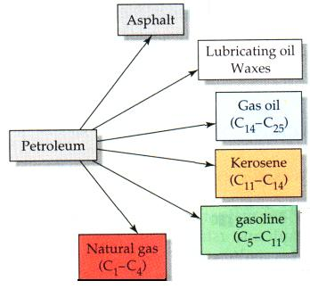
Kerosene fraction – hydrocarbons from C₁₂H₂₆ to C₁₈H₃₈ (boiling point 180-300 ⁰C)
Diesel – hydrocarbons from C₁₃H₂₈ to C₁₉H₃₆ (boiling point 200- 350 ⁰C)

Residual oil is that component of petroleum, which is collected first at the bottom of the tower. It has a boiling range of over 400ºC. It can be further distilled separately to obtain lubricating oil, paraffin wax, asphalt etc.

ALKANES
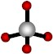
alkanes are very common organic compounds. In our daily lives, we meet
them in most every place, for example, gasoline, natural gas and candle
wax all consist of alkanes.
METHANE

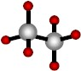
In alkanes or saturated hydrocarbons, each carbon atom forms four
covalent bonds. These are C-C and C-H sigma bonds. Sigma bonds are very
strong, so for this reason, alkanes are also known as paraffins which means
“inert”.

ETHANE The general formula of alkanes is C_{n}H_{2n+2}, where n is an integer and
indicates the number of carbon atoms.
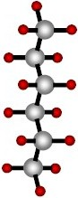
In alkanes all carbon atoms are sp³ hybridized
HEXANE
Name | Number of  carbon  atoms | Molecular  formula | Condensed  formula
Methane | 1 | CH₄ | CH₄
Ethane | 2 | C₂H₆ | CH₃CH₃
Propane | 3 | C₃H₈ | CH₃CH₂CH₃
Butane | 4 | C₄H₁₀ | CH₃CH₂CH₂CH₃
Pentane | 5 | C₅H₁₂ | CH₃CH₂CH₂CH₂CH₃
Hexane | 6 | C₆H₁₄ | CH₃CH₂CH₂CH₂CH₂CH₃
Heptane | 7 | C₇H₁₆ | CH₃CH₂CH₂CH₂CH₂CH₂CH₃
Octane | 8 | C₈H₁₈ | CH₃CH₂CH₂CH₂CH₂CH₂CH₂CH₃
Nonane | 9 | C₉H₂₀ | CH₃CH₂CH₂CH₂CH₂CH₂CH₂CH₂CH₃
Decane | 10 | C₁₀H₂₂ | CH₃CH₂CH₂CH₂CH₂CH₂CH₂CH₂CH₂CH₃

As you see in table there is a (-CH₂-) difference between members of consecutive alkanes. A series of compounds in which the members are built up in this way is referred to as a homologous series. Each member of the series is called homologue.

Characteristics of homologous series
- All homologues of a series have the same general formula e.g., all alkanes have the general formula C_{n}H_{2n+2}.
- Each consecutive member differs from the next by one carbon atom and two hydrogen atoms (-CH₂ group).
- The difference in the molecular mass between two consecutive homologues is 14 amu
- The physical properties of homologues show a regular gradation
- Homologues of a series have similar chemical properties
- Homologues of a series have similar methods of preparation
Example: What is the molecular formula of a saturated hydrovarbon if 0,05 moles of the compound has a mass of 3,6 grams?

Solution: Let us find the molecular mass of the alkane.
If 0,05 mole weighs 3,6 grams
1 mole weighs x grams
X= 72 g/mole
We know that general formula of alkanes is C_{n}H_{2n+2}. So,
C_{n}H_{2n+2} = 72
12n + 1(2n + 2) = 72
14n + 2 = 72, n=5
So the molecular formula of the alkane is C₅H₁₂

ALKYL GROUPS
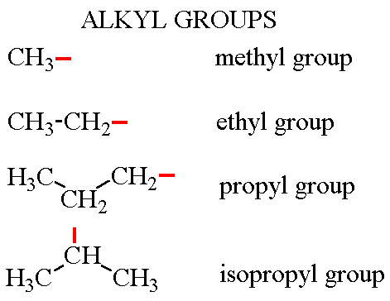
- If one hydrogen atom is removed from an alkane, an alkyl group is formed.
- General formula of alkyl groups is C_{n}H_{2n+1}.
- Instead of the “–ane” suffix in alkanes, “-yl” is used for naming of alkyl groups.
- They are represented as “R”, meaning radical.
- A carbon atom in an alkane can be named as primary, secondary or tertiary according to number alkyl groups bonded to it.
- C_{n}H_{2n+2} → C_{n}H_{2n+1}
Alkane Alkyl

A carbon atom can be named as primary, secondary of tertiary according to the number of other carbon atoms to which it is attached.

Nomenclature OF ALKANES

Nomenclature is the scientific term for naming compounds. The governing body is “The International Union of Pure and Applied Chemistry” or IUPAC for short. The following statement is from their web site:
“The International Union of Pure and Applied Chemistry (IUPAC) serves to advance the worldwide aspects of the chemical sciences and to contribute to the applications of chemistry in the service of Mankind. As a scientific, international, non-govermental and objective body, IUPAC can address many global issues involving the chemical sciences”

IUPAC was formed in 1919 by chemists from industry and academia. One of their main functions is to objectively create rules for naming compounds in the most simplified manner possible. This is equivalent to creating a new language, just like English grammar, there are rules.

Naming of organic structures, unlike biological classification, follows a rigid set of rules. The
International Union of Pure and Applied Chemistry, abbreviated IUPAC, came up with a set of rules that follows the same standards worldwide, and is accepted among all chemists.

However, common names of compounds, or names that have historical roots, are still used today for many compounds.

How alkanes are named?
The suffix for the alkane family is –ane.
prefix – root – suffix
prefix – where the substitutions are located
root – how many carbons are in the molecules longest chain
suffix – family – type of functional group (alkane, alkene, alcohol, ester, etc...)

Root words are named for its number of carbons:
number of C | root
1 | meth-
2 | eth-
3 | prop-
4 | but-
5 | pent-
6 | hex-
7 | hept-
8 | oct-
9 | non-
10 | dec-

Example:
an alkane with 3 carbons is named propane
prop – for the 3 carbons
ane – for the family alkane (meaning all single bonds)

Formula Types:
A variety of methods are used to describe a chemical compounds composition. Sometimes you will find a the chemical formula sufficient. Other times you need to see the structure drawn out, this is referred to as the structural formula. This is a larger drawing which will show the atoms are connected. Another is the condensed structural formula, this shows the connections in around about manner. Lastly, a more lazy form is the line structure. This simplified drawing assumes you know that carbon atoms make 4 bonds and that if you do not see a bond drawn assume a hydrogen is occupying the undesignated bond. Also all ends and turns in the line signify carbon atoms.
Steps to name (IUPAC) alkanes:
- Choose the longest continuous chain of carbons (parent chain)
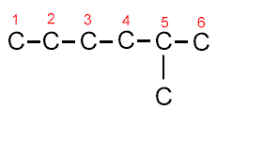
six carbons = hexane

- Locate the side group and circle it.
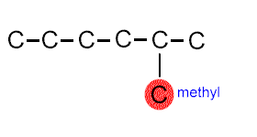
one side group which is a methyl

- Starting from each end of the parent chain, number from the end to give the first side group you come to the lowest possible number. 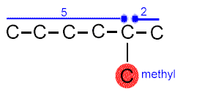
  - If you number from left to right, the methyl would be on the 5th carbon
  - If you number from right to left, the methyl would be on the 2nd carbon

Choose the direction that gives the methyl the lowest carbon number which would be right to left. Therefore, the methyl is on the second carbon.

The name of the compound above would be 2 - methyl hexane (note that a "-" goes between numbers and words)

- If there are two side groups, number from the direction which gives the lowest number for the first side group encountered.
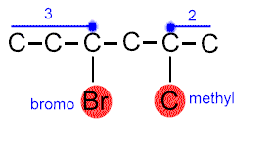
The methyl would be on the 2nd carbon numbering from right to left and the bromo would be on the 3rd carbon numbering from left to right. The lowest number would be the methyl on the 2nd carbon. Therefore, number from right to left.
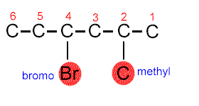
To name the compound, list the side groups in alphabetical order.
4 - bromo - 2 - methyl hexane
- If numbering from each end of the parent chain gives the same initial number (note below that the bromo and the methyl would be on the second carbon), default to the second group of side groups (in this case the chloro side group).
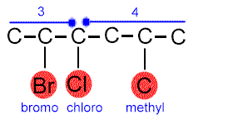
The chloro side group gives the next lowest set of numbers, so we would number from left to right.
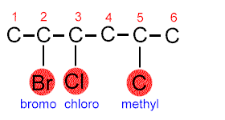
We would then name the compound based on the parent name of hexane and order the side groups in alphabetical order.
2 - bromo - 3 - chloro - 5 - methyl hexane

If this doesn't give a second set of lowest numbers, try a third set of lowest numbers, etc.

- If there is no difference in numbering to find the lowest numbered side group (both the bromo and methyl group below would be on the second carbon),
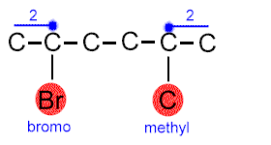
default to the alphabetical names of the side groups.
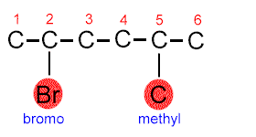

Since bromo is alphabetically before methyl, we would number from left to right,
2 - bromo - 5 - methyl hexane

7. If more than one side group is the same, use di (2) - tri (3) - tetra (4) - etc. 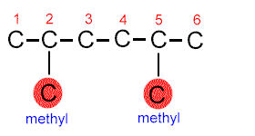
We would name this 2,5 - dimethyl hexane.
Notice that we separate numbers using a comma (,) and numbers and words using a dash (-).
Isomerism in Alkanes

Isomers are compounds having the same molecular formula but different properties due to different structural arrangement of atoms in their molecules.
Isomers have the following characteristics:
- Same molecular formula
- Different structural formula
- Different physical properties (e.g., boiling point)
- Similar or different chemical properties
- Same molecular mass

The minimum number of carbon atoms required to form isomers is four. Butane is the first alkane that can exhibit isomerism. The first three alkanes cannot exhibit isomerism because there can be no change in their three dimensional structure of the molecules.

Alkanes have only structural isomers, which can be:
- Carbon chain isomers

Isomerism in butane

The molecular formula of butane is C₄H_{10.} With this molecular formula, there are two structural arrangements possible as shown below:
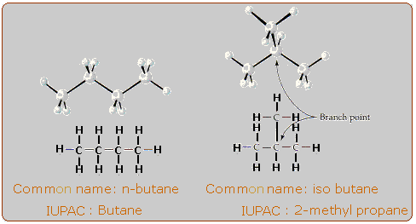

Isomerism in Pentane

The molecular formula of pentane is C₅H₁₂. With this formula, three isomers are possible.
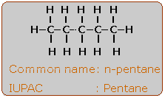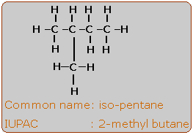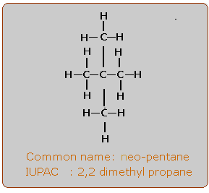

Physical properties of Alkanes

- They are insoluble in water, but soluble in organic solvents such as benzene and carbon tetrachloride. The reason is that water molecules are polar and attract one another. Alkanes are nonpolar.
- Their densities are smaller than 1g/ml and they are generally colorless, tasteless, and odorless.
- Alkanes have lower boiling points for a given molecular weight than most other organic compounds. The boiling point is directly related to the molecular weight.
Methane -162⁰C, ethane -89 ⁰C, propane -42⁰C
- The lower molecular weight alkanes, methane through butane are gases at ordinary temperatures and pressures. The C₅ to C₁₇ alkanes are liquids at room temperature, and alkanes containing more than C₁₇ are solids at room temperature.

Name | Formula | Melting point (⁰C) | Boiling point (⁰C) | State at 25⁰C
methane | CH₄ | -183 | -164 | Gaseous
ethane | C₂H₆ | -183 | -89 | Gaseous
propane | C₃H₈ | -190 | -42 | Gaseous
butane | C₄H₁₀ | -138 | -0.5 | Gaseous
pentane | C₅H₁₂ | -130 | 36 | Liquid
hexane | C₆H₁₄ | -95 | 69 | Liquid
heptane | C₇H₁₆ | -91 | 98 | Liquid
octane | C₈H₁₈ | -57 | 125 | Liquid
nonane | C₉H₂₀ | -51 | 151 | Liquid
decane | C₁₀H₂₂ | -30 | 174 | Liquid
undecane | C₁₁H₂₄ | -25 | 196 | Liquid
dodecane | C₁₂H₂₆ | -10 | 216 | Liquid
eicosane | C₂₀H₄₂ | 37 | 343 | Solid

Table: Physical properties of alkanes

Preparation of alkanes

The two most important natural sources of alkanes are petroleum and natural gas. Petroleum is a complex liquid mixture of organic compounds. Many of these compounds are alkanes or cycloalkanes. All of the alkanes up to and including C₃₃H₆₈ have been isolated from petroleum. Natural gas consists mainly of methane (about 80%) and ethane (5-10%), with lesser amounts of some higher alkanes.

Laboratory methods
1. The Wurtz reaction
When alkyl halides (RX) are heated with sodium in dry ether solution, alkanes of double the carbon content are produced. The reaction can be summarized by general equation:

R- X + 2Na + X – R → R – R + 2 NaX
Alkyl halide Alkane

For example, ethyl bromide gives a good product of n-butane
2 CH₃-CH₂Br + 2Na → CH₃CH₂- CH₂CH₃ + 2 NaBr
Ethyl bromide n-butane

Example: Which alkyl halides should be used to obtain hexane by the Wurtz synthesis?
Explain.
Solution:
The total number of carbon atoms in the reactions must be equal to number of carbon atoms in the product in a Wurtz synthesis. Hexane C₆H₁₄ contains 6 carbon atoms. So the sum of carbon atoms that will be used in forming hexane must be 6. These numbers may be 1-5, 2-4, or 3-3. According to this:
-CH₃ and –C₅H₁₁ (methyl and pentyl)
-C₂H₅ and –C₄H₉ (ethyl and butyl)
-C₃H₇ and –C₃H₇ (propyl and propyl)
may be used to produce hexane by the Wurtz method. If it is desired that the production of hexane be as efficient as possible, the most suitable alkyl groups are propyl-propyl. So propyl chloride would be the recommended starting product.

Exercise: Which alkyl halide must be used to obtain the substance?

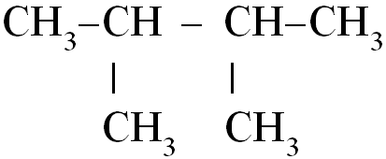

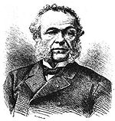
Wurtz, Charles Adolphe, 1817-84, French chemist. He was professor at the Sorbonne (1852-75), at the Faculty of Medicine, Paris (1853-75), and at the Faculty of Sciences, Paris (from 1875). Noted for his research in organic chemistry, he discovered methyl and ethyl amines (1849), glycol (1856), and aldol condensation (1872). He developed (1855) a method of synthesizing hydrocarbons by treating alkyl halides with sodium (Wurtz reaction) that was adapted by the German chemist Rudolf Fittig to the preparation of mixed aliphatic and aromatic hydrocarbons (Wurtz-Fittig reaction). Wurtz also invented a bulbed fractionating column known as the Wurtz column. He wrote influential works in support of the atomic theory and on medical and biological chemistry.

2. Reduction of Alkenes (Hydrogenation)

Unsaturated hydrocarbons, whether involving double or triple bonds, may be converted to alkanes by the addition of hydrogen in the presence of a metal catalyst under high temperature (250 -300 ⁰C) and pressure
Pt/Pd
R – CH ═ CH₂ + H₂ ──→ R- CH₂ – CH₃
Alkene heat Alkane

Pt/Pd
CH₂ ═ CH₂ + H₂ ──→ CH₃ – CH₃
Ethylene heat Ethane

Pt/Pd
R- C ≡ CH + H₂ ──→ R- CH₂ – CH₃
Alkyne heat Alkane

Pt/Pd
CH≡ CH + H₂ ──→ CH₃ – CH₃
Ethyne heat Ethane

3. Heating the metal salts of carboxylic acids (decarboxylation)

When sodium salts of carboxylic acids are heated with NaOH, alkanes are produced.

Heat/CaO
R-COONa + NaOH R-H + Na₂CO₃
sodium salt of Alkane
a carboxylic acid

heat
C₂H₅COONa + NaOH ─→ C₂H₆ + Na₂CO₃
Sodium propionate Ethane

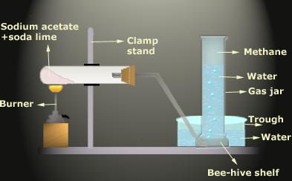

Methane is prepared by heating CH₃COONa with soda-lime.

CH₃COONa + NaOH → CH₄ + Na₂CO₃

Soda lime is a white granular mixture of calcium hydroxide and sodium hydroxide

Example:
What is the molecular formula of an alkane which has density by an air 2?

Solution: M_{r}= D air * 29 g/mol
M_{r} = 2* 29 = 58 g/mol
General formula of an alkane is C_{n}H_{2n+2}
12n + 2n + 2 = 58, 14n= 56, n = 4 .
So the molecular formula of compound is C₄H₁₀

Example: The hydrocarbon contains 81,82% C. Mass of 1 L of the hydrocarbon is 1,964 g
at STP. Find the molar formula and name it.

Solution:
First we can find molecular mass of a compound,
m= n x M_{r}, V= n x 22,4 n= V/22,4;
V x M_{r}
m =
22,4

1,964 = 1/22,4 x M_{r}, M_{r} = 44 g/mol
Find the ratio between C and H atoms
n(C) : n(H) = 81,82/ 12 : 18,18 /1 = 6,82 : 18,18 = 3,41: 9,09= 3:8
By the molecular formula we can also find the formula C₃H₈

Chemical properties of alkanes

Type of chemical reaction | The equation of chemical reaction
Free radical substitution reactions:  Halogenation  Nitration (Konovalov’s reaction) | The hydrogen atoms of methane get substituted one after the other by chlorine atoms to form four substitution products  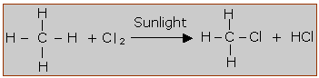  Methyl chloride (IUPAC name - monochloro methane)  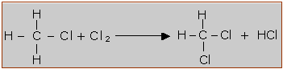  Methylene dichloride (IUPAC name - Dichloro methane)  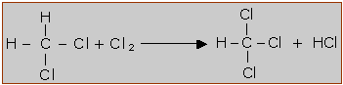  Chloroform (IUPAC name - Trichloro methane)  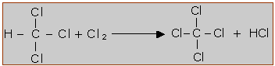  Carbon tetra chloride (IUPAC name - Tetra chloro methane)  CH₄ + HNO₃ → CH₃NO₂ + H₂O  methane nitromethane
Dehydrogenation | t  C₃H₈ → C₃H₆ + H₂  propane propene
Combustion  (excess of oxygen) | CH₄ + 2O₂ → CO₂ + 2H₂O
Catalytic oxidation  (depending on conditions – temperature and catalyst- alcohol, aldehyde, carboxylic acid can be produced) | 2CH₄ + O₂ → 2CH₃OH (methanol)  CH₄ + O₂ → HCHO (methanal)  2CH₄ + 3O₂ → 2HCOOH (methanoic acid)
Thermal decomposition  Cracking  Pyrolysis  (thermal decomposition without oxygen at low pressure) | CH₄ ^{T=1000} C + 2H₂  2CH₄ ^{T=1500} HC≡CH + 3H₂  H₃C-CH₃ ^{T=500, Ni} H₂C=CH₂ + H₂
Isomerisation | CH₃-CH₂-CH₂-CH₂-CH₃ ^{T} ^{AlCl3} CH₃-CH₂-CH-CH₃  |  CH₃  pentane 2-methyl-butane

Some New Terms

- Alkyl group: is one that corresponds to an alkane minus one hydrogen
- Alkane: is a hydrocarbon whose molecules have only single bonds
- Catalytic cracking: is a process of production of mixture of saturated and unsaturated hydrocarbons when alkanes are heated to high temperatures in absence of air or at a lower temperature by use of catalyst such as silica or alumina
- Halogenation: is a substitution reaction of halogens for the hydrogen of an alkane
- Homologous series: is a series of compounds in which each member differs, from the next higher or lower member by a constant increment (which is CH₂).
- Hydrocarbon: a compound whose molecules consist only of carbon and hydrogen
- Hydrogenation: is addition of hydrogen to unsaturated hydrocarbons in the presence of Ni or Pt catalyst
- Isomerism: is the existence of different structural formula
- Isomers: are compounds which have the same molecular formula but different structural formulas
- IUPAC rules: the formal rules for naming compounds as developed by the International Union of Pure and Applied Chemistry
- Nitration: is the introduction of a nitro group (-NO₂) into an organic compound


At the top of a burning candle, the heat from the flame melts the wax. The liquid wax soaks up through tiny channels in the wick. It becomes a gas, mixes with the surrounding air and then burns. This releases more heat, which keeps these processes going, and carries the products of combustion away from the flame, allowing more air to mix with the gaseous hydrocarbon.

Example: When 2,2 grams of an alkane is burnt completely 3,36 liters of carbon dioxide
at STP? What is the molecular formula of this alkane?

Solution:
The general equation for the combustion of alkanes is:
C_{n}H_{2n+2} + (3n+1/2)O₂ → nCO₂ + (n+1)H₂O
Let us find the number of moles in 3,36 liters of CO₂ at STP
n (CO₂) = 3,36/ 22,4 = 0,15 moles
We can find the number of moles of alkane as:
1 mole alkane gives n moles of CO₂
x mole alkane gives 0,15 moles of CO₂
x= 0,15/n
Molar mass of alkane C_{n}H_{2n+2} = 12n + 2n + 2 = 14n + 2
n = m/M

0,15 2,2
──── ═ ──────
n 14n + 2
2,2 n = 0,15 (14n + 2)
n = 3
The formula is C₃H₈

METHANE

Methane, the first member of the alkane is mainly found in mines and in natural gas which is formed over petroleum reserves. It is also known as marsh gas and is formed by the decomposition of plants in the absence of oxygen.

Natural methane
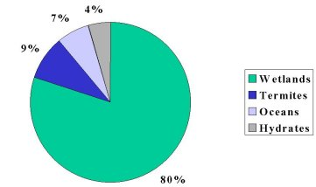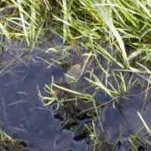

Natural sources of methane include wetlands, gas hydrates, permafrost, termites, oceans, freshwater bodies, non-wetland soils, and other sources such as wildfires.

Termites
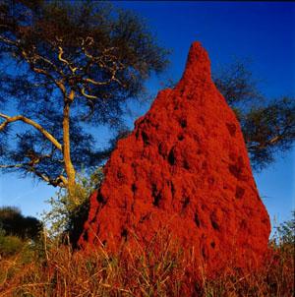

Global emissions of termites are estimated to be about 11% of the global methane emissions from natural sources. Methane is produced in termites as part of their normal digestive process, and the amount generated varies among different species. Ultimately, emissions from termites depend largely on the population of these insects, which can also vary significantly among different regions of the world.

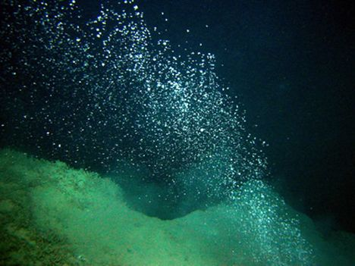
Oceans

Oceans are estimated to be responsible for about 8% of the global methane emissions from natural sources. The source of methane from oceans is not entirely clear, but two identified sources include the anaerobic digestion in marine zooplankton and fish, and also from methanogenisis in sediments and drainage areas along coastal regions

Natural Gas and Petroleum Systems

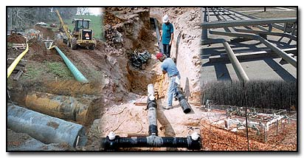
Methane is the primary component of natural gas. Methane losses occur during the production, processing, storage, transmission, and distribution of natural gas. Because gas is often found in conjunction with oil, the production, refinement, transportation, and storage of crude oil is also a source of methane emissions.

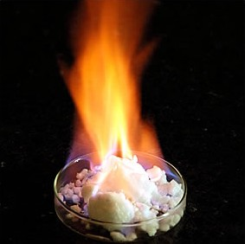
Physical properties

- Methane is a colorless and odorless gas
- It is insoluble in water, but soluble in benzene and gasoline
- It is less dense than air
- It’s boiling point is -161,5ºC

Preparation methods

Methane can be produced by some of the general alkane production method.
In addition there are three special methods for the production of methane.

- The reaction of aluminum carbide in acidic solution produces methane

Al₄C₃ + 12H₂O → 4Al(OH)₃ + 3CH₄↑

- When a mixture of CO and H₂ gas is passed over Nickel (Ni) or Cobalt (Co) at 300- 400ºC, methane is produced.

CO + 3H₂ ^{Ni/300-4000C} CH₄ + H₂O

- Methane can also be obtained from the reaction of carbon with hydrogen under high
temperature and pressure in the presence of a nickel catalyst

C +2H₂ ^{Ni, pressure, heat} CH₄

Usage of methane

- Domestic fuel (It is a component of natural gas, biogas, coal gas, etc.)
- Carbon black produced by pyrolysis of methane is used as a filler for natural rubber. It is also used in paints and printer's ink.
- Hydrogen produced by pyrolysis of methane is used in the manufacture of ammonia, a raw material for nitrogenous fertilizers
- Chloroform, a substitution product of methane has anaesthetic properties
- Carbon tetrachloride, a substitution product of methane is used as a solvent
- Production of formaldehyde, formic acid
- Production of methanol, acetylene

SUPPLEMENTARY QUESTIONS

1. Name following compounds
1.
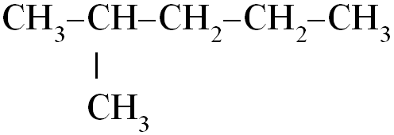
2.
3.
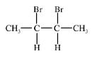
4.
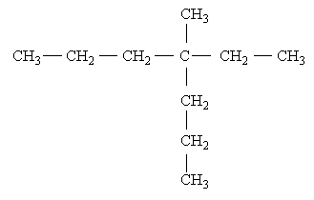
5.
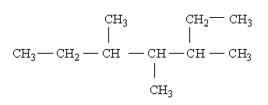
6.
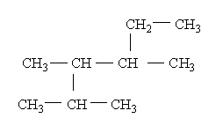
2. Write the structural formula for
the following alkanes:
  - 2-methylpentane
  - 2,2-dimethylpropane
  - n-octane
  - 3-ethyl-2,5-dimethylheptane
  - 3-ethylpentane
  - 2,2,3,3-tetramethylbutane
  - 4-isopropyl-2-methylheptane
  - 2-chloro-2,3-dimethyl-3-ethylheptane
  - 2,5-dimethylheptane
  - 2-bromo-2-methylpropane
  - 2,2,4,6,6-pentamethyloctane
  - 1,1-dichloro-3-ethyl-2,4-dimethylpentane
- What is isomerism? Give the structural formulae of two compounds which are isomers?

- There are one methyl, two ethyl and one propyl group attached to a carbon atom. What is the IUPAC name of this compound.

- Heptane has 9 isomers. Draw their structural formulae, name all these compounds.

- Show all possible structural formulae of C₃H₇Cl

- How many isomers does C₂H₄Cl₂ have? Show the formulae of these isomers.

- 0,25 moles of an alkane weighs 35,5 grams. Find its molecular formula.

- An alkane contains 20% hydrogen by mass. Find the molecular formula of this compound.

- What are the names of the compounds which are formed by the reaction of 2-bromopropane and 2-methyl-3-chlorobutane with a sufficient amount of sodium?

- What is the molecular weight of the compound that is produced by 2 moles of 2-bromopropane and excess Na? Give its IUPAC name.

- Which alkyl halide pairs may be used to obtain 2-methylbutane?

- Complete the equations and name the products
  - isopropyl chloride + sodium →
  - sodium butanoate + NaOH→
  - propene + hydrogen →
  - propyl bromide + sodium →

- How many grams of aluminum carbide must be used to obtain 560 cm³ methane gas at STP by a reaction with 75% yield?

- What volume of air is needed to burn 56 liters of butane gas at STP?

- How many grams of water is produced by burning 1,12 liters of propane in air at STP?

TEST QUESTIONS

1. Structural isomerism is possible in alkanes only if the number of carbon atoms present is
- an odd number
- 4 or more
- an even number
- 5 or more
- none of the above

2. How many carbon atoms are present in the alkane whose IUPAC name is 2,2,4-trimethylpentane?
- Nine
- Five
- Seven
- Eight
- None of the above

3. How many hydrogen atoms are present in the molecule 3,5-dimethyloctane?
- twenty-two
- twenty-four
- eighteen
- twenty
- none of the above

4. In which of the following pairs of alkanes are the two members of the pair structural isomers?
- butane and pentane
- hexane and 2-methylhexane
- 2,3-dimethylhexane and
2,3-dimethylheptane
- 2-methylpentane and
2,3-dimethylbutane
- none of the above

5. Which of the following is a general physical property of alkanes?
- all are very polar molecules
- all are liquids at room temperature
- not soluble in water
- more dense than water
- none of the above

6. Which of the following statements concerning saturated hydrocarbons is incorrect?
- all bonds present are single bonds
- every carbon atom present has four bonds
- every carbon atom present must be bonded to at least two hydrogen atoms
- more than one correct response
- no correct response
7. Which of the following compounds is a structural isomer of CH₃CH₂CH₂CH₂CH₃?
- 2,2-dimethylbutane
- 2-methylpentane
- 2-methylbutane
- more than one correct respons
- no correct response

8. In which of the following alkanes are 10 carbon atoms present?
- 3,4-diethylhexane
- 3-ethyl-2,4-dimethylpentane
- 2,3-dimethyloctane
- more than one correct response
- no correct response

9. Which one of the following is the structural isomer of n-hexane?
- 3-ethylpentane
- 3-methylpropane
- 2,2-dimethylpropane
- 2,2-dimethylbutane

10. Reaction of methane with chlorine is:
- combination, exothermic
- substitution, endothermic
- combination, endothermic
- substitution, exothermic

11. An alkane which has 6 carbon atoms has a formula:
A) C₆H₁₄ B) C₆H₁₂ C) C₆H₁₀ D) C₆H₆

12. Which one of the following can be produced from 2-bromopropane by Wurtz reaction?
A) Butane
B) Hexane
C) 2,2-dimethylbutane
D) 2,3-dimethylbutane

13. How many sigma bonds are there in a molecule of a saturated aliphatic hydrocarbon with 5 carbon carbon atoms?
A) 5 B) 8 C) 12 D) 16 E) 17

14. When 8,8 grams of an alkane is burned, 26,4 grams of CO₂ is produced? What is the molecular formula of this alkane?
A) C₃H₈ B) C₂H₆ C) C₅H₁₂ D) C₄H₁₀

15. How many grams of aluminum carbide must react with water to produce 6,72 liters of methane gas at STP?
A) 14,4 B) 28,8 C) 43,2 D) 57,6
16. The molar mass of an alkyl bromide is 123 g/mol. Which of the compounds below can be produced from the reaction of this alkyl bromide with sodium?
A) Ethane
B) Propane
C) Sodium Propionate
D) Heptane
E) 2,3-dimethylbutane

- Which of the following methods can be used to produce methane?
    - From its elements using catalysrs
    - Addition of hydrogen to alkynes
    - The reaction of CO₂ and H₂O
A) I only B) I and II C) II and III D) I and III E) I, II and III

- Which one of the given compounds cannot be produced by a Wurtz reaction?
A) C₆H₁₄ B) C₄H₁₀ C) C₃H₈
D) C₂H₆ E) CH₄
- Which of the following might be produced by the reaction of C₂H₅Cl and C₃H₇Cl with Na?
    - CH₄
    - C₄H₁₀
    - C₅H₁₂
A) I only B) II and III C) I and III D) I and II E) I,II and III

- I. The alkane that produces 5 moles of water when 1 mole is burned is C₄H₁₀
II. The alkane that gives 1 mol CO₂ when 0,5 mole is burned is C₂H₆
III. The alkane that gives 22,4 liters CO₂ (at STP) when o,25 mole is burned is C₄H₁₀
Which of the above is/are correct?
A) I only B) I and II C) II and III D) I and III E) I, II and III

Choose correct answers

1. Which ones of the following are TRUE for methane?
- undergoes hydrogenation reactions
- has tetrahedral shape of the molecule
- has π-bonds in the molecule
- carbon atoms are sp³-hybridized
- reacts with hydrogen halides
- burns in air

- Which ones are properties of butane?
- isomerization reactions
- reacts with sodium
- undergoes hydration reactions
- undergoes hydrogenation reactions
- reacts with halogens
- can be oxidized by using catalyst

- Which ones of the following are preparation methods of alkanes?
- synthesis from pure substances
- synthesis from carbon monoxide and hydrogen
- dimerization of acetylene
- dehydration of alcohols
- decarboxylation of metal salts with sodium hydroxide
- hydrogenation of unsaturated hydrocarbons

- Determine compounds A-D in the following scheme:
Al₄C₃ ^{+H}₂^{O} A ^{+ Cl}₂ ^{hν} B ^{+ Na, t} C ^{+Cl}₂^{, hν} D

1) CO₂
2) COCl₂
3) Methane

4) Chloromethane
5) Ethane
6) Ethyl

7) Methyl
8) Ethylene
9) Chloroethane

CYCLOALKANES

Another type of molecule containing only sp³ hybridised C and H atoms connected by s bonds is possible with a ring of 3 or more C atoms. These are the cycloalkanes which are fairly common in the world of organic chemistry, both man-made and natural.

In a mono cyclic ring the general formula is C_{n}H_{2n} . The loss of the two hydrogen atoms represents the additional carbon-carbon bond in the ring.

Cyclomethane and cycloethane obviously cannot exist, but cyclopropane can; it is a triangular stable structure, though somewhat reactive because the bond angles are somewhat strained to form the triangular structure. The bond angles in cyclopropane are those of an equilateral triangle, 60 degrees, as compared to the tetrahedral bond angle of 109.5 degrees.
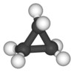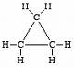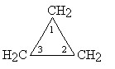

Cyclobutane is a square structure; it is less reactive than cyclopropane because the bond angle strain is less, 90 degrees compared to the tetrahedral bond angle of 109.5 degrees. Cyclopentane and larger cycloalkanes are, like the normal alkanes, quite unreactive; there is no significant bond angle strain in these molecules
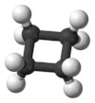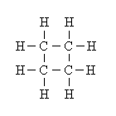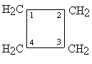

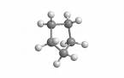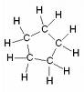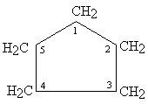

Because these diagrams are somewhat unwieldy, organic chemists use stylized drawings to represent cyclic compounds. In the cyclic compound symbols, a carbon atom is understood to be at the intersection of each pair of straight lines. Each carbon atom is understood to be bonded to a sufficient number of hydrogen atoms to produce a total number of four bonds (the number required for carbon). The standard symbols used to represent the first four cycloalkanes are
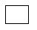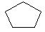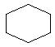

Cycloalkanes with a single ring are named analogously to their normal alkane counterpart of the same carbon count: cyclopropane, cyclobutane, cyclopentane, cyclohexane, etc. The larger cycloalkanes, with greater than 20 carbon atoms are typically called cycloparaffins.

Cyclohexane, for example, has a ring structure which looks like this:

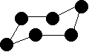
This is known as the "chair" form of cyclohexane - from its shape which vaguely resembles a chair.

Physical properties

- Cyclopropane and cyclo butane are gases, next three members are liquid and higher members are solid.
- They are insoluble in water but soluble in alcohol or acetone.
- Their density increases with increase in molecular weight. Lower members are lighter than water and floats over it. It is therefore cyclohexane floats over water.
- The boiling points increase with increase in molecular weight. The boiling point are also higher than their corresponding alkenes and alkanes.

Chemical properties

Cyclopropane and cyclobutane are comparatively less stable due to more strain in ring and thus tend to breakup and open the ring to act like a double bond species to give addition reactions. The cycloalkanes from cyclopentane and onwards show remarkable similaries with alkanes due to their stability. The stability of higher cycloalkanes is due to less strained ring as well as each carbon atom being sp³ hybridized like alkanes. It is therefore higher cycloalkanes are not attacked by acids, alkalies and common oxidizing under normal conditions. Following are some important reaction of cycloalkanes.

Free radical substitution : Cycloalkanes are halogenated in presence of sun light or UV light like alkane.

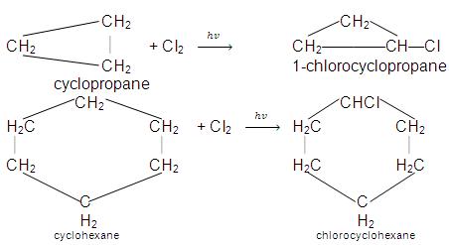

Addition reactions :

Cyclopropane being the most strained ring and more reactive undergoes addition reactions like alkenes.
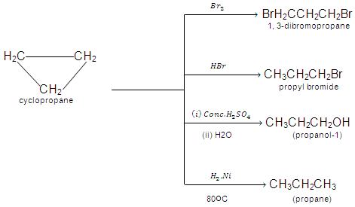

Cyclobutane is relatively less reactive as it does not undergo addition reactions under normal conditions. However it undergoes these reactions under special conditions.

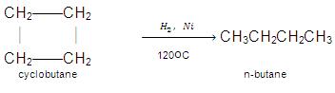

Usage of cycloalkanes

Cyclopentane is used in the manufacture of synthetic resins and rubber adhesives and also as a blowing agent in the manufacture of polyurethane insulating foam, as found in many domestic appliances such as refrigerators and freezers.
More advanced technologies, such as computer hard drives and outerspace equipment employ multiply-alkylated cyclopentane (MAC) lubricants because of their extremely low volatility.

SUPPLEMENTARY QUESTIONS

  - Which compounds are known as cycloalkanes? Why they are called so?
  - Write cyclic isomers for C₆H₁₂ and name them. (There are 8 of them)
  - Write reactions for preparation of:
    - cyclobutane from butane
    - carbon dioxide from cyclopropane
    - benzene from cyclohexane
  - Write complete combustion reactions for cyclopropane, cyclobutane and cyclopentane

