Муниципальное казенное общеобразовательное учреждение
«Школа - интернат среднего общего образования»
с. Самбург Пуровского района

Урок-конференция по английскому языку

“We have a lot in common”
«У нас много общего»

Авторы:
Осипова Г.Г., Акцорина О.А., учителя английского языка
МКОУ «ШИСОО» с. Самбург Пуровского района

с. Самбург, 2013 г.
We have a lot in common (урок – конференция)

Цели урока: -
-практический аспект - развитие умений практического владения учащимися английским языком, применение полученных знаний в условиях, приравненных к реальной жизни;
-образовательный аспект- расширение кругозора учащихся; развитие у них общих и специальных умений, позволяющих совершенствовать учебную деятельность по овладению знаниями на уроках разных дисциплин;
-социокультурный аспект - расширение объема знаний учащихся об особенностях географического положения, природы, национальной культуры, обычаях и традициях родного края и стран изучаемого языка;
-воспитательный аспект - развитие умений учащихся работать в коллективе; воспитание уважительного отношения к культурам разных народов.
Задачи урока:
- совершенствовать коммуникативные умения учащихся;
- содействовать углублению знаний по английскому языку и смежным предметам;
- обобщить ранее полученные знания по изученной теме;
Ожидаемые результаты: развитие устойчивого интереса учащихся к изучению иностранного языка, истории и культуре родного края.
Материалы и ресурсы: Карты Ямала и Пуровского района, мультимедийный проектор, презентации «Добро пожаловать в Самбург», «Национальная ненецкая одежда», «Традиционный костюм шотландцев», «Канада», изображение флагов Канады, России, Великобритании, бейджи, национальные костюмы ненцев и шотландцев, таблички с лексическими единицами, музыкальное сопровождение.
Межпредметные связи: английский язык, география, история и культура народов Ямала, информационные технологии.
Тип урока: урок - конференция (участники конференции - «учащиеся разных стран» - Канады, Великобритании, России).
План урока:
I. Организационный момент
1.1 Приветствие, знакомство участников урока (мини – диалоги).
1.2 Приветствие учителя, объявление темы урока.
II. Основная часть
2.1. Выступление представителей Ямала.
а) Стихотворение о Ямале “My land”.
б) Презентация «Добро пожаловать в Самбург!».
в) Представление национальной ненецкой одежды (презентация).
2.2. Представление шотландской одежды (презентация).
2.3. Выступление представителей Канады (презентация).
III. Заключительная часть
3.1. Рефлексия.
3.2. Песня о дружбе (Auld lang syne).

Ход урока:

I. Организационный момент
1.1 Приветствие, знакомство участников урока (мини – диалоги).
Teacher 1: Good morning, I’m very glad to see you. Today we have a meeting of the pupils from different countries. They are participants of the international conference. Let me introduce myself. My name is Galina Gennadyevna. I’m a leader of the meeting. I greet you all.
Teacher 2: Hello! I’m a leader of the participants from Canada and Scotland. They are 9 in the group. They will present their countries.
***
- Hi, my name is Laura.
- Pleased to meet you. My name is Julia.
- Pleased to meet you too. Where are you from?
- I’m from Russia. I live in Samburg. Where do you come from?
- I am from Canada. I live in Ottawa.
***
- Hello, I’m Galya. What’s your name?
- I’m Ann. Glad to meet you. I’m from Scotland. I live in Edinburgh. Where are you from?
- I’m from Russia. I live in Samburg.
***
- Hi, Helen. How are you?
- Fine, thanks. How are you?
- Brilliant, thanks. Let me introduce my friend. This is Stephanie from Scotland.
- Glad to meet you, Stephanie. I’m Helen. I live in Canada.
***
- Hello! I am Victor. What is your name?
- Hi, I’m Roy. I am from Canada. Where do you come from?
- From Edinburgh. I’m from Scotland. Are you for the first time at an international meeting?
-. Yes, I’m worried a little.
- Don’t worry, everything will be OK.
1.2 Приветствие, знакомство с темой урока.
Teacher 1: So, welcome! The theme we talk about is “We have a lot in common”.
We all live on the same planet, in the northern countries, exactly saying. During our lesson we’ll try to answer some questions:
- Are people of different countries alike?
- What do they have in common?
- What unite them?
II. Основная часть
Teacher 1: I call upon the first speaker from Yamal.
2.1. Выступление представителей Ямала.
а) Стихотворение о Ямале “My land”. Звучит фоновая музыка.
Pupil 1: Hello, I’m Julia. It’s nice to see you on our land. I live in the Purovsky district, in Samburg, and would like to tell you a poem about my homeland:
Some people live in the South,
Some - in the West.
But I live in the North,
In the Far, Far North.
Our region is Yamal.
It’s unique, I know.
Snow- storm and cold rains
Are habitual to us.
Like the other pupils
I attend the school,
And dream to visit countries,
Like Britain and the USA.
I’d like to see the Thames,
Tower Bridge, Big Ben.
I wish I met the English Queen,
And heard her pleasant voice.
б) Презентация «Добро пожаловать в Самбург!».
Teacher 2: Nowadays Yamal is visited by many people and tourists. What attracts people in the North? Let’s listen to the second speaker.
(Презентация «Добро пожаловать в Самбург!»).
Pupil 2 and 3: Hello, my name is Yulia I’m Vika.
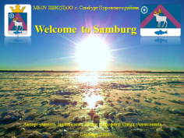 | 1 слайд: Титульный лист.
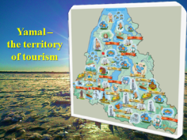 | 2 слайд: Look at the map of Yamal. You can visit a lot of places here.
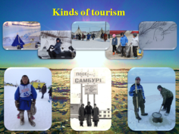 | 3 слайд: There are different kinds of tourism: ethnic geographical tourism, extreme tourism, ecological tourism, historical tourism, sport tourism, fishing tourism, event tourism, hunting tourism. You can choose any tour you want. You can travel in winter or in summer. Yamal and Samburg are greeting you!
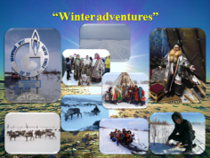 | 4 слайд: We propose “Winter adventures”. You’ll cross the Polar Circle, travel by car “Ural” on “winter road”. You’ll put on national clothes. You’ll visit chum, where you will eat national food and you will see Nenets style of life. You’ll enjoy the trip on reindeer sleigh or travelling by snowmobile. You can also graze reindeer and hunt after rabbits and foxes.
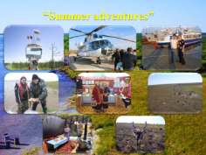 | 5 слайд: We also suggest “Summer adventures”. You’ll cross the Polar Circle too, travel by helicopter or by boat on river Pur, where you can go fishing. You’ll put on national clothes. You’ll visit chum, where you will see Nenets traditions. You can also graze reindeer and hunt after ducks and geese.
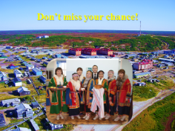 | 6 слайд: Don’t miss your chance. The Nenets people are kind and hospitable! Come and see us!
Teacher 2: Thank you, girls!
Dear guests, have you got any questions?
Pupil 4: Yes, I have. I would like to hunt and to visit the national holiday. What kind of tourism may I choose?
Pupil 2: You can choose any tour you want, we can combine your wishes.
в) Представление национальной ненецкой одежды).
Teacher 1: I know some girls would like to present their clothes.
Pupil 4: We live in Yamal and we have a lot of traditions. One of them is to wear the Nenets national clothes. We have both - daily and holiday, men and women garments.
 | Слайд 1: Титульный лист.
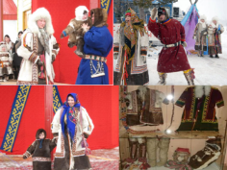 | Слайд 2: Now I show you malitsa, it is like a long coat. The men put it in winter, in the tundra. Malitsa is made from reindeer pelt, it is very warm. The national footwear is kicy. They are made also from reindeer skin.
Pupil 5: Look at the woman clothing, it is yagushka.
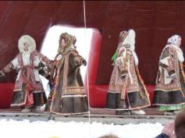 | Слайд 3: Yagushka is sewn from the cloth of different colour. It is decorated with ornaments. The ornaments depend on clans, or tribes. For example, the Ayvasedo clans have their own ornaments and the Pyaks the others.
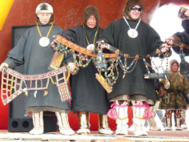 | Слайд 3: Besides they put on fur shoes –burki, warm mittens and a hood. The children have their warm clothes, too.
Teacher 2: Thank you, girls. Have you got some questions? (Учащиеся задают вопросы выступающим)
Pupil 6: Do they wear their clothes every day?
Pupil 4: No, they don’t. They put them only for national holidays.
2.2. Выступление представителей Шотландии.
Teacher 2: There are representatives of Scotland on today’s meeting. Scotland is the most northern part of GB. Meet our guest.
(Презентация “Traditional costumes of the Scotsmen”)
Pupil 7: I’m Ann, I would like to tell you some words about Scottish costume.
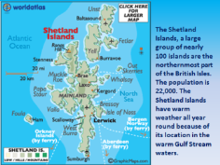 | 1 слайд: The Scottish people live in the northern part of the United Kingdom.
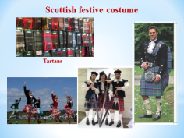 | 2 слайд: They have very beautiful and interesting costumes.
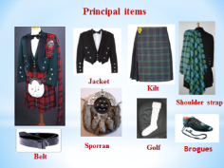 | 3 слайд: They wear a jacket, golf, a sporran, a belt, brogues, and a kilt. The kilt is a skirt, worn by both men and women. Kilts are made of tartan.
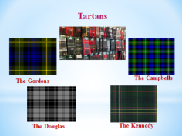 | 4 слайд: Tartan is special cloth of different colour. There are about 300 clans in Scotland, each clan has its own tartan.
Teacher 2: Thank you, it was interesting to know. And now let’s listen to the representative of Canada. Welcome!
2.3. Выступление представителя Канады (презентация «Канада»).
Pupil 8: Hello, I’m Kate, I live in Canada.
 | 1 слайд: Титульный лист.
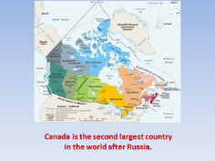 | 2 слайд: Canada is a country in the northern part of North America. By area, Canada is the second largest country in the world after Russia. It is washed by the Pacific, Arctic, and Atlantic Oceans. Canada is made up of 10 provinces and 3 territories. 35 million people live there.
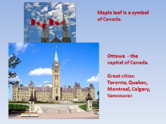 | 3 слайд: Maple leaf is a symbol of Canada. Ottawa is the capital of Canada. It is a political and technological centre of Canada. Other great cities are Toronto, Quebec, Montreal, Calgary, and Vancouver.
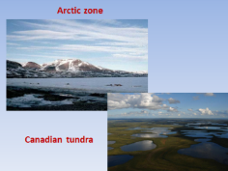 | 4 слайд: The northern parts lie in the subarctic and arctic zones. Most of the northern islands are covered with ice. This territory has a climate with very cold winters and short, cool summers. The average winter temperature is about 35 degrees below zero. The average summer temperature is about 4 degrees above zero.
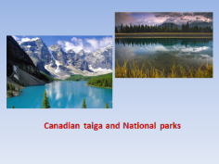 | 5 слайд: Most part of Canada is covered with taiga. There are numerous National parks in the country.
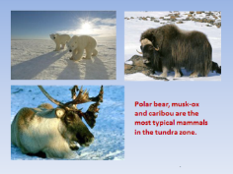 | 6 слайд: Polar bear, musk-ox and caribou are the most typical mammals in the tundra zone.
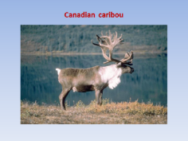 | 7 слайд: On this photo you can see a Canadian caribou.
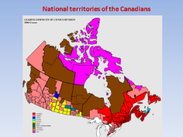 | 8 слайд: On this map we see national territories of the Canadians. The most northern part is Nunavut and it is settled with native people Inuit and Eskimos.
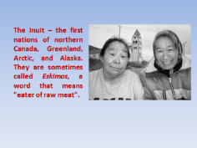 | 9 слайд: The Inuit are one of many groups of first nations who live in very cold places of northern Canada, Greenland, Arctic, and Alaska. They are sometimes called Eskimos, a word that means "eater of raw meat".
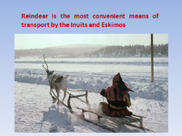 | 10 слайд: Deer is the most convenient means of transport by the Inuit and Eskimos.
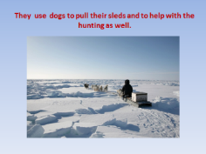 | 11 слайд: They use dogs to pull their sleds and to help with the hunting as well.
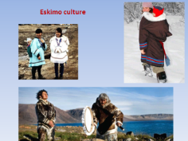 | 12 слайд: Though many Eskimos live in towns and settlements in modern houses, they still hunt and fish for food and follow many customs that are traditional to Eskimo history and culture.
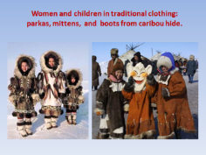 | 13 слайд: They make their own clothing such as parkas, mittens, gloves and even boots from caribou hide. Culture and customs remain traditional with men hunting for food and women caring for the children and making clothing.
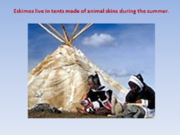 | 14 слайд: Eskimos live in tents made of animal skins during the summer.
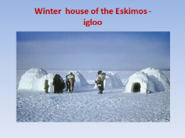 | 15 слайд: In winter they live in igloos.
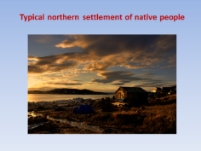 | 16 слайд: Typical northern settlements of native people.
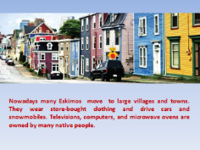 | 17 слайд: Nowadays many Eskimos have moved to modern villages and towns. They wear store-bought clothing and drive cars and snowmobiles. They own televisions, computers, and microwave ovens.  Eskimos work in all sectors of the economy. Some are salespersons, miners, and construction workers, while others are technicians, government officials, and teachers.
III. Заключительная часть
3.1. Рефлексия.
Teacher 1: Well, we talked about different countries: Russia, Canada and Scotland, they are different, but they have a lot in common. Can you answer, what unite them all?
Pupil 1: I can say it’s …
Pupil 2: I guess …
Pupil 3: I think…
Pupil 4: According to my opinion…
Pupil 5: To my mind …
3.2. Teacher 2: And now it’s time to sing a song about friendship, we want people to be always together.
Все участники исполняют песню Роберта Бернса “All lang syne”:
Should auld acquaintance be forgot,
An’ never brought to mind?
Should auld acquaintance be forgot,
An’ days o’ auld lang syne?
Chorus:
For auld lang syne, my friend,
For auld lang syne,
We’ll tak’ a’ cup o’ kindness yet,
For auld lang syne.

Список использованных источников:

1. Бобкова В.И. Краеведческий материал на уроке английского языка. / М.: Иностранные языки в школе, № 5, 2007.
2. Бурлакова И.И. Проект «Использование регионального компонента на уроках английского языка». / М.: Иностранные языки в школе. № 6, 2008.
3. Годунова Н.А. Использование краеведческого материала для повышения мотивации при обучении иностранным языкам. / М.: Иностранные языки в школе, № 7, 2006.
4. Иванова Н.Н. Использование краеведческого материала в обучении иностранному языку. / М.: Иностранные языки в школе. № 4, 2006.
5. Корниенко П.А. Краеведческие материалы как средство обучения иностранному языку в средней школе. / М.: Иностранные языки в школе, № 6, 2004.
6. Сосова Н.А. Пуровская земля. Москва, «Кладезь», 1997 г.
7. http://canada.ru/about/geography/climate.
8. http://canada.turmir.com
9. http://www.en.wikipedia.org
10. http://www.firstpeople.us
11. http://www.nativesofcanada.tripod.com
12. http://www.northstarcompass.org
13. http://www.worlds.ru/america/canada/history-ka
14. http://www.samburg.ru
15. http://www.scotland –travel.ru/category/tradicii-i-obychai
16. http://www.scotlandtour.ru/cultural tradits

