Тема урока: “Ancient and modern wonders of the world”
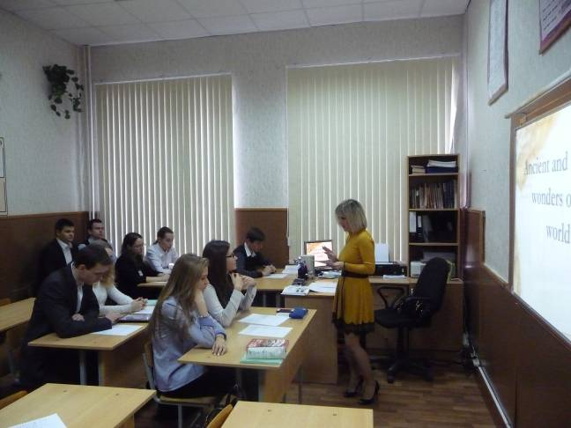
Цель урока: формирование речевой и социокультурной компетентности учащихся.
Задачи:
Развивающая: развитие лексических навыков, связанных с историей, архитектурой и культурой; навыков групповой работы, организация восприятия, внимания и познавательного интереса.
Воспитывающая: воспитание интереса к предмету и познанию исторического и культурного материала, используя возможности английского языка.
Учебно-познавательная: закрепление и контроль усвоения языкового материала в устной речи, навыков выполнения экзаменационных заданий в формате ЕГЭ.
Ход урока
1. Организация урока: приветствие, сообщение темы и плана урока.
T: Good morning boys and girls! Today we are having a lesson on the topic, which you are going to guess about after watching a short episode. (video) Слайд 1
So, what do you think we are going to speak about at our lesson? Yes, you are right about wonders of the world. I know that you’ve already learnt something about it, so we will revise it again and widen our knowledge about it. I hope our lesson will be interesting and usеful.
The planet we live on is full of wonders. We are going to talk about ancient, modern wonders and about wonders of our country. Слайд 2
Warming up.
T. We will start our lesson with a discussion on beauty around us.
What is the most beautiful place you have seen?
Where is it?
Is it natural or man made?
And now let’s find out what the word “wonder “means?
(The possible answer: It is a feeling of amazement and admiration, caused by something beautiful, remarkable, or unfamiliar. Or : It is a person or thing regarded as very good, remarkable, or effective:
What makes a wonder a wonder?
T: Think and tell why the wonders of the ancient world seem to be concentrated around a particular region of the world.
(The possible answer: That was the whole known world of that age.)
T: Why were only 7 masterpieces considered as wonders? Why not 5 or 6?
(The possible answer: The number 7 was chosen because the Greeks believed it to be the symbol of perfection and plenty. This number means “wisdom” and brings happiness).
2. Фонетическая зарядка. Фронтальная работа над наиболее сложными словами и именами собственными.
T: The Seven Wonders of the Ancient World is a listing of notable objects built between 3000 BC and AD 476. The practice of the seven wonders probably began in Ancient Greece. The Ancient Romans also listed memorable things that travellers should see. Through the years, many lists have been made, but all the lists of ancient wonders included only objects MADE BY MAN and considered special because of their GREAT SIZE.
Let’s revise the pronunciation of Ancient wonders of the world.
The Pyramids ['pɪrəmɪd] Слайд 3
The Hanging Gardens of Babylon ['hæŋɪŋ gɑːd(ə)nz əv bæbɪlɔn] Слайд 4
The Statue of Zeus at Olympia ['stæʧuː əv zjuːs ət ə'lɪmpɪə] Слайд 5
The Colossus of Rhodes [kə'lɔsəs əv rəudz ] Слайд 6
The Mausoleum at Halicarnassus [ˌmɔːsə'liːəm] Слайд 7
The Lighthouse at Alexandria ['laɪthaus ət ˌælɪg'zɑːndrɪə] Слайд 8
The Temple of Artemis at Ephesus ['templ əv ˈɑːtɪmɪs ət 'efəsəs] Слайд 9
Now you are going to watch a short video about 7 Ancient wonders of the world. Say how they disappeared and what can still be seen. You have got sheets of paper with the tasks on your desks. Look at task 1. Слайд 10
Task 1
Student’s card
 | can still be seen | Was/were destroyed by an earthquake | was destroyed by a fire
The Pyramids
The Hanging Gardens of Babylon
The Temple of Artemis at Ephesus
The Statue of Zeus at Olympia
The Mausoleum at Halicarnassus
The Colossus of Rhodes
The Lighthouse at Alexandria
(video)
Answers:
The Pyramids can still be seen.
The Hanging Gardens of Babylon were destroyed by an earthquake.
The Temple of Artemis at Ephesus was destroyed by a fire.
The Statue of Zeus at Olympia was destroyed by a fire.
The Mausoleum at Halicarnassus by an earthquake.
The Colossus of Rhodes was destroyed an earthquake.
The Lighthouse at Alexandria was destroyed by an earthquake.
Do you think people should try to rebuild those of the Seven Wonders of the World that have disappeared?
3. Аудирование.
T: Before having a small test let’s listen to the descriptions of the ancient wonders of the world and match them with their names. Look at task 2.
Student’s card.
Task 2
The Pyramids
The Hanging Gardens of Babylon
The Statue of Zeus at Olympia
The Colossus of Rhodes
The Mausoleum at Halicarnassus
The Lighthouse at Alexandria
The Temple of Artemis at Ephesus
Teacher’s card
- It was one of the tallest man-made structures on the Earth for many centuries. It kept a fire burning nightly that could be seen many miles out in the Mediterranean. Its purpose was to guide sailors into the harbor at night time.
- It occupied the whole aisle of the temple that had been built to house it. It was about 12 meters tall and was made of gold and ivory.
- It was the tomb of Anatolian king built by his wife in the middle of the 3rd century .He spent huge amounts of tax money to embellish the city. His tomb was marvelous and it was considered to be an aesthetic triumph.
- This shrine was dedicated to one of the Greek goddesses. It was burnt down by Herostratus in an attempt to achieve lasting fame.
- They were the serious of landscaped terraces. The King of Babylon constructed them to please his homesick wife who longed for the plants of her homeland. They were said to have been destroyed by several earthquakes after the 2nd century BC.
- It was a giant statue of the Greek God Helios. It was the same size as today’s Statue of Liberty in New York.
- Scientists believe that it was built as a tomb for fourth dynasty Egyptian Pharaoh Khufu on the Nile River near the city of Cairo. It is the oldest of the Seven Wonders of the Ancient World, and the only one to remain largely intact.
Now we shall check.
Answers: Слайд 11
The Great Pyramid of Giza | 7
The Hanging Gardens of Babylon | 5
The Statue of Zeus at Olympia | 2
The Colossus of Rhodes | 6
The Mausoleum at Halicarnassus | 3
The Lighthouse at Alexandria | 1
The Temple of Artemis at Ephesus | 4
4. Информативное чтение с детальным пониманием прочитанного.
T. You have some statements in your sheets of paper, some of them are incorrect. Find out the mistakes and correct them. You can work in pairs. I hope it will be not difficult for you. Look at task 3.
The small test on ancient wonders of the world
Student’s card.
Task 3. Слайд 12
Agree or disagree/give the right answer.
- The Pyramid of Giza is the tomb of the Anatolian king built by his widow.
- The Mausoleum at Halicarnassus is the only ancient world wonder that still exists.
- The Hanging Gardens of Babylon used to be located in modern Iraq.
- The Statue of Zeus at Olympia was about 5 meters tall and was made of wood.
- The Colossus of Rhodes was a giant statue of the Egyptian God Helios. It was twice bigger than today’s Statue of Liberty in New York.
- The Temple of Artemis was a shrine dedicated to one Greek goddess, who protected the city of Athens.
- The Lighthouse at Alexandria was destroyed by one man who wanted his name to go down in history.
Answers: Слайд 13
- False. The Mausoleum at Halicarnassus was the tomb of the Anatolian king built by his widow.
- False. The Pyramid of Giza is the only ancient world wonder that still exists.
- True.
- False. The Statue of Zeus at Olympia was about 12 meters tall and was made of gold and ivory.
- False. The Colossus of Rhodes was a giant statue of the Greek God Helios. It was the same size as today’s Statue of Liberty in New York.
- True.
- False. The Temple of Artemis was destroyed by one man who wanted his name to go down in history.
You did well, I am sure that your history teacher would be proud of you.
Please, imagine one of the 7 wonders of the world could have been saved from destruction. Which one would you choose to save and why?
5. Просмотровое чтение.
T. Unfortunately, we are unable to see the ancient wonders today except the Pyramids, but we are lucky to see a lot of remarkable man made creatures and natural wonders now. Слайд 14
Is there an agreed ranking on the most beautiful creations in the world?
Who decides what the wonders of the world are?
Is it important to have an official list of the wonders of the world?
New 7 Wonders of the World (2001-2007) was an initiative started in 2001 by the Swiss corporation New 7 Wonders Foundation to choose Wonders of the World from a selection of 200 existing monuments.
A popular poll was led by Canadian-Swiss Bernard Weber and organized by the New 7 Wonders Foundation based in Zurich, Switzerland, with winners announced on ….
Who knows when the winners were announced? You may easily guess…
Answer:
July 7, 2007 in Lisbon
And now I’d like to show you the announced New 7 Wonders. Watch this video and do the task multiple choice in your sheet of paper. It is task4.(video) Слайд 15
Task 4. Слайд 17
1. The Christ the Redeemer statue took … years to build.
a)4 b)5 c)6
2. The Taj Mahal was completed in … .
a)1652 b)1752 c)1552
3. Machu Pichu is located …
a)in Brazil b)in Peru c)at the bottom of the mountain.
4. Chichen Itza has … steps.
a)364 b)366 c)365
5. The first games at Colosseum were held in … .
a)80 AD b)180 AD c)80 BC
6. Petra is thought to be … years old.
a)2000 b)2500 c)3000
7. More than … of the Great Wall of Chine is in poor condition.
a)50 b)60 c)7
Now let’s check. Слайд 18
1. The Christ the Redeemer statue took … years to build.
a)4 b)5 c)6
2. The Taj Mahal was completed in … .
a)1652 b)1752 c)1552
3. Machu Pichu is located …
a)in Brazil b)in Peru c)at the bottom of the mountain.
4. Chichen Itza has … steps.
a)364 b)366 c)365
5. The first games at Colosseum were held in … .
a)80 AD b)180 AD c)80 BC
6. Petra is thought to be … years old.
a)2000 b)2500 c)3000
7. More than … of the Great Wall of Chine is in poor condition.
a)50 b)60 c)70
T. Here is a table where you can see pictures of New 7 Wonders of the world, and their descriptions. But they are mixed. Your task: look at the pictures and match them with the text. Look at task 5.
Task 5.

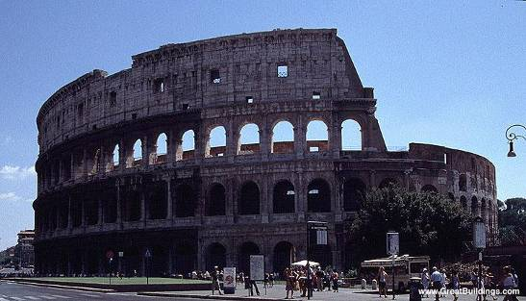  - The Coliseum | 1. It snakes its way for more than 4,000 miles, and is the largest man-made structure ever built, the only one visible from the moon. Слайд 19
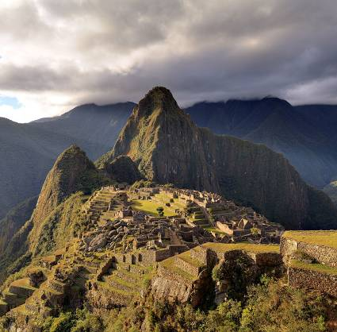  - Machu Pichu | 2. This greatest amphitheatre was built 2,000 years ago and stands near downtown Rome, still celebrating the glory of the Roman Empire Слайд 20
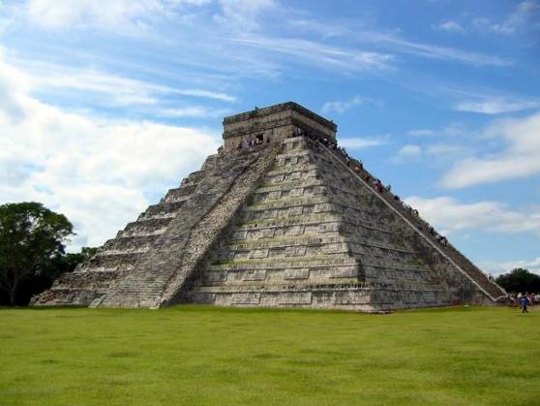  C. Chichen Itza | 3. This building, the Treasury, was carved right into the mountain many centuries ago in Jordan. It’s one of the magnificent buildings of the town hidden in the rocks Слайд 21
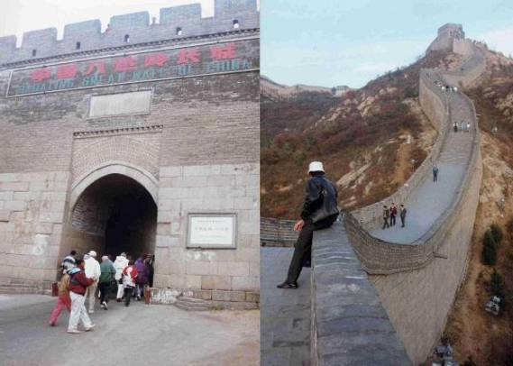  - The Great Wall of China | 4. It is considered to be the lost town of the Incas, which is in Peru. The Incas built the estate around 1450, but abandoned it a century later at the time of the Spanish Conquest. Слайд 22
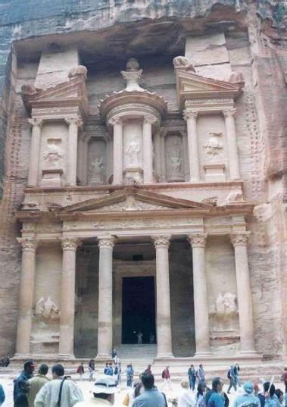  E. Petra | 5. You can see the marvellous views of Rio de Janeiro, in Brazil, down below.  Слайд 23
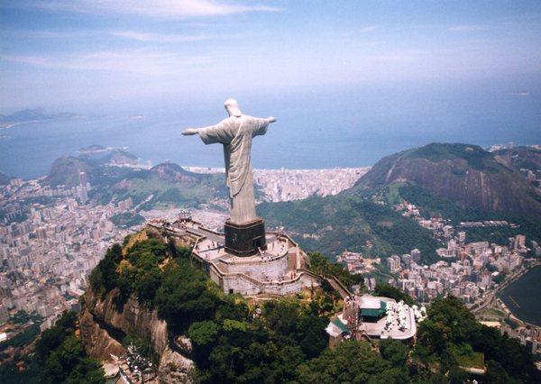  F. Christ the Redeemer. Brazil | 6. This is really a mausoleum built by a Mogul emperor to honour his beloved wife It took 20,000 artisans and workers more than 20 years to build. It has become the symbol of love and passion.  Слайд 24
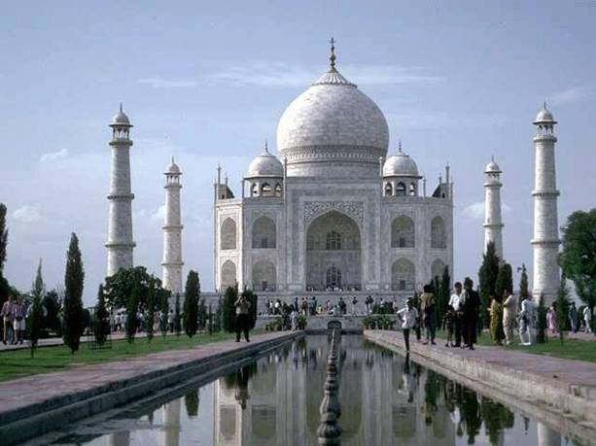  G. The Taj Mahal India | 7. It is the largest of the archaeological cities of the pre-Columbian Maya civilization in Mexico. It is one of Mexico's most visited tourist destinations. It was granted World Heritage Site status in 1988 by UNESCO World Heritage Site.  Слайд 25
Answers:
1 | 2 | 3 | 4 | 5 | 6 | 7
D | A | E | B | F | G | C
T: Do you think the ancient wonders of the world are better than the modern ones?
Is there anyone in the class who has actually seen them? Can you describe how you felt seeing the sight?
6. Комментирование современных чудес света. Фронтальный опрос.
T. Which of these places would you like to visit and why?
As you tell us about these places, use the adjectives from the list below.

THE KEY WORDS (AJECTIVES): marvelous, amazing, impressive, gorgeous, magnificent, remarkable, unique, breathtaking, picturesque, fascinating
Working model
Visiting India has always been a dream of mine and I would like to see the amazing Taj Mahal with my own eyes.
7. Практика УР в рамках подготовки к сдаче ЕГЭ.
T: You know, children, we live in the largest country in the world. And, it goes without saying, there are also some wonders in Russia. And I would like to show you 7 Wonders of Russia. (video) Слайд 26
Are all of them created by man?
One of the wonders of our country is its symbol St Basil’s Cathedral. What do you know about it?
If you could design a wonder of the world in our country, what would you design?
С 4.Now imagine you are going to travel to one of 7 wonders of Russia. You have just seen an advertisement about a tour to Lake Baikal. Слайд 27
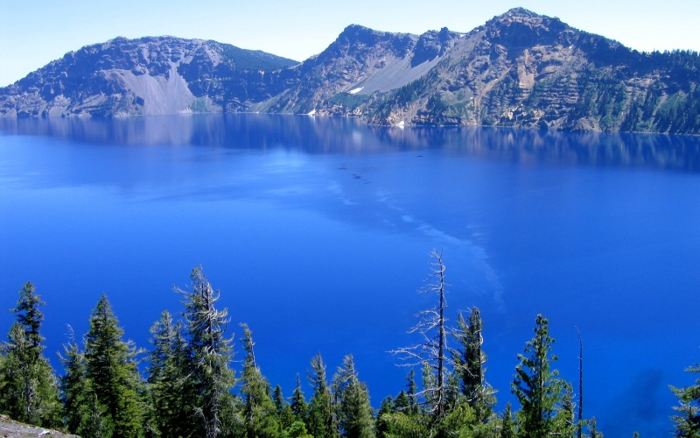
Study the advertisement.
Tour to Lake Baikal
You decided to visit the place and now you are calling to make some clarifications. You are to ask five questions to find out the following:
1) dates for departures
2) hotel facilities
3) if breakfast is included
4) discounts for groups
5) duration of the tour
С 5. Now imagine that while travelling during your holidays to 7 wonders of Russia you took some photos. Choose one photo to present to your friend whose role will be played by the examiner. You have 2 minutes to think it over and will speak not more than 2 minutes. Слайд 28
When presenting the picture remember to mention:
1)when you took the photo
2)what/who is in the photo
3)what is happening
4)why you took the photo
5)why you decided to show the picture to your friend
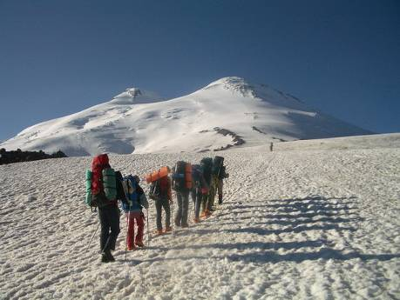 | 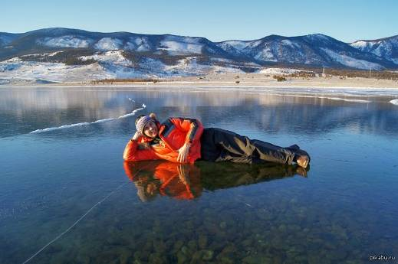 | 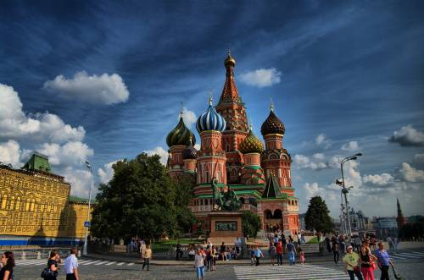
С 6. Study the two photographs. In 2 minutes be ready to compare and contrast the photographs. You will speak for not more than 2 minutes. You have to talk continuously. Слайд 29
1) give a brief description (action, location)
2) say what the pictures have in common
3) say in what way the pictures are different
4) say which wonder of the world you would like to visit
5) explain why
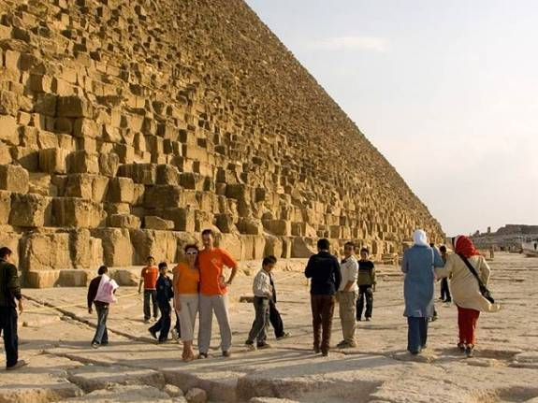 | 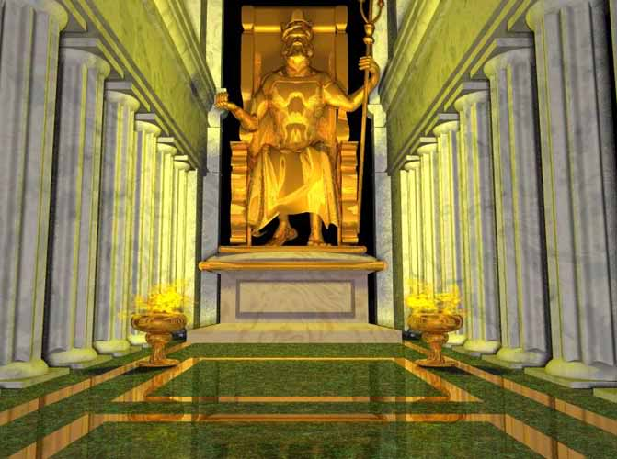

8. Подведение итогов урока.
T: Our lesson has proved us one more time that we live in the world full of wonders and there are a lot of perfect things around us to admire. Who knows, may be in some years, one of you will create a real masterpiece that will go down in history!
You have worked a lot today. It was wonderful. I’m satisfied with your work. Was it informative for you? Have you learnt anything new?
T:– Oh, thank you! I’m glad you’ve enjoyed our lesson.
9. Домашнее задание Слайд 30
1.You have received a letter from your English-speaking pen-friend Mary who writes:
… It was great to hear that you went to India during your spring holidays. I have always wanted to visit this wonderful country. Did you enjoy your journey? Did you see Taj Mahal? What impressed you most of all?
As for me, I am awfully tired because We’ve got too many tests at school. Can’t wait for my summer break…
Write a letter to Mary.
In your letter
-tell her about your journey to India;
-ask 3 questions about her plans for the summer.
Write 100-140 words. Remember the rules of writing.

