Match to make up words.

Mus nema

To pital

Ci tion

Bus sta wn

Sports c eum

Hos ming pool

The entre

Pla me park

Ce
Read. Translate. Find the odd sentence.
I’d like to visit 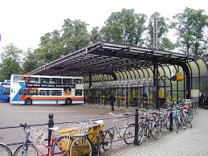 because I can roller-skate there.
I’d like to visit 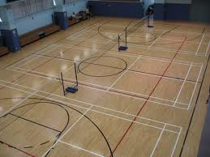 because I can do sports there.
I’d like to visit 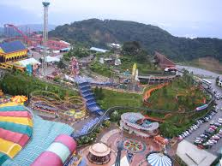 because I can have fun there.
I’d like to visit 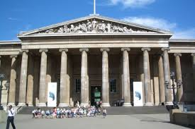 because I can see a lot of interesting things there.
I’d like to visit 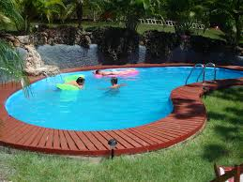 because I can swim there.
I’d like to visit 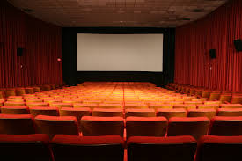 because I can watch an exciting film there.

Guess the word.
It’s a place where we can swim and dive.
It’s a place where we can watch films cartoons and fairy tales.
It’s a place where we can see and learn a lot of interesting things.
It’s a place where we can have fun.
It’s a place where we can play basketball, volleyball; skip, jump, run.
It’s a place where we can find a bus to different cities and towns.
Insert the missing letters.
m-seum, c –nem-, spo - -s cen –e, t –wn, t—me par-, ho-p-tal, sw-m-ng p—l.

