МЕТОДИЧЕСКАЯ
РАЗРАБОТКА

по дисциплине "Иностранный язык"

на тему: "Женщины-писатели Великобритании"

Содержание мероприятия
1.Введение___________________________________________________3
2.Цели и задачи мероприятия___________________________________4
3.Этапы проведения мероприятия_______________________________5
3.Ход мероприятия____________________________________________5
4.Заключение ________________________________________________15
5. Приложение________________________________________________16
6.Список использованной литературы____________________________18

Введение
Великобритания -страна,которая произвела огромное количество писателей и поэтов. Они внесли огромный вклад в британскую литературу. В данной разработке рассказывается о женщинах-писателях, которые завоевали всемирную славу на литературном поприще. Среди первых женщин-писателей, упомянутых в литературе, можно выделить Энн Киллигру и Эфру Бенн . Эфра Бенн известна как первая женщина, зарабатывающая себе на жизнь литературной работой. До 20 века женщины не могли издавать произведения под своим именем, поэтому им приходилось использовать мужские имена в качестве псевдонима. Например, Джордж Эллиот, знаменитая писательница 19 века, никогда не использовала свое настоящее имя Мэри Энн Эванс. В данной разработке рассказывается о нескольких женщинах- писателях Великобритании, которые являются настоящими мастерами своего дела. С 1950 годов возросло число известных женщин-писателей. Сейчас они получают высокие награды за свои труды, их включают в книгу рекордов Гинесса и они среди самых высокооплачиваемых и богатых писателей в мире. Студенты подготовили презентацию по биографии знаменитых женщин-писателей и нашли кинофрагменты по их произведениям. После каждой презентации студенты выполняли различные задания на проверку понимания услышанного и увиденного.

3

Цели мероприятия.

Образовательный компонент цели:
1. Совершенствование навыков активного овладения чтением, пониманием и восприятием текстов и кинофрагментов
2. Углубление знаний учащихся в области английской литературы.

Развивающий компонент цели:
Развитие индивидуальных умений работы в паре, группе, к переключению внимания в упражнениях комплексного характера, в разных видах речевой деятельности.

Воспитательный компонент цели:
1. Развитие эстетического вкуса, воспитание уважения к носителям иноязычной культуры. 2.Углубление познавательного интереса к предмету, привитие вкуса к чтению.

ЗАДАЧИ МЕРОПРИЯТИЯ

- Развитие навыков устной речи и аудирования
- Развитие навыков самостоятельной работы в процессе подготовки к мероприятию.

Оборудование и оформление:
1. Стенд с произведениями британских писателей (книги на русском и английском языках)
2. DVD-проигрыватель и телевизор
3. Магнитофон
4. Компьютер
5. Проектор
6. Приложение

4

ЭТАПЫ ПРОВЕДЕНИЯ МЕРОПРИЯТИЯ

- Приветствие. Оргмомент. Ознакомление с целями и задачами мероприятия.
- Презентация по биографии и творчеству Джейн Остин. Просмотр и обсуждение фрагмента из фильма «Любовь и предубеждение».
- Презентация по биографии и творчеству Мэри Шелли. Чтение отрывка из произведения «Франкейнштейн» и задания.
- Презентация по биографии и творчеству сестер Бронте и выполнение задания.
- Презентация по биографии и творчеству Агаты Кристи и выполнение задания.
- Презентация по биографии и творчеству Джоанн Роулинг и выполнение упражнений.
- Описание произведений различных писателей и выполнение упражнений.
- Подведение итогов. Рефлексия.

Ход мероприятия
Этап 1
Teacher: Good morning, children. Let us continue our talk about British literature. You know that Britain is a country that has produced a great number of literary people. You have already learned about some noted British writers and poets, essayists and playwrights, critics and diarists who made their country famous and contributed much in British literature.
Look at the titles of the books and try to guess what they have in common.
Pride and Prejudices | Frankenstein | Love in the Ritz Hotel
Jane Eyre | Ten Little Niggers | The Growing Pains of Adrian Mole
Teacher: Today we shall speak about women writers who also made a great contribution to British literature. Among the first women writers that are recorded are Ephelia (1641-1700), Ann Killigrew (c. 1660-1685), Aphra Behn (1640-1689). Aphra Behn, for example, is a Restoration playwright, novelist and poet, known as the first western woman to earn her living by literary works.There have always been good women writers, but until the XXth century it was not easy for a woman writer to get her works published and sell many of the copies under her own name. Many XVIIIth and XIXth century women writers used male pen-names or pseudonyms: George Eliot, for example, an important XIXth century writer (1819-1880), never used her real name which was Mary Ann Evans. During the lesson we shall speak about only six of them but there are, of course, much more women writers who deserve being spoken about.
Этап 2
Teacher: Look at the titles of the books again and try to guess which one was written by Jane Austen.
Задания:
1.Студенты рассказывают биографию Джейн Остин по подготовленной презентации.
2.Просмотр и обсуждение фрагмента из фильма «Любовь и предубеждение»
5
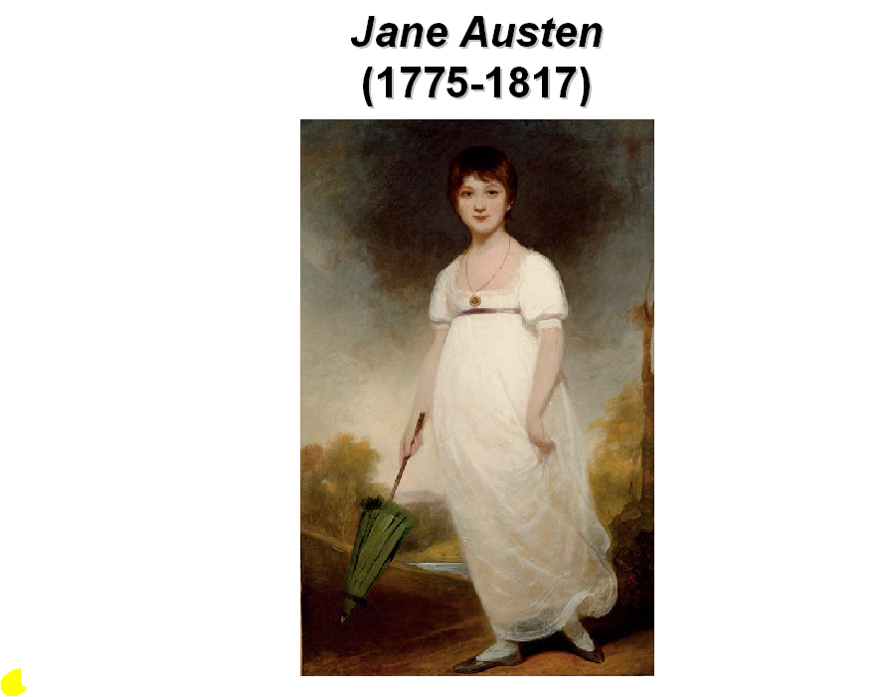
Jane Austen was born in 1775, the seventh of eight children, in the family of a clergyman and spent her short life in Hampshire, near the south coast of England. Her novels describe the everyday life of people in the upper-middle class circle she knew best. Money and social position were very important and the only role of a woman of that class was to find a rich husband. Her characters spend most of the time in the countryside, doing little or no work. Occasionally they go to London; sometimes they go to Bath, a fashionable town. Her novels may sound boring, but they are a record of what life was like for the upper- middle class in the early nineteenth century and are among the finest and the most entertaining novels written at that time. When she died, in 1817, only four of her six novels had been published, all anonymously. Now, nearly 200 years later, sales of her novels rival modern bestsellers. Since the age of the cinema and television her novels have become more and more popular. There have been film and television productions of not only Pride and Prejudice, but also Emma, Persuasion, and the Oscar-winning Sense and Sensibility. There are Jane Austen fans in all corners of the globe, and even special Jane Austen discussion groups on the Internet. Her house in Chawton in Hampshire is visited by about 200 people a day.
Этап 3
Teacher: I am sure nobody will fail to name the author of Frankenstein.
Listen to the information about Mary Shelley and say how her famous book appeared.
Задания:
1.Презентация биографии Мэри Шелли.
- Чтение отрывка из произведения «Франкейнштейн».
- Расположить 4 предложения в правильном порядке.
6
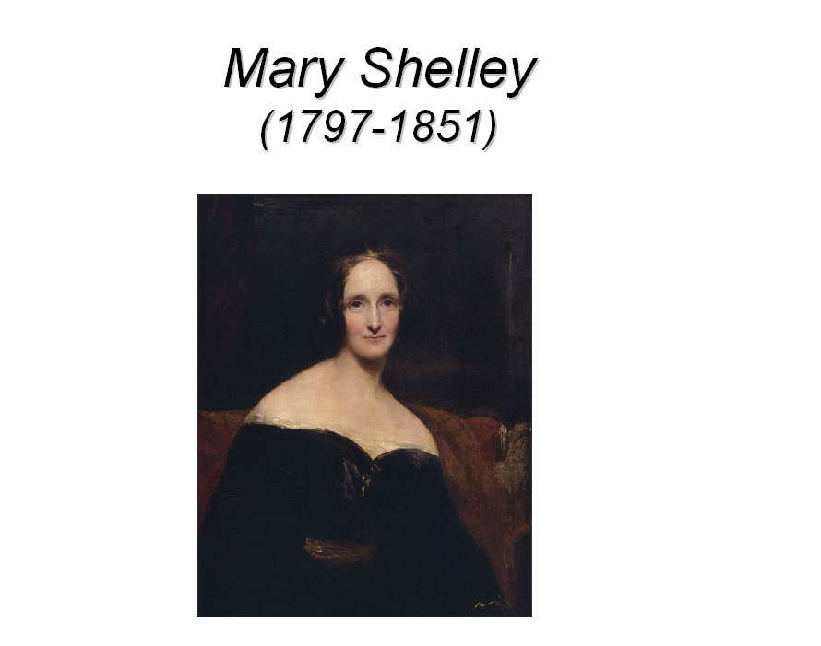
Student: Born August 30, 1797, in London, England, Mary Shelley came from a rich literary family. She was the daughter of William Godwin, a political theorist, novelist, and publisher and of Mary Wollstonecraft, a writer and early feminist thinker. Her mother died 10 days after her daughter's birth. In her childhood, Mary Shelley educated herself amongst her father's intellectual circle and he encouraged her youthful literary efforts. There she met Percy Bysshe Shelley in 1812, when she was fifteen. Shelley was married at the time, but the two spent the summer of 1814 traveling together. In the summer of 1816, Percy Shelley and 19-year-old Mary visited the poet Lord Byron at his villa beside Lake Geneva in Switzerland. Stormy weather frequently forced them indoors, where they and Byron's other guests sometimes read from a volume of ghost stories. One evening, Byron challenged his guests to write one themselves. Mary's story became Frankenstein. Mary and Percy Shelley were married December 30, 1816. Mary Shelley's Frankenstein was published in 1818, when Mary was 21, and became a huge success. The first edition of the book had a preface by Percy Shelley. Many, disbelieving that a 19-year-old woman could have written such a horror story, thought that it was his novel.
FRANKENSTEIN
Frankenstein was written by Mary Shelley, the wife of the poet P.B. Shelley, in 1818.
(1)__________________
The story is told through the letters of a man called Walton, an English explorer. We are told of Victor
7
Frankenstein, a student from Geneva, who discovers the secret of life.
(2)___________________ People are terrified of it because it is so huge and ugly. The poor monster has no friends and feels lonely and depressed, so it asks Frankenstein to make it a wife.
(3)___________________Then the monster attacks and kills not only Frankenstein’s friend, but also his brother and his brother’s bride Elizabeth. Frankenstein is heartbroken and is determined to kill the monster.
(4)___________________ Frankenstein is a fascinating story because of the character of the monster, which is both sad and frightening at the same time.
a. So he collects bones and bodies from graveyards, and constructs a creature which is more monster than man.
b. However he is killed first by the monster, which then kills itself.
c. This he refuses to do.
d. It is a horror story which is thought to be the original science fiction novel.

Этап 4
Задания:
1.Рассказ о сестрах Бронте
2.Составить вопросы для заполнения пропусков в предложениях.
Teacher: Listen to the story about the Brontё sisters and say what pen-name they used and why.
The Brontё sisters were exceptional writers of poetry as well as fiction. Between 1847 and 1848, all three sisters published novels. They all wrote under different names because “good” women were not allowed to write: Emily Brontё became Ellis Bell; Charlotte Brontё, Currer Bell; Anne Brontё, Acton Bell.
Wuthering Heights by Emily Brontё is one of the most famous of their novels. The story tells about the destructive and passionate love between two children, Catherine and Heathcliff, who grow up on the farm when Catherine, for reasons of class, refuses to marry him.

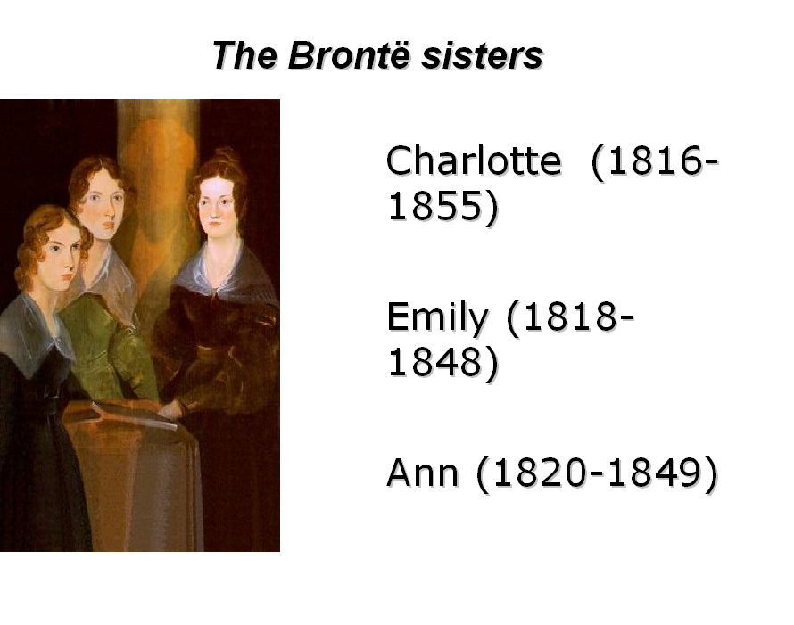
8
Jane Eyre by Charlotte Brontё is a most romantic, exciting story about a little orphan Jane, who went to the Lowood school for poor girls and later became a governess in the house of Mr. Rochester (a man with a strange history), and eventually married him. This novel was accepted at once and published quickly, and it has a tremendous success which lasted to this very day. Anne’s novel Agnes Grey tells about the adventures and bitter experience of the governess in two Yorkshire families. All three sisters died very young. The house where they lived is now a museum and you can walk from it over to the Yorkshire moors to the farm where Wuthering Heights is set.
Teacher: Work in pairs. Each of you has a text with some missing information in it. Don’t show your card to your partner. Ask each other questions to fill in the gaps with the missing information.
Pupil A card
Charlotte Brontё was one of __ children. After the death of her mother and her two sisters Charlotte and the three remaining children were placed in the care of ___ . At the age of sixteen, Charlotte accepted the post of a _____ for two separate families. She traveled to France to study music and further perfect her ___ . Secretly she was writing poems. Her sisters were also writing poetry and soon the three jointly published a book of their verses under the pen name___. After this each sister began independent work on a novel. Emily’s book Wuthering Heights And Anne’s book ___ were accepted for publication. Charlotte’s first novel was not a success. Her next effort, an autobiography of
an orphan girl, was immediately accepted by a publisher in 1846 and became a sensation among readers. This was her masterpiece ___. All in all Charlotte Brontё wrote four books. In1847, the year after she completed her fourth and final novel, Charlotte ______. A year later she died.

Pupil B card
Charlotte Brontё was one of six children. _________ Charlotte and the three remaining children were placed in the care of an aunt. At the age of ____, Charlotte accepted the post of a governess for two separate families. She traveled to ____ to study music and further perfect her drawing skills. Secretly she was writing poems. Her sisters were also writing ______ and soon the three jointly published a book of their verses under the pen name Bell. After this each sister began independent work on a novel. Emily’s book ___________ and Anne’s book Agness Grey were accepted for publication. Charlotte’s first novel was not a success. Her next effort, an autobiography of an orphan girl, was immediately accepted by a publisher in ____ and became a sensation among readers. This was her masterpiece Jane Eyre. All in all Charlotte Brontё wrote ____ books. In1847, the year after she completed her fourth and final novel, Charlotte got married. ____ later she died.
Этап 5
Задания:
1.Рассказ о произведениях Агаты Кристи.
- Выбрать правильный вариант слова.
Teacher: The name of the next person we are going to speak about is surely familiar to you. Read the information about Agatha Christie and name the most famous characters of her detective stories and novels.
Agatha Christie is known all over the world as the Queen of Crime. She was born in 1890 in Torquay, Devonshire. During her long writing career she wrote over 83 books. Her detective novels are translated into every major language and he is one of the best-selling authors in the world. Many of the novels and short stories have been filmed. The Mousetrap, her famous play, is now the longest-running play in history. Besides being a detective story writer, Agatha Christie wrote several plays as well as six romantic novels and a book of poems (under the name of Mary Westmacott). She has been writing since the end of the First World War, when she created Hercule Poirot, the Belgian detective with his love of order- the most popular detective in fiction since Sherlock Holmes. Christie became generally recognized in1926, after publishing of her novel The Murder of Roger Ackroyd.
9
When Chrisie got tired of Hercule Poirot she invented Miss Marple, a deceptively mild old lady with her own method of investigation. Agatha Chrisie died in 1976 at the age of eighty-five. Her last Poirot book, Curtain, appeared shortly before her death, and her last Miss Marple story, Sleeping Murder, and her autobiography were published after her death. But it is obvious from the number of her books still sold that her famous characters continue to live many years to come.
Teacher: Thousands of people enjoy reading Christie’s stories and novels. Read a short review of the reader’s best beloved book and choose the appropriate text organizer.
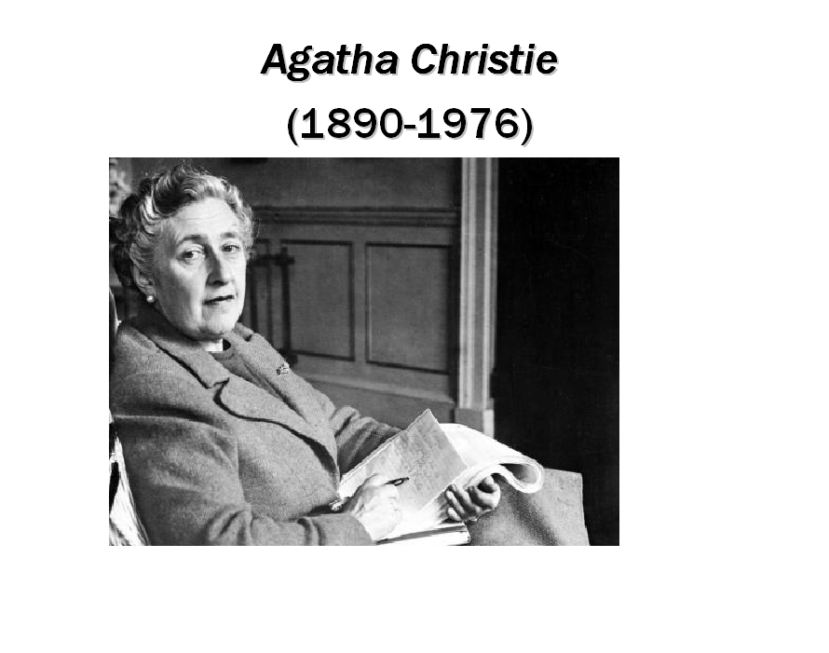
Seven months ago I read a detective novel called “Ten Little Niggers” which is written by a well known woman writer Agatha Christie. And I recommend to everyone, - it doesn’t matter whether you are a child, adolescent or adult - to read this magnificent masterpiece of all ages. Furthermore / Firstly the writer is one of the greatest authors of her century and deserves to be called “The Queen of Detective Stories”. Secondly / Moreover “Ten Little Niggers” is unique in its own way, distinguishing this masterpiece from other great works of Agatha Christie. First of all / On the one hand, the composition of the novel is very unusual. We are fascinated with the thoughts and mental state of the main characters, we find out that they are a little bit puzzled and confused with the strange offer to visit this island. On the other hand / Secondly, the plot of “Ten Little Niggers” is rather simple, and at the same time / on the other hand extraordinary. It turns out that these people stay there as mice in a trap without any chance to escape. More than that / To begin with each of them has “his own skeleton in the wardrobe”.
10
Furthermore / Finally, there no detective, researcher or anyone else who investigates the murders that happen on Nigger Island. In conclusion / To begin with I would like to say that “Ten Little Niggers” is a fast-moving, amusing and fascinating masterpiece that will always attract readers of all ages. The events here happen so quickly and abruptly that during the whole story you are totally absorbed in reading and continue to wonder: “What will happen next? Who will be the next victim? Who is the murderer?” Till the end you don’t have any clue, only vague guesses and that makes you thrilled.
Этап 6
Задания:
- Рассказ о Джоанн Роулинг.
- Просмотр фрагмента фильма «Гарри Поттер» и обсуждение увиденного.
- Выполнить тест по биографии Джоанн Роулинг.
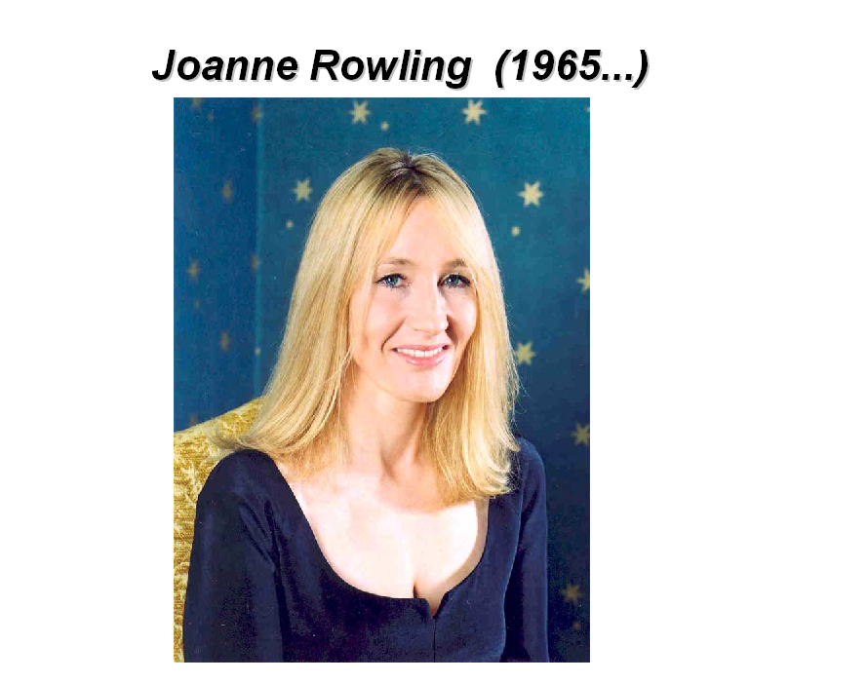
J.K. Rowling’s road to fame and fortune was a bit rocky sometimes, but her success is sure. In 2000, the35-year-old author became the highest-earning woman in Britain. She received an OBE (Order of the British Empire), a medal of achievement awarded by the Queen, in March 2001. Harry Potter books have been translated into more than 60 languages. In February2004, Forbes magazine estimated that Rowling had Ј576 million, or more than a million dollars. This would make her the first person ever to become a billionaire from writing books.
11
Read what J. K. Rowling tells about her life and about how her famous book appeared. Say if the following statements are true or false.
I was born Chipping Sodbury General Hospital, which I think appropriate for someone who collects funny names. My sister, Di, was born just under two years later, and she was the person who suffered my first efforts of story-telling. Rabbits loomed several times in our story-telling sessions; we wanted a rabbit very much.Certainly the first story I ever wrote down (when I was five or six) was about a rabbit called Rabbit. And since that time, I have wanted to be a writer, though I rarely told anyone so. I was afraid they’d tell me I didn’t have a hope.We changed houses twice when I was growing up. The first move was from Yate to Winterbourne. A gang of children including myself and my sister used to play together up and down the street in Winterbourne. Two of the gang members were a brother and a sister whose name was Potter. I always liked the name, but then I was always keener on my friends’ surnames than my own.When I was nine we moved to Tutshill near Chepstow in the Forest of Dean. We were finally out in the countryside, which has always my parents’ dream, and we spend most of the time wandering across fields and along the river Wye. The only fly in the ointment was the fact that I hated my new school.From Tushill Primary I went to Wyedean Comprehensive. My favourite subjects were English and languages. I used to tell my friends long serial stories at lunchtime. They involved us all doing heroic and daring deeds we certainly wouldn’t have done in real life.I went to Exeter University just after school, where I studied French. This was a big mistake. I listened too much to my parents, who thought languages would lead to a great career of a bilingual secretary. Unfortunately I am one of the most disorganized people in the world and, as I later proved, the worst secretary ever. When I was twenty-six I gave up on offices completely and went abroad to teach English as Foreign Language. As I worked afternoons and evenings, I had mornings free for writing and started a new book about a boy who found out that he was a wizard and was sent off to wizard school. When I came back from Portugal half a suitcase was full of papers covered with stories about Harry Potter. I came live in Edinburgh with my very small daughter, and set myself a deadline; I would finish the Harry Potter novel before starting work as a French teacher, and try to get published. It was a year after finishing the book before a publisher bought it. The moment when I found out that Harry would be published was one of the best in my life.
1. The person who first suffered her writing efforts was
a. her mother
b. her best friend
c. her sister
2. Potter was the surname of
a. her primary school teacher
b. two of her young days’ friends
c. a relation of her
3. Her favourite subjects at school were
a. English and Literature
b. Languages and Literature
c. English and Languages
4. After graduating from Exeter University she became
a. a secretary
b. a school teacher
c. a writer
5. J.K. Rowling started writing about Harry Potter when she was
a. working as a secretary in England
b. working as a teacher in Portugal
c. being a lonely parent with no work

12
Этап 7
Задания:
1.Соотнесите описание произведения с его названием.
2.Расположите буквы в правильном порядке и угадайте автора произведения
3.Правильно соотнесите автора и его произведение.
1. Teacher: You know that there are different ways to choose a book. Some people choose a book reading blurbs. Let us try to do it.
Blurb The blurb about a new book, film, or exhibition is information that is written about in order to attract people’s interest. [informal] Collins Cobuild English Dictionary Here are three blurbs to books written by A.Christie, J.Austen and J.K.Rowling. Match the name of the book with the blurb.

Persuasion  by J. Austen | The Clocks  by A. Christie | Harry Potter and the Goblet of Fire  by J.K. Rowling
1. Like a lot of other people, the girl was drawn like a magnet to the house in Wilbraham Crecent. She found herself in a crowd looking at a murder house.
To think that it was a house where it happened! It looked ever so nice, neat curtains and all. Yet a man has been killed there – with a kitchen knife. An ordinary kitchen knife. Mesmerized by people swirling round her, she stared and stared and ceased to think…
She started when a voice spoke in her ear. Then turned her head in surprised recognition. Approximately two minutes later she was dead.
2. It is the summer holidays and soon he will be starting his fourth year at the School of Witchcraft and Wizardy. He is counting the days. There are more spells to be learned, more Quiddich to be played, and the castle to continue exploring. But he needs to be careful – there are unexpected dangers lurking… The author continues to delight with the power of her rich, demanding and action-packed storytelling.
3. Anne Elliot, 19, falls in love with Frederick Wentworth, a young man with no connections and only himself to recommend him. Persuaded by her great friend to break off their engagement, Anne regrets her decision afterwards.
Some years later, her father Sir Walter Elliot finds himself financially embarrassed and is forced to let the family house. The new tenants are the relatives of Wentworth, who has prospered and now is a captain. Although he and Anne are thrown into each other’s company he still feels bitterness at her rejection. Once again it seems as though happiness is about to allude them…

- There are six main characters’ names which are scrambled. Guess the names:

TORVIC KENNETFAIRSN
ANJE REAY
NARIDA LOME
RARHY TORTEP
SMIS RAMPLE
RISTEM SHORECRET

13

3. Match the name of the author with the name of the book:
1. Frankenstein | a. Joanne Rowling
2. Harry Potter and the Philosopher’s Stone | b. Jane Austen
3. Pride and Prejudices | c. Sue Townsend
4. Jane Eyre | d. Agatha Christie
5. Ten Little Niggers | e. Charlotte Brontё
6. Love in the Ritz Hotel | f. Barbara Cartland
7. The Growing Pain of Adrian Mole | g. Marry Shelley

Этап 8

Teacher: Look at the handouts and say how British people honour their women writers.
There are, of course, a number other women writers to learn about. Things are changing now and since 1950s, the number of well- known women writers has increased. Women writers are now winning prizes for literature, they are given the highest awards, they are included in the Guinness Book of Records and are now among the most prolific writers and wealthy people in the world. British people are very proud of them and honour them in different ways. I am sure that today you have learned a lot of new information and will have a clearer idea about these writers and their works.

Задания:
1. Найти информацию о том, как англичане чтят своих деятелей литературы.
- Домашняя работа: подготовить пересказ одного произведения женщин- писателей Великобритании (по выбору).

1. How We Can Honour Famous Literary People (как мы чтим знаменитых деятелей литературы)
(X – stands for the person’s name)
- to erect a monument to X
- to place a memorial sign
- to name a town/school/street/library/etc. after X
- to organize a museum of X
- to celebrate the anniversary of X
- to write the biography of X
- to make a film version of X’s works
- to stage X’s works
- to organize a literary contest in memory of X
- to organize readings of X’s works
- to give literary awards named after X
- to hold a festival where X lived/ worked
- to publish X’s works in great numbers
- to issue posters/cards/coins/banknotes/etc. with the image of X
- to paint portraits of X.

14

Заключение
В настоящей работе представлена разработка на тему «Женщины-писатели Великобритании». Данное мероприятие позволяет студентам познакомиться с литературным наследием Великобритании. Содержание разработки нацелено на расширение культурного и лингвострановедческого кругозора студентов. Данное мероприятие целесообразно использовать на внеклассном мероприятии при прохождении темы «Знаменитые люди Великобритании». Мероприятие позволяет совершенствовать навыки активного овладения чтением, пониманием и восприятием текстов и кинофрагментов и углубить знания учащихся в области английской литературы, также воспитывает уважение к носителям иноязычной культуры, побуждает познавательный интерес к предмету.

15
Приложение
Keys (ключи):
M.Shelley 1.d 2.a 3.c 4.b
Brontё sisters
Charlotte Brontё was one of six children. After the death of her mother and her two sisters Charlotte and the three remaining children were placed in the care of an aunt. At the age of sixteen, Charlotte accepted the post of a governess for two separate families. She traveled to France to study music and further perfect her drawing skills. Secretly she was writing poems. Her sisters were also writing poetry and soon the three jointly published a book of their verses under the pen name Bell. After this each sister began independent work on a novel. Emily’s book Wuthering Heights and Anne’s book Agness Grey were accepted for publication. Charlotte’s first novel was not a success. Her next effort, an autobiography of an orphan girl, was immediately accepted by a publisher in 1846 and became a sensation among readers. This was her masterpiece Jane Eyre. All in all Charlotte Brontё wrote four books. In1854, the year after she completed her fourth and final novel, Charlotte got married. A year later she died.
J. K. Rowling 1.c 2.b 3.c 4.a 5.b.
A.Christie
Seven months ago I read a detective novel called “Ten Little Niggers” which is written by a well known woman writer Agatha Christie. And I recommend anyone, - it doesn’t matter whether you are a child, adolescent or adult - to read this magnificent masterpiece of all ages. Firstly the writer is one of the greatest authors of her century and deserves to be called “The Queen of Detective Stories”. Secondly “Ten Little Niggers” is unique in its own way, distinguishing this masterpiece from other great works of Agatha Christie. On the one hand, the composition of the novel is very unusual. The story takes place on a little picturesque island called Nigger Island. We are fascinated with the thoughts and mental state of the main characters, we find out that they are a little bit puzzled and confused with the strange offer to visit this island. On the other hand, the plot of “Ten Little Niggers” is rather simple, and at the same time extraordinary. It turns out that these people stay there as mice in a trap without any chance to escape. More than that each of them has “his own skeleton in the wardrobe”. Finally, there no detective, researcher or anyone else who investigates the murders that happen on Nigger Island. We know that there are ten people on the island and one of them is a murderer, and so the research and at the same time work of our imagination begins. In conclusion I would like to say that “Ten Little Niggers” is a fast-moving, amusing and fascinating masterpiece that will always attract readers of all ages. The events here happen so quickly and abruptly that during the whole story you are totally absorbed in reading and continue to wonder: “What will happen next? Who will be the next victim? Who is the murderer?” Till the end you don’t have any clue, only vague guesses and that makes you thrilled.
Blurbs: 1. The Clocks by A. Christie 2. Harry Potter and the Goblet of Fire by J.K.Rowling 3. Persuasion by J. Austen.

16
1. Frankenstein | a. Joanne Rowling
2. Harry Potter and the Philosopher’s Stone | b. Jane Austen
3. Pride and Prejudices | c. Sue Townsend
4. Jane Eyre | d. Agatha Christie
5. Ten Little Niggers | e. Charlotte Brontё
6. Love in the Ritz Hotel | f. Barbara Cartland
7. The Growing Pain of Adrian Mole | g. Marry Shelley

Key: 1.g 2.a 3.b 4.e 5.d 6.f 7.c
TORVIC KENNETFAIRSN  ANJE REAY  NARIDA LOME  RARHY TORTEP  SMIS RAMPLE  RISTEM SHORECRET | VICTOR FRANKENSTEIN  JANE EYRE  ADRIAN MOLE  HARRY POTTER  MISS MARPLE  MISTER ROCHESTER

17

Список использованной литературы:
- English Первое Cентября №18, 2006, с.46.
2. English Первое Cентября №14, 2007, с.44-45.
3. Английский язык. Библиотечка «Первого Cентября» №3(15) 2007, с.4-6.
4. 1200 тестов по английскому языку Гичева Н., Дворжец О., Черкашина Л. - М.: «Айрис-пресс», 2004.
5. Кузовлев В.П.и др. English Reader 9класс с. 16. - М. Просвещение, 2000.
6. In Britain by Michael Vaughan-Rees, Peter Bystrom, Steve Bateman. - Титул, 1999, с.50-53.
7. Цветкова И. В.и др. Английский язык для школьников, поступающих в ВУЗы и студентов. - М.: Глосса, 1995, с. 5.
8. Путеводитель по английской литературе М. Дрэббл, Д. Стинджер. - М.: ОАО Издательство «Радуга», 2003.
9. 2005 Universal Studios and Scion Films (P&G) Production Partnership Pride and Prejudices. Supplement: Lifestyles in the Times of Jane Austen.
10. New Headway Upper-Intermediate by Liz and John Soars. Oxford University Press 1998 Student’s Book, c. 82-83.

