**Урок английского языка в 5 классе**

**по теме: «We have had a nice trip to England»**

урок 4 “Would you like to …?”

(учебник Кузовлёва В.П.)

**Цель**: знакомство с достопримечательностями Йорка.

**Задачи:**

* развитие социокультурной компетенции через знакомство учащихся с культурой, достопримечательностями страны изучаемого языка;
* развитие внимания, памяти, способности к сравнению и сопоставлению речевых единиц, к анализу, обобщению;
* воспитание потребности и способности к сотрудничеству и взаимопомощи;
* воспитание толерантности к стране изучаемого языка.

**Ход урока**

**1. Начало урока.**

Good morning, dear friends!

We will travel today and visit one of the towns of UK – York. It is famous for it̕s Viking Center.

2. **Фонетическая зарядка.**

Let̕s read the poem and find Present Perfect and Past Simple.

Little girl, little girl

Where have you been?

I̕ve been to see grandmother

Over the green.

What did she give you?

Milk in a can.

What did you say for it?

Thank you Grandam.

(учащиеся называют глаголы)

**3. Развитие навыка диалогической речи.**

Стр.103 упр.1.Прослушайте диалог и скажите, какие формы глагола здесь используются. Where did the children travel? Let̕s find the information about the Vikings Center. (учащиеся работают с лингвострановедческим справочником).

Чтение диалога по ролям.

Do you know who were Vikings?

Now would you like to go to the Vikings Center?

**4. Словарная работа.**

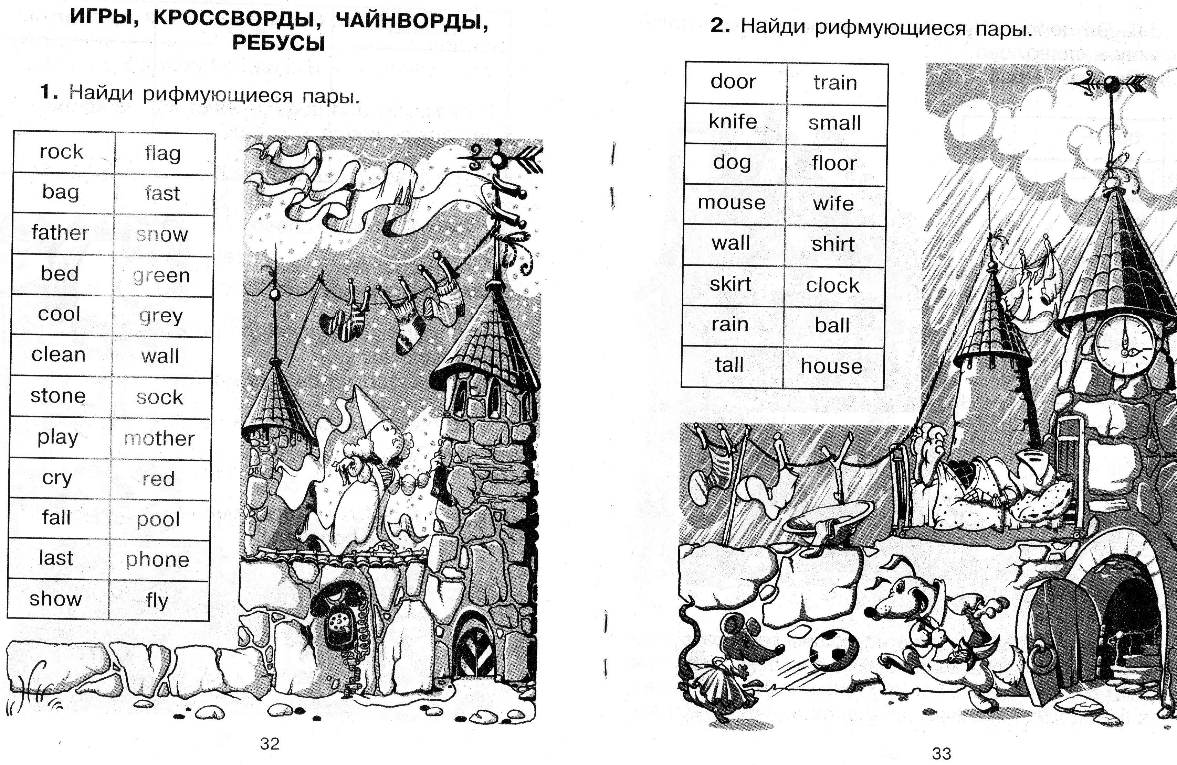

Найди рифму.

Подставить слова и составить стишок о викингах.

If we go many years back

We see a Viking ….(flag).

The seawide was ….(clean),

And Viking̕ s land – ever….(green).

The warrers climb rocks and ….(wall)

The towers of enemy always …(fall).

**5. Развитие навыка чтения**

Now would you like to go to the Vikings Center?

(слайд 4). You are standing on the site of one of the most famous discoveries of modern archaeology. Thirty years ago archaeologists found the houses, workshops and backyards of the Viking-Age city of Jorvik, as it stood 1,000 years ago along with over 40,000 artefacts!

(слайд 5) Vikings were warriors. They had quiver, arrows, bow and axe. Originally they were fishermen and farmers who spent much of the year at home. Only in the summer they have followed to the call of a local leader and went across the sea to raid, trade or seek out new lands to settle.

(слайд 8) Men were at this time about 1.73m (5ft 8 inches), and women about 1.57m (5ft 2 inches).

(слайд 10) Houses were single-store structures, typically at least 7m (23ft) long by about 4.5m (14ft 9in) wide. The floors were simply made of earth.

Metal workers were producing iron objects such as knives, dress accessories, tools and a host of other items, as well as working in gold and silver.

1. Find out:

When did the Vikings live?

Who were Vikings?

What have they had?

Were Vikings tall men?

What did the houses look like?

What were Vikings produce?

2. Find the verbs in Past Simple.

Found, stood, were, had, spent, went.

3. Write the first form of this verbs.

4. What other Tenses can you find in the text?

are standing – Present Progressive

have followed - Present Perfect

were producing – Past Progressive

5.Match the picture with the word. (слайд 14)

6. Fill in the gaps with the verbs.

The Vikings …1000 years ago. Vikings …warriors. They … quiver, arrows, bow and axe. Their houses … single-store structures. They …had ships – drags.

**6.Подведение итогов урока.**

What did you know about Vikings?

What new information have you learned at the lesson?

Was it interesting for you?