SEASONS

I like summer. Because in summer I can swim, go for a walk аnd and in August my birthday! I do not go to school in summer! I like summer best of all!

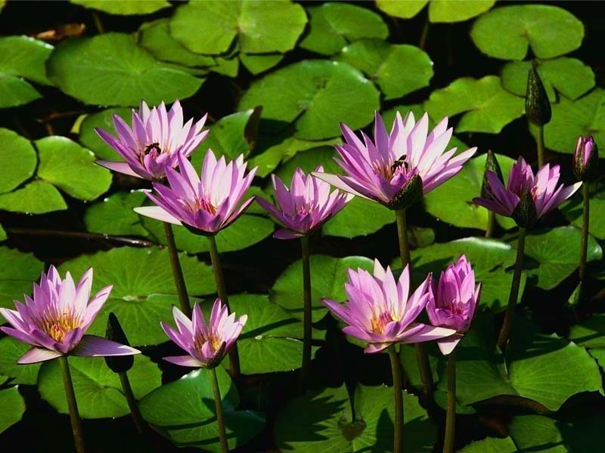

I think that winter is a beautiful season. On the 31st of December people celebrate New Year. I like winter because in winter I can ski and skate.

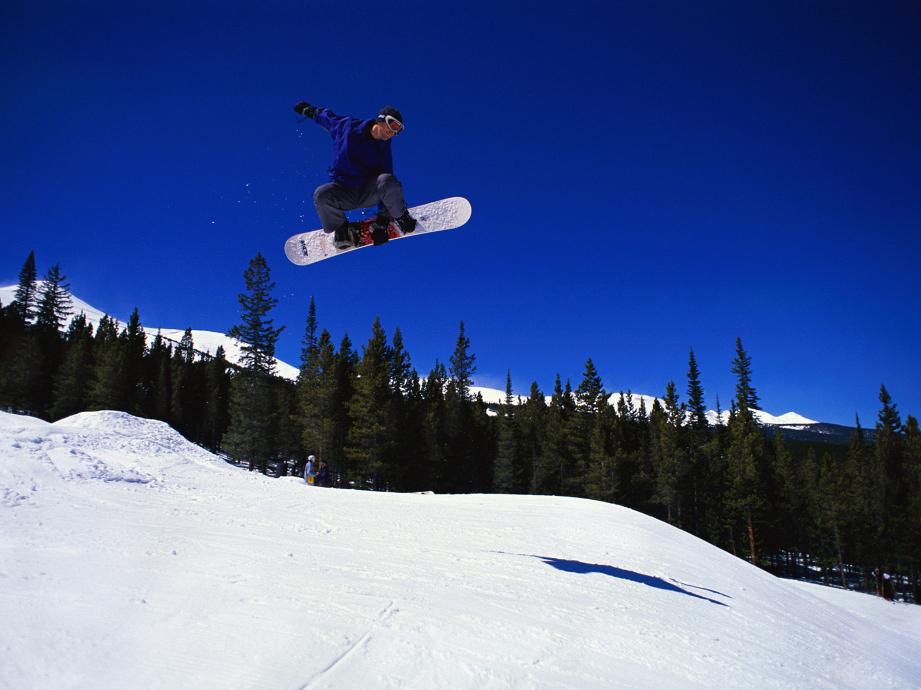

I like autumn, because I go to school. I like the 1st of September. I think the forests are more beautiful in autumn than in winter – the leaves in the trees are of different colors – green, yellow, orange, red and brown. They look beautiful!

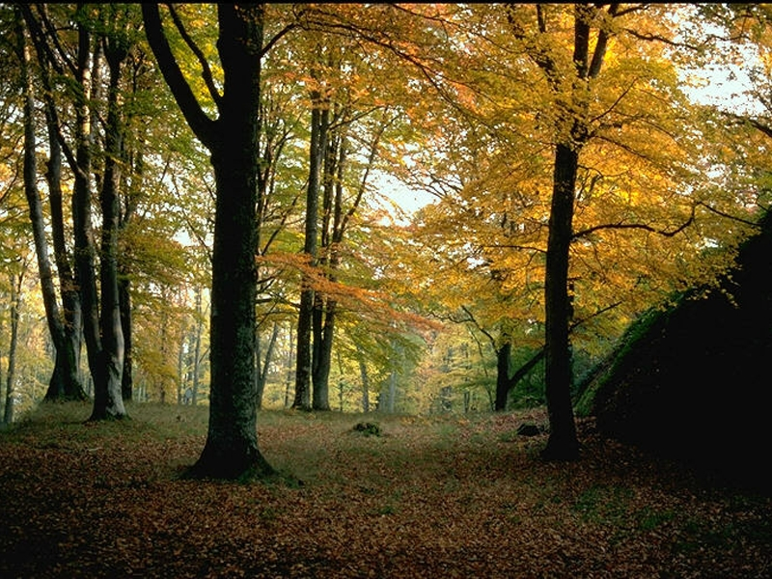

I like spring, too. The leaves are small and green. The grass is green, too. In March is also a holiday for Russian women – Mothers day.
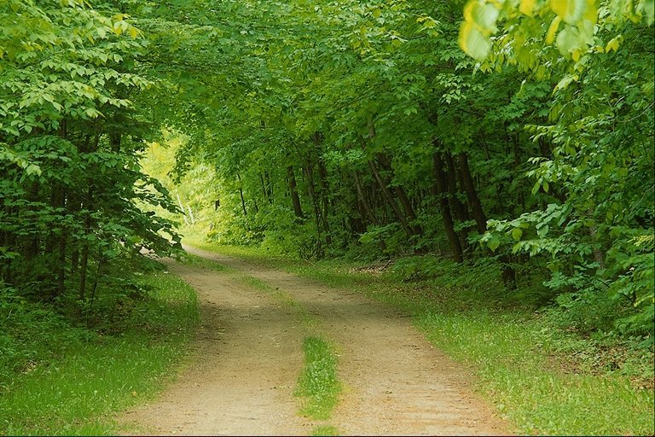

I think all the seasons are beautiful!

