Open lesson plan.

Topic: Money matters.
Date:
Aims:
-to learn new vocabulary;
-to raise students' awareness about phrasal verbs and verbs that go with money;
-to develop students' listening skills;
-to develop students' speaking skills on this topic.
Time: 45 min.
Age: 15-16 years.
Level: Pre-Intermediate.
Students' book: Opportunities. Russian Edition.

The procedure of the lesson:

I. Org. moment. Greeting. (1 min)
II. Lead in activity. (1 min)
Teacher: Today we are going to talk about money. It is almost impossible to imagine life of a modern person without money because we need to pay practically for everything in this life. Only mother's and father's love and friend's support are free.
Will you answer my questions.
1.What do we use money for?
2. Do you like to spend money? What for?
3. Where do you get money?
4. Do you have pocket money?

III. Warm up activity. (6 min) Watching the video: “The story of money” (3,5 min).
The video is taken from: https://www.youtube.com/watch?v=ADaY6THQp3Y
Teacher: I hope you've enjoyed this video. Let's discuss it. What was long ago instead of money?
Pupil 1: Swapping or bartering.
Teacher: What problems were with swapping?
Pupil 2: The items have not got similar value.
Pupil 3: Some items can become rotten soon.
Pupil 4: Some thing were heavy to carry.
Teacher: What did Chinese use as first money?
Pupil 5: Shells.
Teacher: What did people start to use in the West?
Pupil 6: The used items that were difficult to carry.
Teacher: When were first coins made?
Pupil 7: In 280
Teacher: When did the first credit cards appear?
Pupil 8: In 1950
Teacher: What does “to keep money on credit card” mean?
Pupil 9: It means that money is invisible.

IV. Vocabulary study. (5 min)

Teacher: Open your books on page 60. Let's have a look at the key words in exercise 1. Repeat them after me. (Reading in chorus)
Now match the key words with the definitions given below and pictures A-E. Use the mini dictionary if necessary.

Doing an exercise

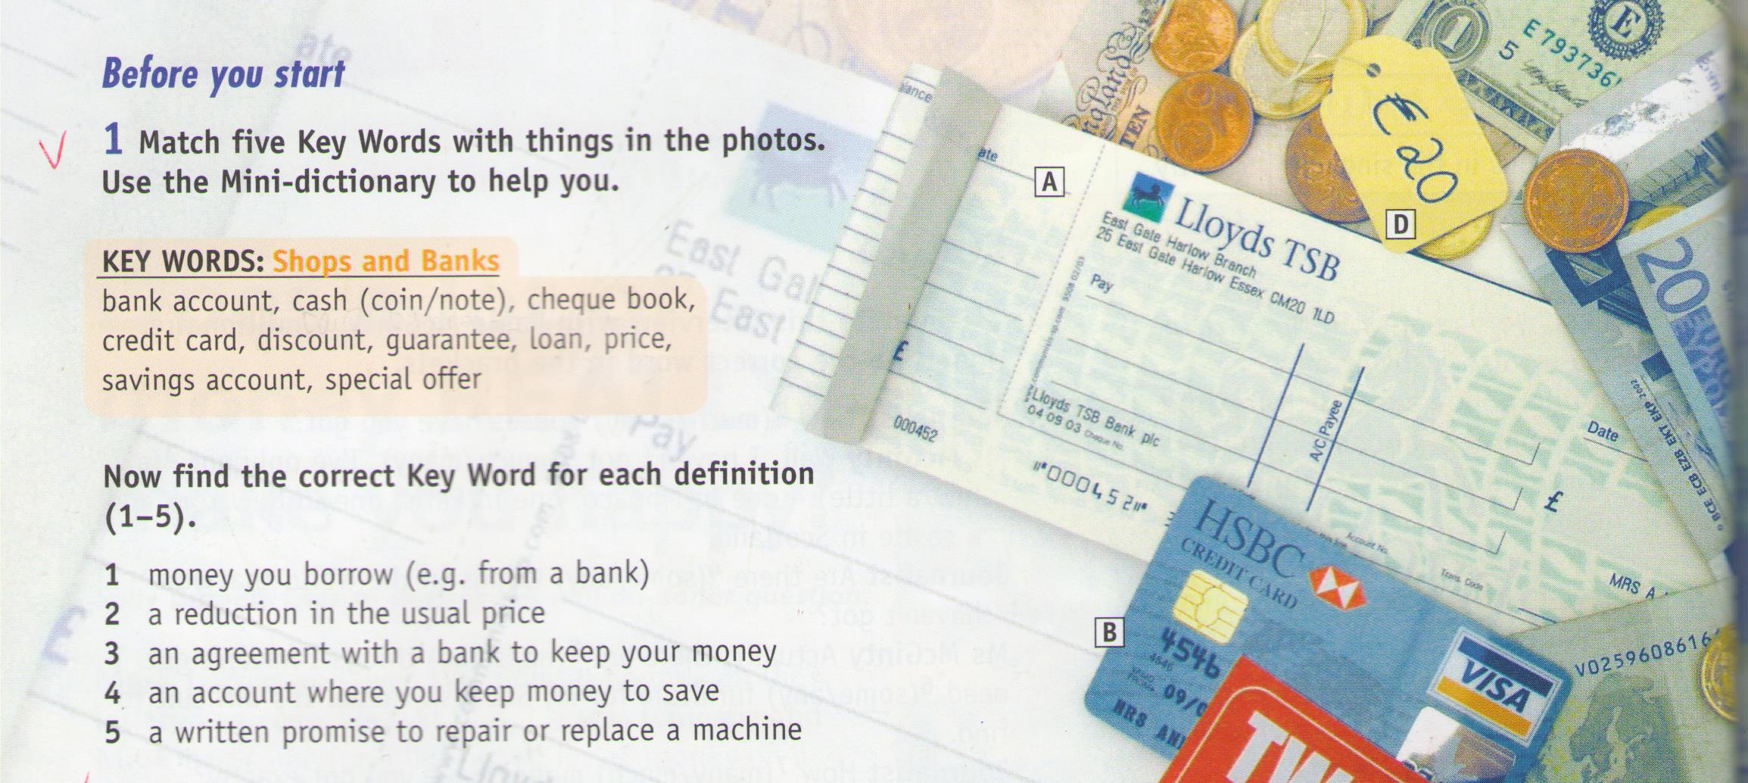
Teacher: Let's check what you have done.
Pupils' answers: 1-loan, 2-discount, 3-bank account, 4-savings account, 5-quarantee.
A-check book, B-credit card, C-cash, D-price, E-special offer.
Teacher: Money, money, money: As you know we can't go to the shop if we haven't got money, credit cards or cheques. What can we do with money?
Pupils: spend, borrow, keep...
Have a look at the blackboard. There are some phrasal verbs. Let's read and translate them.
Verbs on the board:
put into
save up for
give away
take out
ask for
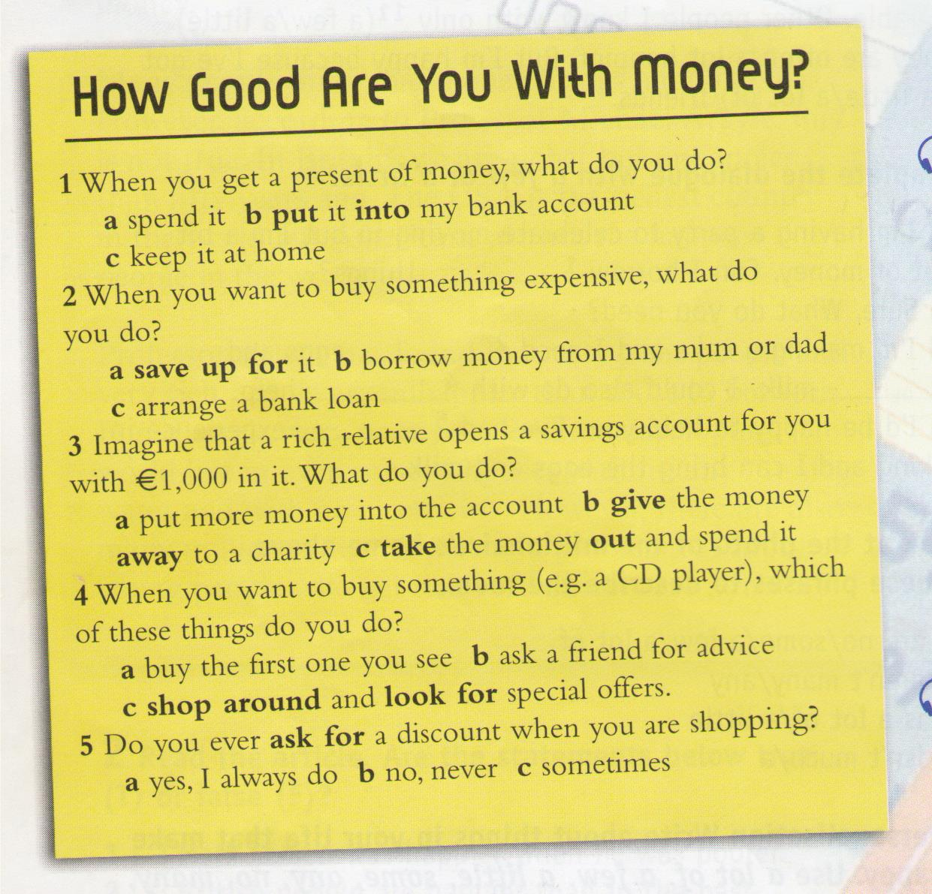
Reading the verbs, guessing the meaning and translating. (1 min)

V. Pair work. (6 min)
Teacher: I'd like to see how good you are with money. Answer the questionnaire in ex. 2 p.60 for you and share your answers with your partner.
Pair work. The teacher is monitoring this activity.
Teacher: Let's summarize. (1 min)
When we want to buy something expensive what do we do?
Pupils: We save up for it.
Teacher: If you are rich and want to help, what can you do?
Pupils: We can give the money away to a charity.
Teacher: If you have a bank account, what can you do with the money?
Pupils: We can put it into the bank account and take it out.
Teacher: If we are in the shop and want to buy something cheaper than usual, what do we do?
Pupils: We look for special offers and ask for the discounts.
Teacher: How can we pay in the shop?
Pupils: by credit card or by cash.

VI. Listening (5 min).
Teacher: Now you'll listen to the dialogue in the shop. A girl is looking for a new mobile phone. The dialogue is between the customer and the shop assistant. Complete the function file in exercise 7 on p. 61. Use the words in yellow line above the function file.
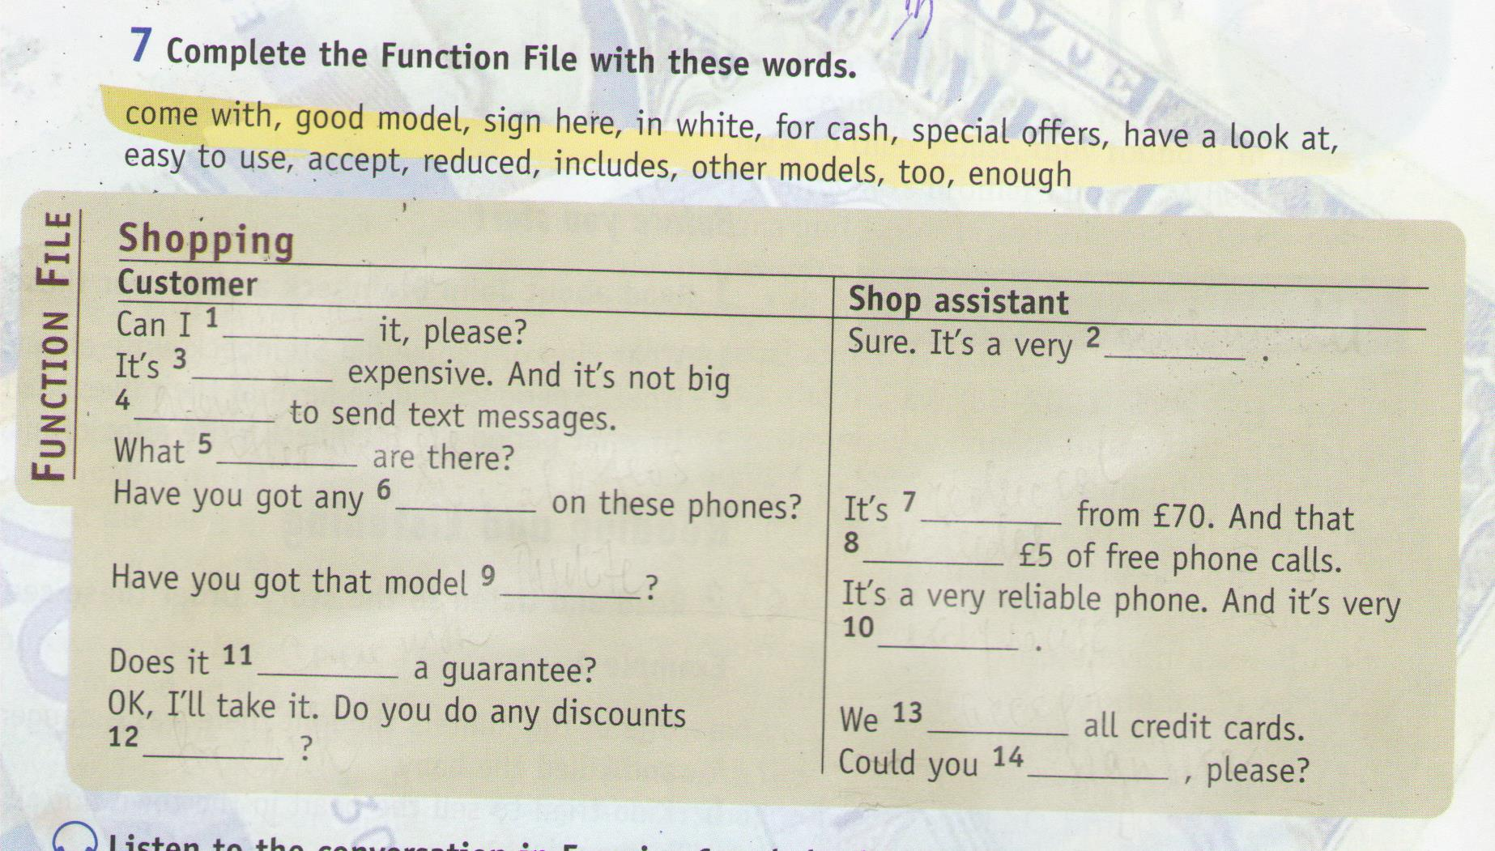
Pupils are filling in the gaps while listening.

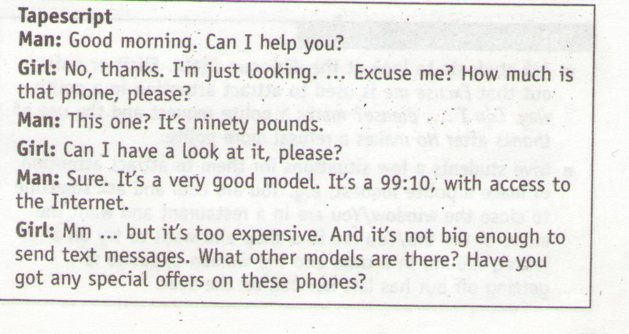

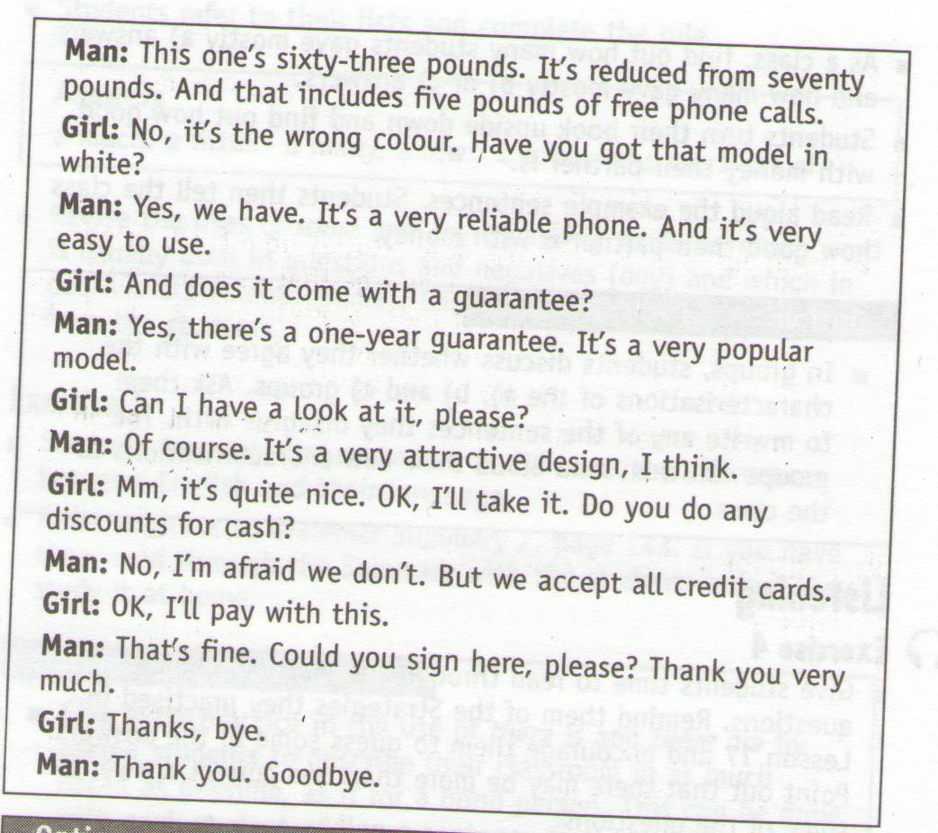

Teacher: Let's check. Answers: 1-have a look at, 2-good model, 3-too, 4-enough, 5-other models, 6-special offers, 7-reduced, 8-includes, 9-in white, 10-easy ti use, 11-come with, 12-for cash, 13- accept, 14- sign here.

VII. Making up dialogues. (10 min).
Teacher: Make up your own dialogues using the phrases from exercise 7 with the objects you like, for example, a CD player, a laptop computer, a hairdryer.
Pupils are making conversations in pairs. The teacher is monitoring this activity.

VIII. Listening, completing and singing a song. (10 min)
Teacher: Now, I'd like you to listen to a song which is called “Ka-ching”, your task is to fill in the gaps on the hand outs. (Giving out).
The song is taken:
http://www.youtube.com/watch?v=DQKuFDL-kos&list=RDDQKuFDL-kos#t=2
First the pupils listen without watching and completing the song on the handout while listening. The second time they listen and watch the video with the text of the song, checking the activity.
Answers: around, Sunday, before, beautiful, king, spend, pocket.
The third time pupils sing the song with the teacher and video.
Homework. (1 min).
Learn the phrases in exercise 7 on p. 61. Make up and role play the dialogues in the clothes shop, using these phrases. Translate the song at home.

