Приложение
Конкурс капитанов.
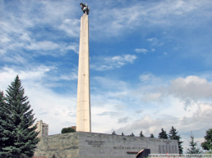 |  | 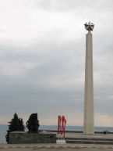
Ответ: Obelisk of Glory in honour of the 30th Anniversary of Victory in the Great Patriotic War

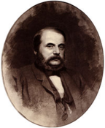 | 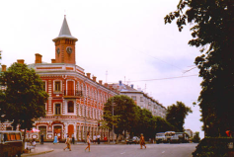 |  | 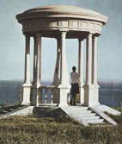
Ответ: The Goncharov Arbour

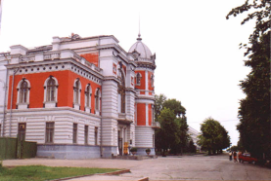 |  | 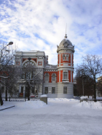
Ответ: The Goncharov Regional Museum of Local Lore

