ПОПАДИ В ЦЕЛЬ

СОБЕРИ МОРСКУЮ ЗВЕЗДУ

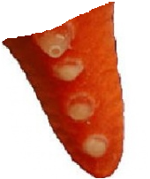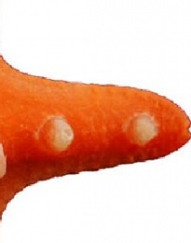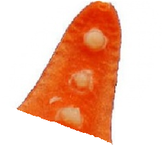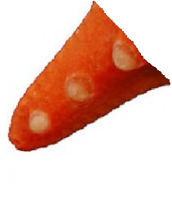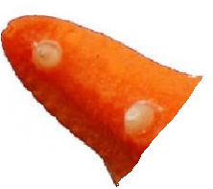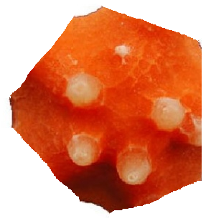

ОПРЕДЕЛИТЕ МАРШРУТ

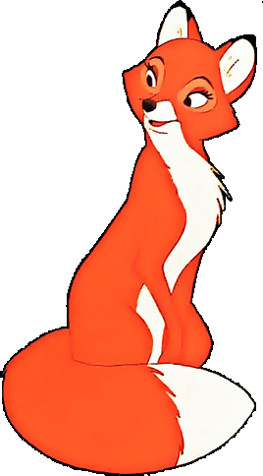

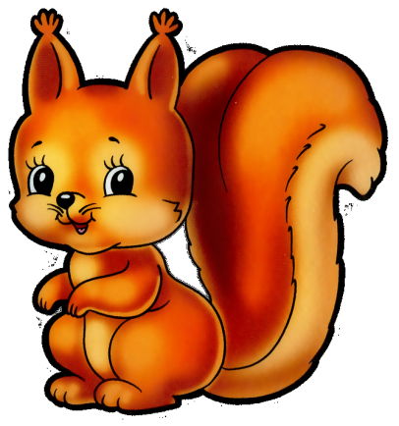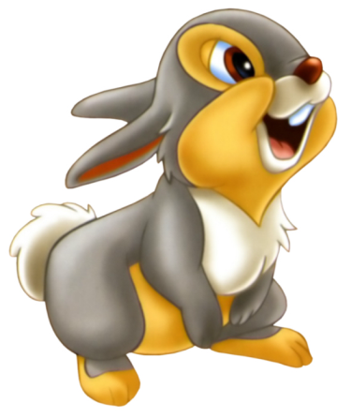

КРОССВОРД

|  |  |  |  |  |  |  |  |  |  |  |  |  |
| --- | --- | --- | --- | --- | --- | --- | --- | --- | --- | --- | --- | --- |
|  |  | |  | | | 1 |  |  |  |  |  |  |
| 2 |  |  |  |  |  |  |  |  | |
|  | | 3 |  |  |  |  |  |  | |
| 4 |  |  |  |  |  |  |
|  | 5 |  |  |  |  |  |

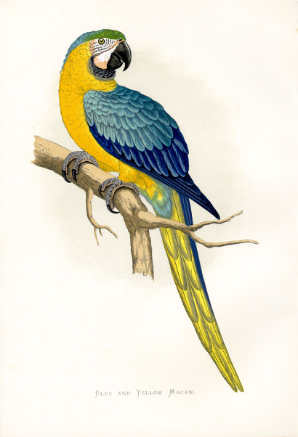 1000 – 784 – 213 =

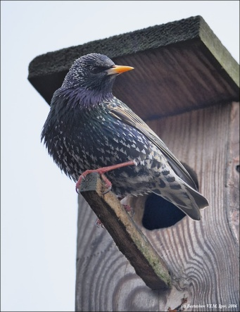

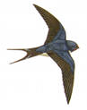254 – 128 – 125=

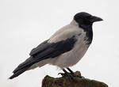

354 + 176 – 526 =

746 – 329 – 412 = 342 – (274 + 66) =

МОРСКОЙ БОЙ

|  |  |  |  |  |  |  |  |  |
| --- | --- | --- | --- | --- | --- | --- | --- | --- |
|  | а | б | а | г | д | е | и | к |
| 1 |  |  |  | 0,2 |  |  |  |  |
| 2 |  |  |  |  |  | 16 |  |  |
| 3 |  | 2 |  |  |  |  |  |  |
| 4 |  |  |  |  |  |  | 90 |  |
| 5 |  |  | 0,8 |  |  |  |  |  |
| 6 |  |  |  |  | 0,02 |  |  |  |
| 7 | 1,6 |  |  |  |  |  |  |  |
| 8 |  |  |  |  |  |  |  | 10 |

1) от 15

2) от 180

3) 0,8 \* 2

4) 0,02 \* 100

5) 20 : 100

6) 2 : 100

7) 2,4 : 3

8) от 20

Ответы:

1. К8
2. И4
3. А7
4. Б3
5. Г1
6. Д6
7. Б5
8. Е2

ЧТО ИЩЕТ ВОДОЛАЗ?

|  |  |  |  |  |  |  |  |  |  |  |  |  |  |  |  |  |  |  |  |  |
| --- | --- | --- | --- | --- | --- | --- | --- | --- | --- | --- | --- | --- | --- | --- | --- | --- | --- | --- | --- | --- |
|  |  |  |  |  |  |  |  |  |  | С |  |  |  |  |  |  |  |  |  |  |
|  |  |  |  |  |  |  |  |  |  |  |  |  |  |  |  |  |  |  |  |  |
|  |  |  |  |  |  |  |  |  |  |  |  |  |  |  |  |  |  |  |  |  |
|  |  |  |  |  |  |  |  |  |  |  |  |  |  |  |  |  |  |  |  |  |
|  |  |  |  |  | 1 |  |  |  | 2 |  |  |  |  |  |  |  |  |  |  |  |
|  |  |  |  |  |  |  |  |  |  |  |  |  |  |  |  | H:\Documents and Settings\user\Рабочий стол\dfeb28e25eb2cad233a51658854649f6_600.jpg |  |  |  |  |
|  |  |  |  |  |  |  |  |  |  |  |  |  |  |  |  |  |  |  |  |  |
|  |  |  |  |  |  |  |  |  |  |  |  |  |  | 3 |  |  |  |  |  |  |
|  |  |  |  |  |  |  |  |  |  |  |  |  |  |  |  | 6 |  |  |  |  |
|  |  |  |  |  |  |  |  |  |  |  |  |  |  |  |  |  |  |  |  |  |
|  |  |  |  |  |  |  |  |  |  |  |  |  |  |  |  | 4 |  |  | 5 |  |
| З |  |  |  |  |  |  |  |  |  |  |  |  |  |  |  |  |  |  |  | В |
|  |  |  |  |  |  |  |  |  |  | 7 |  |  |  |  |  |  |  |  |  |  |
|  |  |  |  |  |  |  |  |  |  |  |  |  |  |  |  |  |  |  |  |  |
|  |  |  |  |  |  |  |  |  |  |  |  |  |  |  |  |  |  |  |  |  |
|  |  |  |  |  |  |  |  |  |  |  |  |  |  |  |  |  |  |  |  |  |
|  |  |  |  |  |  |  |  | 10 |  |  |  |  |  |  |  |  |  |  |  |  |
|  |  |  |  |  |  |  |  |  |  |  |  |  |  | 9 |  |  |  |  |  |  |
|  |  |  |  |  |  |  |  |  |  |  |  |  |  |  |  |  |  |  |  |  |
|  |  |  |  |  |  | 11 |  |  |  |  |  | 8 |  |  |  |  |  |  |  |  |
|  |  |  |  |  |  |  |  |  |  |  |  |  |  |  |  |  |  |  |  |  |
|  |  |  |  |  |  |  |  |  |  |  |  |  |  |  |  |  |  |  |  |  |
|  |  |  |  |  |  |  |  | 12 |  |  |  |  |  |  |  |  |  |  |  |  |
|  |  |  |  |  |  |  |  |  |  |  |  |  |  |  |  |  |  |  |  |  |
|  |  |  |  |  |  |  |  |  |  |  |  |  |  |  |  |  |  |  |  |  |
|  |  |  |  |  |  |  |  |  |  | Ю |  |  |  |  |  |  |  |  |  |  |

1. $\frac{1}{6}$ от 12 Ю 5)0,2 \* 10 С 9) 0,02 \* 100 С
2. $10\% от 80$ В 6) $\frac{2}{5}$ от 20 З 10) 25% от 28 З
3. 20% от 30 Ю 7) 50% от 20 Ю 11) 500 : 100 Ю
4. $\frac{1}{5}$ от 25 В 8) 1% от 300 В 12) $\frac{1}{2}$\* 4 В