|  |  |
| --- | --- |
| *РАССКАЖИТЕ ДЕТЯМ О ХЛЕБЕ.* |  |

[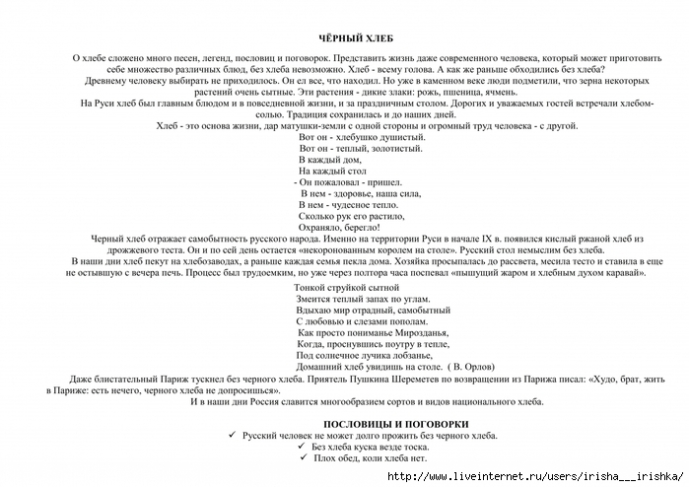](http://img0.liveinternet.ru/images/attach/c/6/90/729/90729552_large_4979214_0__0003.jpg)

[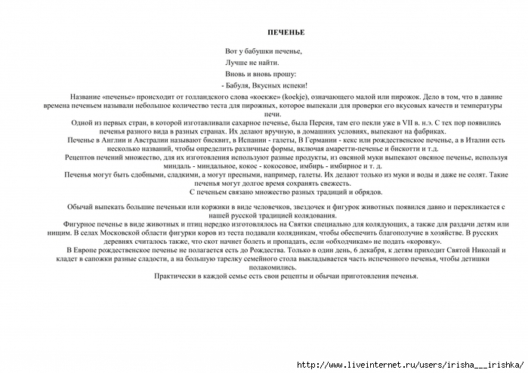](http://img1.liveinternet.ru/images/attach/c/6/90/729/90729555_large_4979214_0__0005.jpg)

[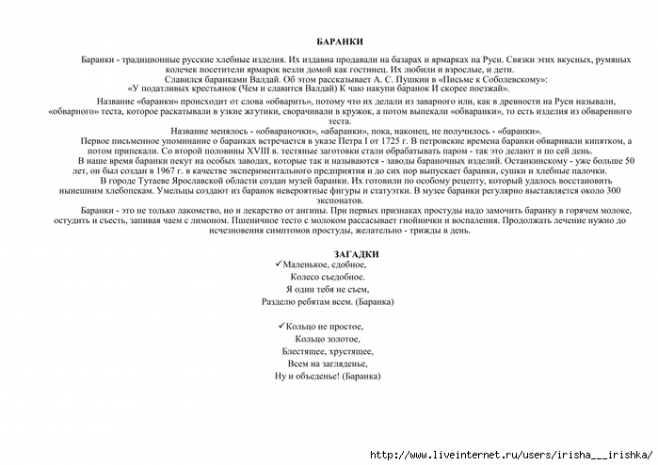](http://img0.liveinternet.ru/images/attach/c/6/90/729/90729558_large_4979214_0__0007.jpg)

[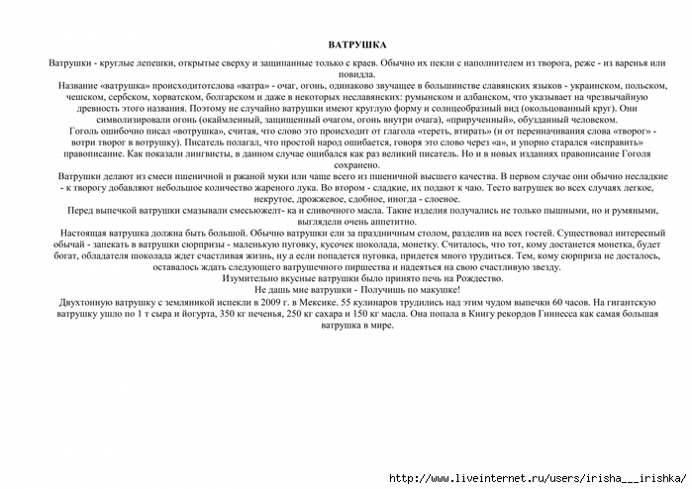](http://img0.liveinternet.ru/images/attach/c/6/90/729/90729562_large_4979214_0__0009.jpg)

[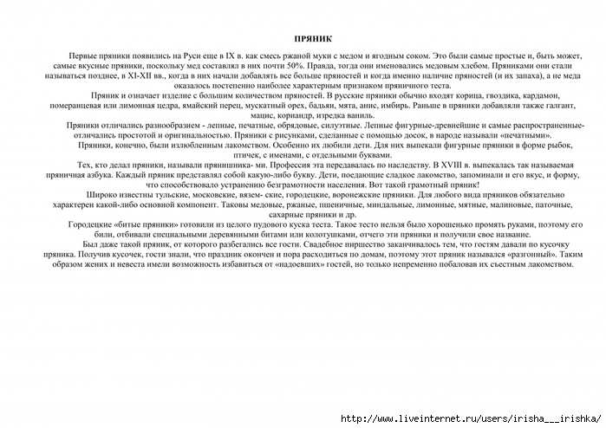](http://img1.liveinternet.ru/images/attach/c/6/90/729/90729565_large_4979214_0__0011.jpg)

[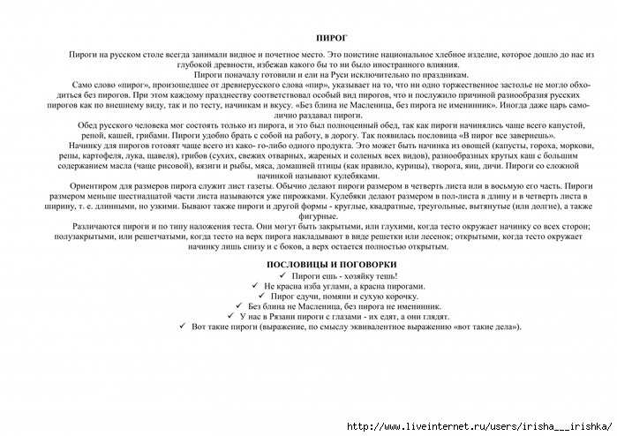](http://img1.liveinternet.ru/images/attach/c/6/90/729/90729567_large_4979214_0__0013.jpg)

[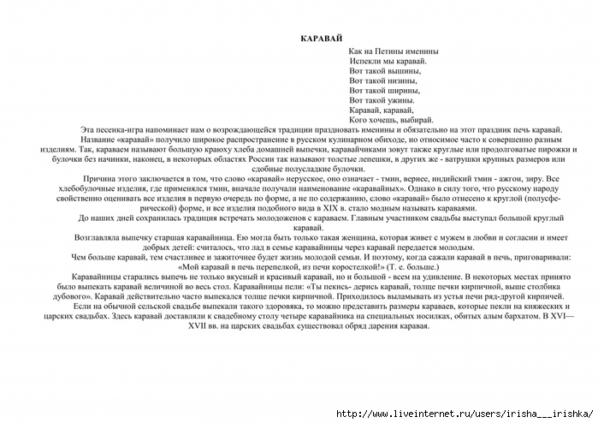](http://img1.liveinternet.ru/images/attach/c/6/90/729/90729571_large_4979214_0__0015.jpg)

[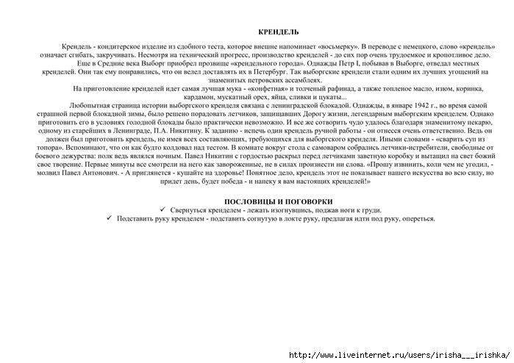](http://img1.liveinternet.ru/images/attach/c/6/90/729/90729573_large_4979214_0__0017.jpg)

[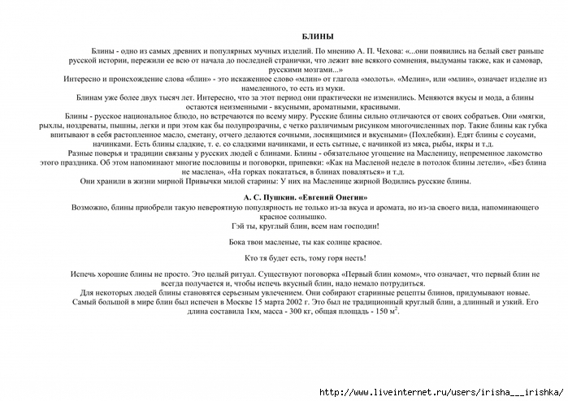](http://img1.liveinternet.ru/images/attach/c/6/90/729/90729575_large_4979214_0__0019.jpg)

[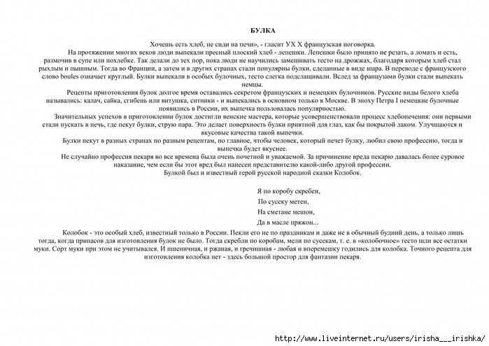](http://img1.liveinternet.ru/images/attach/c/6/90/729/90729577_large_4979214_0__0021.jpg)

[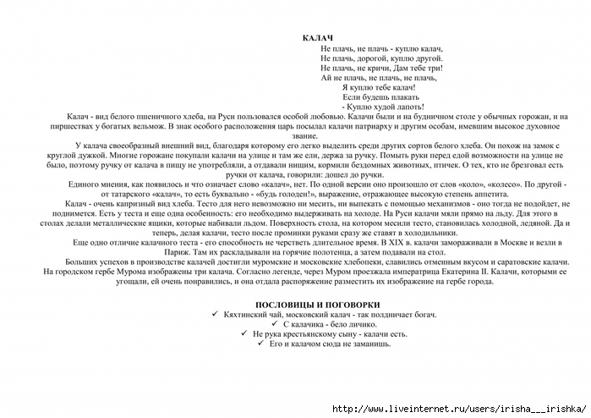](http://img1.liveinternet.ru/images/attach/c/6/90/729/90729579_large_4979214_0__0023.jpg)