|  |  |
| --- | --- |
| Aa | [eI] |
| [æ] |
| Bb [b] | |
|  | |
| Cc | [s] |
| [k] |
| Dd | [d] |
|  | |
| Ee | [i:] |
| [e] |
| Ff | [f] |
|  | |

|  |  |
| --- | --- |
| Gg | [d ʒ] |
| [**g**] |
| Hh | [h] |
|  | |

|  |  |
| --- | --- |
| Ii | [ai] |
| [i] |
| Jj | [d ʒ] |
|  |  |

|  |  |
| --- | --- |
| Kk | [k] |
| Ll | [l] |
| Mm | [m] |
|  | |

|  |  |
| --- | --- |
| Nn | [n] |
| Oo | [əU] |
| [**ɒ** ] |

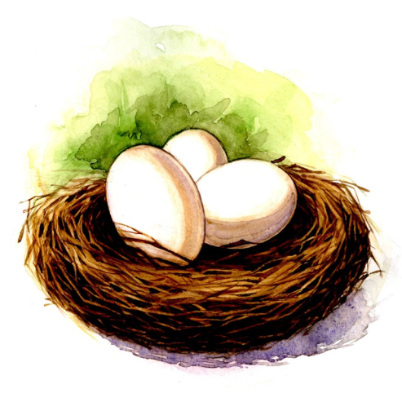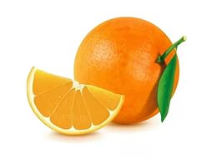

|  |  |
| --- | --- |
| Pp | [p] |
| Qq | [kw] |
| Rr | [r] |

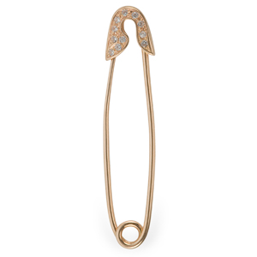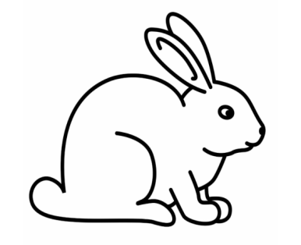

|  |  |
| --- | --- |
| Ss | [s] |
| [z] |
| Tt | [t] |

 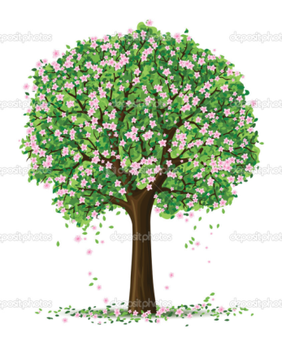

|  |  |
| --- | --- |
| Uu | [ju:] |
| [ʌ] |
| Vv | [v] |

 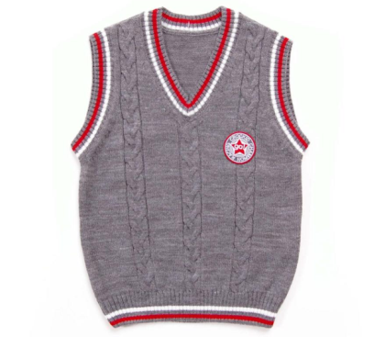

|  |  |
| --- | --- |
| Ww | [w] |
| Xx | [ks] |

 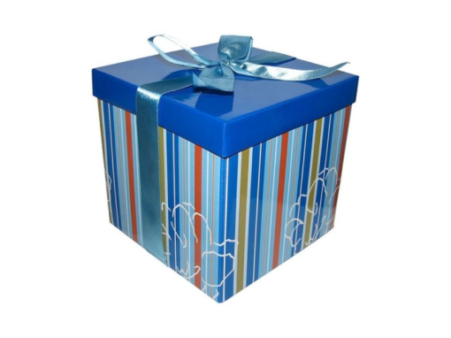

|  |  |
| --- | --- |
| Yy | [ai] |
| [i] |
| Zz | [z] |