Брейн – ринг
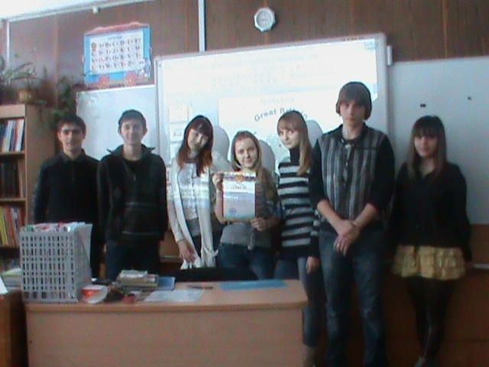
Классы:9 А,9Б,9В
Проводила: учитель английского языка Л.Б.Листопадова

1.Вступление
Good-afternoon,dear boys and girls! We are glad to greet you at our game . All children like to play.That is why we shall play the game
“Brain-ring” today.

1раунд « Разминка»

1.In what book one of the characters got his name when he was a grown up?

- It was Alice from “Alice in Wonderland”
- It was Friday from “Robinson Crusoe”
- It was Guliver from “the Adventures of Guliver”

2.The symbol of this country is the thistle. What country is it?

a) Scotland
b) Wales
c) London

1.Where can you see ravens in London?

- In Westminster Abbey
- In Trafalgar Square
- In the Tower of London

2.What is the capital of Wales?

- Cardiff
- Belfast
- London

1.What English cities are famous for their universities?

- Eton and Harrow
- Harrow and Winchester
- O[ford and Cambridge

2.What is the nationality of people who were born in Northen Ireland?

- Ireland
- Irish
- Scots

2раунд «Достопримечательности Лондона»
Командам выдаются названия достопримечательностей.На доске они записаны для зрителей. Ведущий зачитывает небольшие рассказы- описание различных достопримечательностей.Прослушав,команды подбирают название и описание.
3 раунд «Аукцион неправильных глаголов»
Каждая команда по очереди называет три формы неправильных глаголов.
4 раунд «Раунд капитанов»
Капитаны команд получают задание на карточках.Им необходимо продолжить логическую цепочку.

spring | summer | autumn
warm | hot
summer | autumn | winter
football | basketball

spring | summer | autumn
warm | hot
summer | autumn | winter
football | basketball

spring | summer | autumn
warm | hot
summer | autumn | winter
football | basketball

5 раунд « Времена английского глагола»
Необходимо указать видо-временную форму этих предложений.

- Present Simple
- Present Perfect
- Present Perfect Continuous
- Past Simple
- Past Continuous
- Past Perfect
- Future Simple

- I have never been to Great Britain.
- We play tennis every day.
- He usually goes to the shop in the evening.
- My uncle built this house two years ago.
- Bob had done this homework by 6 o’clock.
- Little children will sledge in winter.
- Nick was painting when his mother came home.
- She has been waiting for Ann since Monday.

6 раунд «Составь слова»
На карточках записаны части английских слов. Необходимо из этих частей составить слова.

to squ mus
buil sta mo
eum pal wn
tou um ment
nu ding are
di rist ace

Спасибо! Итак ,время подходит к концу. Необходимо выбрать победителя.
Приложение
1.In what book one of the characters got his name when he was a grown up?

- It was Alice from “Alice in Wonderland”
- It was Friday from “Robinson Crusoe”
- It was Guliver from “the Adventures of Guliver”

2.The symbol of this country is the thistle. What country is it?

a) Scotland
b) Wales
c) London

1.Where can you see ravens in London?

- In Westminster Abbey
- In Trafalgar Square
- In the Tower of London

2.What is the capital of Wales?

- Cardiff
- Belfast
- London

1.What English cities are famous for their universities?

- Eton and Harrow
- Harrow and Winchester
- O[ford and Cambridge

2.What is the nationality of people who were born in Northen Ireland?

- Ireland
- Irish
- Scots

Buckingham Palace
St. Paul’s Cathedral
The Houses of Parliament
Trafalgar Square

spring | summer | autumn
warm | hot
summer | autumn | winter
football | basketball

spring | summer | autumn
warm | hot
summer | autumn | winter
football | basketball

spring | summer | autumn
warm | hot
summer | autumn | winter
football | basketball

- Present Simple
- Present Perfect
- Present Perfect Continuous
- Past Simple
- Past Continuous
- Past Perfect
- Future Simple

- I have never been to Great Britain.
- We play tennis every day.
- He usually goes to the shop in the evening.
- My uncle built this house two years ago.
- Bob had done this homework by 6 o’clock.
- Little children will sledge in winter.
- Nick was painting when his mother came home.
- She has been waiting for Ann since Monday.

- Present Simple
- Present Perfect
- Present Perfect Continuous
- Past Simple
- Past Continuous
- Past Perfect
- Future Simple

- I have never been to Great Britain.
- We play tennis every day.
- He usually goes to the shop in the evening.
- My uncle built this house two years ago.
- Bob had done this homework by 6 o’clock.
- Little children will sledge in winter.
- Nick was painting when his mother came home.
- She has been waiting for Ann since Monday.

- Present Simple
- Present Perfect
- Present Perfect Continuous
- Past Simple
- Past Continuous
- Past Perfect
- Future Simple

- I have never been to Great Britain.
- We play tennis every day.
- He usually goes to the shop in the evening.
- My uncle built this house two years ago.
- Bob had done this homework by 6 o’clock.
- Little children will sledge in winter.
- Nick was painting when his mother came home.
- She has been waiting for Ann since Monday.

to squ mus
buil sta mo
eum pal wn
tou um ment
nu ding are
di rist ace

Grammar Test
1. Complete the sentences.Use “nobody,nothing,anything,no”
1.Who has eaten my porridge? There is ………… on my plate.
2.There are …………… at the sportsground.
3.Are there anything for brearfast?
4.There is ………. place like home.
5.When I came into the room my little sister was writting ……….. in her
exercise – book.
6.My mother didn’t say …….. .
2. Say the same differently.
1.I don’t want to eat anything. - ………………………………………………………. …………………………………………………………………………………………………………….
2.You can’t see anybody there. - ………………………………………………………. …………………………………………………………………………………………………………….
3.We haven’t got anything to do this evening. - ………………………………..

