[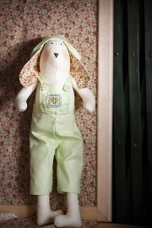](http://odnoklassniki.ru/dk?cmd=PopLayerPhoto&st.layer.cmd=PopLayerViewAltGroupPhotoStickyOuter&st.layer.showNav=on&st.layer.revNav=off&st.layer.photoThread=off&st.layer.happening=off&st.layer.type=GROUP&st.layer.navStartPhotoId=558423922586&st.layer.limitedUi=false&st.layer.photoId=558423922586&st.cmd=altGroupAlbumPhotos&st.albumId=oqvagqqbdgygrjnykzn0rmeibasqnojsyvpixzg&st.groupId=oqvagqqbdgygrjnykzn0ruwzlvrqnojtcqxty&st._aid=Groups_Photo_Album_openPhoto)[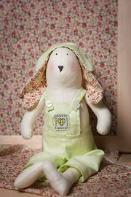](http://odnoklassniki.ru/dk?cmd=PopLayerPhoto&st.layer.cmd=PopLayerViewAltGroupPhotoStickyOuter&st.layer.showNav=on&st.layer.revNav=off&st.layer.photoThread=off&st.layer.happening=off&st.layer.type=GROUP&st.layer.navStartPhotoId=558423900314&st.layer.limitedUi=false&st.layer.photoId=558423900314&st.cmd=altGroupAlbumPhotos&st.albumId=oqvagqqbdgygrjnykzn0rmeibasqnojsyvpixzg&st.groupId=oqvagqqbdgygrjnykzn0ruwzlvrqnojtcqxty&st._aid=Groups_Photo_Album_openPhoto)[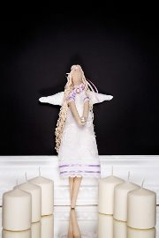](http://odnoklassniki.ru/dk?cmd=PopLayerPhoto&st.layer.cmd=PopLayerViewAltGroupPhotoStickyOuter&st.layer.showNav=on&st.layer.revNav=off&st.layer.photoThread=off&st.layer.happening=off&st.layer.type=GROUP&st.layer.navStartPhotoId=558423863962&st.layer.limitedUi=false&st.layer.photoId=558423863962&st.cmd=altGroupAlbumPhotos&st.albumId=oqvagqqbdgygrjnykzn0rmeibasqnojsyvpixzg&st.groupId=oqvagqqbdgygrjnykzn0ruwzlvrqnojtcqxty&st._aid=Groups_Photo_Album_openPhoto)

[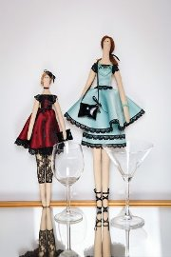](http://odnoklassniki.ru/dk?cmd=PopLayerPhoto&st.layer.cmd=PopLayerViewAltGroupPhotoStickyOuter&st.layer.showNav=on&st.layer.revNav=off&st.layer.photoThread=off&st.layer.happening=off&st.layer.type=GROUP&st.layer.navStartPhotoId=558423830426&st.layer.limitedUi=false&st.layer.photoId=558423830426&st.cmd=altGroupAlbumPhotos&st.albumId=oqvagqqbdgygrjnykzn0rmeibasqnojsyvpixzg&st.groupId=oqvagqqbdgygrjnykzn0ruwzlvrqnojtcqxty&st._aid=Groups_Photo_Album_openPhoto)[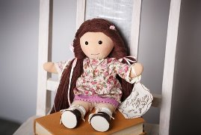](http://odnoklassniki.ru/dk?cmd=PopLayerPhoto&st.layer.cmd=PopLayerViewAltGroupPhotoStickyOuter&st.layer.showNav=on&st.layer.revNav=off&st.layer.photoThread=off&st.layer.happening=off&st.layer.type=GROUP&st.layer.navStartPhotoId=558423803546&st.layer.limitedUi=false&st.layer.photoId=558423803546&st.cmd=altGroupAlbumPhotos&st.albumId=oqvagqqbdgygrjnykzn0rmeibasqnojsyvpixzg&st.groupId=oqvagqqbdgygrjnykzn0ruwzlvrqnojtcqxty&st._aid=Groups_Photo_Album_openPhoto)[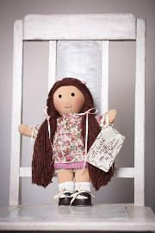](http://odnoklassniki.ru/dk?cmd=PopLayerPhoto&st.layer.cmd=PopLayerViewAltGroupPhotoStickyOuter&st.layer.showNav=on&st.layer.revNav=off&st.layer.photoThread=off&st.layer.happening=off&st.layer.type=GROUP&st.layer.navStartPhotoId=558423768218&st.layer.limitedUi=false&st.layer.photoId=558423768218&st.cmd=altGroupAlbumPhotos&st.albumId=oqvagqqbdgygrjnykzn0rmeibasqnojsyvpixzg&st.groupId=oqvagqqbdgygrjnykzn0ruwzlvrqnojtcqxty&st._aid=Groups_Photo_Album_openPhoto)[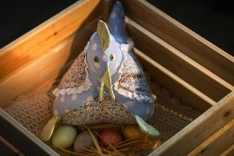](http://odnoklassniki.ru/dk?cmd=PopLayerPhoto&st.layer.cmd=PopLayerViewAltGroupPhotoStickyOuter&st.layer.showNav=on&st.layer.revNav=off&st.layer.photoThread=off&st.layer.happening=off&st.layer.type=GROUP&st.layer.navStartPhotoId=558423720346&st.layer.limitedUi=false&st.layer.photoId=558423720346&st.cmd=altGroupAlbumPhotos&st.albumId=oqvagqqbdgygrjnykzn0rmeibasqnojsyvpixzg&st.groupId=oqvagqqbdgygrjnykzn0ruwzlvrqnojtcqxty&st._aid=Groups_Photo_Album_openPhoto)[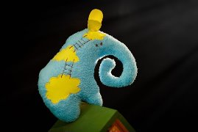](http://odnoklassniki.ru/dk?cmd=PopLayerPhoto&st.layer.cmd=PopLayerViewAltGroupPhotoStickyOuter&st.layer.showNav=on&st.layer.revNav=off&st.layer.photoThread=off&st.layer.happening=off&st.layer.type=GROUP&st.layer.navStartPhotoId=558423611034&st.layer.limitedUi=false&st.layer.photoId=558423611034&st.cmd=altGroupAlbumPhotos&st.albumId=oqvagqqbdgygrjnykzn0rmeibasqnojsyvpixzg&st.groupId=oqvagqqbdgygrjnykzn0ruwzlvrqnojtcqxty&st._aid=Groups_Photo_Album_openPhoto)[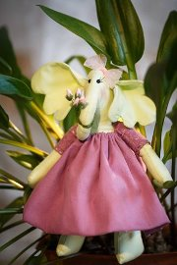](http://odnoklassniki.ru/dk?cmd=PopLayerPhoto&st.layer.cmd=PopLayerViewAltGroupPhotoStickyOuter&st.layer.showNav=on&st.layer.revNav=off&st.layer.photoThread=off&st.layer.happening=off&st.layer.type=GROUP&st.layer.navStartPhotoId=558423568026&st.layer.limitedUi=false&st.layer.photoId=558423568026&st.cmd=altGroupAlbumPhotos&st.albumId=oqvagqqbdgygrjnykzn0rmeibasqnojsyvpixzg&st.groupId=oqvagqqbdgygrjnykzn0ruwzlvrqnojtcqxty&st._aid=Groups_Photo_Album_openPhoto)

[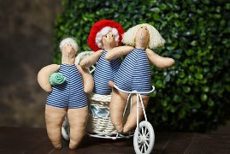](http://odnoklassniki.ru/dk?cmd=PopLayerPhoto&st.layer.cmd=PopLayerViewAltGroupPhotoStickyOuter&st.layer.showNav=on&st.layer.revNav=off&st.layer.photoThread=off&st.layer.happening=off&st.layer.type=GROUP&st.layer.navStartPhotoId=558423453338&st.layer.limitedUi=false&st.layer.photoId=558423453338&st.cmd=altGroupAlbumPhotos&st.albumId=oqvagqqbdgygrjnykzn0rmeibasqnojsyvpixzg&st.groupId=oqvagqqbdgygrjnykzn0ruwzlvrqnojtcqxty&st._aid=Groups_Photo_Album_openPhoto)[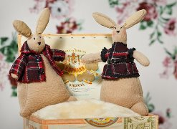](http://odnoklassniki.ru/dk?cmd=PopLayerPhoto&st.layer.cmd=PopLayerViewAltGroupPhotoStickyOuter&st.layer.showNav=on&st.layer.revNav=off&st.layer.photoThread=off&st.layer.happening=off&st.layer.type=GROUP&st.layer.navStartPhotoId=558423379866&st.layer.limitedUi=false&st.layer.photoId=558423379866&st.cmd=altGroupAlbumPhotos&st.albumId=oqvagqqbdgygrjnykzn0rmeibasqnojsyvpixzg&st.groupId=oqvagqqbdgygrjnykzn0ruwzlvrqnojtcqxty&st._aid=Groups_Photo_Album_openPhoto)

[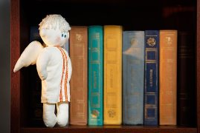](http://odnoklassniki.ru/dk?cmd=PopLayerPhoto&st.layer.cmd=PopLayerViewAltGroupPhotoStickyOuter&st.layer.showNav=on&st.layer.revNav=off&st.layer.photoThread=off&st.layer.happening=off&st.layer.type=GROUP&st.layer.navStartPhotoId=558423347354&st.layer.limitedUi=false&st.layer.photoId=558423347354&st.cmd=altGroupAlbumPhotos&st.albumId=oqvagqqbdgygrjnykzn0rmeibasqnojsyvpixzg&st.groupId=oqvagqqbdgygrjnykzn0ruwzlvrqnojtcqxty&st._aid=Groups_Photo_Album_openPhoto)[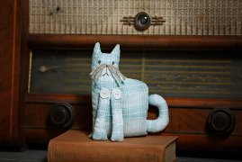](http://odnoklassniki.ru/dk?cmd=PopLayerPhoto&st.layer.cmd=PopLayerViewAltGroupPhotoStickyOuter&st.layer.showNav=on&st.layer.revNav=off&st.layer.photoThread=off&st.layer.happening=off&st.layer.type=GROUP&st.layer.navStartPhotoId=558423327386&st.layer.limitedUi=false&st.layer.photoId=558423327386&st.cmd=altGroupAlbumPhotos&st.albumId=oqvagqqbdgygrjnykzn0rmeibasqnojsyvpixzg&st.groupId=oqvagqqbdgygrjnykzn0ruwzlvrqnojtcqxty&st._aid=Groups_Photo_Album_openPhoto)

[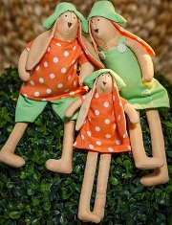](http://odnoklassniki.ru/dk?cmd=PopLayerPhoto&st.layer.cmd=PopLayerViewAltGroupPhotoStickyOuter&st.layer.showNav=on&st.layer.revNav=off&st.layer.photoThread=off&st.layer.happening=off&st.layer.type=GROUP&st.layer.navStartPhotoId=558423297690&st.layer.limitedUi=false&st.layer.photoId=558423297690&st.cmd=altGroupAlbumPhotos&st.albumId=oqvagqqbdgygrjnykzn0rmeibasqnojsyvpixzg&st.groupId=oqvagqqbdgygrjnykzn0ruwzlvrqnojtcqxty&st._aid=Groups_Photo_Album_openPhoto)[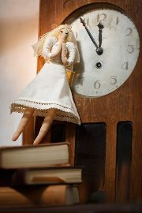](http://odnoklassniki.ru/dk?cmd=PopLayerPhoto&st.layer.cmd=PopLayerViewAltGroupPhotoStickyOuter&st.layer.showNav=on&st.layer.revNav=off&st.layer.photoThread=off&st.layer.happening=off&st.layer.type=GROUP&st.layer.navStartPhotoId=558423245722&st.layer.limitedUi=false&st.layer.photoId=558423245722&st.cmd=altGroupAlbumPhotos&st.albumId=oqvagqqbdgygrjnykzn0rmeibasqnojsyvpixzg&st.groupId=oqvagqqbdgygrjnykzn0ruwzlvrqnojtcqxty&st._aid=Groups_Photo_Album_openPhoto)[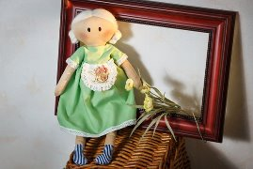](http://odnoklassniki.ru/dk?cmd=PopLayerPhoto&st.layer.cmd=PopLayerViewAltGroupPhotoStickyOuter&st.layer.showNav=on&st.layer.revNav=off&st.layer.photoThread=off&st.layer.happening=off&st.layer.type=GROUP&st.layer.navStartPhotoId=558423219354&st.layer.limitedUi=false&st.layer.photoId=558423219354&st.cmd=altGroupAlbumPhotos&st.albumId=oqvagqqbdgygrjnykzn0rmeibasqnojsyvpixzg&st.groupId=oqvagqqbdgygrjnykzn0ruwzlvrqnojtcqxty&st._aid=Groups_Photo_Album_openPhoto)[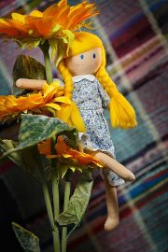](http://odnoklassniki.ru/dk?cmd=PopLayerPhoto&st.layer.cmd=PopLayerViewAltGroupPhotoStickyOuter&st.layer.showNav=on&st.layer.revNav=off&st.layer.photoThread=off&st.layer.happening=off&st.layer.type=GROUP&st.layer.navStartPhotoId=558423189402&st.layer.limitedUi=false&st.layer.photoId=558423189402&st.cmd=altGroupAlbumPhotos&st.albumId=oqvagqqbdgygrjnykzn0rmeibasqnojsyvpixzg&st.groupId=oqvagqqbdgygrjnykzn0ruwzlvrqnojtcqxty&st._aid=Groups_Photo_Album_openPhoto)[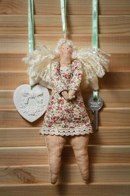](http://odnoklassniki.ru/dk?cmd=PopLayerPhoto&st.layer.cmd=PopLayerViewAltGroupPhotoStickyOuter&st.layer.showNav=on&st.layer.revNav=off&st.layer.photoThread=off&st.layer.happening=off&st.layer.type=GROUP&st.layer.navStartPhotoId=558423177626&st.layer.limitedUi=false&st.layer.photoId=558423177626&st.cmd=altGroupAlbumPhotos&st.albumId=oqvagqqbdgygrjnykzn0rmeibasqnojsyvpixzg&st.groupId=oqvagqqbdgygrjnykzn0ruwzlvrqnojtcqxty&st._aid=Groups_Photo_Album_openPhoto)[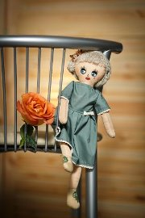](http://odnoklassniki.ru/dk?cmd=PopLayerPhoto&st.layer.cmd=PopLayerViewAltGroupPhotoStickyOuter&st.layer.showNav=on&st.layer.revNav=off&st.layer.photoThread=off&st.layer.happening=off&st.layer.type=GROUP&st.layer.navStartPhotoId=558423161754&st.layer.limitedUi=false&st.layer.photoId=558423161754&st.cmd=altGroupAlbumPhotos&st.albumId=oqvagqqbdgygrjnykzn0rmeibasqnojsyvpixzg&st.groupId=oqvagqqbdgygrjnykzn0ruwzlvrqnojtcqxty&st._aid=Groups_Photo_Album_openPhoto)[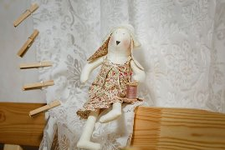](http://odnoklassniki.ru/dk?cmd=PopLayerPhoto&st.layer.cmd=PopLayerViewAltGroupPhotoStickyOuter&st.layer.showNav=on&st.layer.revNav=off&st.layer.photoThread=off&st.layer.happening=off&st.layer.type=GROUP&st.layer.navStartPhotoId=558423107482&st.layer.limitedUi=false&st.layer.photoId=558423107482&st.cmd=altGroupAlbumPhotos&st.albumId=oqvagqqbdgygrjnykzn0rmeibasqnojsyvpixzg&st.groupId=oqvagqqbdgygrjnykzn0ruwzlvrqnojtcqxty&st._aid=Groups_Photo_Album_openPhoto)